**How to Use this Template**

1. Make a copy [ File → Make a copy... ]
2. Rename this file: “**Capstone_Stage1**”
3. Replace the text in green

**Submission Instructions**

1. After you’ve completed all the sections, download this document as a PDF [ File → Download as PDF ]
2. Create a new GitHub repo for the capstone. Name it “**Capstone Project**”
3. Add this document to your repo. Make sure it’s named “**Capstone_Stage1.pdf**”

Description

Intended User

Features

User Interface Mocks

Screen 1

Screen 2

Key Considerations

How will your app handle data persistence?

Describe any corner cases in the UX.

Describe any libraries you’ll be using and share your reasoning for including them.

Describe how you will implement Google Play Services.

Next Steps: Required Tasks

Task 1: Project Setup

Task 2: Implement UI for Each Activity and Fragment

Task 3: Your Next Task

Task 4: Your Next Task

Task 5: Your Next Task

**GitHub Username**: [mehtaprashant19@gmail.com](mailto:mehtaprashant19@gmail.com)

Student Monitoring System

# Description

This application provide information like as

* Student Attendance
* Results
* Mid-Semester Marks
* Time Table etc…

# Intended User

Parents and Students

# Features

List the main features of the app.

* Student Profile
* Students’ Attendance
* Students’ Results

# User Interface Mocks

These can be created by hand (take a photo of your drawings and insert them in this flow), or using a program like Photoshop or Balsamiq.

## Screen 1

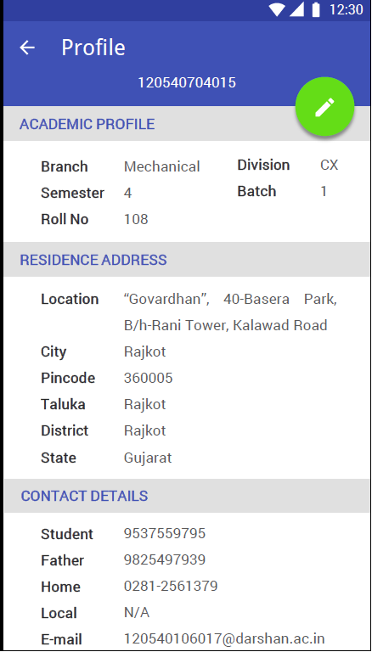

Student Profile Screen

## Screen 2

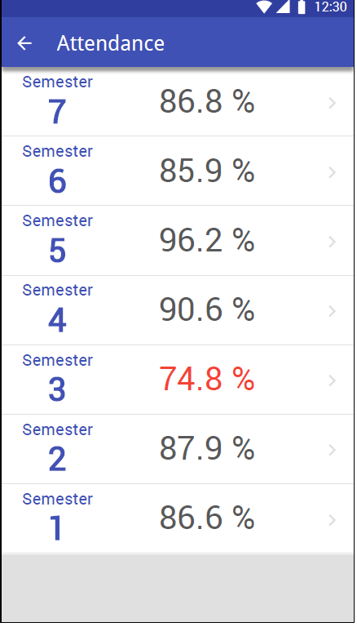

Students’ Attendance Screen

Add as many screens as you need to portray your app’s UI flow.

# Key Considerations

### How will your app handle data persistence?

Through Web Service

### Describe any corner cases in the UX.

For example, how does the user return to a Now Playing screen in a media player if they hit the back button?

### Describe any libraries you’ll be using and share your reasoning for including them.

For example, Picasso handle the loading and caching of images.

### Describe how you will implement Google Play Services.

Not Using

# Next Steps: Required Tasks

This is the section where you can take the main features of your app (declared above) and decompose them into tangible technical tasks that you can complete incrementally until you have a finished app.

## Task 1: Project Setup

Write out the steps you will take to setup and/or configure this project. See previous implementation guides for an example.

You may want to list the subtasks. For example:

* Configure libraries
* Something else

If it helps, imagine you are describing these tasks to a friend who wants to follow along and build this app with you.

## Task 2: Implement UI for Each Activity and Fragment

List the subtasks. For example:

* Build UI for DashBoardActivity
* Build UI for ProfileActivity
* Build UI for AttendanceActivity
* Build UI for ResultActivity

## Task 3: Implements Web Services

Will Implement Web Services for all the activities

## Task 4: Implements App Widgets

Next and Last Task is to Implement App Widgets