Filter Head Ablation Study
Comparing input-token filtering strategies for CBM-style concept alignment on CheXpert, using a frozen Qwen3.5-2B backbone

1. Objective
Determine which input-token filtering strategy best supports a frozen-backbone, CBM-style concept alignment head on CheXpert chest X-rays, without fine-tuning the underlying vision-language model. Five candidate filter heads are compared against a common alignment head, training pipeline, and evaluation protocol so that differences in results are attributable to the filtering mechanism itself.

2. Architecture overview
The backbone (Qwen3.5-2B) stays frozen throughout every experiment — forward-only, no gradients ever reach it. Only the filter head and the alignment head are trained. The filter head is the only component that changes between experimental arms; the alignment head, loss weighting, and training schedule are held constant across all five variants to isolate the effect of the filtering mechanism.
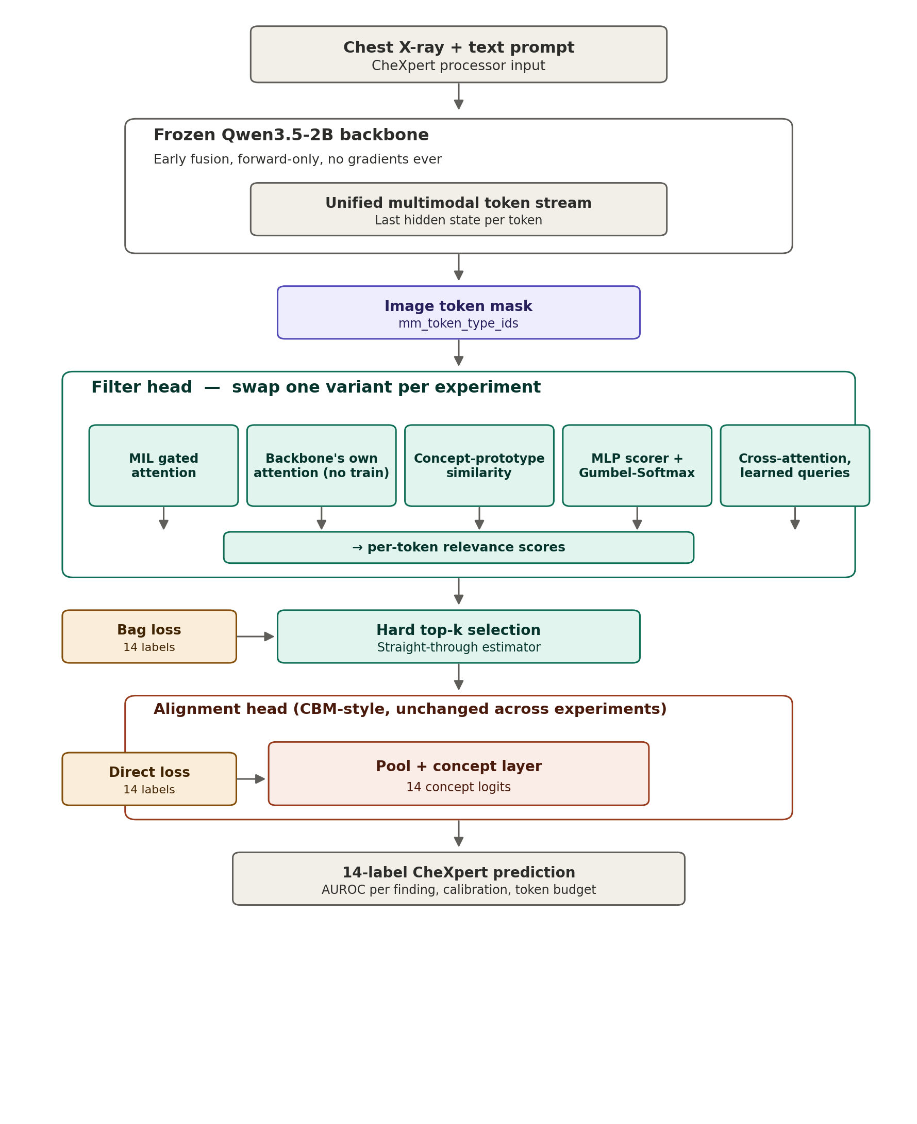
Gray = frozen backbone (never trained). Teal = filter head (the experimental variable). Coral = alignment head (held constant). Amber = the two points where CheXpert's 14 labels supply supervision — a bag-level loss shaping the filter's attention, and a direct loss on the alignment head's concept predictions using only the tokens that survive filtering.

3. Filter head variants

3.1 MIL gated attention (primary hypothesis)
Gated attention Multiple Instance Learning [1], as used in weakly supervised histopathology models such as CLAM [2]. Learns a scorer softmax(w · (tanh(Vx) ⊙ sigmoid(Ux))) over image tokens, trained only on image-level bag labels — no token-level annotation required. Includes its own bag-level auxiliary classifier used purely to supervise the attention weights.
- Trainable parameters: attention gate (V, U, w) + bag classifier
- Supervision: bag-level CheXpert labels only
- Expected strength: learns task-specific relevance beyond what the backbone's native attention captures

3.2 Backbone's own attention (zero-training baseline)
Reuses the frozen backbone's last-layer attention weights directly (via output_attentions=True), aggregated over image-token positions. No new trainable parameters at all — the cheapest possible baseline, run first to establish whether a trained filter is earning its cost.
- Trainable parameters: none
- Supervision: none (read directly from the frozen forward pass)
- Purpose: sanity-check floor for all other variants

3.3 Concept-prototype similarity
Scores each image token by cosine similarity to the alignment head's own 14 concept vectors (the concept_layer weight rows), taking the max similarity across concepts as the token's relevance score. Reuses weights already being trained elsewhere in the pipeline rather than introducing a new mechanism, and is directly interpretable — a kept token can be traced back to the specific finding it matched.
- Trainable parameters: none beyond the existing alignment head
- Supervision: implicit, inherited from the alignment head's own training
- Expected strength: best interpretability-to-cost ratio

3.4 MLP scorer + Gumbel-Softmax
A small two-layer MLP scores each token independently (no cross-token interaction), with a Gumbel-Softmax (Concrete distribution) relaxation [3] making the discrete keep/drop decision differentiable during training, without needing a separate straight-through step at the end.
- Trainable parameters: small MLP only
- Supervision: bag-level CheXpert labels
- Expected weakness: no token-to-token context informing relevance

3.5 Cross-attention with learnable queries
A small set of learnable query vectors (one per CheXpert finding) cross-attend into the image tokens and pull out the most relevant ones per query — similar in spirit to DETR-style or Perceiver-style query attention. Most expressive variant; only worth its added complexity if 3.1–3.4 prove insufficiently selective.
- Trainable parameters: 14 query vectors + cross-attention weights
- Supervision: bag-level CheXpert labels
- Expected strength: per-finding specialization

4. Shared training pipeline
Identical for every variant, so results are comparable:
- Phase 1 — soft attention. Filter head runs in soft mode (reweight, don't drop); alignment head sees the full token set, reweighted. Stabilizes gradients before any hard selection is introduced.
- Phase 2 — hardening. Switch to hard top-k selection (straight-through estimator for the trainable variants; direct top-k for the training-free baseline). Fine-tune briefly so heads adapt to genuinely losing information from dropped tokens.
- Phase 3 — calibration. Sweep token budget k ∈ {16, 32, 64, 128} on held-out validation data; report the smallest k that does not meaningfully reduce concept-prediction AUROC relative to using the full token set.
Loss (variants with trainable filters): total = 1.0 × concept_loss + 0.3 × bag_loss + 0.01 × entropy_regularizer, where entropy_regularizer pushes the attention distribution toward a peaky, few-token shape.

5. Dataset and label handling
CheXpert [4]: 224,316 chest radiographs from 65,240 patients, 14 automatically extracted observations per study, each labeled positive, negative, uncertain, or not mentioned.
- Frontal-only for the primary runs; frontal+lateral as a secondary ablation, since lateral views help some findings (e.g. effusion) and hurt others
- Uncertainty policy: report results under both U-Ones and U-Zeros mappings for the labels most sensitive to this choice, rather than defaulting silently — the original CheXpert paper found the best policy differs by pathology
- Official CheXpert train/valid splits; the 200-study radiologist-annotated validation set is reserved for the final AUROC comparison across variants

6. Evaluation protocol
- Primary metric: per-label AUROC and macro-averaged AUROC across all 14 findings, at each calibrated token budget k
- Efficiency metric: tokens retained vs. AUROC retained, to compare the filtering-quality/compute tradeoff across variants directly
- Interpretability check: for any available radiologist-marked regions of interest (even a small sample), compare kept-token maps against marked regions across variants
- Calibration sanity check: verify concept probability outputs are not systematically over- or under-confident post-filtering, relative to the unfiltered baseline

7. Ablation matrix
Filter variant | New params | Training cost | Interpretability | Priority
Backbone attention | None | None | Low | Run first (baseline)
Concept-prototype similarity | None new | Very low | High | Run second
MIL gated attention | Small | Low | Medium | Primary hypothesis
MLP + Gumbel-Softmax | Small | Low | Low | Run if 3.1 underperforms
Cross-attention queries | Medium | Medium | Medium-High | Run only if needed

8. Risks and mitigations
- Bag-level supervision is weaker than token-level supervision — the filter may need more data or a stronger sparsity term than pure classification training to converge on genuinely diagnostic regions rather than spurious correlates.
- Qwen3.5's mm_token_type_ids field and its exact image-type integer value need verification against the actual processor output before training — do not assume the value without printing a sample batch.
- CheXpert's uncertainty-label policy materially changes per-label results; report both policies for sensitive labels rather than picking one silently.
- Hardened (top-k) training can be unstable immediately after switching from soft attention — keep the phase-2 learning rate lower than phase-1.

References
[1] Ilse, M., Tomczak, J. M., & Welling, M. (2018). Attention-based Deep Multiple Instance Learning. ICML 2018. https://arxiv.org/abs/1802.04712
[2] Lu, M. Y., Williamson, D. F. K., Chen, T. Y., Chen, R. J., Barbieri, M., & Mahmood, F. (2021). Data-efficient and weakly supervised computational pathology on whole-slide images. Nature Biomedical Engineering. https://arxiv.org/abs/2004.09666
[3] Rao, Y., Zhao, W., Liu, B., Lu, J., Zhou, J., & Hsieh, C.-J. (2021). DynamicViT: Efficient Vision Transformers with Dynamic Token Sparsification. NeurIPS 2021. https://arxiv.org/abs/2106.02034
[4] Irvin, J., Rajpurkar, P., Ko, M., et al. (2019). CheXpert: A Large Chest Radiograph Dataset with Uncertainty Labels and Expert Comparison. AAAI 2019. https://arxiv.org/abs/1901.07031
[5] Koh, P. W., Nguyen, T., Tang, Y. S., Mussmann, S., Pierson, E., Kim, B., & Liang, P. (2020). Concept Bottleneck Models. ICML 2020. https://arxiv.org/abs/2007.04612
[6] Chen, L., et al. (2024). An Image is Worth 1/2 Tokens After Layer 2: Plug-and-Play Inference Acceleration for Large Vision-Language Models (FastV). https://arxiv.org/abs/2403.06764
[7] DSpark: Confidence-Scheduled Speculative Decoding with Semi-Autoregressive Generation (2026) — origin of the frozen-backbone / trained-side-module design pattern this plan adapts. https://www.alphaxiv.org/abs/2026.dspark
[8] Qwen3.5 model documentation, Hugging Face Transformers — processor fields (mm_token_type_ids, image_grid_thw) referenced in Section 8. https://huggingface.co/docs/transformers/en/model_doc/qwen3_5

