Websites for SSL Redirect Task

SAN=www.classifiedsolutionsgroup.com

SAN=classifiedsolutionsgroup.com

SAN=eguttercleaning.com

SAN=portal.citysoundsny.com

SAN=www.careerengine.net

SAN=net.classifiedsolutionsgroup.com

New SAN=www.ITClassifieds.com

New SAN=www.SalesClassifieds.com

New SAN=www.FinancialPositions.com

New SAN=www.AccountingClassifieds.com

New SAN=www.DiversityClassifieds.com

New SAN=www.EngineeringClassifieds.com

ORDER NUMBER: 14947166

COMMON NAME: [www.classifiedsolutionsgroup.com](http://www.classifiedsolutionsgroup.com)

As I have the Two website from above colored: -

As in IIS 8 and Https forcing from Https://exapmle.com to Https://www.example.com will give errors

http://example.com to http://www.example.com is possible and already done

http://www.example.com to https://www.example.com is also possible and also done

http://example.com to https://www.example.com is also possible and also done

but in https://example.com to https://www.example.com won’t work as it will check (SSL)certificate and in Firefox will show details that why it does not match certificate

https://www.classifiedsolutionsgroup.com and https://classifiedsolutionsgroup.com

will work because In the recent certificate we installed on Client's Server Both the Domain Names are Registered

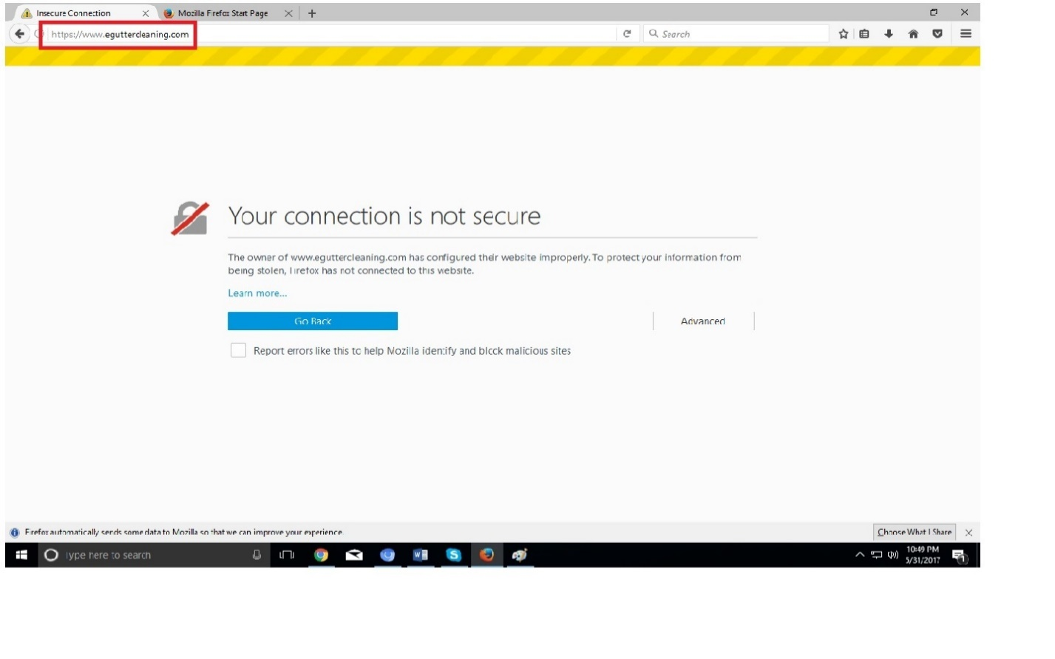 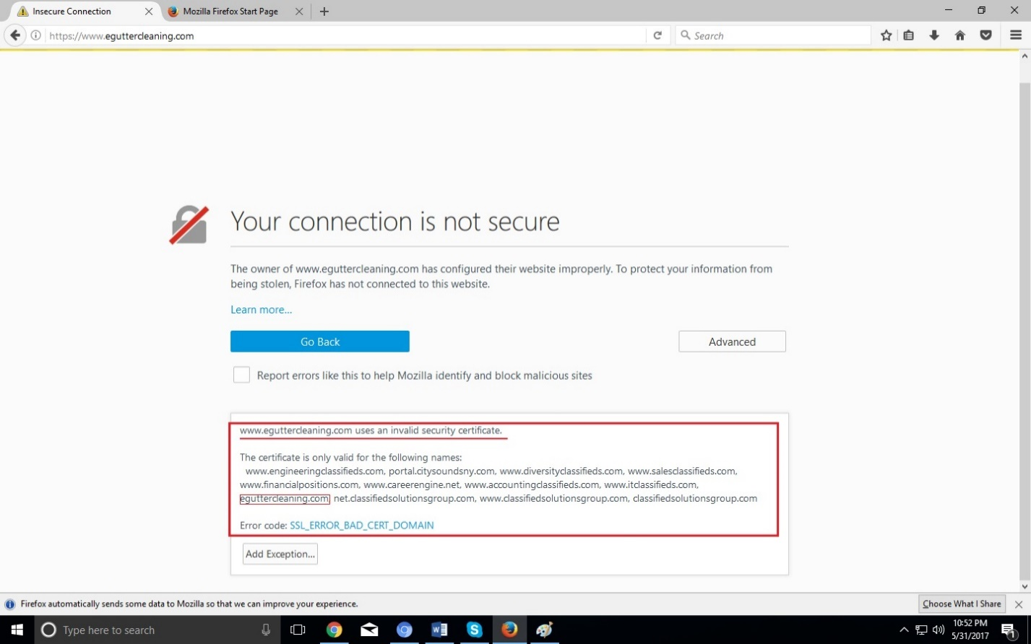

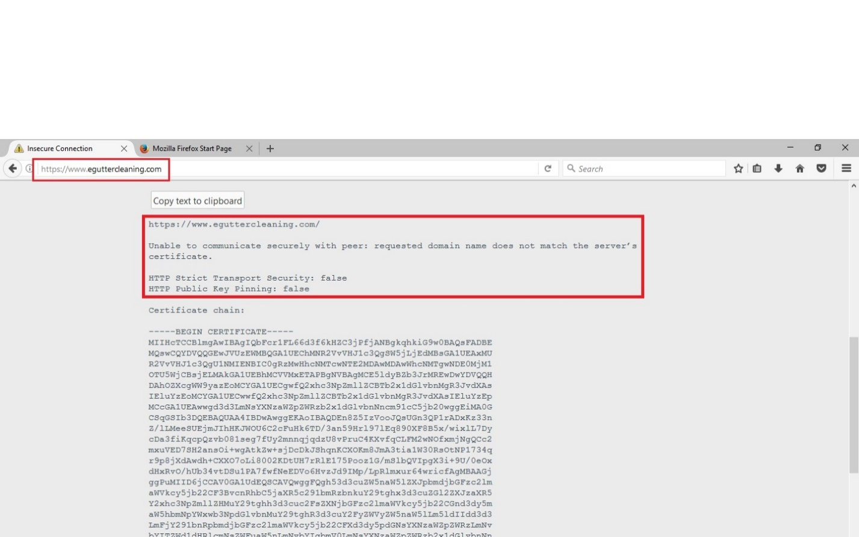

I have applied Forcing 301 Redirect rules in Web config of Few Given Site but those didn’t work at all on Firefox and Internet explorer gave us access but with error.

Following are snapshots from Internet Explorer (With Forcing): -

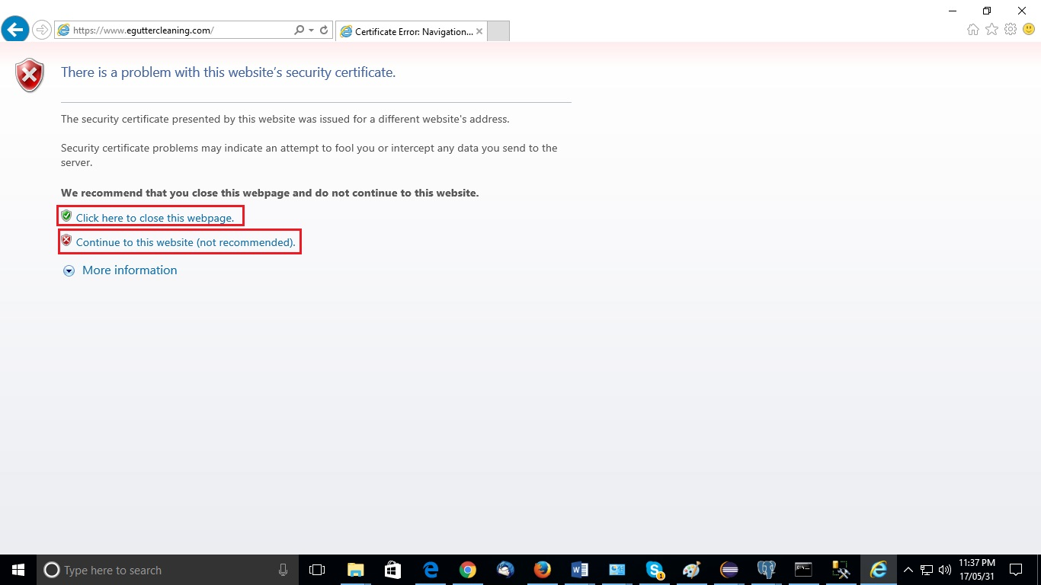

After we click on “Continue to the Website (not recommended)”

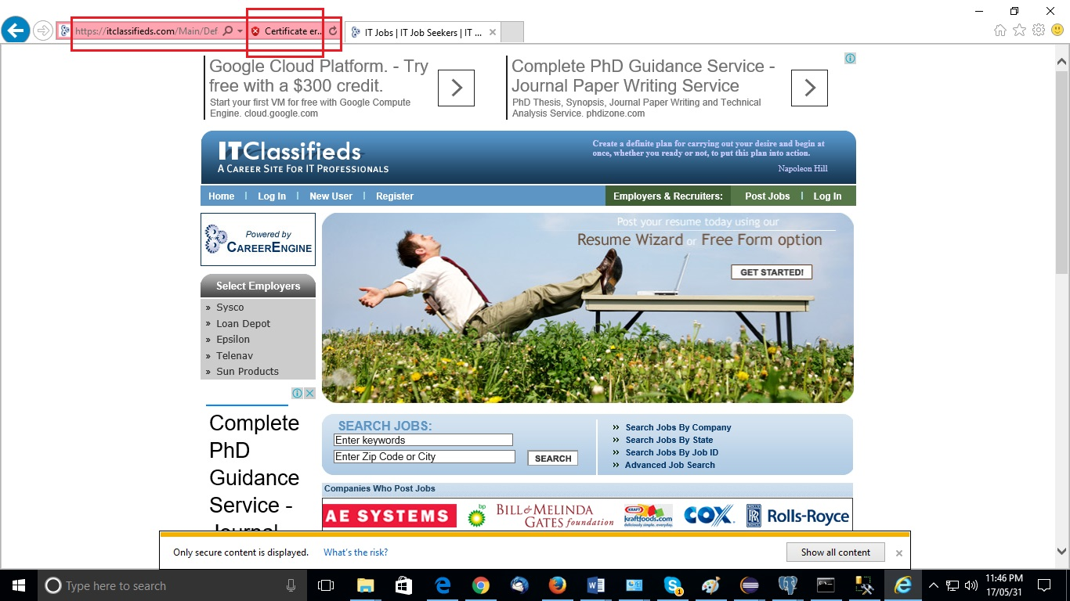

Website will show the following error in the URL of every Page.