Project_2

2021-04-27

airfares <- read.csv("Airfares.csv", header = TRUE)  
airfares.dt <- setDT(airfares)  
airlines <- airfares.dt[,!c(1,2,3,4,7,8,14,15)]   
airlines2 <- airfares.dt[,!c(1,2,3,4)]  
airlines2.df <- setDF(airlines2)

#Answer 1

library(corrplot)

## Warning: package 'corrplot' was built under R version 3.6.3

## corrplot 0.84 loaded

cor.mat <- round(cor(airlines[,]),2)  
cor.mat

## COUPON NEW HI S_INCOME E_INCOME S_POP E_POP DISTANCE PAX FARE  
## COUPON 1.00 0.02 -0.35 -0.09 0.05 -0.11 0.09 0.75 -0.34 0.50  
## NEW 0.02 1.00 0.05 0.03 0.11 -0.02 0.06 0.08 0.01 0.09  
## HI -0.35 0.05 1.00 -0.03 0.08 -0.17 -0.06 -0.31 -0.17 0.03  
## S_INCOME -0.09 0.03 -0.03 1.00 -0.14 0.52 -0.27 0.03 0.14 0.21  
## E_INCOME 0.05 0.11 0.08 -0.14 1.00 -0.14 0.46 0.18 0.26 0.33  
## S_POP -0.11 -0.02 -0.17 0.52 -0.14 1.00 -0.28 0.02 0.28 0.15  
## E_POP 0.09 0.06 -0.06 -0.27 0.46 -0.28 1.00 0.12 0.31 0.29  
## DISTANCE 0.75 0.08 -0.31 0.03 0.18 0.02 0.12 1.00 -0.10 0.67  
## PAX -0.34 0.01 -0.17 0.14 0.26 0.28 0.31 -0.10 1.00 -0.09  
## FARE 0.50 0.09 0.03 0.21 0.33 0.15 0.29 0.67 -0.09 1.00

corrplot(cor.mat,)

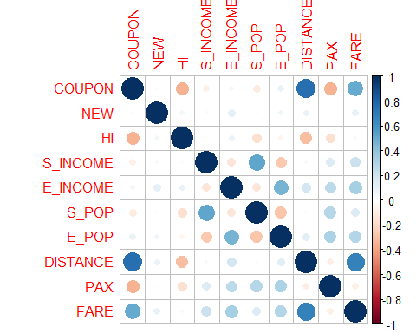

ggplot(airlines, aes(y = FARE, x = COUPON)) +   
 geom_point(alpha = 0.6) +  
 geom_smooth(method="lm", se=TRUE, fullrange=FALSE, level=0.95) +  
 ggtitle("FARE vs COUPON")

## `geom_smooth()` using formula 'y ~ x'

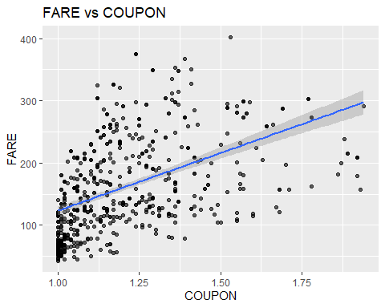

ggplot(airlines, aes(y = FARE, x = NEW))+  
 geom_point(alpha = 0.6)+  
 geom_smooth(method="lm", se=TRUE, fullrange=FALSE, level=0.95)+  
 ggtitle("FARE vs NEW CARRIERS ON ROUTE")

## `geom_smooth()` using formula 'y ~ x'

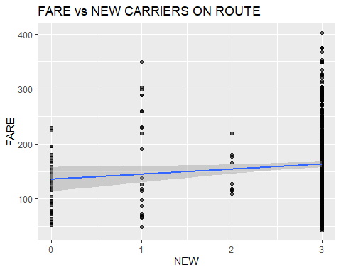

ggplot(airlines, aes(y = FARE, x = HI))+  
 geom_point(alpha = 0.6)+  
 geom_smooth(method="lm", se=TRUE, fullrange=FALSE, level=0.95)+  
 ggtitle("FARE vs HERFINDAHL INDEX")

## `geom_smooth()` using formula 'y ~ x'

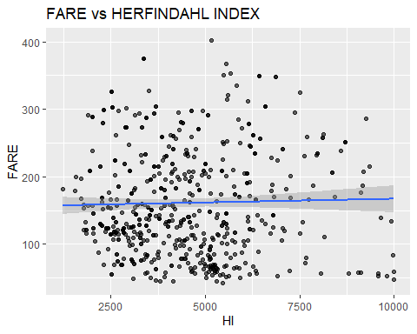

ggplot(airlines, aes(y = FARE, x = S_INCOME))+  
 geom_point(alpha = 0.6)+  
 geom_smooth(method="lm", se=TRUE, fullrange=FALSE, level=0.95)+  
 ggtitle("FARE vs S-INCOME")

## `geom_smooth()` using formula 'y ~ x'

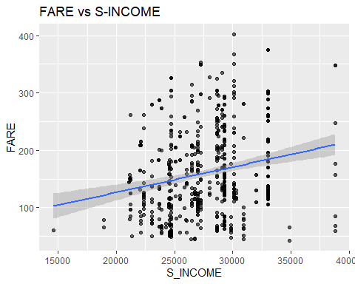

ggplot(airlines, aes(y = FARE, x = E_INCOME))+  
 geom_point(alpha = 0.6)+  
 geom_smooth(method="lm", se=TRUE, fullrange=FALSE, level=0.95)+  
 ggtitle("FARE vs E-INCOME")

## `geom_smooth()` using formula 'y ~ x'

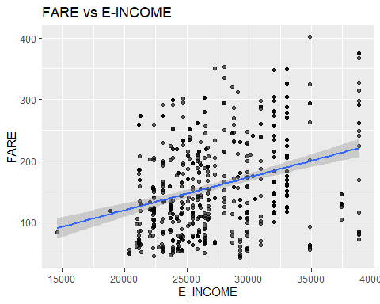

ggplot(airlines, aes(y = FARE, x = S_POP))+  
 geom_point(alpha = 0.6)+  
 geom_smooth(method="lm", se=TRUE, fullrange=FALSE, level=0.95)+  
 ggtitle("FARE vs S-POP")

## `geom_smooth()` using formula 'y ~ x'

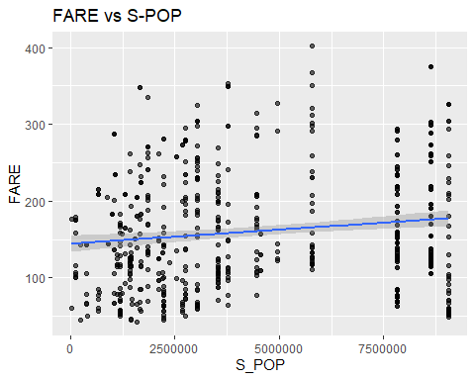

ggplot(airlines, aes(y = FARE, x = E_POP))+  
 geom_point(alpha = 0.6)+  
 geom_smooth(method="lm", se=TRUE, fullrange=FALSE, level=0.95)+  
 ggtitle("FARE vs E-POP")

## `geom_smooth()` using formula 'y ~ x'

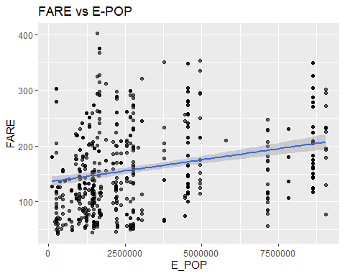

ggplot(airlines, aes(y = FARE, x = DISTANCE))+  
 geom_point(alpha = 0.6)+  
 geom_smooth(method="lm", se=TRUE, fullrange=FALSE, level=0.95)+  
 ggtitle("FARE vs DISTANCE")

## `geom_smooth()` using formula 'y ~ x'

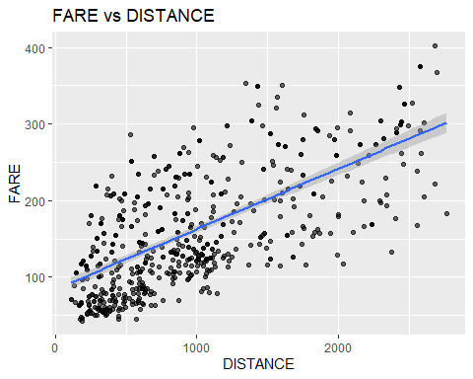

ggplot(airlines, aes(y = FARE, x = PAX))+  
 geom_point(alpha = 0.6)+  
 geom_smooth(method="lm", se=TRUE, fullrange=FALSE, level=0.95)+  
 ggtitle("FARE vs PAX")

## `geom_smooth()` using formula 'y ~ x'

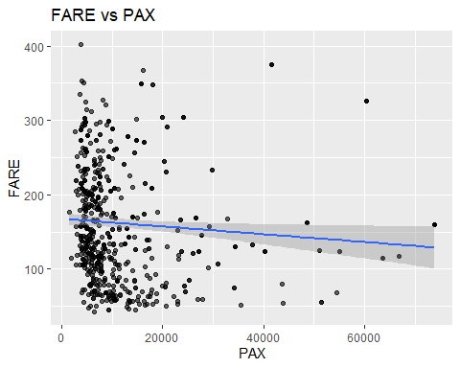 **From the Correlation matrix and the scatter plots we can see that distance is highly correlated and followed by coupon.This both are highly positively correlated with each other.Single best predictor of Fare is Distance because it has highest correlation coefficent 0.67**

#Answer 2

library(dplyr)  
library(rvest)  
library(magrittr)

## Warning: package 'magrittr' was built under R version 3.6.3

##   
## Attaching package: 'magrittr'

## The following object is masked from 'package:purrr':  
##   
## set_names

## The following object is masked from 'package:tidyr':  
##   
## extract

PivotVacation <- airfares.dt %>%  
 dplyr::select(VACATION,FARE) %>%  
 group_by(VACATION) %>%  
 summarise(Response_Count = length(VACATION),ResponseTotal = nrow(airfares.dt), ResponsePercent = percent(length(VACATION)/nrow(airfares.dt)), AvgFare = mean(FARE))  
  
PivotSW <- airfares.dt %>%  
 dplyr::select(SW,FARE) %>%  
 group_by(SW) %>%  
 summarise(Response_Count = length(SW),ResponseTotal = nrow(airfares.dt), ResponsePercent = percent(length(SW)/nrow(airfares.dt)), AvgFare = mean(FARE))  
  
PivotGate <- airfares.dt %>%  
 dplyr::select(GATE,FARE) %>%  
 group_by(GATE) %>%  
 summarise(Response_Count = length(GATE),ResponseTotal = nrow(airfares.dt), ResponsePercent = percent(length(GATE)/nrow(airfares.dt)), AvgFare = mean(FARE))  
  
PivotSlot <- airfares.dt %>%  
 dplyr::select(SLOT,FARE) %>%  
 group_by(SLOT) %>%  
 summarise(Response_Count = length(SLOT),ResponseTotal = nrow(airfares.dt), ResponsePercent = percent(length(SLOT)/nrow(airfares.dt)), AvgFare = mean(FARE))  
  
PivotVacation

## # A tibble: 2 x 5  
## VACATION Response_Count ResponseTotal ResponsePercent AvgFare  
## <fct> <int> <int> <chr> <dbl>  
## 1 No 468 638 73% 174.  
## 2 Yes 170 638 27% 126.

PivotSW

## # A tibble: 2 x 5  
## SW Response_Count ResponseTotal ResponsePercent AvgFare  
## <fct> <int> <int> <chr> <dbl>  
## 1 No 444 638 70% 188.   
## 2 Yes 194 638 30% 98.4

PivotGate

## # A tibble: 2 x 5  
## GATE Response_Count ResponseTotal ResponsePercent AvgFare  
## <fct> <int> <int> <chr> <dbl>  
## 1 Constrained 124 638 19% 193.  
## 2 Free 514 638 81% 153.

PivotSlot

## # A tibble: 2 x 5  
## SLOT Response_Count ResponseTotal ResponsePercent AvgFare  
## <fct> <int> <int> <chr> <dbl>  
## 1 Controlled 182 638 29% 186.  
## 2 Free 456 638 71% 151.

**Categorical predictor which seems best for predicting Fare is SW as wherever SW airlines is serving fares are much lower than the route where sw is not serving, so we can decide if sw is serving on that route then fare will be low else it will be high.**

#Answer 3

set.seed(42)  
train.index <- sample(1:638, round(0.8*nrow(airlines2)))  
airfare.train.df <- airlines2[train.index, ]  
  
airfare.test.df <- airlines2[-train.index, ]

airfares.lm <- lm(FARE ~ ., data = airfare.train.df)  
options(scipen = 999)  
summary(airfares.lm)

##   
## Call:  
## lm(formula = FARE ~ ., data = airfare.train.df)  
##   
## Residuals:  
## Min 1Q Median 3Q Max   
## -99.282 -23.384 -2.476 22.156 106.501   
##   
## Coefficients:  
## Estimate Std. Error t value Pr(>|t|)   
## (Intercept) 13.8781441835 30.7076946550 0.452 0.651507   
## COUPON 11.6744988371 13.6949175687 0.852 0.394365   
## NEW -2.2468005921 2.0827213457 -1.079 0.281210   
## VACATIONYes -37.8385127965 3.9788129464 -9.510 < 0.0000000000000002 ***  
## SWYes -38.9566477546 4.2526101838 -9.161 < 0.0000000000000002 ***  
## HI 0.0085414832 0.0010936608 7.810 0.0000000000000343 ***  
## S_INCOME 0.0006160967 0.0005709965 1.079 0.281119   
## E_INCOME 0.0015472928 0.0004141497 3.736 0.000209 ***  
## S_POP 0.0000040087 0.0000007411 5.409 0.0000000987167149 ***  
## E_POP 0.0000039572 0.0000008329 4.751 0.0000026562530825 ***  
## SLOTFree -16.4322948237 4.3647846605 -3.765 0.000187 ***  
## GATEFree -21.1634823059 4.4093579183 -4.800 0.0000021065804690 ***  
## DISTANCE 0.0715673994 0.0039223121 18.246 < 0.0000000000000002 ***  
## PAX -0.0007340587 0.0001662490 -4.415 0.0000123830100844 ***  
## ---  
## Signif. codes: 0 '***' 0.001 '**' 0.01 '*' 0.05 '.' 0.1 ' ' 1  
##   
## Residual standard error: 35.41 on 496 degrees of freedom  
## Multiple R-squared: 0.7817, Adjusted R-squared: 0.7759   
## F-statistic: 136.6 on 13 and 496 DF, p-value: < 0.00000000000000022

#Answer 4

Stepwise <- regsubsets(FARE ~ ., data = airfare.train.df, nbest = 1, nvmax = dim(airfare.train.df)[2],  
 method = "seqrep")  
Stepwise.Summary <- summary(Stepwise)  
Stepwise.Summary

## Subset selection object  
## Call: regsubsets.formula(FARE ~ ., data = airfare.train.df, nbest = 1,   
## nvmax = dim(airfare.train.df)[2], method = "seqrep")  
## 13 Variables (and intercept)  
## Forced in Forced out  
## COUPON FALSE FALSE  
## NEW FALSE FALSE  
## VACATIONYes FALSE FALSE  
## SWYes FALSE FALSE  
## HI FALSE FALSE  
## S_INCOME FALSE FALSE  
## E_INCOME FALSE FALSE  
## S_POP FALSE FALSE  
## E_POP FALSE FALSE  
## SLOTFree FALSE FALSE  
## GATEFree FALSE FALSE  
## DISTANCE FALSE FALSE  
## PAX FALSE FALSE  
## 1 subsets of each size up to 13  
## Selection Algorithm: 'sequential replacement'  
## COUPON NEW VACATIONYes SWYes HI S_INCOME E_INCOME S_POP E_POP  
## 1 ( 1 ) " " " " " " " " " " " " " " " " " "   
## 2 ( 1 ) " " " " " " "*" " " " " " " " " " "   
## 3 ( 1 ) " " " " "*" "*" " " " " " " " " " "   
## 4 ( 1 ) " " " " "*" "*" "*" " " " " " " " "   
## 5 ( 1 ) " " " " "*" "*" "*" " " " " " " " "   
## 6 ( 1 ) " " " " "*" "*" "*" " " " " " " " "   
## 7 ( 1 ) " " " " "*" "*" "*" " " "*" " " " "   
## 8 ( 1 ) " " " " "*" "*" "*" " " "*" "*" "*"   
## 9 ( 1 ) " " " " "*" "*" "*" " " " " "*" "*"   
## 10 ( 1 ) "*" "*" "*" "*" "*" "*" "*" "*" "*"   
## 11 ( 1 ) " " "*" "*" "*" "*" " " "*" "*" "*"   
## 12 ( 1 ) " " "*" "*" "*" "*" "*" "*" "*" "*"   
## 13 ( 1 ) "*" "*" "*" "*" "*" "*" "*" "*" "*"   
## SLOTFree GATEFree DISTANCE PAX  
## 1 ( 1 ) " " " " "*" " "  
## 2 ( 1 ) " " " " "*" " "  
## 3 ( 1 ) " " " " "*" " "  
## 4 ( 1 ) " " " " "*" " "  
## 5 ( 1 ) "*" " " "*" " "  
## 6 ( 1 ) "*" "*" "*" " "  
## 7 ( 1 ) "*" "*" "*" " "  
## 8 ( 1 ) " " " " "*" "*"  
## 9 ( 1 ) "*" "*" "*" "*"  
## 10 ( 1 ) "*" " " " " " "  
## 11 ( 1 ) "*" "*" "*" "*"  
## 12 ( 1 ) "*" "*" "*" "*"  
## 13 ( 1 ) "*" "*" "*" "*"

Stepwise.Summary$which

## (Intercept) COUPON NEW VACATIONYes SWYes HI S_INCOME E_INCOME S_POP  
## 1 TRUE FALSE FALSE FALSE FALSE FALSE FALSE FALSE FALSE  
## 2 TRUE FALSE FALSE FALSE TRUE FALSE FALSE FALSE FALSE  
## 3 TRUE FALSE FALSE TRUE TRUE FALSE FALSE FALSE FALSE  
## 4 TRUE FALSE FALSE TRUE TRUE TRUE FALSE FALSE FALSE  
## 5 TRUE FALSE FALSE TRUE TRUE TRUE FALSE FALSE FALSE  
## 6 TRUE FALSE FALSE TRUE TRUE TRUE FALSE FALSE FALSE  
## 7 TRUE FALSE FALSE TRUE TRUE TRUE FALSE TRUE FALSE  
## 8 TRUE FALSE FALSE TRUE TRUE TRUE FALSE TRUE TRUE  
## 9 TRUE FALSE FALSE TRUE TRUE TRUE FALSE FALSE TRUE  
## 10 TRUE TRUE TRUE TRUE TRUE TRUE TRUE TRUE TRUE  
## 11 TRUE FALSE TRUE TRUE TRUE TRUE FALSE TRUE TRUE  
## 12 TRUE FALSE TRUE TRUE TRUE TRUE TRUE TRUE TRUE  
## 13 TRUE TRUE TRUE TRUE TRUE TRUE TRUE TRUE TRUE  
## E_POP SLOTFree GATEFree DISTANCE PAX  
## 1 FALSE FALSE FALSE TRUE FALSE  
## 2 FALSE FALSE FALSE TRUE FALSE  
## 3 FALSE FALSE FALSE TRUE FALSE  
## 4 FALSE FALSE FALSE TRUE FALSE  
## 5 FALSE TRUE FALSE TRUE FALSE  
## 6 FALSE TRUE TRUE TRUE FALSE  
## 7 FALSE TRUE TRUE TRUE FALSE  
## 8 TRUE FALSE FALSE TRUE TRUE  
## 9 TRUE TRUE TRUE TRUE TRUE  
## 10 TRUE TRUE FALSE FALSE FALSE  
## 11 TRUE TRUE TRUE TRUE TRUE  
## 12 TRUE TRUE TRUE TRUE TRUE  
## 13 TRUE TRUE TRUE TRUE TRUE

print("Adjusted R-Squared")

## [1] "Adjusted R-Squared"

as.matrix(Stepwise.Summary$adjr2)

## [,1]  
## [1,] 0.4156589  
## [2,] 0.5777302  
## [3,] 0.6948231  
## [4,] 0.7210558  
## [5,] 0.7340429  
## [6,] 0.7536799  
## [7,] 0.7570792  
## [8,] 0.7637820  
## [9,] 0.7707638  
## [10,] 0.6229086  
## [11,] 0.7760679  
## [12,] 0.7760708  
## [13,] 0.7759476

print("BIC")

## [1] "BIC"

as.matrix(Stepwise.Summary$bic)

## [,1]  
## [1,] -262.5420  
## [2,] -422.9811  
## [3,] -583.3777  
## [4,] -623.9909  
## [5,] -643.0825  
## [6,] -676.9795  
## [7,] -678.8472  
## [8,] -687.8998  
## [9,] -697.9854  
## [10,] -438.9274  
## [11,] -699.4997  
## [12,] -694.2972  
## [13,] -688.8094

print("CP")

## [1] "CP"

as.matrix(Stepwise.Summary$cp)

## [,1]  
## [1,] 818.89220  
## [2,] 451.53899  
## [3,] 187.21153  
## [4,] 128.72255  
## [5,] 100.26346  
## [6,] 56.99127  
## [7,] 50.27558  
## [8,] 36.20326  
## [9,] 21.56831  
## [10,] 351.84190  
## [11,] 11.73270  
## [12,] 12.72670  
## [13,] 14.00000

**Answer 4: We can see in the stepwise regression that initial data had 13 variables to start with. After running this regression against Fare, the variables have been dropped to 10.The dropped variables are Coupons and S_Income.We have arrived to this conclusion based on the adjusted Rsquare values and cp and bic and R square values obtained.As adjusted R square has to be highest ‘0.7760679’, the safest place where it is highest ‘0.7760679’ and CP is should be 12 and ’11.73270 closest value is found at 11th place.As we can seein 11th pattern, Coupons and S_Income is False, hence it suffices to say that these variables dropped would make the model work better.**

#Answer 5

Exhaustive <- regsubsets(FARE ~ ., data = airfare.train.df, nbest = 1, nvmax = dim(airfare.train.df)[2],  
 method = "exhaustive")  
Exhaustive.Summary <- summary(Exhaustive)  
Exhaustive.Summary$which

## (Intercept) COUPON NEW VACATIONYes SWYes HI S_INCOME E_INCOME S_POP  
## 1 TRUE FALSE FALSE FALSE FALSE FALSE FALSE FALSE FALSE  
## 2 TRUE FALSE FALSE FALSE TRUE FALSE FALSE FALSE FALSE  
## 3 TRUE FALSE FALSE TRUE TRUE FALSE FALSE FALSE FALSE  
## 4 TRUE FALSE FALSE TRUE TRUE TRUE FALSE FALSE FALSE  
## 5 TRUE FALSE FALSE TRUE TRUE TRUE FALSE FALSE FALSE  
## 6 TRUE FALSE FALSE TRUE TRUE TRUE FALSE FALSE FALSE  
## 7 TRUE FALSE FALSE TRUE TRUE TRUE FALSE FALSE TRUE  
## 8 TRUE FALSE FALSE TRUE TRUE TRUE FALSE TRUE TRUE  
## 9 TRUE FALSE FALSE TRUE TRUE TRUE FALSE FALSE TRUE  
## 10 TRUE FALSE FALSE TRUE TRUE TRUE FALSE TRUE TRUE  
## 11 TRUE FALSE TRUE TRUE TRUE TRUE FALSE TRUE TRUE  
## 12 TRUE FALSE TRUE TRUE TRUE TRUE TRUE TRUE TRUE  
## 13 TRUE TRUE TRUE TRUE TRUE TRUE TRUE TRUE TRUE  
## E_POP SLOTFree GATEFree DISTANCE PAX  
## 1 FALSE FALSE FALSE TRUE FALSE  
## 2 FALSE FALSE FALSE TRUE FALSE  
## 3 FALSE FALSE FALSE TRUE FALSE  
## 4 FALSE FALSE FALSE TRUE FALSE  
## 5 FALSE TRUE FALSE TRUE FALSE  
## 6 FALSE TRUE TRUE TRUE FALSE  
## 7 TRUE FALSE FALSE TRUE TRUE  
## 8 TRUE FALSE FALSE TRUE TRUE  
## 9 TRUE TRUE TRUE TRUE TRUE  
## 10 TRUE TRUE TRUE TRUE TRUE  
## 11 TRUE TRUE TRUE TRUE TRUE  
## 12 TRUE TRUE TRUE TRUE TRUE  
## 13 TRUE TRUE TRUE TRUE TRUE

print("Adjusted R-Squared")

## [1] "Adjusted R-Squared"

as.matrix(Exhaustive.Summary$adjr2)

## [,1]  
## [1,] 0.4156589  
## [2,] 0.5777302  
## [3,] 0.6948231  
## [4,] 0.7210558  
## [5,] 0.7340429  
## [6,] 0.7536799  
## [7,] 0.7574419  
## [8,] 0.7637820  
## [9,] 0.7707638  
## [10,] 0.7759090  
## [11,] 0.7760679  
## [12,] 0.7760708  
## [13,] 0.7759476

print("BIC")

## [1] "BIC"

as.matrix(Exhaustive.Summary$bic)

## [,1]  
## [1,] -262.5420  
## [2,] -422.9811  
## [3,] -583.3777  
## [4,] -623.9909  
## [5,] -643.0825  
## [6,] -676.9795  
## [7,] -679.6093  
## [8,] -687.8998  
## [9,] -697.9854  
## [10,] -704.3493  
## [11,] -699.4997  
## [12,] -694.2972  
## [13,] -688.8094

print("CP")

## [1] "CP"

as.matrix(Exhaustive.Summary$cp)

## [,1]  
## [1,] 818.89220  
## [2,] 451.53899  
## [3,] 187.21153  
## [4,] 128.72255  
## [5,] 100.26346  
## [6,] 56.99127  
## [7,] 49.46286  
## [8,] 36.20326  
## [9,] 21.56831  
## [10,] 11.08605  
## [11,] 11.73270  
## [12,] 12.72670  
## [13,] 14.00000

**Answer 5: The results of the stepwise and exhaustive are almost similar.With exhaustive we can see that the model with 10 variables is the best model.The variables include are VACATION, SW, HI, E_INCOME, S_POP, E_POP, SLOT, GATE, DISTANCE, PAX.The cp value is also almost closest to 11 and Adjusted R2 is also highest.The dropped variables are NEW,Coupon,S_Income**

#Answer 6

print("Accuracy of Stepwise Regression")

## [1] "Accuracy of Stepwise Regression"

stepwise.lm <- lm(formula = FARE ~ NEW + VACATION + SW + HI + E_INCOME + S_POP + E_POP + SLOT + GATE + DISTANCE + PAX, data = airfare.train.df)  
stepwise.lm.predict <- predict(stepwise.lm, airfare.test.df)  
accuracy(stepwise.lm.predict, airfare.test.df$FARE)

## ME RMSE MAE MPE MAPE  
## Test set 3.166677 36.82363 27.57897 -5.812025 21.44043

print("Accuracy of Exhaustive Regression")

## [1] "Accuracy of Exhaustive Regression"

exhaustive.lm <- lm(formula = FARE ~ VACATION + SW + HI + E_INCOME + S_POP + E_POP + SLOT + GATE + DISTANCE + PAX, data = airfare.train.df)  
exhaustive.lm.predict <- predict(exhaustive.lm, airfare.test.df)  
accuracy(exhaustive.lm.predict, airfare.test.df$FARE)

## ME RMSE MAE MPE MAPE  
## Test set 3.06081 36.8617 27.70568 -5.938062 21.62142

**Answer 6: The RMSE value for stepwise Regression is less compared to the exhaustive search model. So we can say that the stepwise regression model is best compared exhaustive search**

#Answer 7 & 8

Exhaustive_pred_value_SW0 <- stepwise.lm$coefficients["VACATIONYes"]*0+  
 stepwise.lm$coefficients["SWYes"]*0+  
 stepwise.lm$coefficients["HI"]*4442.141 +  
 stepwise.lm$coefficients["E_INCOME"]*27664 +  
 stepwise.lm$coefficients["S_POP"]*4557004 +  
 stepwise.lm$coefficients["E_POP"]*3195503 +  
 stepwise.lm$coefficients["DISTANCE"]*1976 +  
 stepwise.lm$coefficients["PAX"]*12782 +  
 stepwise.lm$coefficients["(Intercept)"]  
print("Exhaustive_pred_value_SW0")

## [1] "Exhaustive_pred_value_SW0"

print(Exhaustive_pred_value_SW0)

## VACATIONYes   
## 293.1706

Exhaustive_pred_value_SW1 <- stepwise.lm$coefficients["VACATIONYes"]*0+  
 stepwise.lm$coefficients["SWYes"]*1+  
 stepwise.lm$coefficients["HI"]*4442.141 +  
 stepwise.lm$coefficients["E_INCOME"]*27664 +  
 stepwise.lm$coefficients["S_POP"]*4557004 +  
 stepwise.lm$coefficients["E_POP"]*3195503 +  
 stepwise.lm$coefficients["DISTANCE"]*1976 +  
 stepwise.lm$coefficients["PAX"]*12782 +  
 stepwise.lm$coefficients["(Intercept)"]  
print("Exhaustive_pred_value_SW1")

## [1] "Exhaustive_pred_value_SW1"

print(Exhaustive_pred_value_SW1)

## VACATIONYes   
## 252.599

avg_reduction_fare <- Exhaustive_pred_value_SW0-Exhaustive_pred_value_SW1  
print("AVERAGE REDUCTION FARE")

## [1] "AVERAGE REDUCTION FARE"

print(avg_reduction_fare)

## VACATIONYes   
## 40.57159

** Answer 7 & 8 :we see that there is a reduction in Fare of $40.57 when Southwest airline is not serving versus when it is serving the route.**

#Answer 9 :

lm.backward_S_airfares<- regsubsets(FARE~., data=airfare.train.df, nbest= 1,nvmax=dim(airfare.train.df)[2], method="backward")  
summary_Q9<- summary(lm.backward_S_airfares)  
summary_Q9$which

## (Intercept) COUPON NEW VACATIONYes SWYes HI S_INCOME E_INCOME S_POP  
## 1 TRUE FALSE FALSE FALSE FALSE FALSE FALSE FALSE FALSE  
## 2 TRUE FALSE FALSE FALSE TRUE FALSE FALSE FALSE FALSE  
## 3 TRUE FALSE FALSE TRUE TRUE FALSE FALSE FALSE FALSE  
## 4 TRUE FALSE FALSE TRUE TRUE TRUE FALSE FALSE FALSE  
## 5 TRUE FALSE FALSE TRUE TRUE TRUE FALSE FALSE FALSE  
## 6 TRUE FALSE FALSE TRUE TRUE TRUE FALSE FALSE TRUE  
## 7 TRUE FALSE FALSE TRUE TRUE TRUE FALSE FALSE TRUE  
## 8 TRUE FALSE FALSE TRUE TRUE TRUE FALSE FALSE TRUE  
## 9 TRUE FALSE FALSE TRUE TRUE TRUE FALSE FALSE TRUE  
## 10 TRUE FALSE FALSE TRUE TRUE TRUE FALSE TRUE TRUE  
## 11 TRUE FALSE TRUE TRUE TRUE TRUE FALSE TRUE TRUE  
## 12 TRUE FALSE TRUE TRUE TRUE TRUE TRUE TRUE TRUE  
## 13 TRUE TRUE TRUE TRUE TRUE TRUE TRUE TRUE TRUE  
## E_POP SLOTFree GATEFree DISTANCE PAX  
## 1 FALSE FALSE FALSE TRUE FALSE  
## 2 FALSE FALSE FALSE TRUE FALSE  
## 3 FALSE FALSE FALSE TRUE FALSE  
## 4 FALSE FALSE FALSE TRUE FALSE  
## 5 TRUE FALSE FALSE TRUE FALSE  
## 6 TRUE FALSE FALSE TRUE FALSE  
## 7 TRUE FALSE FALSE TRUE TRUE  
## 8 TRUE FALSE TRUE TRUE TRUE  
## 9 TRUE TRUE TRUE TRUE TRUE  
## 10 TRUE TRUE TRUE TRUE TRUE  
## 11 TRUE TRUE TRUE TRUE TRUE  
## 12 TRUE TRUE TRUE TRUE TRUE  
## 13 TRUE TRUE TRUE TRUE TRUE

summary_Q9$cp

## [1] 818.89220 451.53899 187.21153 128.72255 110.32120 69.68802 49.46286  
## [8] 38.75199 21.56831 11.08605 11.73270 12.72670 14.00000

summary_Q9$adjr2

## [1] 0.4156589 0.5777302 0.6948231 0.7210558 0.7295718 0.7480243 0.7574419  
## [8] 0.7626422 0.7707638 0.7759090 0.7760679 0.7760708 0.7759476

**Answer 9 :We have dropped 3 variables from the model namely: COUPON, S_INCOME & NEW based on the ajusted R2 and Cp values. The model dropped similar variables as the exhaustive search.**

#Answer 10

lm.backward_S_AIC_airfares <-lm(FARE ~., data = airfare.train.df)  
lm.backward_S_AIC_airfares_Predict <- stepAIC(lm.backward_S_AIC_airfares, direction = "backward")

## Start: AIC=3652.06  
## FARE ~ COUPON + NEW + VACATION + SW + HI + S_INCOME + E_INCOME +   
## S_POP + E_POP + SLOT + GATE + DISTANCE + PAX  
##   
## Df Sum of Sq RSS AIC  
## - COUPON 1 911 622732 3650.8  
## - NEW 1 1459 623280 3651.3  
## - S_INCOME 1 1460 623281 3651.3  
## <none> 621821 3652.1  
## - E_INCOME 1 17499 639320 3664.2  
## - SLOT 1 17769 639590 3664.4  
## - PAX 1 24441 646263 3669.7  
## - E_POP 1 28296 650118 3672.8  
## - GATE 1 28881 650702 3673.2  
## - S_POP 1 36680 658501 3679.3  
## - HI 1 76469 698290 3709.2  
## - SW 1 105205 727026 3729.8  
## - VACATION 1 113382 735204 3735.5  
## - DISTANCE 1 417379 1039200 3912.0  
##   
## Step: AIC=3650.81  
## FARE ~ NEW + VACATION + SW + HI + S_INCOME + E_INCOME + S_POP +   
## E_POP + SLOT + GATE + DISTANCE + PAX  
##   
## Df Sum of Sq RSS AIC  
## - S_INCOME 1 1261 623994 3649.8  
## - NEW 1 1678 624410 3650.2  
## <none> 622732 3650.8  
## - E_INCOME 1 17126 639859 3662.6  
## - SLOT 1 18407 641139 3663.7  
## - GATE 1 29285 652018 3672.2  
## - E_POP 1 29484 652217 3672.4  
## - PAX 1 34128 656860 3676.0  
## - S_POP 1 36089 658821 3677.5  
## - HI 1 78594 701326 3709.4  
## - SW 1 107735 730468 3730.2  
## - VACATION 1 114276 737009 3734.7  
## - DISTANCE 1 824468 1447200 4078.9  
##   
## Step: AIC=3649.84  
## FARE ~ NEW + VACATION + SW + HI + E_INCOME + S_POP + E_POP +   
## SLOT + GATE + DISTANCE + PAX  
##   
## Df Sum of Sq RSS AIC  
## - NEW 1 1697 625690 3649.2  
## <none> 623994 3649.8  
## - E_INCOME 1 16167 640161 3660.9  
## - SLOT 1 20012 644006 3663.9  
## - E_POP 1 28559 652552 3670.7  
## - GATE 1 29766 653759 3671.6  
## - PAX 1 32869 656863 3674.0  
## - S_POP 1 41722 665715 3680.8  
## - HI 1 79501 703495 3709.0  
## - SW 1 126837 750831 3742.2  
## - VACATION 1 128080 752073 3743.1  
## - DISTANCE 1 826967 1450960 4078.2  
##   
## Step: AIC=3649.22  
## FARE ~ VACATION + SW + HI + E_INCOME + S_POP + E_POP + SLOT +   
## GATE + DISTANCE + PAX  
##   
## Df Sum of Sq RSS AIC  
## <none> 625690 3649.2  
## - E_INCOME 1 15649 641339 3659.8  
## - SLOT 1 19217 644907 3662.6  
## - E_POP 1 28766 654456 3670.1  
## - GATE 1 29165 654856 3670.5  
## - PAX 1 32706 658396 3673.2  
## - S_POP 1 42648 668338 3680.9  
## - HI 1 78891 704581 3707.8  
## - SW 1 126577 752267 3741.2  
## - VACATION 1 127066 752756 3741.5  
## - DISTANCE 1 825966 1451656 4076.4

summary_Q10<-summary(lm.backward_S_AIC_airfares_Predict)  
summary_Q10

##   
## Call:  
## lm(formula = FARE ~ VACATION + SW + HI + E_INCOME + S_POP + E_POP +   
## SLOT + GATE + DISTANCE + PAX, data = airfare.train.df)  
##   
## Residuals:  
## Min 1Q Median 3Q Max   
## -99.148 -22.077 -2.028 21.491 107.744   
##   
## Coefficients:  
## Estimate Std. Error t value Pr(>|t|)   
## (Intercept) 42.0764345686 14.7566725244 2.851 0.004534 **   
## VACATIONYes -38.7574569132 3.8500841929 -10.067 < 0.0000000000000002 ***  
## SWYes -40.5282166043 4.0337560764 -10.047 < 0.0000000000000002 ***  
## HI 0.0082681499 0.0010423739 7.932 0.0000000000000143 ***  
## E_INCOME 0.0014446281 0.0004089281 3.533 0.000450 ***  
## S_POP 0.0000041850 0.0000007176 5.832 0.0000000098509604 ***  
## E_POP 0.0000037791 0.0000007890 4.790 0.0000022053722984 ***  
## SLOTFree -16.8515659965 4.3045728245 -3.915 0.000103 ***  
## GATEFree -21.2165142735 4.3991611435 -4.823 0.0000018824635124 ***  
## DISTANCE 0.0736714582 0.0028704349 25.666 < 0.0000000000000002 ***  
## PAX -0.0007619280 0.0001491869 -5.107 0.0000004660838631 ***  
## ---  
## Signif. codes: 0 '***' 0.001 '**' 0.01 '*' 0.05 '.' 0.1 ' ' 1  
##   
## Residual standard error: 35.41 on 499 degrees of freedom  
## Multiple R-squared: 0.7803, Adjusted R-squared: 0.7759   
## F-statistic: 177.2 on 10 and 499 DF, p-value: < 0.00000000000000022

**Answer 10: We say that when we didn’t drop any variable, our AIC was 3652.07. AIC kept on reducing as we kept dropping variables one by one. We are eliminating variables because to make a model better fit, we need to reduce AIC. Let’s say when we dropped COUPON our AIC came to 3650.82 which is a minor drop. Now when we drop S_INCOME, Our AIC became 3649.84. Lastly when we dropped NEW; AIC was decreased to 3649.22. So, basically AIC from 3652.07 came drop to 3649.22 after removal of 3 variables. Also results in question 9 and 10 are same.**