1. area of circle Name:-Mehul Vinod Gohil Roll No:-306

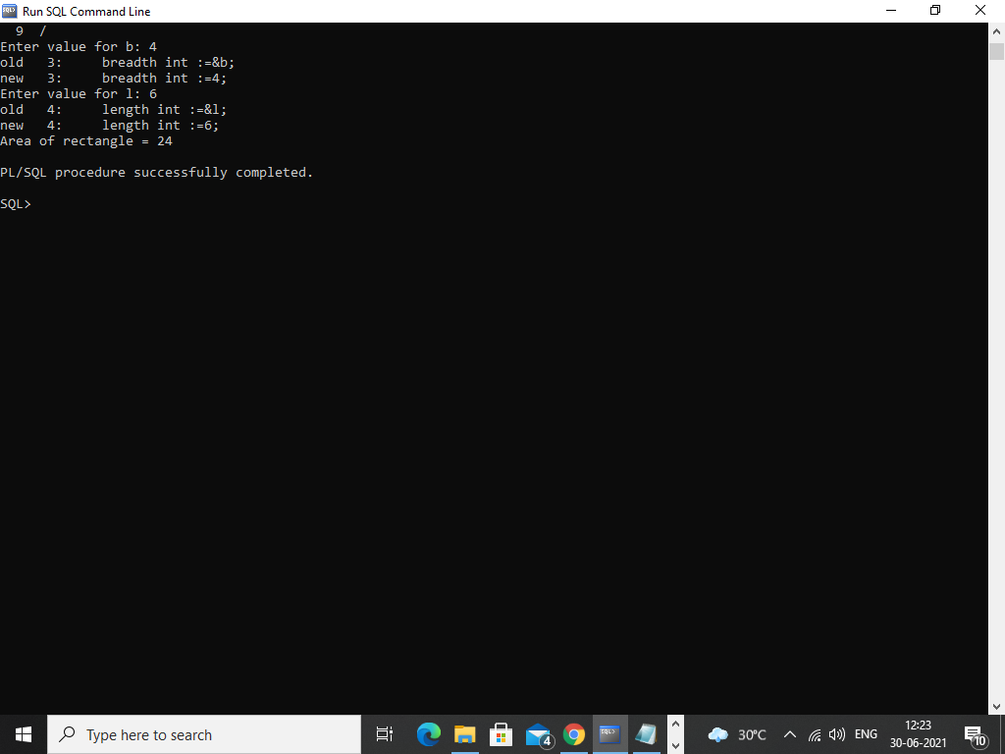

2. perimeter of circle

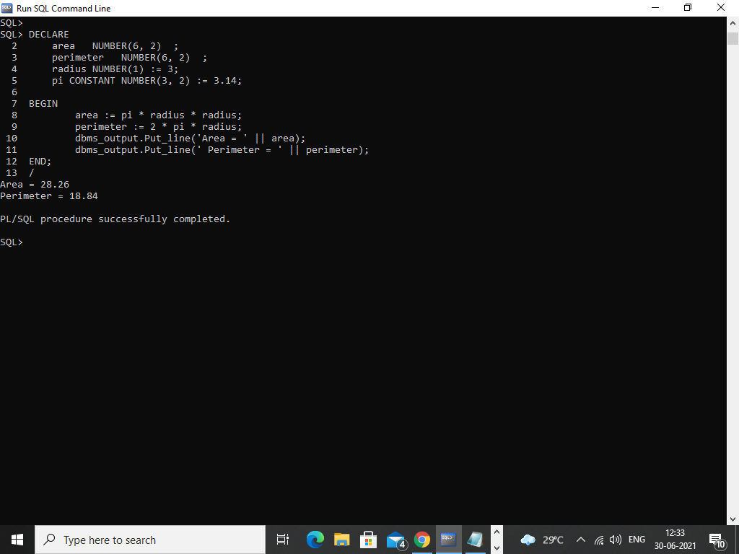

3. area of rectangle

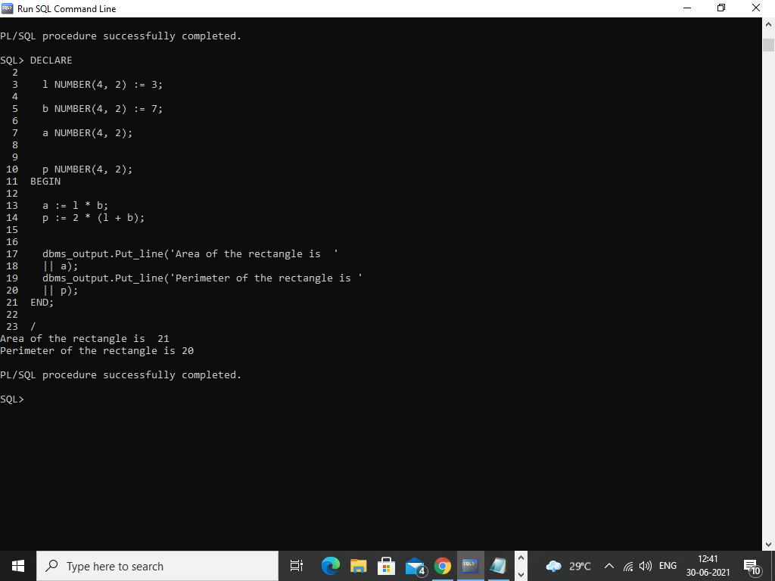

4. swap of two numbers

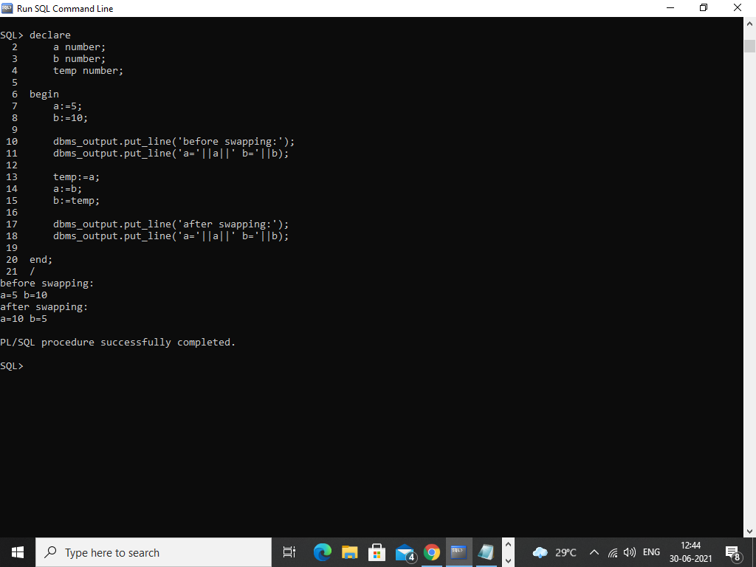

5.read temperature in Celsius and convert into Fahrenheit and vice versa

