|  |
| --- |
| ABSA - Corporate and Investment Banking |
| Guide for Technical and End Users |

|  |
| --- |
| 2022 | By: Mehul Panchal |



|  |
| --- |
| ABSA - Corporate and Investment Banking |
| CIB Digital Tech – Assessment  Guide for Technical and End Users. |
|  |

|  |  |
| --- | --- |
| **Created For** | **ABSA – Corporate and Investment Banking** |
| **Submitted By** | **Mehul Panchal** |
| **Date** | **29th-Jul-2022** |
| **Version** | **1.0** |

Contents

Overview 4

A –End User 4

B – Technical User 5

System Requirement and Configuration guide 5

Configure Source and Restore Database 7

# Overview

This document will help technical and end user. Technical user can understand how this application has created and how user can configure the application.

# A –End User

After configuring the source code, when you first run this project, you will be landed on this page. User can add phone book and Entry details.

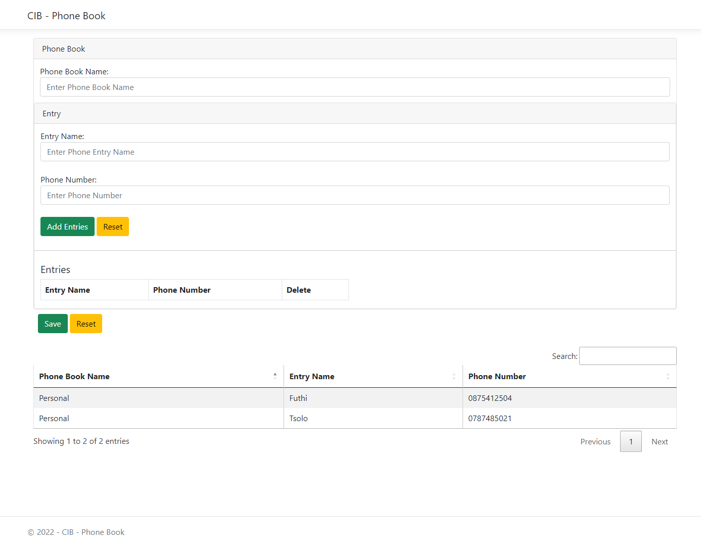

As per the data structure, One Phone Book can have multiple Entries so user can add one phone book and entry and can add by adding Add Entries button.

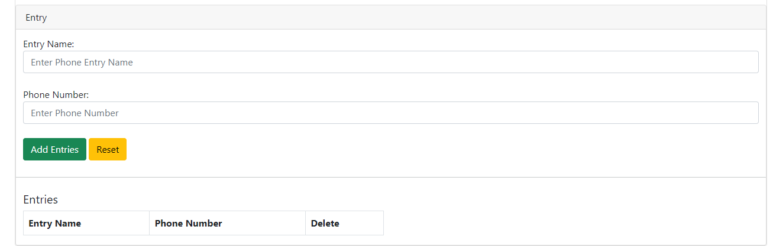

Once your entry finish you need to press SAVE button and then records get saved into database.

List will be populated with inserted records.

User can search into the list as well.

This solution is working solution with basic validation.

Improvements

1 – We can validate duplicate phone number and phone book entries.

2 – We can give CRUD facility to end user.

# B – Technical User

## System Requirement and Configuration guide

|  |  |
| --- | --- |
| Development Stack | .NET Framework 6.0 |
| Entity Framework Core |
| Repository Pattern |
| asp.net core web api and jQuery based front end |
| Development Machine | Minimum Core i3 processor |
| 64 GB Free Hard disk Space |
| 8 GB Ram |
| Internet Connection |
| Software Requirement | Windows 8 or above operating system |
| Visual Studio 2022 |
| MS SQL SERVER Express and Management studio 2017 |

### Configure Source and Restore Database

This solution is based on CODE FIRST. User should follow below steps to before run the solution.

1 - User needs to change connection string into CIB.WebAPI->appsettings.json file.

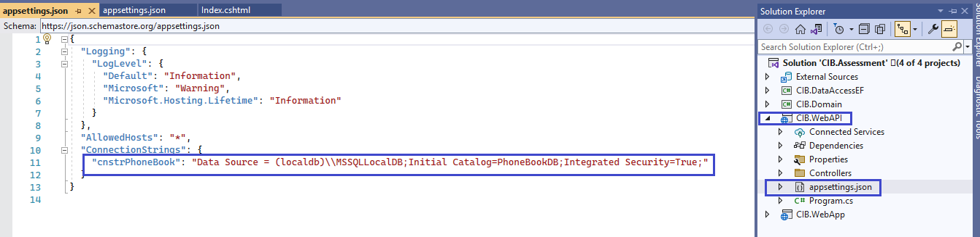

2 – Set CIB.WebAPI as startup project and open Package Manager Console.

3 – In Package Manaer Console, select Package Source All and Default Project to CIB.DataAccessEF

* Run update-database command
* This will create PhoneBookDB database into your SQL Server.

4 – Rebuild the solution.

5 – To run the solution, you need to select CIB.WebAPI and CIB.WebApp as startup projects.

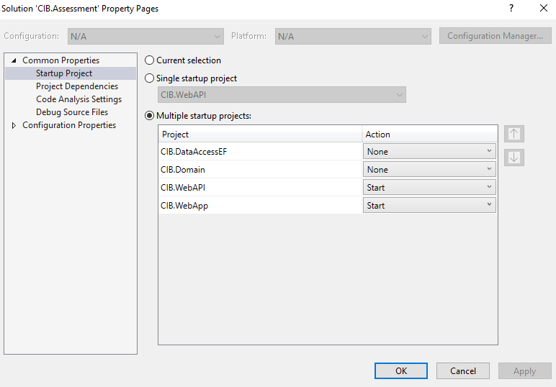

In case of any query please let me know I will help you.

Here is my contact details

E-Mail – [mehulpanchalsa@gmail.com](mailto:mehulpanchalsa@gmail.com)

Skype – Mehul_a_Panchal

Thank you