CLUSTER COMPUTING
PROJECT REPORT

Congress Twitter Interaction Analysis

Submitted by: Mehul Agrawal
Registration No: 12309613
Programme and Section: K2P23QG
Academic Task No. 2 | Academic Task Title: Congress Twitter Interaction Analysis
Course Code: INT315

Under the Guidance of
Ms. Kondapalli Pravallika

Discipline of CSE/IT
Lovely School of Computer Science and Engineering
Lovely Professional University, Phagwara

CONTENTS

Abstract ........................................................................ 3
1. Introduction ............................................................. 3
1.1 Problem Statement and Objectives ............................ 3
1.2 Project Goals ....................................................... 3
2. Dataset Description ................................................ 4
2.1 Dataset Source and Graph Structure ......................... 4
2.2 Dataset Files, Preprocessing and Limitations .............. 4
3. Implementation / Methodology ................................... 5
3.1 Environment and Technologies ............................... 5
3.2 Workflow and Algorithms ...................................... 5
3.3 Implementation Files ........................................... 6
3.5 Command Prompt Execution Evidence ...................... 6
4. Results and Evaluation ............................................. 8
4.1 Graph Summary .................................................. 8
4.2 Top Accounts by In-Degree .................................... 8
4.3 Top Accounts by Out-Degree ................................ 8
4.4 PageRank and Ranking Comparison .......................... 9
4.5 Evaluation Approach ........................................... 9
5. Visualization and Interpretation ................................. 9
5.1 In-Degree and Out-Degree Charts ............................ 9
5.2 PageRank versus In-Degree .................................. 10
5.3 Directed Congress Twitter Network ........................ 11
6. Conclusion and Future Work ...................................... 12
7. References .............................................................. 13
8. Appendix: Code and Reproducibility ............................ 13

Abstract
This report examines the Twitter interaction network of members of the 117th United States Congress. The network is represented as a directed graph, where each edge records a relationship from one account to another. Apache Spark GraphX is used to construct the graph and calculate in-degree, out-degree, connected components and PageRank. The resulting metrics are matched with the supplied Twitter usernames and explored through Python visualizations. The processed graph contains 475 vertices and 13,289 directed edges. GOPLeader ranks first by both in-degree and PageRank, while SpeakerPelosi has the highest out-degree.

1. Introduction

1.1 Problem Statement
A social network may contain hundreds of accounts and thousands of relationships. An edge-list file stores these relationships in rows, but it does not immediately show which accounts receive many connections, which accounts connect outward to many others, or which accounts occupy central positions. This project addresses that challenge by modelling the Congress Twitter data as a directed graph and examining its structure with standard graph algorithms.

1.2 Objectives
Construct a directed graph from the Congress Twitter edge list.
Calculate the in-degree and out-degree of every vertex.
Identify accounts with the highest incoming and outgoing interaction counts.
Determine connected-component structure using GraphX.
Calculate PageRank scores and compare their ranking with in-degree ranking.
Map numeric vertex IDs to Twitter usernames.
Export graph metrics and create visualizations.

1.3 Project Goals
The project has two practical aims: to demonstrate graph processing with Spark GraphX, and to turn the resulting numeric measures into findings that can be interpreted through account usernames. The work is descriptive. It measures connectivity and structural prominence; it does not infer political opinions or analyse the text of individual tweets.

2. Dataset Description

2.1 Dataset Source
The dataset was obtained from the Stanford Network Analysis Project (SNAP), which publishes the “Twitter Interaction Network for the US Congress” [1]. It represents interactions among members of the 117th United States Congress. The underlying collection covers February 9, 2022 to June 9, 2022 [2]. Dataset page: https://snap.stanford.edu/data/congress-twitter.html

2.2 Dataset Size and Graph Structure
The parsed graph contains 475 vertices and 13,289 directed edges. Vertices represent Congressional Twitter accounts. An edge from account A to account B preserves the direction encoded in the supplied data. Each edge also has a weight described by the dataset authors as an empirically estimated probability of influence [1, 2].
Item | Description | Project value
Vertices | Twitter accounts represented as nodes | 475
Edges | Directed relationships between accounts | 13,289
Edge attribute | Weight / transmission probability | Preserved as Double
Username mapping | Vertex ID mapped to usernameList position | 475 usernames

2.3 Dataset Files and Features
congress.edgelist: source ID, destination ID, and edge weight.
congress_network_data.json: inList, inWeight, outList, outWeight, and usernameList arrays.
usernameList: maps numeric vertex IDs to usernames using zero-based list positions.

2.4 Preprocessing
The Scala preprocessing code reads each edge-list row and extracts the source ID, destination ID and numeric weight with a regular expression. Each valid row is converted into a GraphX Edge[Double]. The JSON file is processed separately to obtain usernameList. Since the list is indexed from zero, position i is used as the username for vertex ID i. The exported metrics are joined with this mapping so that the final tables and charts show account names rather than numeric identifiers.

2.5 Dataset Limitations
The dataset is a time-bounded snapshot, not a live description of Twitter. Its authors explain that it was built from interactions collected during the stated period and that the estimated influence weights may change as tweets are deleted, edited or become unavailable, or as account visibility changes [2]. The findings should therefore be interpreted as results for this supplied snapshot.
Edge direction is retained: source → destination.
The in-degree and out-degree functions used in this implementation count incoming and outgoing edges. They do not sum the edge weights. Degree therefore measures the number of direct connections, not total weighted influence strength.
PageRank is calculated with GraphX staticPageRank(10). The code does not define a custom transition model that uses the dataset's influence probabilities as edge-transition weights. The reported values are therefore the output of the implemented GraphX PageRank routine, not probabilities of influence.
Account usernames are taken from the dataset and are not independently verified as current.

3. Implementation / Methodology

3.1 Environment and Technologies
Technology | Version / Use
Apache Spark | 3.5.9
Scala | 2.13.8
SBT | 2.0.11
Java | 17.0.21
Python | 3.11
Python libraries | pandas, matplotlib, seaborn, NetworkX
Graph engine | Apache Spark GraphX

3.2 Workflow
Read and parse the weighted edge list into GraphX Edge[Double] records.
Build a graph using Graph.fromEdges.
Count vertices and edges.
Calculate graph.inDegrees and graph.outDegrees.
Run connectedComponents() and count distinct component identifiers.
Run staticPageRank(10).
Join graph metrics by vertex ID and export graph_metrics.csv and top_accounts.csv.
Map vertex IDs to usernames and export username-enriched CSV files.
Generate degree charts, a PageRank scatter plot, and a directed network visualization using Python.

3.3 Algorithms and Metrics
In-degree counts edges entering a vertex; out-degree counts edges leaving it. An in-degree of 127, for example, means that 127 directed edges end at that account. GraphX connectedComponents groups vertices connected by paths when edge direction is disregarded for component membership. The single component reported here is therefore one weakly connected component; it does not establish that every account can reach every other account by following edge directions. PageRank estimates relative structural importance from the link pattern. This project uses ten iterations of GraphX static PageRank, so the resulting scores are ranking values rather than probabilities.

3.4 Implementation Files
src/main/scala/CongressTwitterAnalysis.scala – Spark GraphX implementation.
build.sbt – Scala and Spark dependencies and Java runtime options.
src/username_mapping.py – maps graph metrics to Twitter usernames.
visualization/visualize.py – generates degree and PageRank charts.
visualization/network_graph.py – generates the directed network graph.

3.5 Command Prompt Execution
The following screenshots document the local build, successful Spark GraphX execution, metric output, username mapping, and generation of the Python visualizations. They provide reproducibility evidence for the six project tasks.
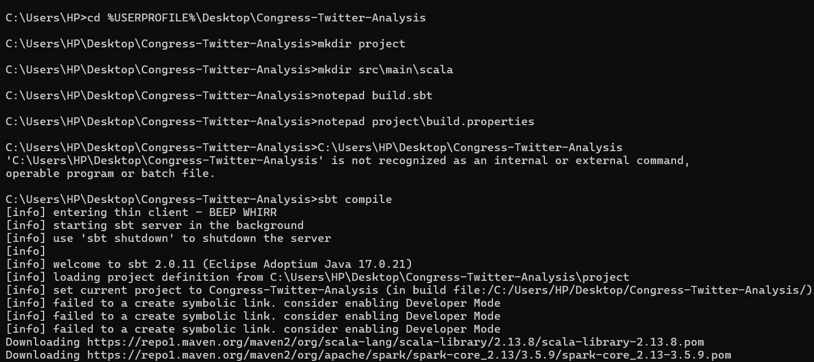
Figure 1. SBT compilation and dependency resolution.
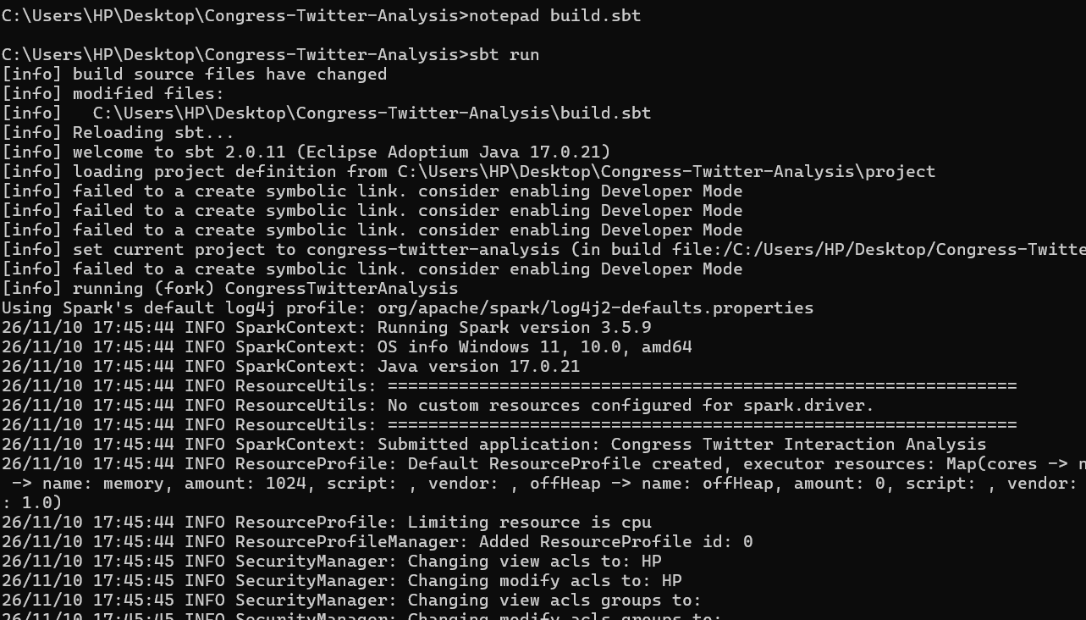
Figure 2. Spark application launch using SBT and the local Spark runtime.

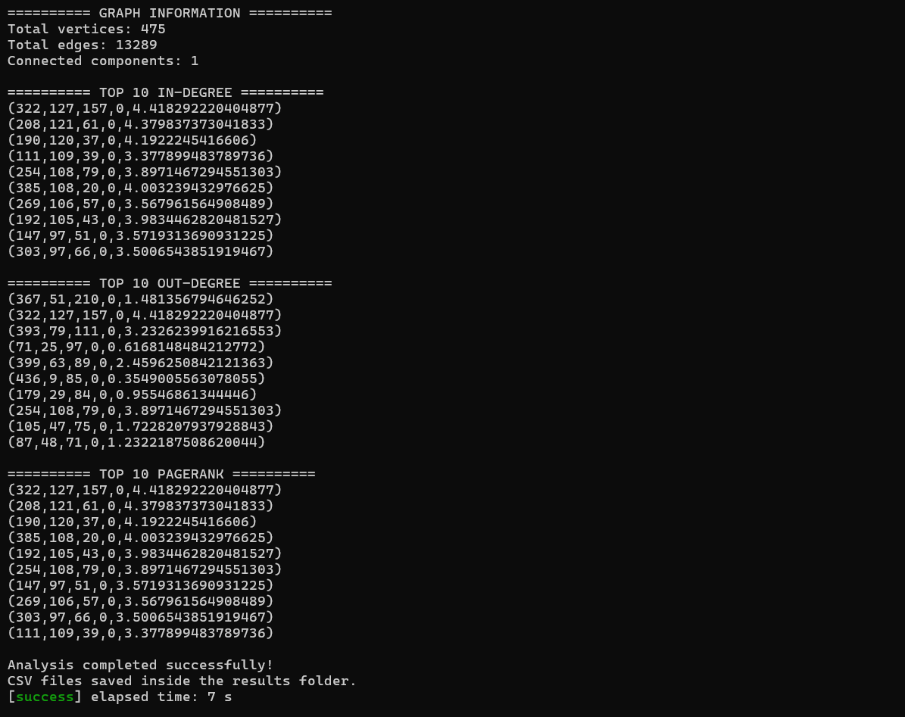
Figure3. GraphX output: 475 vertices, 13,289 edges, one connected component, and top account rankings.
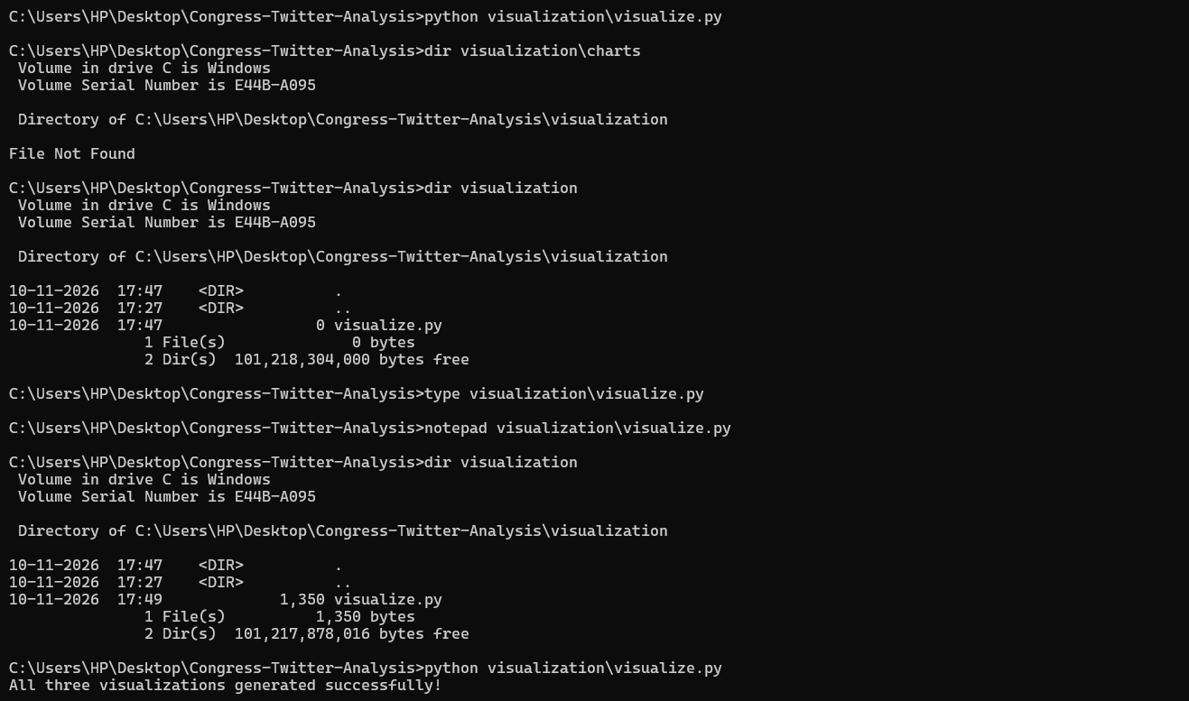
Figure 4. Python visualization script execution and successful chart generation.

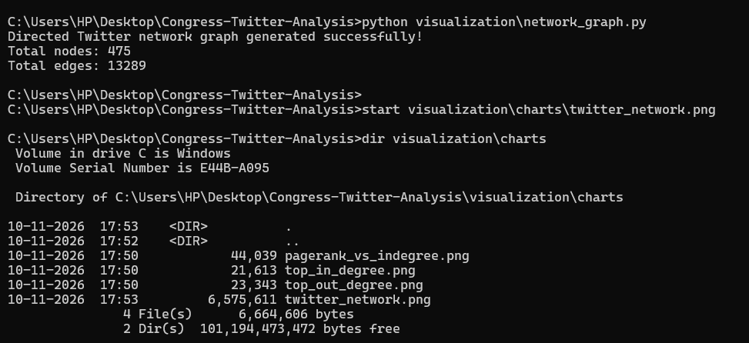
Figure5. Directed network visualization generation and chart-file verification.
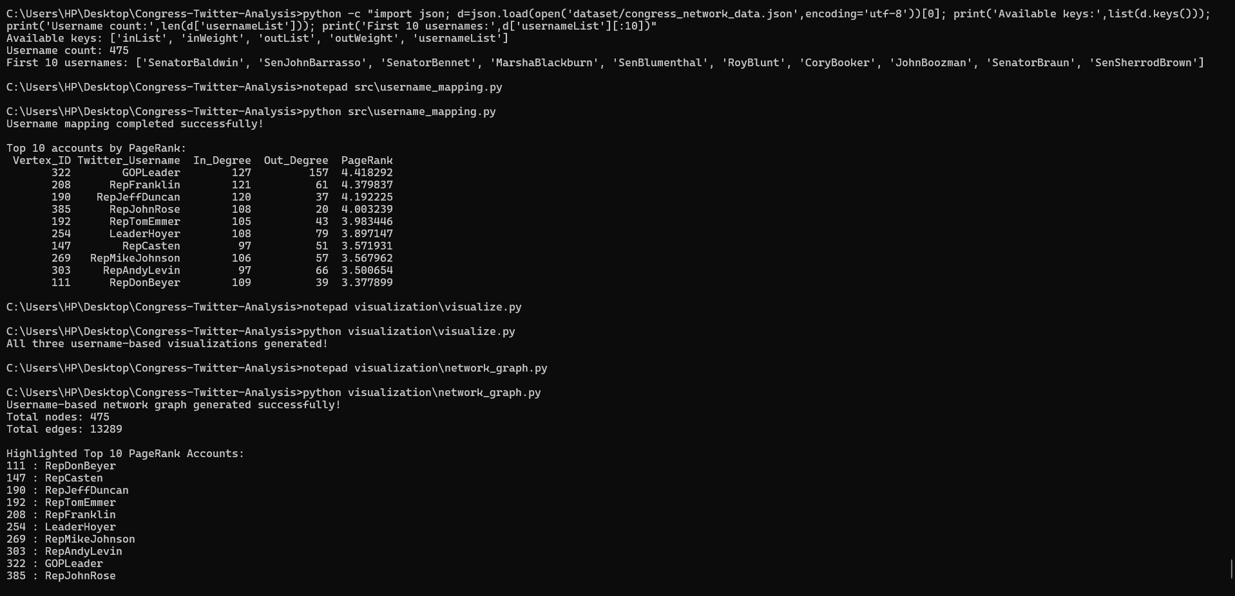
Figure 6. Username mapping and top PageRank account output.

4. Results and Evaluation

4.1 Graph Summary
The Spark execution completed successfully and reported 475 vertices, 13,289 edges, and one connected component. This indicates that all vertices in the processed graph belong to a single weakly connected component under the GraphX connected-components operation.

4.2 Top Accounts by In-Degree
Rank | Twitter username | In-degree
1 | GOPLeader | 127
2 | RepFranklin | 121
3 | RepJeffDuncan | 120
4 | RepDonBeyer | 109
5 | LeaderHoyer | 108
6 | RepJohnRose | 108
7 | RepMikeJohnson | 106
8 | RepTomEmmer | 105
9 | RepCasten | 97
10 | RepAndyLevin | 97
GOPLeader has the highest in-degree with 127 incoming edges. It receives direct connections from more accounts than any other vertex in the computed graph.

4.3 Top Accounts by Out-Degree
The ten accounts with the highest out-degree are shown in the table below. SpeakerPelosi leads with 210 outgoing edges, followed by GOPLeader with 157 and RepBobbyRush with 111. A high out-degree means an account has outgoing connections to many other accounts; it does not automatically mean that it receives many connections or has the highest PageRank.
Rank | Twitter account | Out-degree | In-degree
1 | SpeakerPelosi | 210 | 51
2 | GOPLeader | 157 | 127
3 | RepBobbyRush | 111 | 79
4 | SenSchumer | 97 | 25
5 | SteveScalise | 89 | 63
6 | RepMarkTakano | 85 | 9
7 | rosadelauro | 84 | 29
8 | LeaderHoyer | 79 | 108
9 | RepJimBanks | 75 | 47
10 | SenWarren | 71 | 48

4.4 PageRank Results
Rank | Twitter username | PageRank
1 | GOPLeader | 4.418292
2 | RepFranklin | 4.379837
3 | RepJeffDuncan | 4.192225
4 | RepJohnRose | 4.003239
5 | RepTomEmmer | 3.983446
6 | LeaderHoyer | 3.897147
7 | RepCasten | 3.571932
8 | RepMikeJohnson | 3.567962
9 | RepAndyLevin | 3.500654
10 | RepDonBeyer | 3.377900
The top-ten PageRank list contains the same ten accounts as the top-ten in-degree list (10/10 overlap), although their ordering differs. Across all 475 vertices, the Pearson correlation between in-degree and PageRank is 0.9773, while the Spearman rank correlation is 0.9707. These strong positive associations show that accounts with more incoming connections generally also receive higher PageRank scores in this dataset; the metrics are related but not identical.
Task completion summary: all six required analysis tasks were executed. The evidence and numerical outputs are documented in Sections 4–5 and the command-line execution evidence below.

4.5 Evaluation Approach
This is a graph analytics project rather than a supervised prediction task. The workflow has no labelled target variable and does not train or test a predictive model. Accuracy, precision, recall, F1-score, R-squared and mean absolute error are therefore not appropriate evaluation measures for these algorithms. Evaluation is based on successful graph construction, graph counts, degree calculations, connected-component output, PageRank rankings and consistency of the exported results.

5. Visualization and Interpretation
The scripts generate four figures. Insert the PNG files from visualization/charts into the marked positions below before final submission.

5.1 Top 10 Accounts by In-Degree
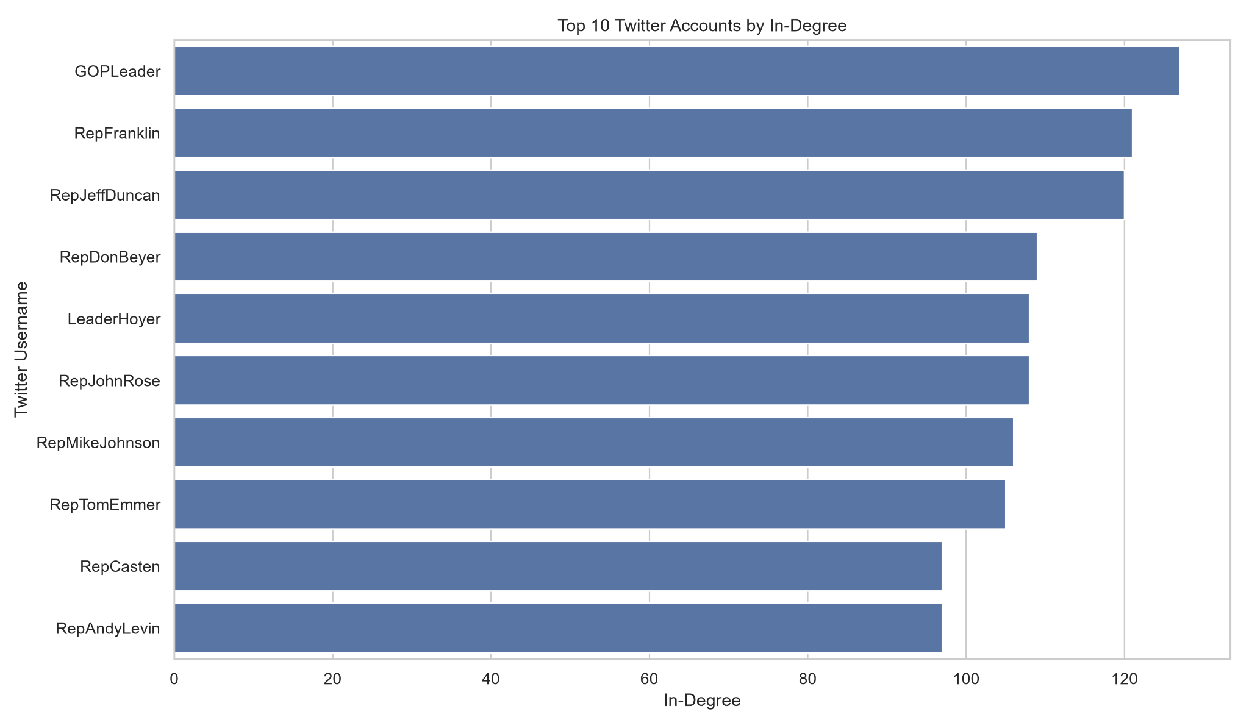
Figure 1. Top 10 Congress Twitter accounts ranked by in-degree.
The horizontal bar chart compares incoming edge counts. GOPLeader leads with 127 incoming edges.

5.2 Top 10 Accounts by Out-Degree
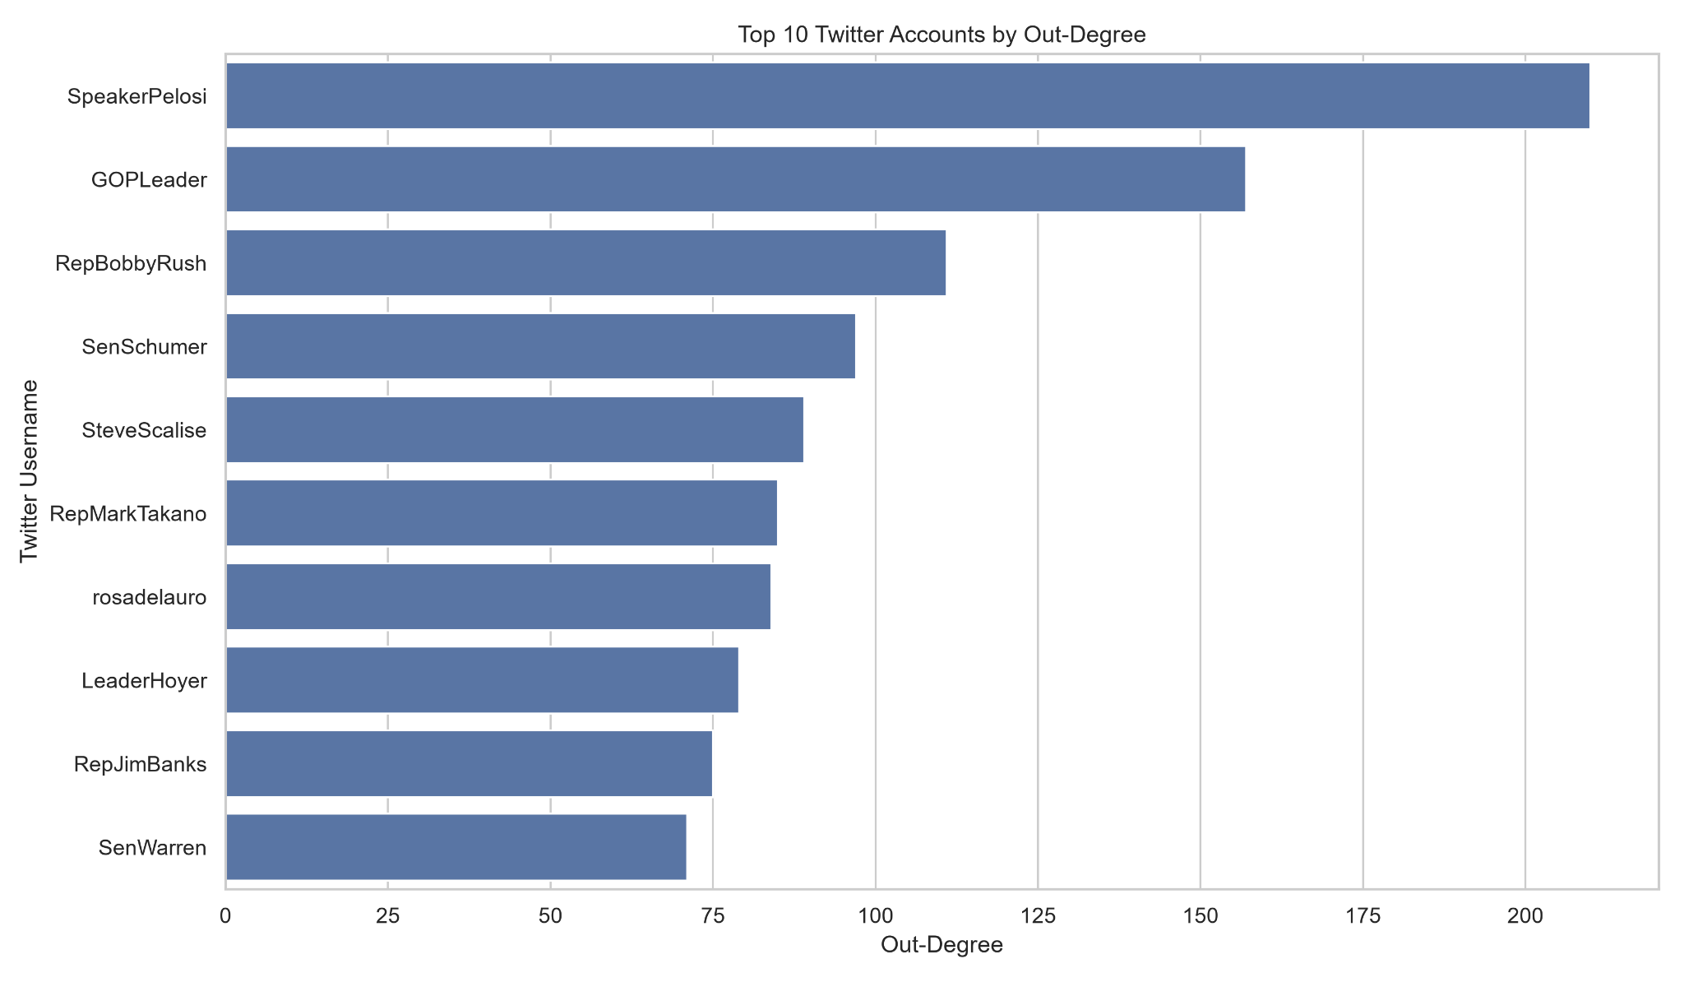
Figure 2. Top 10 Congress Twitter accounts ranked by out-degree.
SpeakerPelosi has the highest out-degree (210), followed by GOPLeader (157) and RepBobbyRush (111). The remaining high-outdegree accounts include SenSchumer (97), SteveScalise (89), and RepMarkTakano (85).

5.3 PageRank versus In-Degree
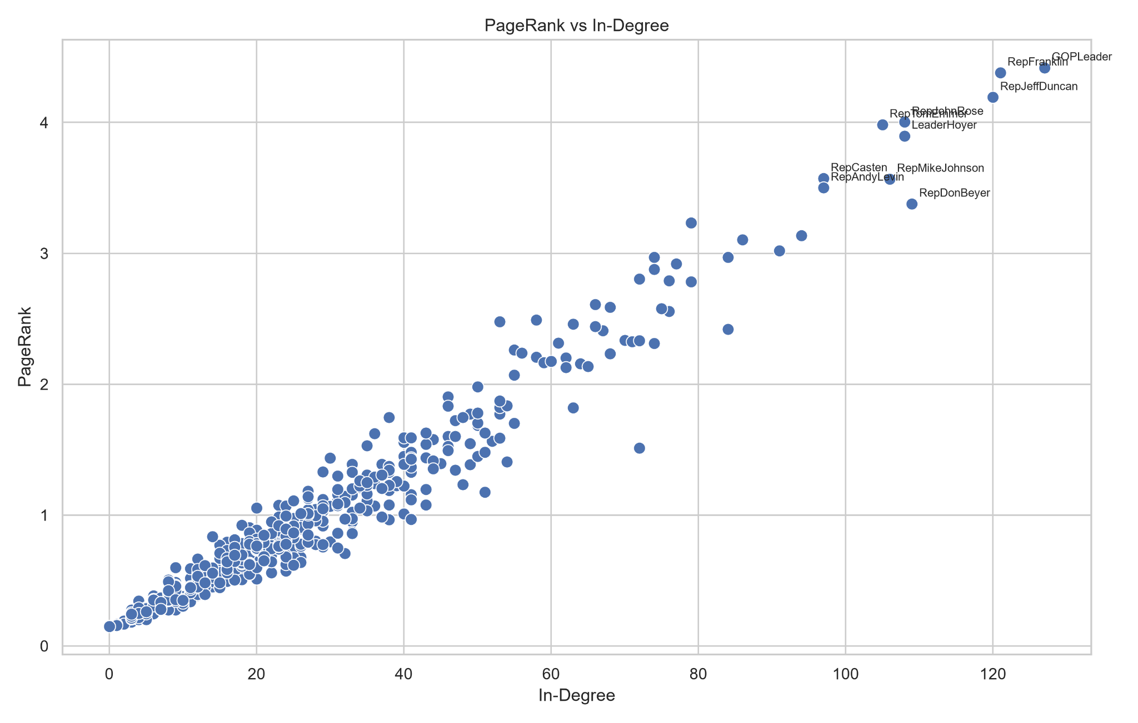
Figure 3. Scatter plot comparing in-degree and PageRank across vertices.
The scatter plot shows a strong upward relationship. The Pearson correlation is 0.9773 and the Spearman rank correlation is 0.9707 across all 475 accounts. The top-ten sets for in-degree and PageRank overlap completely (10 of 10 accounts), although the rank order differs.

5.4 Directed Congress Twitter Network
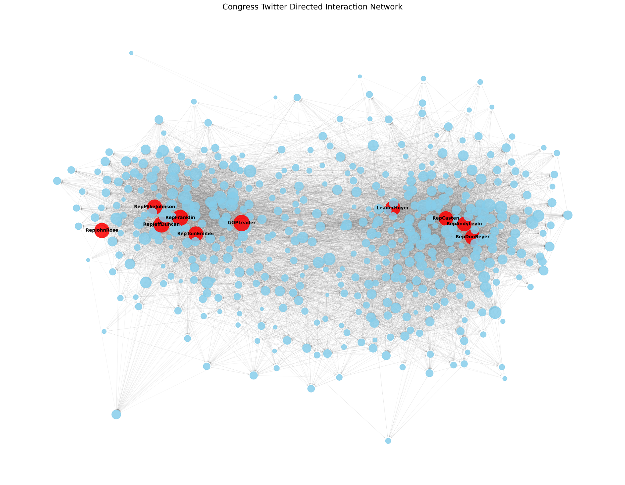
Figure 4. Directed network graph with top ten PageRank accounts highlighted.
Red nodes indicate the ten highest PageRank accounts; blue nodes indicate the remaining accounts. Node size is proportional to in-degree. Only the top ten are labelled.

6. Conclusion and Future Work

6.1 Conclusion
The project successfully built and analysed the Congress Twitter interaction graph using Apache Spark GraphX. The graph contains 475 accounts and 13,289 directed edges and forms one weakly connected component. Degree analysis identified GOPLeader as the account with the highest in-degree (127), while SpeakerPelosi has the highest out-degree (210). PageRank ranked GOPLeader first (4.418292), followed by RepFranklin and RepJeffDuncan. The in-degree and PageRank top-ten sets overlap completely, with a Spearman rank correlation of 0.9707. Username mapping and four Python visualizations make the results easier to interpret.

6.2 Limitations
The current degree analysis uses unweighted edge counts even though source edge weights are available.
The current PageRank call does not implement a custom transition rule based on source edge weights.
The full network visualization is dense because it displays 475 vertices and 13,289 edges.
The analysis is descriptive and does not establish causation or analyse interaction content or sentiment.

6.3 Future Work
Calculate weighted in-strength and out-strength by summing edge weights.
Compare standard PageRank with a custom weighted PageRank implementation.
Create filtered visualizations for the top 25 or top 50 accounts and their neighbours.
Analyse community structure and compare communities with centrality rankings.
Add betweenness and closeness centrality measures.
Study changes over time if timestamped interaction data is available.

7. References
Fink, C. G., Fullin, K., Gutierrez, G., Omodt, N., Zinnecker, S., Sprint, G., & McCulloch, S. (2023). A centrality measure for quantifying spread on weighted, directed networks. Physica A: Statistical Mechanics and its Applications, 626, 129083. https://doi.org/10.1016/j.physa.2023.129083
Fink, C. G., Omodt, N., Zinnecker, S., & Sprint, G. (2023). A Congressional Twitter network dataset quantifying pairwise probability of influence. Data in Brief, 50, 109521. https://doi.org/10.1016/j.dib.2023.109521
Stanford Network Analysis Project (SNAP). (2023). Twitter Interaction Network for the US Congress. https://snap.stanford.edu/data/congress-twitter.html
Apache Software Foundation. (2024). GraphX Programming Guide (Apache Spark 3.5.9). https://spark.apache.org/docs/3.5.9/graphx-programming-guide.html
NetworkX Developers. (n.d.). NetworkX documentation: Drawing. https://networkx.org/documentation/stable/reference/drawing.html
The pandas development team. (n.d.). pandas documentation. https://pandas.pydata.org/docs/
Matplotlib Development Team. (n.d.). Matplotlib documentation. https://matplotlib.org/stable/
Seaborn Developers. (n.d.). seaborn documentation. https://seaborn.pydata.org/
Stanford Network Analysis Project (SNAP), “Congress Twitter Dataset.” https://snap.stanford.edu/data/congress-twitter.html
Apache Spark Documentation, “GraphX Programming Guide.” https://spark.apache.org/docs/3.5.9/graphx-programming-guide.html
Apache Spark Scala API Documentation, GraphX package. https://spark.apache.org/docs/3.5.9/api/scala/org/apache/spark/graphx/index.html
NetworkX Documentation, “Drawing.” https://networkx.org/documentation/stable/reference/drawing.html
Pandas Documentation. https://pandas.pydata.org/docs/
Matplotlib Documentation. https://matplotlib.org/stable/
Seaborn Documentation. https://seaborn.pydata.org/

8. Appendix: Code and Reproducibility

8.1 Project Structure
Congress-Twitter-Analysis/
├── dataset/ (congress.edgelist, congress_network_data.json)
├── results/ (CSV metrics and username-enriched CSV files)
├── src/main/scala/CongressTwitterAnalysis.scala
├── src/username_mapping.py
├── visualization/ (visualize.py, network_graph.py, charts/)
├── report/
└── build.sbt

8.2 Reproduction Steps
Install Java 17, Apache Spark 3.5.9, SBT and Python 3.11. Install pandas, matplotlib, seaborn and NetworkX in the Python environment used to generate the charts.
Place congress.edgelist and congress_network_data.json in the dataset folder.
From the project root, run: sbt compile, followed by sbt run.
Generate username-enriched CSV files: python src/username_mapping.py
Generate metric charts: python visualization/visualize.py
Generate the directed network graph: python visualization/network_graph.py
Check results/ for CSV outputs and visualization/charts/ for PNG figures.

8.3 Source Code Link
Include all source files in the submitted ZIP. If hosted on GitHub, add the repository URL here: [https://github.com/mehulagrawal87/Congress-Twitter-Interaction-Analysis-.git].

8.4 Reproducibility Notes
Run all commands from the Congress-Twitter-Analysis project root so that relative file paths resolve correctly. The Spark program writes CSV results to results/, the username-mapping script creates username-enriched CSV files, and the visualization scripts save PNG figures in visualization/charts/. Keep the dataset README and original dataset files with the submitted project so the source and field meanings remain documented.
The four figures included in Section 5 were generated by the project’s Python visualization scripts from the exported GraphX metrics and the original directed edge list. Six Command Prompt screenshots are included in Section 3.5 as evidence of compilation, execution, metric output, visualization generation, and username mapping.

