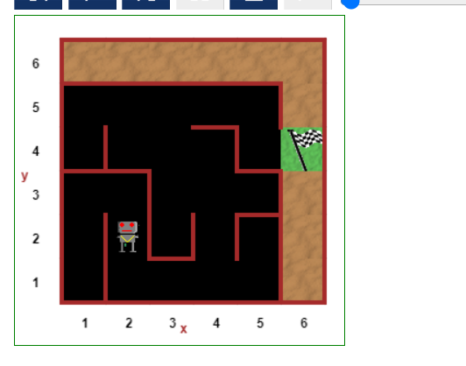

Write a code to make the robot win the maze and move out of it.

