Please work in **groups**of max 4and min 2 to complete this Assignment. This Assignment is worth 7% of the total course grade and will be evaluated through your written submission, as well as the Assignment demo in the class worth 1%. During the Assignment demo, group members are randomly selected to present the answers to each of the lab questions. Group members not present during the Assignment demo will lose the demo mark. Individual submission will have penalty of 10%.

Please submit the following files through Blackboard. Only one person must submit for the team.

* Project SQL file: Project1_GroupNumber.SQL
* Project document: Project1_ GroupNumber.docx
* In the docx file use the same document as Assignment 1. Put the query and screenshot of the results below each question.

# Part I. Group work

1. Add this declaration on the top of your file.

We, declare that the attached assignment is our own work in accordance with the Seneca Academic Policy. No part of this assignment has been copied manually or electronically from any other source (including web sites) **or distributed to other students.**

1. Specify what each member has done towards the completion of this work:

**The ERD of movie rental database is provided below. The database is provided on Blackboard under assignment 1 link with the name of Movie_Rental.rtf. The first 20 questions are worth 2.5 each and last 10 questions are worth 5 marks each. Run the script and then run the queries after solving in the questions below.**

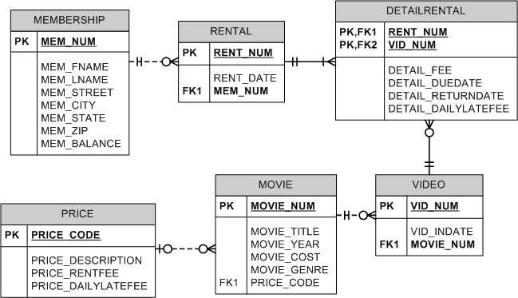

1. **Write the SQL command to change the movie year for movie number 1245 to 2008.**

**Answer:**

**UPDATE movie**

**SET movie_year = 2008**

**WHERE movie_num = 1245;**

**a1.JPG**

1. **Write the SQL command to change the price code for all Action movies to price code 3.**

**Answer:**

**UPDATE movie**

**SET price_code = 3**

**WHERE movie_genre = 'ACTION';**

**a2.JPG**

1. **Write a single SQL command to increase all price rental fee values by $0.50.**

**Answer:**

**UPDATE price**

**SET price_rentfee = price_rentfee + 0.50;**

**a3.JPG**

1. **Write a query to display the movie title, movie year, and movie genre for all movies (result shown in Figure P7.72).**

**Answer:**

**SELECT movie_title, movie_year, movie_genre**

**FROM movie;**

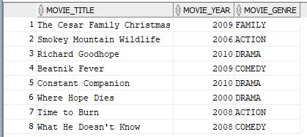

Figure P7.72 All Movies

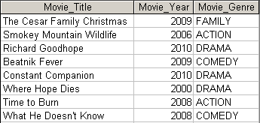

1. **Write a query to display the movie year, movie title, and movie cost sorted by movie year in descending order (result shown in Figure P7.73).**

**Answer:**

**SELECT movie_year, movie_title, movie_cost**

**FROM movie**

**ORDER BY movie_year DESC, movie_title;**

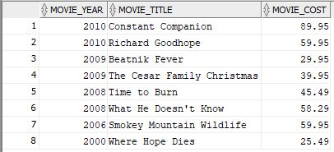

Figure P7.73 Movies by year

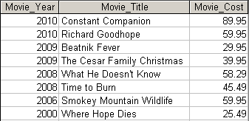

1. **Write a query to display the movie title, movie year, and movie genre for all movies sorted by movie genre in ascending order, then sorted by movie year in descending order within genre (result shown in Figure P7.74).**

**Answer:**

**SELECT movie_title, movie_year, movie_genre**

**FROM movie**

**ORDER BY 3, 2 DESC;**

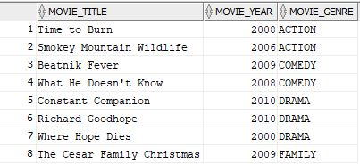

Figure P7.74 Movies with multicolumn sort

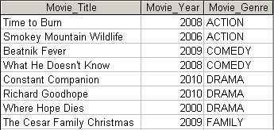

1. **Write a query to display the movie number, movie title, and price code for all movies with a title that starts with the letter “R” (result shown in Figure P7.75).**

**Answer:**

**SELECT movie_num, movie_title, price_code**

**FROM movie**

**WHERE UPPER(movie_title) LIKE 'R%';**

**a7.JPG0**

Figure P7.75 Movies starting with R

FigP7-54-Movies-Starting-with-R

1. **Write a query to display the movie title, movie year, and movie cost for all movies that contain the word “hope” anywhere in the title. Sort the results in ascending order by title (result shown in figure P7.76).**

**Answer:**

**SELECT movie_title, movie_year, movie_cost**

**FROM movie**

**WHERE UPPER(movie_title) LIKE '%HOPE%'**

**ORDER BY movie_title;**

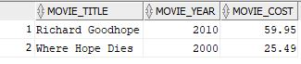

Figure P7.76 Movies with “Hope” in the title

FigP7-76-Movies-with-Hope

1. **Write a query to display the movie title, movie year, and movie genre for all action movies (result shown in Figure P7.77).**

**Answer:**

**SELECT movie_title, movie_year, movie_genre**

**FROM movie**

**WHERE UPPER(movie_genre) = 'ACTION';**

**a9.JPG**

Figure P7.77 Action movies

FigP7-77-Action-Movies

1. **Write a query to display the movie number, movie title, and movie cost for all movies with a cost greater than $40 (result shown in Figure P7.78).**

**Answer:**

**SELECT movie_num, movie_title, movie_cost**

**FROM movie**

**WHERE movie_cost > 40;**

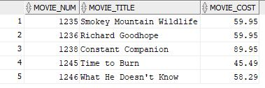

P7.78 Movies costing more than $40

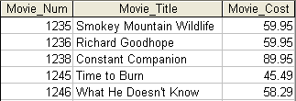

1. **Write a query to display the movie number, movie title, movie cost, and movie genre for all movies that are either action or comedy movies and that have a cost that is less than $50. Sort the results in ascending order by genre. (Result shown in Figure P7.79.)**

**Answer:**

**SELECT movie_num, movie_title, movie_cost, movie_genre**

**FROM movie**

**WHERE UPPER(movie_genre) IN ('ACTION', 'COMEDY')**

**OR movie_cost < 50**

**ORDER BY movie_genre;**

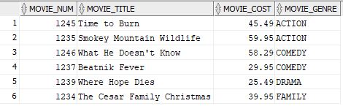

Figure P7.79 Action or comedy movies costing less than $50

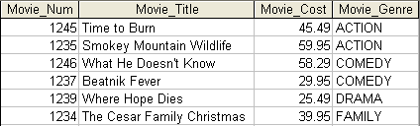

1. **Write a query to display the movie number, and movie description for all movies where the movie description is a combination of the movie title, movie year and movie genre with the movie year enclosed in parentheses (result shown in Figure P7.80).**

**Answer:**

**SELECT movie_num, movie_title || ' (' || movie_year || ') ' || movie_genre "Movie Desciption"**

**FROM movie;**

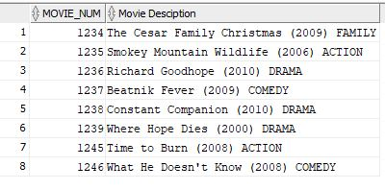

Figure P7.80 Movies with concatenated descriptions

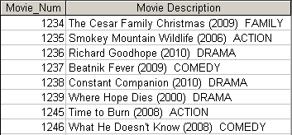

1. **Write a query to display the movie genre and the number of movies in each genre (result shown in Figure P7.81).**

**Answer:**

**SELECT movie_genre, COUNT(*) "Number of Movies"**

**FROM movie**

**GROUP BY movie_genre**

**ORDER BY 1;**

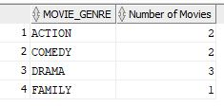

Figure P7.81 Number of movies in genre

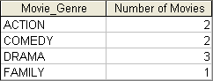

1. **Write a query to display the average cost of all of the movies (result shown in Figure P7.82).**

**Answer:**

**SELECT ROUND(AVG(movie_cost),4) "Average Movie Cost"**

**FROM movie;**

**a14.JPG**

Figure P7.82 Average movie cost

FigP7-61-Average-Movie-Cost

1. **Write a query to display the movie genre and average cost of movies in each genre (result shown in Figure P7.83).**

**Answer:**

**SELECT movie_genre, ROUND(AVG(movie_cost), 2) "Average Cost"**

**FROM movie**

**GROUP BY movie_genre**

**ORDER BY 1;**

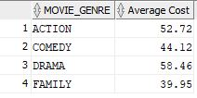

Figure P7.83 Average movie cost by genre

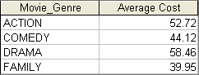

1. **Write a query to display the movie title, movie genre, price description, and price rental fee for all movies with a price code (result shown in Figure P7.84).**

**Answer:**

**SELECT m.movie_title, m.movie_genre, p.price_description, p.price_rentfee**

**FROM movie m JOIN price p**

**ON m.price_code = p.price_code**

**ORDER BY p.price_code;**

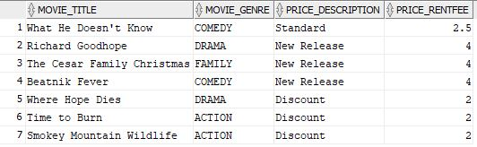

Figure P7.84 Rental fees for movies

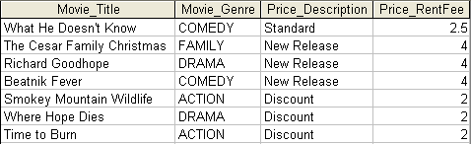

1. **Write a query to display the movie genre and average price rental fee for movies in each genre that have a price (result shown in Figure P7.85).**

**Answer:**

**SELECT m.movie_genre, ROUND(AVG(p.price_rentfee),2)**

**FROM movie m JOIN price p**

**ON m.price_code = p.price_code**

**GROUP BY m.movie_genre**

**ORDER BY 1;**

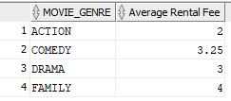

Figure P7.85 Average rental fee by genre

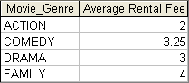

1. **Write a query to display the movie title, movie year, and the movie cost divided by the price rental fee for each movie that has a price to determine the number of rentals it will take to break even on the purchase of the movie (result shown in Figure P7.86).**

**Answer:**

**SELECT m.movie_title, m.movie_year, ROUND((m.movie_cost / p.price_rentfee), 2) "Breakeven Rentals"**

**FROM movie m JOIN price p**

**ON m.price_code = p.price_code**

**ORDER BY p.price_code;**

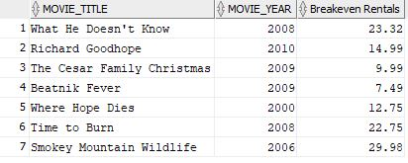

Figure P7.86 Breakeven rentals

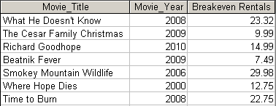

1. **Write a query to display the movie title and movie year for all movies that have a price code (result shown in Figure P7.87).**

**Answer:**

**SELECT movie_title, movie_year**

**FROM movie**

**WHERE price_code IS NOT NULL;**

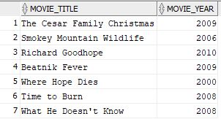

P7.87 Movies with a price

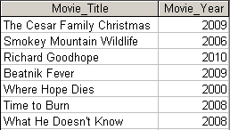

1. **Write a query to display the movie title, movie year, and movie cost for all movies that have a cost between $44.99 and $49.99 (result shown in Figure P7.88).**

**Answer:**

**SELECT movie_title, movie_year, movie_cost**

**FROM movie**

**WHERE movie_cost BETWEEN 44.99 AND 49.99;**

**a20.JPG**

Figure P7.88 Movies costs within a range

FigP7-88-Movie-Costs-within-a-Range

1. **Write a query to display the movie title, movie year, price description, and price rental fee for all movies that are in the genres Family, Comedy, or Drama (result shown in Figure P7.89).**

**Answer:**

**SELECT m.movie_title, m.movie_year, p.price_description, p.price_rentfee, m.movie_genre**

**FROM movie m JOIN price p**

**ON m.price_code = p.price_code**

**WHERE UPPER(m.movie_genre) IN ('FAMILY', 'COMEDY', 'DRAMA')**

**ORDER BY m.movie_num;**

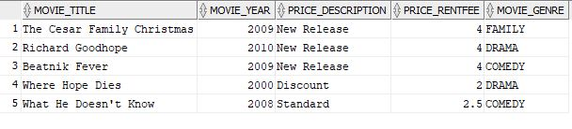

Figure P7.89 Movies with specific genres

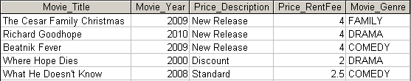

1. **Write a query to display the movie number, movie title, and movie year for all movies that do not have a video (result shown in Figure P7.90).**

**Answer:**

**SELECT m.movie_num, m.movie_title, m.movie_year**

**FROM movie m LEFT JOIN video v**

**ON m.movie_num = v.movie_num**

**WHERE v.vid_num is null;**

**a22.JPG**

Figure P7.90 Movies without videos

FigP7-90-Movies-without-Videos

1. **Write a query to display the membership number, first name, last name, and balance of the memberships that have a rental (result shown in Figure P7.91).**

**Answer:**

**SELECT DISTINCT(m.mem_num), m.mem_fname, m.mem_lname, m.mem_balance**

**FROM membership m JOIN rental r**

**ON m.mem_num = r.mem_num**

**ORDER BY 1;**

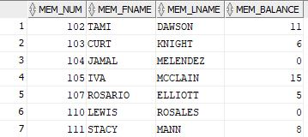

Figure P7.91 Balances of memberships with rentals

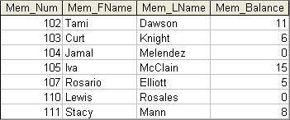

1. **Write a query to display the minimum balance, maximum balance, and average balance for memberships that have a rental (result shown in Figure P7.92).**

**Answer:**

**SELECT MIN(m.mem_balance) "Minimum Balance", MAX(m.mem_balance) "Maximum Balance", ROUND(SUM(DISTINCT m.mem_balance)/COUNT(DISTINCT m.mem_num), 2) "Average Balance"**

**FROM membership m JOIN rental r**

**ON m.mem_num = r.mem_num;**

**a24.JPG**

Figure P7.92 Minimum, maximum, and average balances

FigP7-71-Min-Max-Avg-of-Balances

1. **Write a query to display the membership name (concatenate the first name and last name with a space between them into a single column), membership address (concatenate the street, city, state, and zip codes into a single column with spaces (result shown in Figure P7.93).**

**Answer:**

**SELECT mem_fname || ' ' || mem_lname "Membership Name", mem_street || ' ' || mem_city || ', ' || mem_state || ' ' || mem_zip "Membership Address"**

**FROM membership;**

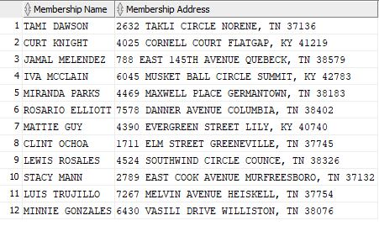

Figure P7.93 Concatenated membership data

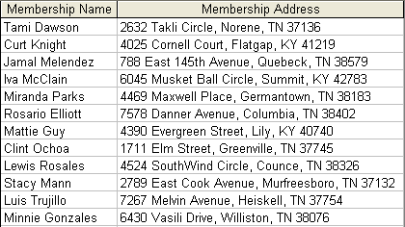

1. **Write a query to display the rental number, rental date, video number, movie title, due date, and return date for all videos that were returned after the due date. Sort the results by rental number and movie title (result shown in Figure P7.94).**

**Answer:**

**SELECT r.rent_num, TO_CHAR(rent_date, 'dd-Mon-yy') rent_date, v.vid_num, m.movie_title, TO_CHAR(detail_duedate, 'dd-Mon-yy') "Detail_DueDate", TO_CHAR(detail_returndate, 'dd-Mon-yy') "Detail_ReturnDate"**

**FROM rental r JOIN detailrental d**

**ON r.rent_num = d.rent_num**

**JOIN video v**

**ON d.vid_num = v.vid_num**

**JOIN movie m**

**ON v.movie_num = m.movie_num**

**WHERE detail_duedate < detail_returndate**

**ORDER BY r.rent_num, m.movie_title;**

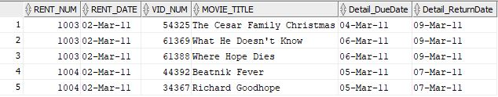

Figure P7.94 Late video returns

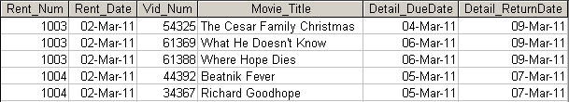

1. **Write a query to display the rental number, rental date, video number, movie title, due date, return date, detail fee, and number of days past the due date that the video was returned for each video that was returned after the due date. Sort the results by rental number and movie title. (Result shown in Figure P7.95.)**

**Answer:**

**SELECT r.rent_num, TO_CHAR(r.rent_date, 'dd-Mon-yy') rent_date, v.vid_num, m.movie_title, TO_CHAR(detail_duedate, 'dd-Mon-yy') "Detail_DueDate", TO_CHAR(detail_returndate, 'dd-Mon-yy') "Detail_ReturnDate", d.detail_fee, ROUND(d.detail_returndate - d.detail_duedate) "Days Past Due"**

**FROM rental r join detailrental d ON r.rent_num = d.rent_num**

**join video v ON d.vid_num = v.vid_num**

**join movie m ON v.movie_num = m.movie_num**

**WHERE d.detail_returndate > d.detail_duedate**

**ORDER BY r.rent_num, m.movie_title;**

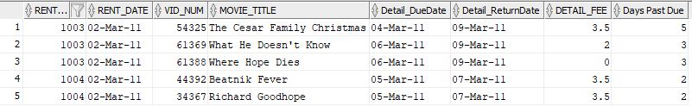

Figure P7.95 Number of days late

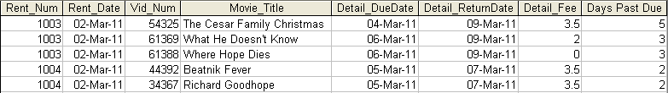

1. **Write a query to display the rental number, rental date, movie title, and detail fee for each movie that was returned on or before the due date (result shown in Figure P7.96).**

**Answer:**

**SELECT r.rent_num, r.rent_date, m.movie_title, d.detail_fee**

**FROM rental r JOIN detailrental d ON r.rent_num = d.rent_num**

**JOIN video v ON d.vid_num = v.vid_num**

**JOIN movie m ON v.movie_num = m.movie_num**

**WHERE d.detail_duedate >= d.detail_returndate;**

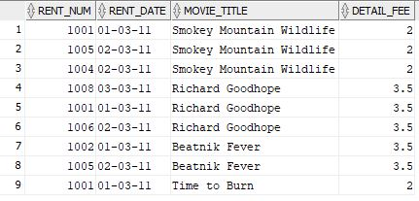

Figure P7.96 Actual rental fees charged

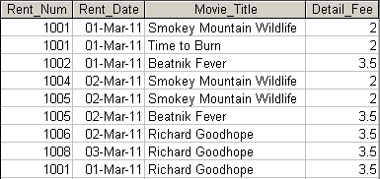

1. **Write a query to display the membership number, last name, and total rental fees earned from that membership (result shown in Figure P7.97). The total rental fee is the sum of all of the detail fees (without the late fees) from all movies that the membership has rented.**

**Answer:**

**SELECT m.mem_num, m.mem_lname, m.mem_fname,**

**SUM(d.detail_fee)"Rental Fee Revenue"**

**FROM membership m**

**JOIN rental r**

**ON m.mem_num = r.mem_num**

**JOIN detailrental d**

**ON r.rent_num = d.rent_num**

**GROUP BY m.mem_num, m.mem_lname, m.mem_fname**

**ORDER BY m.mem_num;**

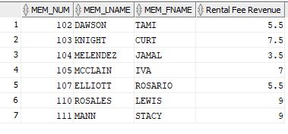

Figure P7.97 Total rental fees paid by membership

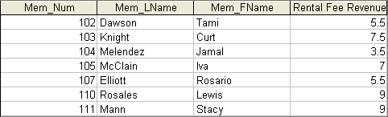

1. **Write a query to display the movie number, movie genre, average movie cost of movies in that genre, movie cost of that individual movie, and the percentage difference between the average movie cost and the individual movie cost (result shown in Figure P7.98). Note: the percentage difference is calculated as the cost of the individual movie minus the average cost of movies in that genre, divided by the average cost of movies in that genre multiplied by 100. For example, if the average cost of movies in the “Family” genre is $25, if a given Family movie cost $26, then the calculation would be ((26 – 25) / 25 * 100), which would work out to be 4.00%. This indicates that this movie costs 4% more than the average Family movie.**

**Answer:**

**SELECT m.Movie_Num, m.Movie_Genre, trunc(avg(abc.movie_cost),2) as "Average Cost", m.Movie_Cost, trunc((m.movie_cost- avg(abc.movie_cost))/avg(abc.movie_cost)*100, 2 )as "Percent Difference" FROM movie m, movie abc WHERE m.movie_genre = abc.movie_genre GROUP BY m.Movie_Num, m.Movie_Genre, m.Movie_Cost ORDER BY m.Movie_Num;**

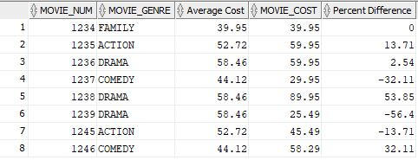

Figure P7.98 Movie difference from genre average

