L10-DBS301-savepoint rollback etc

You will **create 2 tables** first, then **remove / restore** these tables and also to **add / modify /remove** certain database objects like **views** in this lab.

1. Create table CITIES **from table LOCATIONS,** but only for location numbers less than 2000 (do NOT create this table from scratch).

🡪 You will have exactly 10 rows here.

When you describe CITIES, the output is shown below:

SQL> DESC cities

Name Null? Type

----------------------------------------- -------- -----------------

LOCATION_ID NUMBER(4)

STREET_ADDRESS VARCHAR2(40)

POSTAL_CODE VARCHAR2(12)

CITY NOT NULL VARCHAR2(30)

STATE_PROVINCE VARCHAR2(25)

COUNTRY_ID CHAR(2)

Answer:

CREATE TABLE CITIES

AS (SELECT LOCATION_ID,STREET_ADDRESS,

POSTAL_CODE, CITY,STATE_PROVINCE,

COUNTRY_ID

FROM LOCATIONS

WHERE LOCATION_ID < 2000

) ;

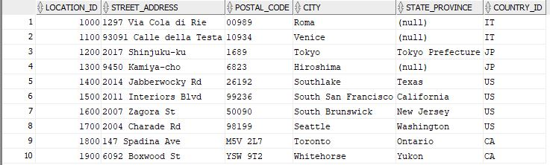

2. Create table TOWNS **from table LOCATIONS,** but only for location numbers less than 1500 (do NOT create this table from scratch). This table will have same structure as table CITIES.

🡪 You will have exactly 5 rows here.

Answer;

CREATE TABLE TOWNS

AS (SELECT LOCATION_ID ,

STREET_ADDRESS,

POSTAL_CODE,

CITY,

STATE_PROVINCE,

COUNTRY_ID

FROM LOCATIONS

WHERE LOCATION_ID < 1500

) ;

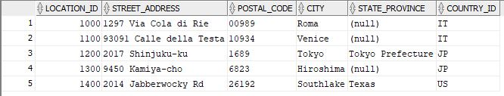

3. Now you will insert a row in TOWNS table, then delete the rows with Country_id CA. Check the new values with SELECT. Later run the command rollback, and then check the values in the table.

Answer:

INSERT INTO towns VALUES(1500, '470 Sentinal Road', 'M3J1V6', 'Toronto', 'ON', 'CA');

SELECT * FROM towns;

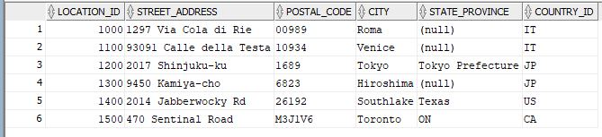

DELETE FROM towns WHERE country_id = 'CA';

SELECT * FROM towns;



ROLLBACK;

SELECT * FROM towns;



4. INSERT INTO cities VALUES (2000,‘70 Pond Rd’,‘M1L’, ‘Toronto’, ‘ON’, ‘CA’);

SAVEPOINT Insert_Done;

DELETE FROM cities WHERE country_id = ‘IT’;

SAVEPOINT Delete_Done;

UPDATE city SET city = 'York';

Answer:

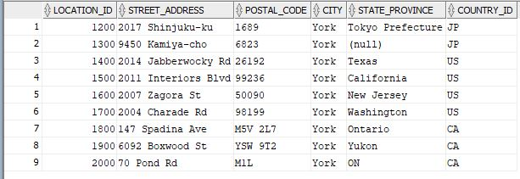

What will be the result if you execute the following command:

* 1. ROLLBACK to SAVEPOINT Delete_Done;

Answer:

ROLLBACK to Delete_Done;

SELECT * FROM cities;

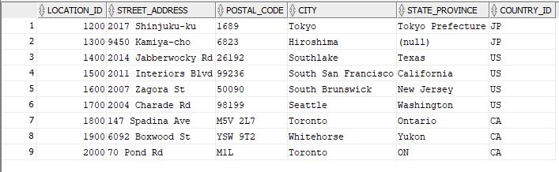

* 1. COMMIT Delete_Done;
  2. Rollback;

Answer:

COMMIT;

ROLLBACK;

select * from cities;



5. Add a check constraint in Cities table that will have country_id as IT and CA only.

Answer:

ALTER TABLE cities

ADD CONSTRAINT CHK_COUNTRY_ID CHECK (country_id IN ('IT', 'CA'));

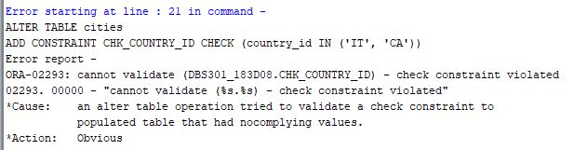

6. Create simple view called CA_CITY_VU, based on table CITIES so that will contain only columns Street_Address, City and State_Province for locations only in CANADA. Then display all data from this view.

Answer:

CREATE VIEW CAN_CITY_VU (STREET_ADDRESS,CITY,STATE_PROVINCE)

AS SELECT STREET_ADDRESS,CITY,STATE_PROVINCE

FROM CITIES

WHERE COUNTRY_ID = 'CA' ;

SELECT * FROM CAN_CITY_VU;

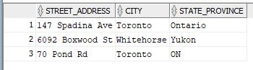

7. Modify your simple view so that will have following aliases instead of original column names: Street, City and Prov and also will include cities from ITALY as well. Then display all data from this view.

Answer:

CREATE OR REPLACE VIEW CAN_CITY_VU

AS SELECT STREET_ADDRESS Street,

CITY City,

STATE_PROVINCE Prov

FROM CITIES

WHERE COUNTRY_ID IN ('CA','IT');

SELECT * FROM CAN_CITY_VU;

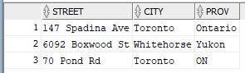

8. Create complex view called CITY_DEPNAME_VU, based on tables EMPLOYEES, LOCATIONS and DEPARTMENTS, so that will contain only columns Last_name, Department_Name, City and State_Province for locations in ITALY or CANADA. Then display all data from this view.

CREATE VIEW CITY_DEPNAME_VU

AS SELECT e.last_name, d.department_name, l.city, l.state_province

FROM employees e JOIN departments d

ON e.department_id = d.department_id

JOIN locations l

ON d.location_id = l.location_id

WHERE COUNTRY_ID IN ('CA', 'IT');

SELECT * FROM CITY_DEPNAME_VU;

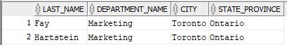

9. Modify your complex view so that will have following aliases instead of original column names: Lname, DName, City and Prov and also will include all cities outside United States.

Then display all data from this view.

Answer:

CREATE or REPLACE VIEW CITY_DEPNAME_VU

AS SELECT e.last_name Lname, d.department_name DName, l.city, l.state_province Prov

FROM employees e JOIN departments d

ON e.department_id = d.department_id

JOIN locations l

ON d.location_id = l.location_id

WHERE NOT COUNTRY_ID = 'US';

SELECT * FROM CITY_DEPNAME_VU;

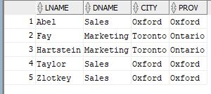

10. Check in the Data Dictionary what Views (their names and definitions) are created so far in your account. Then drop your CITY_DEPNAME_VU and check Data Dictionary again. What is different?

SELECT Lname,DName,City,Prov FROM CITY_DEPNAME_VU;

DROP VIEW CITY_DEPNAME_VU;

SELECT Lname,DName,City,Prov FROM CITY_DEPNAME_VU;