110288172-W2-DBS301-select-range-order

*STEP 1: rename the file to L2-your id name*

*STEP 2: Put the SQL and the results after each question below*

*STEP 3: Submit on Blackboard.*

Question 1. Display the employee_id, last name and salary of employees earning in the range of $8000 to $15,000. Sort the output by top salaries first and then by last name.

Answer:

SELECT employee_id, last_name, salary

FROM employees

WHERE salary BETWEEN 8000 AND 15000

ORDER BY salary, last_name;

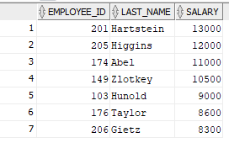

Question 2. Modify previous query (#1) so that additional condition is to display only if they work as Programmers or Sales Representatives. Use same sorting as before.

Answer:

SELECT employee_id, last_name, salary

FROM employees

WHERE (salary BETWEEN 8000 AND 15000) AND (job_id = 'IT_PROG' OR job_id = 'SA_REP')

ORDER BY salary DESC, last_name;

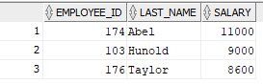

Question 3.The Human Resources department wants to find high salary and low salary employees. Modify previous query (#2) so that it displays the same job titles but for people who earn outside the given salary range from question 1. Use same sorting as before.

Answer:

SELECT employee_id, last_name, salary

FROM employees

WHERE (salary NOT BETWEEN 8000 AND 15000) AND (job_id = 'IT_PROG' OR job_id = 'SA_REP')

ORDER BY salary DESC, last_name;

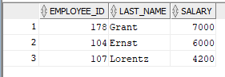

Question 4.The company needs a list of long term employees, in order to give them a thankyou dinner. Display the last name, job_id and salary of employees hired before 1998. List the most recently hired employees first.

Answer:

SELECT last_name, job_id, salary

FROM employees

WHERE hire_date< '01-JAN-98'

ORDER BY hire_date DESC;

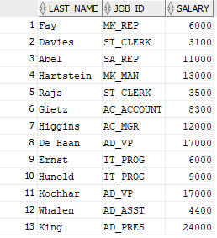

Question 5. Modify previous query (#4) so that it displays only employees earning more than $10,000. List the output by job title alphabetically and then by highest paid employees.

Answer:

SELECT last_name, job_id, salary

FROM employees

WHERE hire_date< '01-JAN-98' AND salary > 10000

ORDER BY job_id, salary DESC;

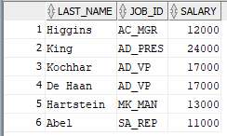

Question 6. Display the job titles and full names of employees whose first name contains an ‘e’ or ‘E’ anywhere. The output should look like:

Job Title Full name

--------------------------------------

AD_VP Neena Kochhar

… more rows

Answer:

SELECT job_id "Job Title", first_name || ' ' || last_name "Full name"

FROM employees

WHERE first_name LIKE '%e%' OR first_name LIKE '%E%';

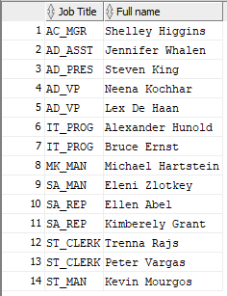

Question 7. Create a report to display last name, salary, and commission percentage for all employees that earn a commission.

Answer:

SELECT last_name, salary, commission_pct

FROM employees

WHERE commission_pct IS NOT NULL;

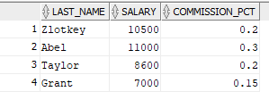

Question 8. Do the same as question 7, but put the report in order of descending salaries.

Answer:

SELECT last_name, salary, commission_pct

FROM employees

WHERE commission_pct IS NOT NULL

ORDER BY salary DESC;

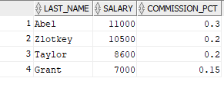

Question 9. Do the same as 8, but use a numeric value instead of a column name to do the sorting.

Answer:

SELECT last_name, salary, commission_pct

FROM employees

WHERE commission_pct IS NOT NULL

ORDER BY 2 DESC;

