110288172-L4-W5-DBS301-Group functions

*STEP 1: Put the SQL and the results after each question below*

*STEP 2: Submit on Blackboard.*

1 Display the difference between the Average pay and Lowest pay in the company.

Name this result *Real Amount*.

Answer:

SELECT AVG(salary) - MIN(salary) "Real Amount"

FROM employees;



2 Display the department number and Highest, Lowest and Average pay per each department. Name these results *High, Low* and *Avg.*

Sort the output so that the department with highest average salary is shown first.

Answer:

SELECT department_id, MAX(salary) "High", MIN(salary) "Low", ROUND(AVG(salary), 0) "Avg"

FROM employees

GROUP BY department_id

ORDER BY 4 DESC;

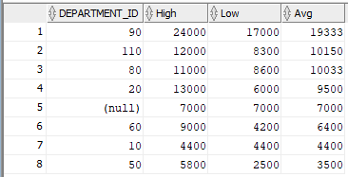

3 Display how many people work the same job in the same department.

Name these results *Dept#, Job* and *How Many.*

Include only jobs that involve more than one person.

Sort the output so that jobs with the most people involved are shown first.

Answer:

SELECT department_id "Dept#", job_id "Job", COUNT(*) "How Many"

FROM employees

GROUP BY department_id, job_id

HAVING COUNT(*) > 1

ORDER BY 3 DESC;

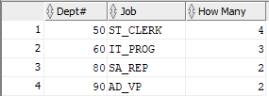

4 For each job title display the job title and total amount paid each month for this type of the job. Exclude titles *AD_PRES* and *AD_VP* and also include only jobs that require more than $15,000.

Sort the output so that top paid jobs are shown first.

Answer:

SELECT job_id, SUM(salary)

FROM employees

GROUP BY job_id

HAVING SUM(salary) > 15000 AND job_id NOT IN ('AD_PRES', 'AD_VP')

ORDER BY 2 DESC;

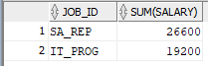

5 For each manager number display how many persons he / she supervises. Exclude managers with numbers 100, 101 and 102 and also include only those managers that supervise more than 2 persons.

Sort the output so that manager numbers with the most supervised persons are shown first.

Answer:

SELECT manager_id, COUNT(*)

FROM employees

GROUP BY manager_id

HAVING manager_id NOT IN (100, 101, 102) AND COUNT(*) > 2

ORDER BY 2 DESC;



6 For each department show the latest and earliest hire date, BUT

- exclude departments 10 and 20

- also exclude those departments where the last person was hired in this century.

- Sort the output so that the most recent, meaning latest hire dates, are shown first.

Answer:

SELECT MIN(hire_date), MAX(hire_date)

FROM employees

GROUP BY department_id

HAVING department_id NOT IN (10, 20) AND MAX(hire_date) < '01-JAN-00'

ORDER BY 2 DESC;

