110288172-L5a-DBS301-Simple Joins

**NOTE 1: This is about simple joins, so no LEFT or RIGHT joins etc. Required.**

**NOTE 2: There is a 5b on joins that also needs to be done**

**NOTE 3: If you are not finishing this in week 5, then you are actually running behind. Please catch up.**

1)      Display the department name, city, street address and postal code for departments sorted by city and department name.

Answer:

SELECT d.department_name, l.city, l.street_address, l.postal_code

FROM departments d, locations l

WHERE d.location_id = l.location_id

ORDER BY l.city, d.department_name;

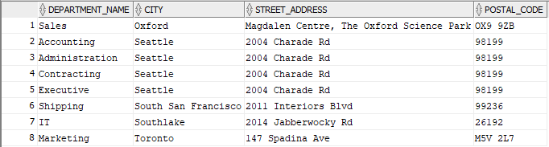

2)      Display full name of employees as a single field using format of **Last,First**, their hire date, salary, department name and city, but only for departments with names starting with an **A** or **S** sorted by department name and employee name.

Answer:

SELECT e.last_name || ', ' || e.first_name "Full Name", e.hire_date, e.salary, d.department_name, l.city

FROM employees e, departments d, locations l

WHERE e.department_id = d.department_id

AND d.location_id = l.location_id

AND (UPPER(d.department_name) LIKE 'A%' OR UPPER(d.department_name) LIKE 'S%')

ORDER BY d.department_name, "Full Name";

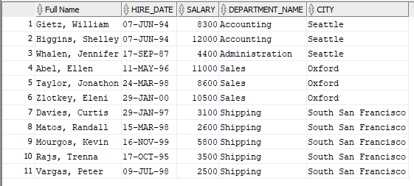

3)      Display the full name of the manager of each department in states/provinces of Ontario, California and Washington along with the department name, city, postal code and province name. Sort the output by city and then by department name.

Answer:

SELECT e.first_name || ', ' || e.last_name "Full Name", d.department_name, l.city, l.postal_code, l.state_province

FROM departments d, employees e, locations l

WHERE d.manager_id = e.employee_id

AND d.location_id = l.location_id

AND UPPER(l.state_province) IN ('ONTARIO', 'CALIFORNIA' , 'WASHINGTON')

ORDER BY l.city, d.department_name;

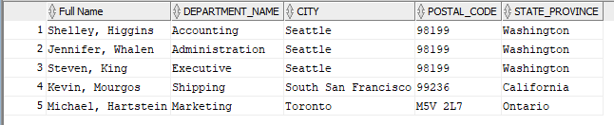

4)      Display employee’s last name and employee number along with their manager’s last name and manager number. Label the columns Employee, Emp#, Manager, and Mgr# respectively.

 Answer:

SELECT e.last_name "Employee" ,e.employee_id "Emp#", m.last_name "Manager" ,e.manager_id "Mgr#"

FROM employees e, employees m

WHERE e.manager_id = m.employee_id;

