110288172-L05b-DBS301-non-simple joins

1. Display the department name, city, street address and postal contry name for all Departments. Use the JOIN and USING form of syntax.

Sort the output by department name descending.

Answer:

SELECT department_name, city, street_address, postal_code

FROM departments JOIN locations USING (location_id)

ORDER BY department_name DESC;

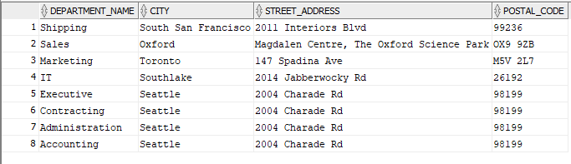

2. Display full name of the employees, their hire date and salary together with their department name, but only for departments which names start with **A** or **S**. Full name should be in format of :

**First / Last.** Use the JOIN and ON form of syntax.

Sort the output by department name and then by last name.

Answer:

SELECT e.first_name || ' / ' || e.last_name "Full Name", e.hire_date, e.salary, d.department_name

FROM employees e JOIN departments d

ON e.department_id = d.department_id

WHERE UPPER(department_name) LIKE 'A%' OR UPPER(department_name) LIKE 'S%'

ORDER BY department_name, last_name;

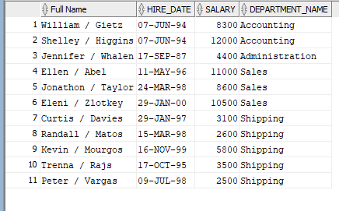

3. Rewrite the previous question by using Standard (Old -- prior to Oracle9i) Join

method.

Answer:

SELECT e.first_name || ' / ' || e.last_name "Full Name", e.hire_date, e.salary, d.department_name

FROM employees e, departments d

WHERE e.department_id = d.department_id

AND (UPPER(department_name) LIKE 'A%' OR UPPER(department_name) LIKE 'S%')

ORDER BY department_name, last_name;



4. Display full name of the manager of each department in provinces Ontario,

California and Washington plus department name, city, postal code and province name. Full name should be in format as follows:

**Last, First.** Use the JOIN and ON form of syntax.

Sort the output by city and then by department name.

Answer:

SELECT e.last_name || ', ' || e.first_name "Full Name", d.department_name, l.city, l.postal_code, l.state_province

FROM departments d JOIN employees e

ON (d.manager_id = e.employee_id)

JOIN locations l

ON (d.location_id = l.location_id)

WHERE UPPER(l.state_province) IN ('ONTARIO', 'CALIFORNIA' , 'WASHINGTON')

ORDER BY l.city, d.department_name;

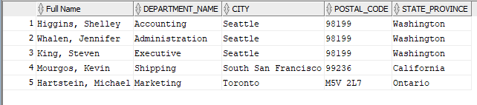

5. Rewrite the previous question by using Standard (Old -- prior to Oracle9i) Join method.

Answer:

SELECT e.last_name || ', ' || e.first_name "Full Name", d.department_name, l.city, l.postal_code, l.state_province

FROM departments d, employees e, locations l

WHERE d.manager_id = e.employee_id

AND d.location_id = l.location_id

AND UPPER(l.state_province) IN ('ONTARIO', 'CALIFORNIA' , 'WASHINGTON')

ORDER BY l.city, d.department_name;



6. Display the department name and Highest, Lowest and Average pay per each department. Name these results *High, Low* and *Avg.*

Use JOIN and ON form of the syntax.

Sort the output so that department with highest average salary are shown first.

Answer:

SELECT d.department_name, MAX(e.salary) "High", MIN(e.salary) "Low", ROUND(AVG(e.salary)) "Avg"

FROM departments d JOIN employees e

ON d.department_id = e.department_id

GROUP BY d.department_name

ORDER BY 4 DESC;

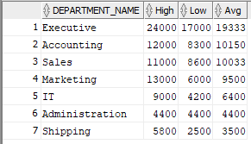

7. Display the employee last name and employee number along with their manager’s last name and manager number. Label the columns Employee,

Emp#, Manager, and Mgr#, respectively. Include also employees who do

NOT have a manager and also employees who do NOT supervise anyone (or

you could say managers without employees to supervise).

Answer:

SELECT e.last_name "Employee" ,e.employee_id "Emp#", m.last_name "Manager" ,e.manager_id "Mgr#"

FROM employees e FULL JOIN employees m

ON (e.manager_id = m.employee_id);

