Go installed with protocol buffer and go plugin

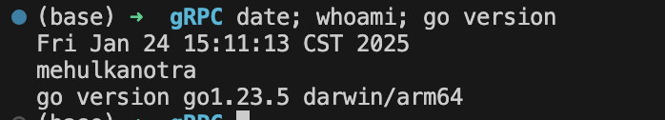

Installed protobuf

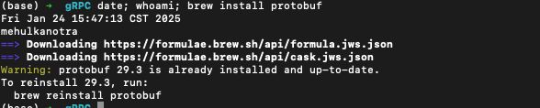

Installed plugin



Cloned repo

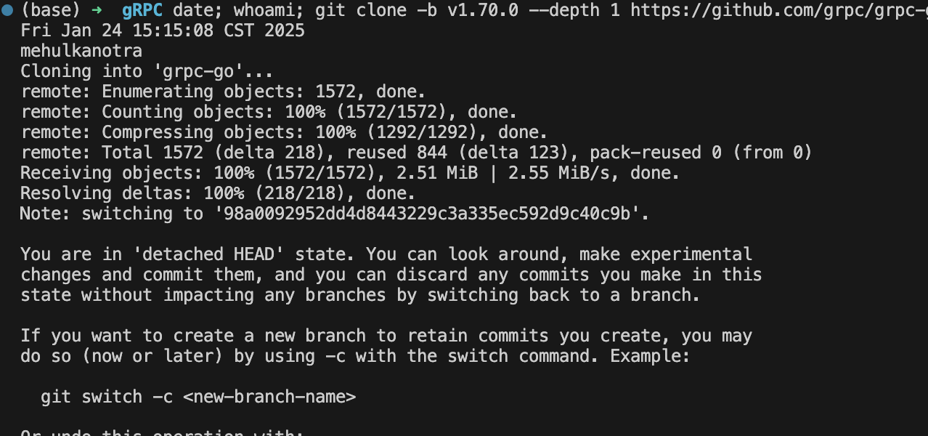

Running the example  
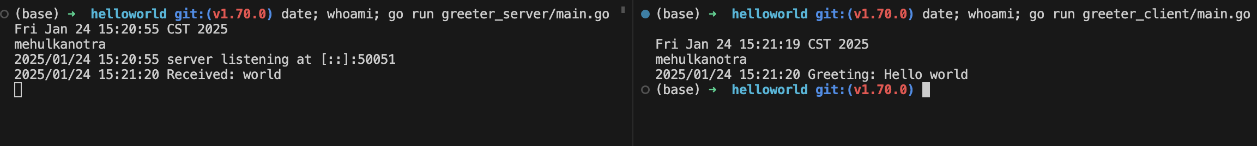

Updating gRPC service  
  
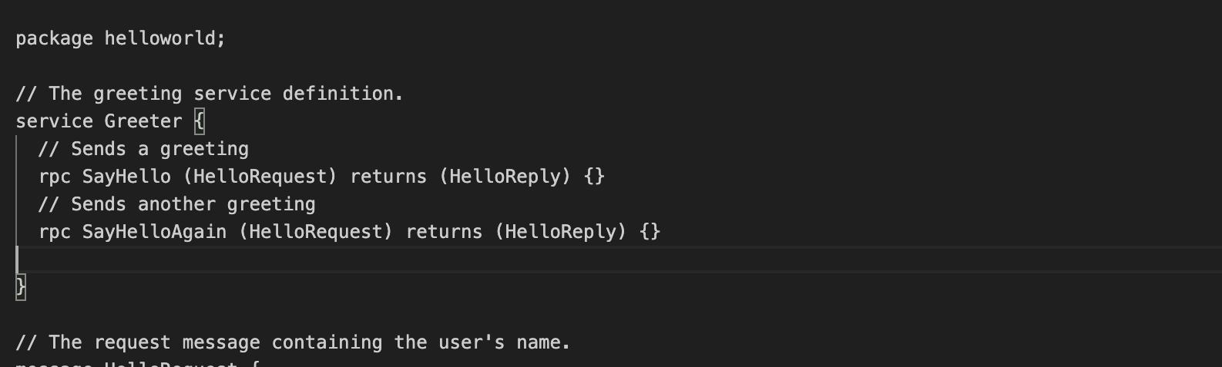

Compiling proto file  
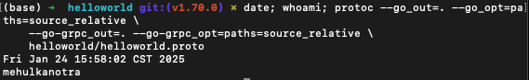

Updating server



Updating client

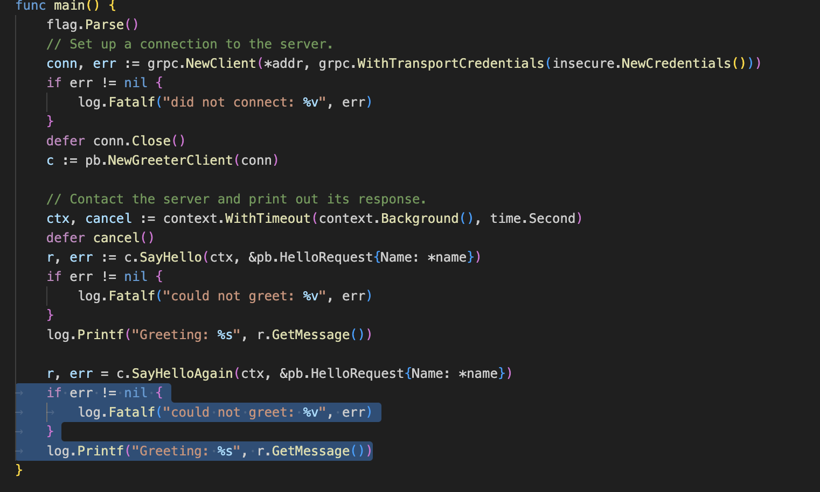

Running after changes

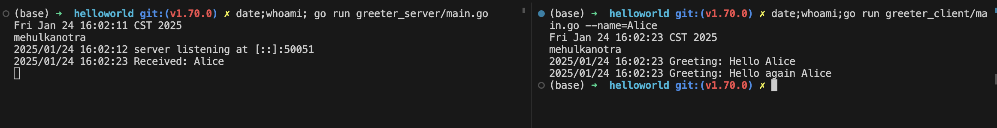

Basic Tutorial

Cd into dir

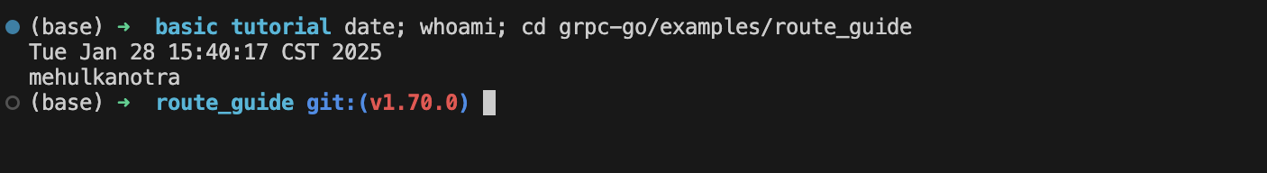

Generating client and server code  
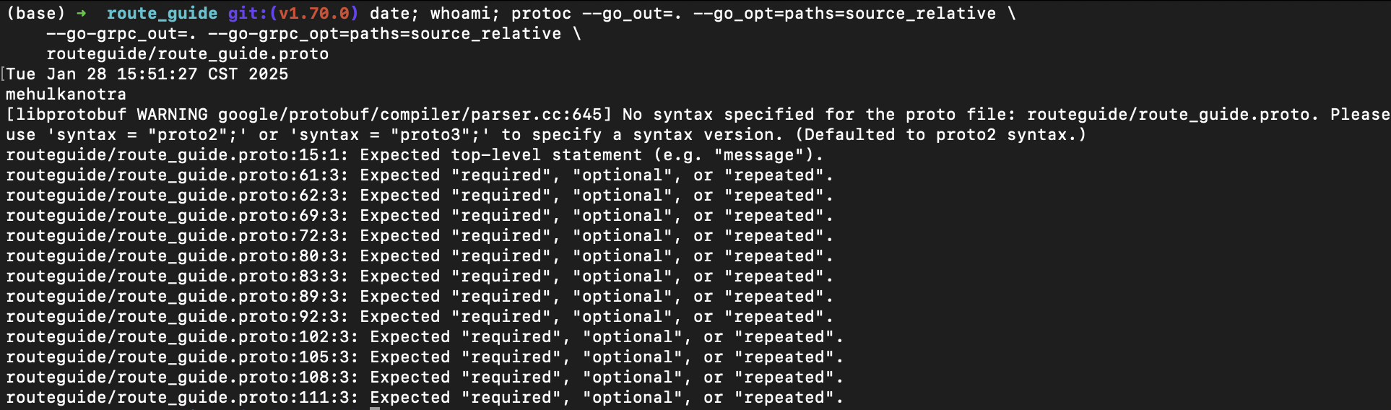

Running the server

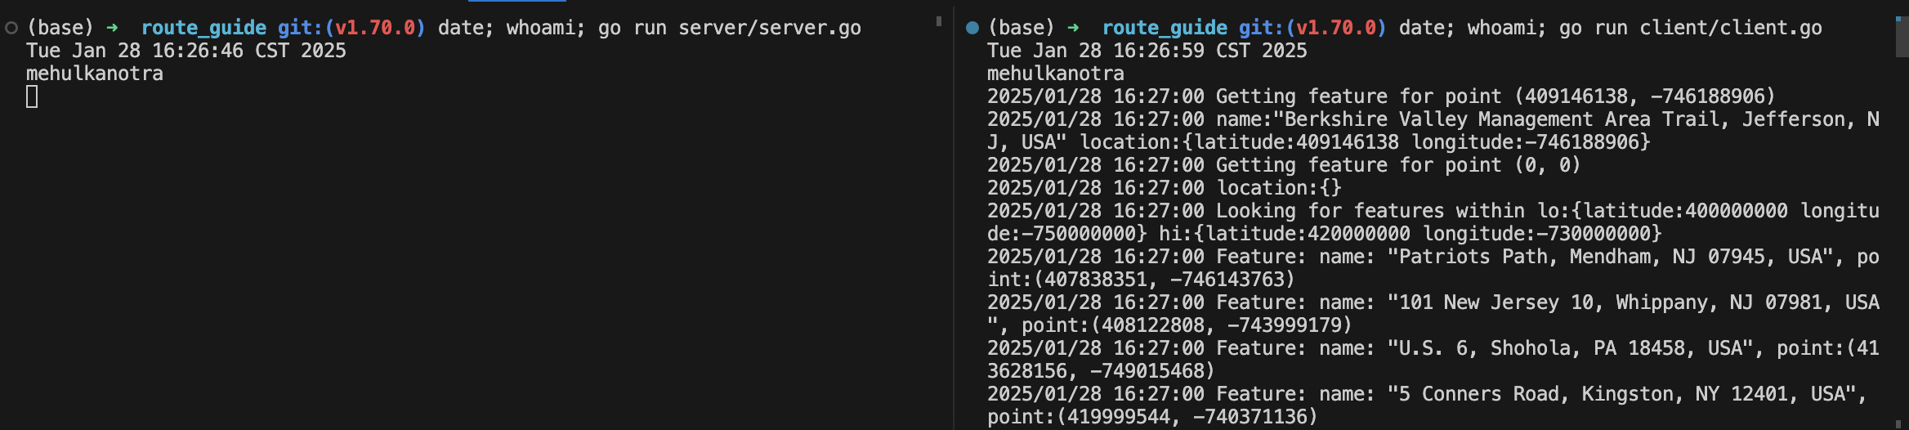

Continued for client side

