**Dr. AMBEDKAR INSTITUTE OF TECHNOLOGY**

Near Jnana Bharathi Campus, Bengaluru-560 056.

(An Autonomous Institution, Aided by Government of Karnataka)



**IoT Mini Project Report**

**on**

**“ANTI THEFT ALARM SYSTEM”**

**Submitted By**

**Modupalli Vishnupriya 1DA20CS076**

**Mohammed Ahmad Raza Khan 1DA20CS077**

**Naik Mehul Manjunath 1DA20CS078**

**Navyatha A 1DA20CS079**

**Neha Kulkarni 1DA20CS080**

**Under the Guidance**

**Of**

**Vinodkumar. K.P Veena Potdar**

**Assistant Prof.,Dept of CSE Associate Prof., Dept of CSE**

**Dr. AIT Dr. AIT**

**Department of Computer Science & Engineering**

**2022-2023**

**Dr. AMBEDKAR INSTITUTE OF TECHNOLOGY**

Near Jnana Bharathi Campus, Bengaluru-560 056.

(An Autonomous Institution, Aided by Government of Karnataka)



**CERTIFICATE**

This is to certify that the project entitled “**Anti Theft Alarm System**” submitted in the partial fulfillment of the requirement of the 6th semester IoT laboratory curriculum during the year 2022-23 is a result of bonafide work carried out by

Modupalli Vishnupriya-1DA20CS076

Mohammed Ahmad Raza Khan-1DA20CS077

Naik Mehul Manjunath-1DA20CS078

Navyatha A-1DA20CS079

Neha Kulkarni-1DA20CS080

Signature of the guides:

**________________________ ________________________**

**Vinodkumar. K.P Veena Potdar**

**Assistant Prof., Dept of CSE Associate Prof., Dept of CSE**

**Dr. AIT Dr. AIT**

1. Internal Examiner _____________
2. External Examiner _____________

**ABSTRACT**

The IoT-based Anti-Theft Alarm System is a cutting-edge security solution that harnesses the power of the Internet of Things (IoT) to safeguard homes, businesses, and valuable assets from theft and intrusions. By integrating smart devices, motion sensors, cameras, and cloud-based communication, this innovative system offers a proactive defense mechanism against potential security breaches.The system's motion sensors and door/window sensors work in unison to detect any unauthorized movement or forced entry, triggering real-time alerts and notifications to the user's smartphone or designated devices. With cloud connectivity, users can remotely monitor their premises, access live video feeds, and even activate deterrents such as sirens and alarms, irrespective of their physical location.The scalability of the IoT-based Anti-Theft Alarm System allows users to customize and expand the security coverage as per their specific needs, making it suitable for residential, commercial, and industrial applications. Moreover, its seamless integration with other smart home devices adds to the overall connected experience.As IoT continues to reshape security paradigms, this smart security solution emerges as a powerful testament to the potential of connected technology. With enhanced security, cost-effectiveness, and real-time accessibility, the IoT-based Anti-Theft Alarm System is poised to shape the future of security, fortifying our world with smart connectivity and peace of mind.

**ACKNOWLEDGEMENT**

The satisfaction that accompanies to this project would be incomplete without the mention of the people who made it possible, without whose constant guidance and encouragement would have made our efforts go in vain.

We consider ourselves privileged to express our gratitude and respect towards all those who guided us through the project, “**Anti Theft Alarm System**”.

We would like to express our gratitude to **Dr. M Meenakshi, Principal, Dr. A.I.T.,** for providing us the congenial environment to work in.

We would like to express our profuse gratitude to **Dr. Siddaraju, HOD, Dept. of Computer Science & Engineering, Dr. AIT,** for giving us the support, encouragement and providing us the required lab facilities that was necessary for the completion of this project.

As a token of gratitude, we would like to acknowledge our sincere gratefulness to our subject faculty incharge **Dr.Smitha Shekhar B, Assoc. Prof., Dept. of CSE, Dr.A.I.T.,** for her unlimited support and encouragement provided throughout the process

We also express our gratitude and sincere thanks to all the teaching and non-teaching staff of **Computer Science & Engineering Department.**

Finally, yet importantly, we would like to express our heartfelt thanks to our beloved **Parents** for their blessings and our **Friends** for their help and wishes for the successful completion of this project report.

Modupalli Vishnupriya

Mohammed Ahmad Raza Khan

Naik Mehul Manjunath

Navyatha A

Neha Kulkarni

**CONTENTS**

|  |  |  |
| --- | --- | --- |
| CHAPTER NO | TITLE | PAGE NO |
| 1 | Introduction | 1 |
| 2 | Literature survey | 2 |
| 3 | Requirement specification | 4 |
| 3.1 | Software | 4 |
| 3.2 | Hardware | 4 |
| 4 | System design | 5 |
| 5 | Implementation | 6 |
| 6 | Snapshots | 8 |
| 7 | Test cases | 9 |
| 8 | Conclusion | 11 |
| 9 | Bibliograph | 12 |

**CHAPTER 1**

**INTRODUCTION**

In an era of heightened security concerns, the Internet of Things (IoT) has emerged as a transformative force in shaping modern safety solutions. The IoT-based Anti-Theft Alarm System is a pioneering innovation that utilizes interconnected devices and cloud technology to fortify security measures and protect against theft and intrusions.

This smart and proactive security system integrates motion sensors, door/window sensors, cameras, and sirens, all interconnected through cloud connectivity. The IoT-based Anti-Theft Alarm System detects suspicious activities in real-time and promptly responds with immediate alerts and deterrents. Its remote monitoring capability allows users to access their premises from anywhere, ensuring peace of mind even when away.

This introduction highlights the seamless integration of IoT and security, underscoring the system's advantages in enhancing safety, scalability, and cost-effectiveness. As IoT continues to revolutionize security, the IoT-based Anti-Theft Alarm System stands at the forefront, safeguarding our homes, businesses, and valuable assets with smart connectivity.

**CHAPTER 2**

**LITERATURE SURVEY**

* Manjunath, M., G. Venkatesha, and S. Dinesh. "Raspberry Pi Based Anti-Theft Security System using Home Automation for Multi-Level Authentication." Perspectives in Communication, Embedded-systems and Signal-processing-PiCES 4, no. 10 (2021): 249-253.The main objective of this project is to illustrate the technology used for security systems. This work presents the development process in security system that uses CCTV for security purpose. This security system is implemented using Raspberry Pi 3B. In home automation security system, once the person enters the building, the lights will be turned on automatically. We use face recognition systems which detects the liveliness of the person for the authorizations for the restricted section of the building and is secured by motion sensors and sound detection sensors. When any motion or sound is detected there without authorization, then the alarm is triggered, the camera is activated and a message is sent to the security. Further, if smoke or fire is detected, the fire will be extinguished automatically by the water sprinkler system.
* Pandya, Sharnil, Hemant Ghayvat, Ketan Kotecha, Mohammed Awais, Saeed Akbarzadeh, Prosanta Gope, Subhas Chandra Mukhopadhyay, and Wei Chen. "Smart home anti-theft system: a novel approach for near real-time monitoring and smart home security for wellness protocol." Applied System Innovation 1, no. 4 (2018): 42.

The proposed research methodology aims to design a generally implementable framework for providing a house owner/member with the immediate notification of an ongoing theft (unauthorized access to their premises). For this purpose, a rigorous analysis of existing systems was undertaken to identify research gaps. The problems found with existing systems were that they can only identify the intruder after the theft, or cannot distinguish between human and non-human objects. Wireless Sensors Networks (WSNs) combined with the use of Internet of Things (IoT) and Cognitive Internet of Things are expanding smart home concepts and solutions, and their applications. The present research proposes a novel smart home anti-theft system that can detect an intruder, even if they have partially/fully hidden their face using clothing, leather, fiber, or plastic materials. The proposed system can also detect an intruder in the dark using a CCTV camera without night vision capability. The fundamental idea was to design a cost-effective and efficient system for an individual to be able to detect any kind of theft in real-time and provide instant notification of the theft to the house owner. The system also promises to implement home security with large video data handling in real-time. The investigation results validate the success of the proposed system. The system accuracy has been enhanced to 97.01%, 84.13, 78.19%, and 66.5%, in scenarios where a detected intruder had not hidden his/her face, hidden his/her face partially, fully, and was detected in the dark from 85%, 64.13%, 56.70%, and 44.01%

* Shunxia, Cao, and Chen Yanda. "Design of wireless intelligent home alarm system." In 2012 International Conference on Industrial Control and Electronics Engineering, pp. 1511-1513. IEEE, 2012.This paper presents a secure and reliable wireless intelligent home alarm systems. It consists of anti-theft feature, anti-fire feature and anti-harmful gas leak feature, and can achieve automatic detection and automatic telephone dial-up alarm calls. The system will send out alarm signals when disaster monitored by intelligent detector occurs. It can send the message to alarm host by wireless transmission, control telephone interface circuits, realize analogue hook, automatically dial the alarm call of the relevant departments, and send a voice message for police.
* Teja, P. Amith, A. Anne Frank Joe, and V. Kalist. "Home security system using raspberry PI with IOT." In 2021 International Conference on Advance Computing and Innovative Technologies in Engineering (ICACITE), pp. 450-453. IEEE, 2021.Westernization of today's society has led to the increase in the number of small families while the gradual spread of living into the suburban areas has raised a significant concern in the security of the individuals. Although there are many security systems available in the market today, they are mostly expensive. The objective of the model described in this paper is to present a simple and low-cost design to make our homes smarter and safer. The Raspberry pi based framework built in this project comprises of PIR sensor, IR sensor, Piezoelectric sensor and Sound sensor which not only alerts an intruder action but also captures the images and recordings through a camera from the scene. An intrusion can be identified with the help of the above mentioned sensors that can detect the presence of a person, temperature variations and sound at the location. In case of a deviant output from the above measurements, the owner of the house is immediately alerted through IoT. The rightful person receives a message on his phone immediately followed by images of the person causing the sceptical situation along with a captured video that gives a detailed picture of the happenings and will also serve as an evidence for further investigations.

**CHAPTER 3**

**SYSTEM REQUIREMENTS AND SPECIFICATION**

**3.1:Software Requirements**

The software requirements specify the pre-installed software needed to run the code being implemented in this project

* Windows 7 or above
* 4 GB Ram
* API-Twilio
* Thonny IDE

**3.2:Hardware Requirements**

The Hardware requirements specify the necessary hardware components which provides us the platform to implement our programs

BOARD

RASBERRY PI PICO W

SENSORS

* Passive infrared sensor
* Infrared sensor
* LEDs(Red ,Yellow , Green )
* Buzzer

**CHAPTER 4**

**SYSTEM DESIGN**

This Anti Theft Alarm System develops an efficient and reliable anti-theft alert system which prevents unauthorized access and deter potential thieves.This also enhances security measures for personal belongings, residential properties, and commercial establishments and provides real-time alerts to relevant parties.It also helps minimize losses and damages caused by theft.

IOT deployment template used here is level -2.

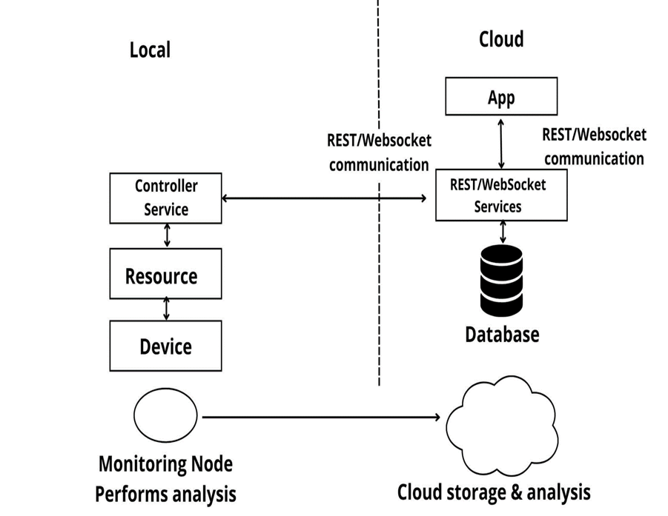

**CHAPTER 5**

**IMPLEMENTATION**

Initialization

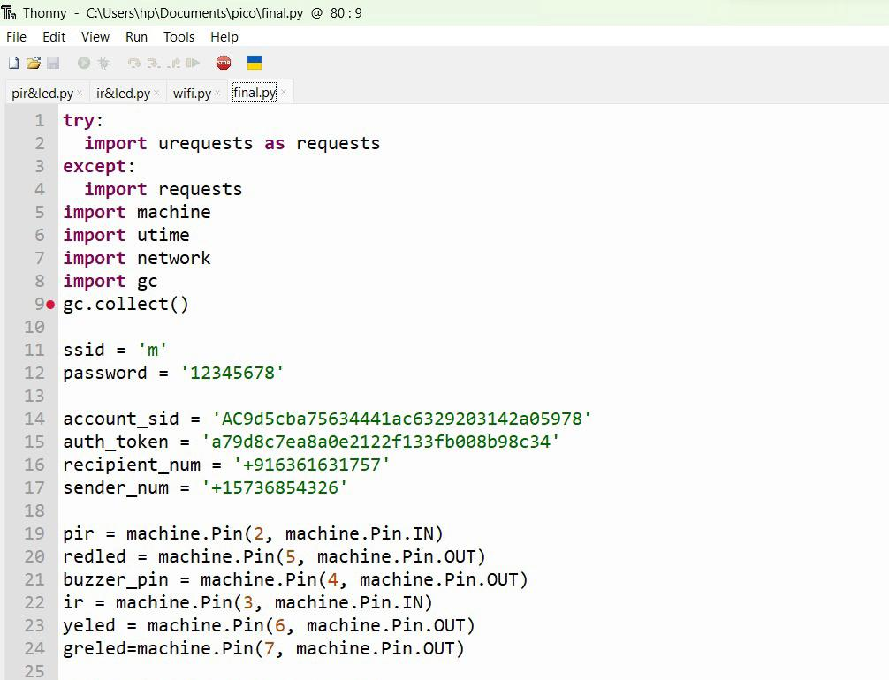

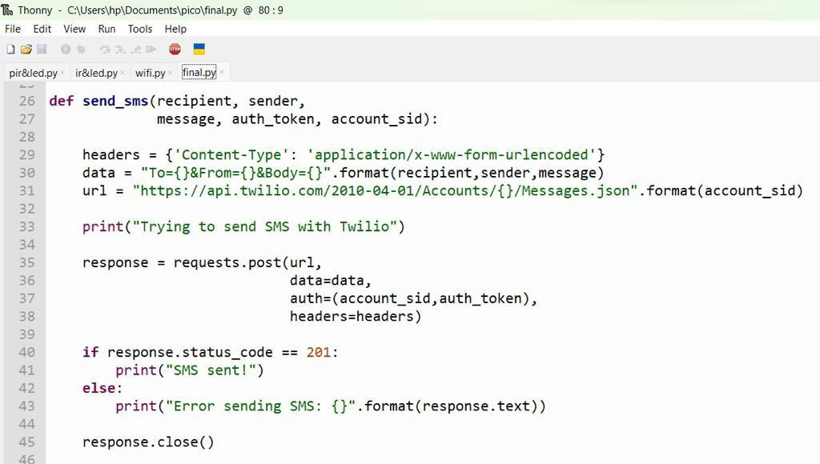Function to send sms to phone

Function to connect to Wi-Fi network

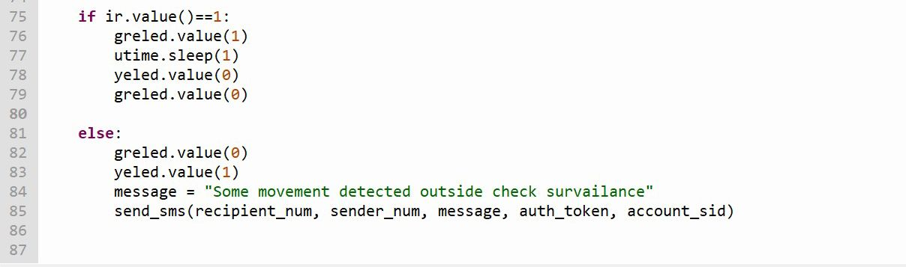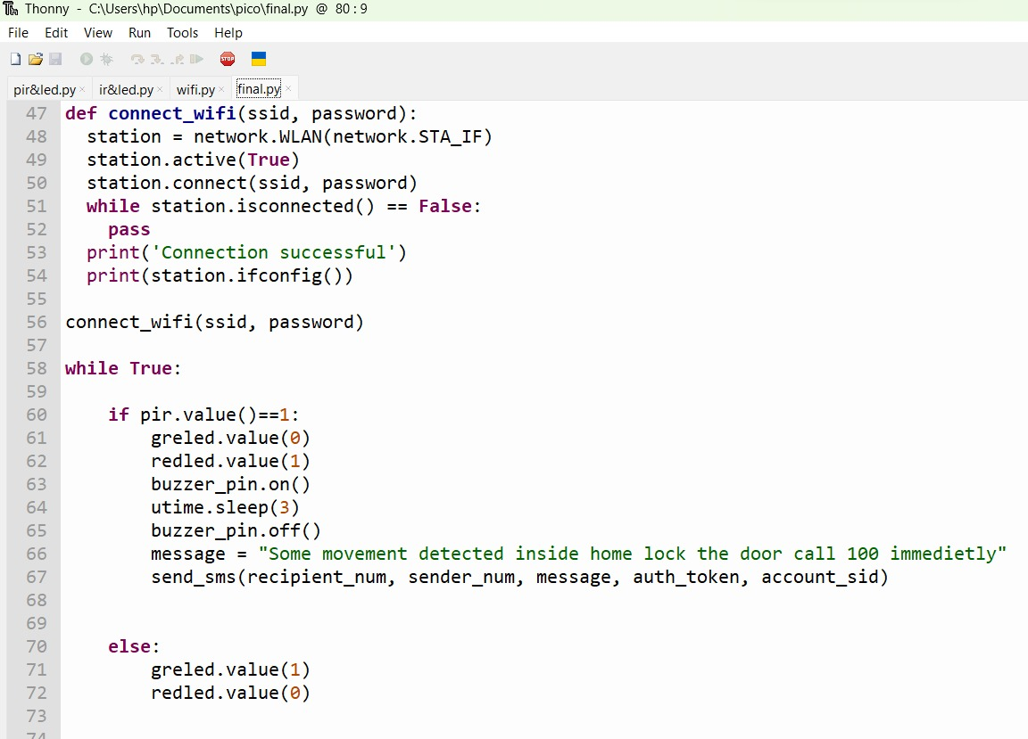

**CHAPTER 6**

**SNAPSHOTS**

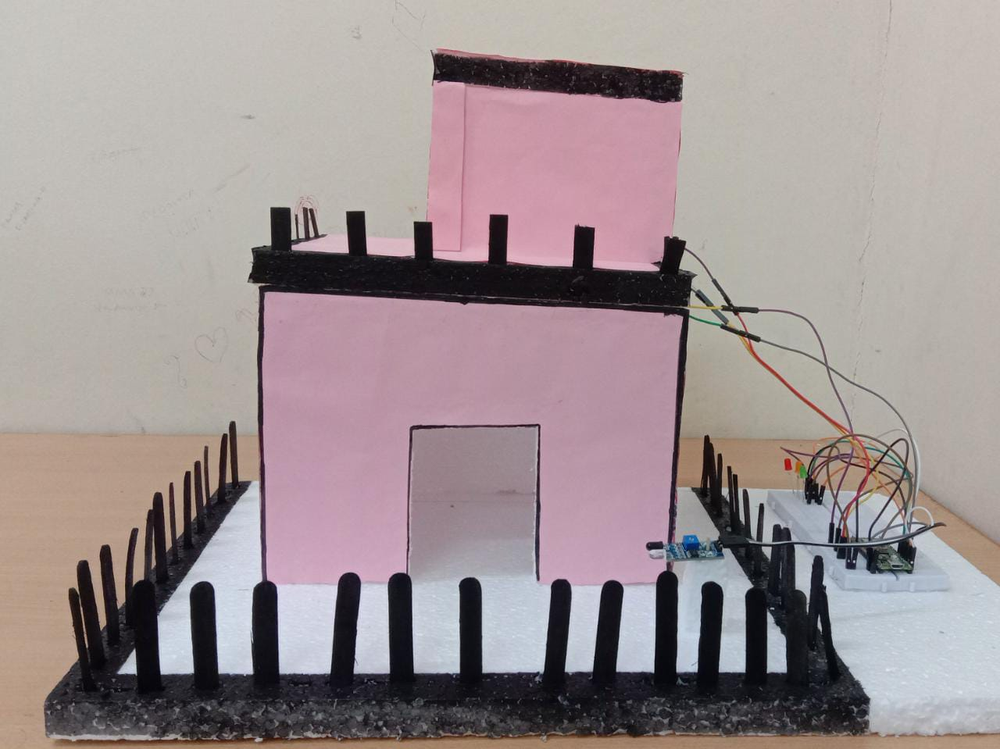

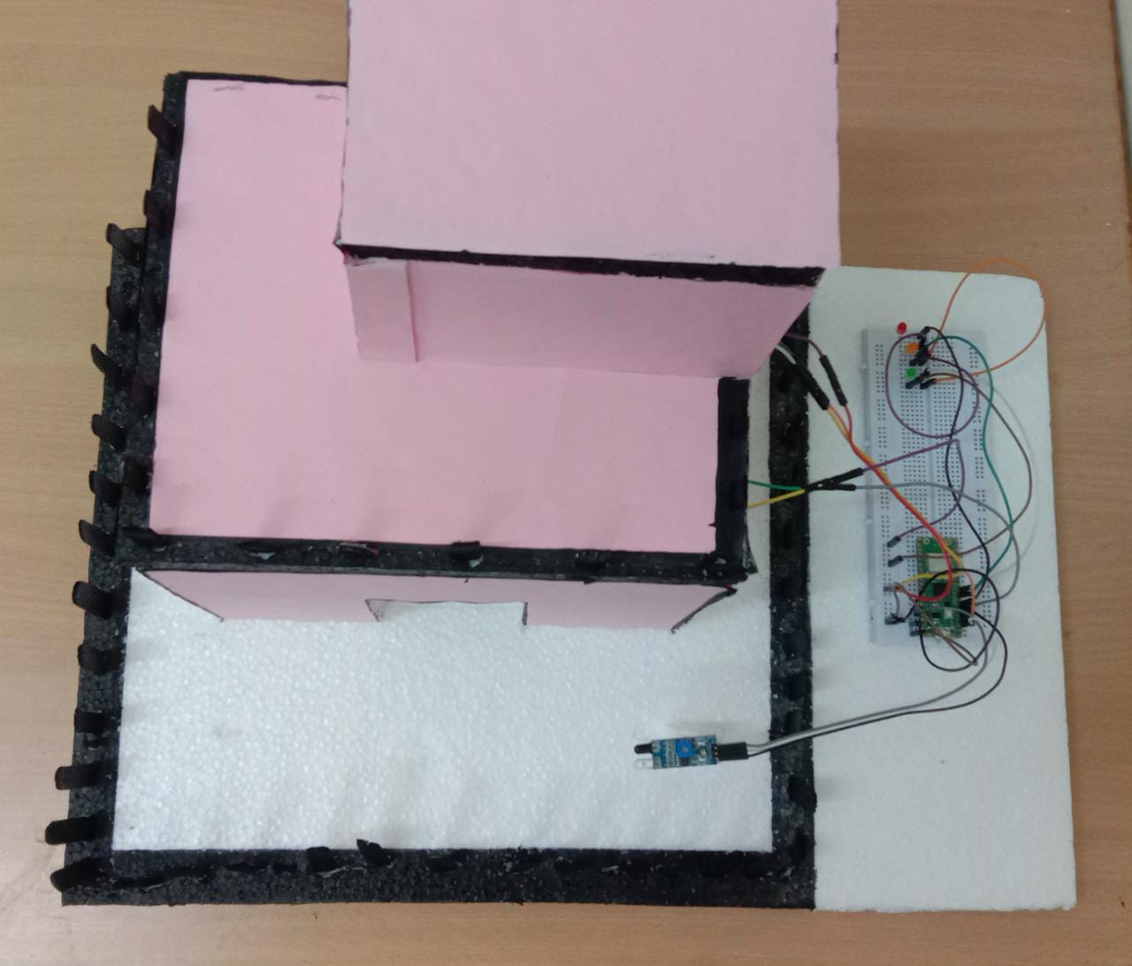

**CHAPTER 7**

**TEST CASES**

**CASE 1:**

The green LED serves as a visual indicator to show that the house is safe i.e no intruders detected

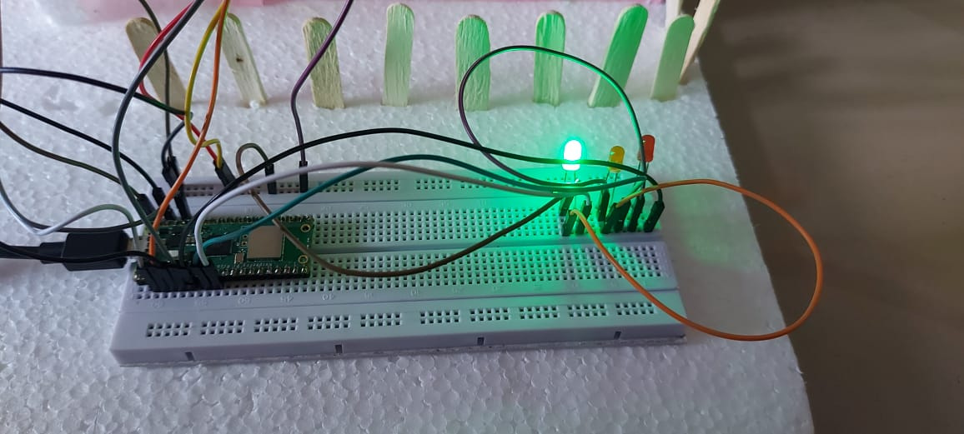

**CASE 2:**

The yellow LED serves as a visual indicator to show that the system has detected some movement outside the house and alert the home owner by sending message through sms

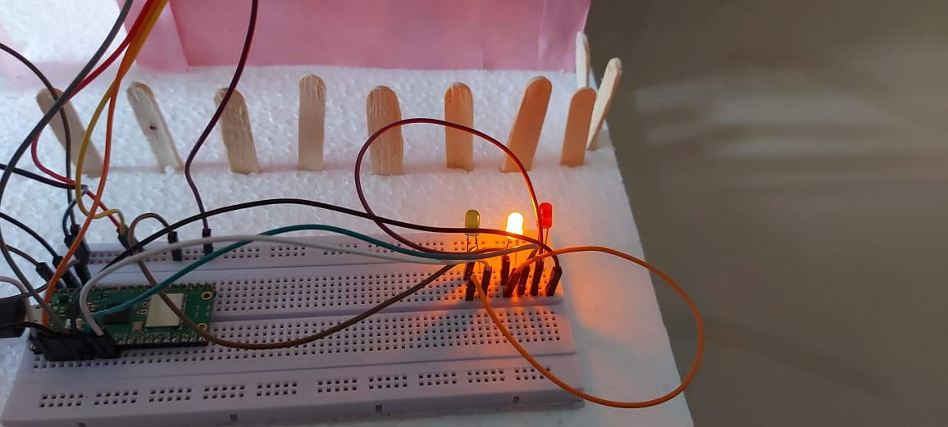

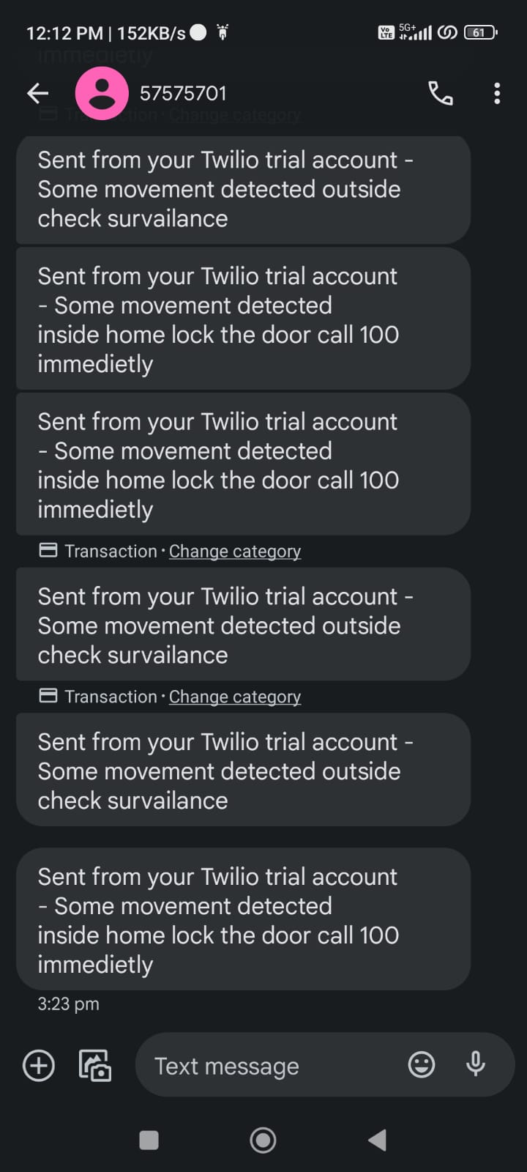

**CASE 3:**

The red LED comes into play when the system detects that intruders have managed to breach the security and entered the house. The message will be sent to home owner through sms and and the buzzer will be played for at least 15 sec before it detects some other movement

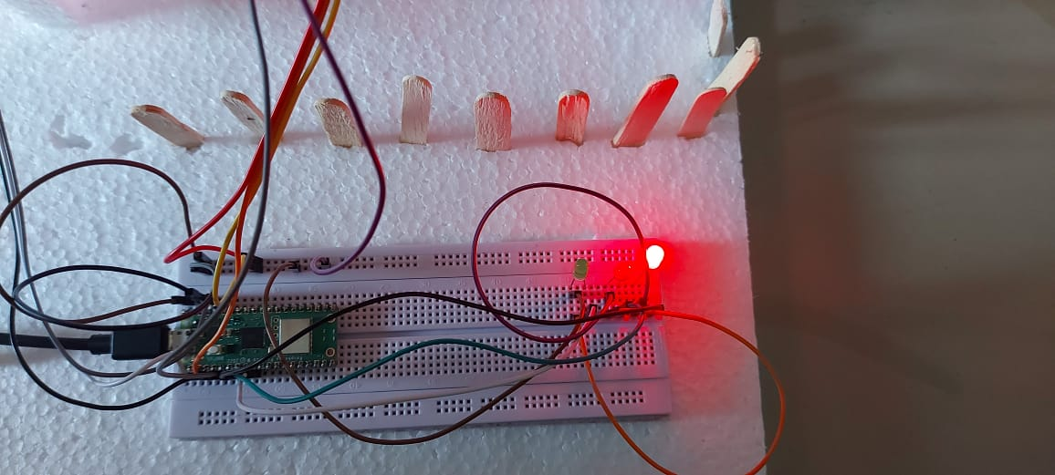



**CHAPTER 7**

**CONCLUSION**

The IoT-based Anti-Theft Alarm System represents a groundbreaking leap in security technology, paving the way for a safer and more connected world. Through the seamless integration of Internet of Things (IoT) devices, cloud communication, and smart sensors, this innovative solution offers a proactive and robust defense against unauthorized access and potential theft.

With motion sensors, door/window sensors, cameras, and sirens working in tandem, the system acts as an intelligent watchdog, instantly detecting suspicious activities and alerting users in real-time. Its cloud connectivity enables remote monitoring and control, empowering users to stay informed and take immediate action, even when far from their premises.

The system's scalability allows for effortless customization, catering to the unique security needs of residential, commercial, and industrial settings. Not only does it enhance security, but it also offers cost-effectiveness in installation, maintenance, and expansion compared to traditional security systems.

As IoT continues to shape the future of security, the IoT-based Anti-Theft Alarm System stands as a testament to the transformative power of connected technology. It empowers individuals, businesses, and industries alike with a proactive and modern approach to security, safeguarding their assets and ensuring peace of mind.

In an increasingly interconnected world, the IoT-based Anti-Theft Alarm System stands as a beacon of innovation and safety, paving the way towards a secure and smart future. As technology advances further, its impact on security solutions will undoubtedly continue to redefine our notion of safety and fortify our world against potential threats.

**CHAPTER 8**

**BIBLIOGRAPHY**

* Rani, T. P., Susila Sakthy, P. Kalaichelvi, T. Vignesh, and M. Priyadharshan. "Home Security and Anti-Theft System." In 2022 1st International Conference on Computational Science and Technology (ICCST), pp. 130-133. IEEE, 2022.
* Singh, Akanksha, Arijit Pal, and Bijay Rai. "GSM based home automation, safety and security system using android mobile phone." International Journal of Engineering Research & Technology (IJERT) 4.05 (2015).
* Kodali, Ravi Kishore, et al. "IoT based smart security and home automation system." 2016 international conference on computing, communication and automation (ICCCA). IEEE, 2016.
* Brundha, S. M., P. Lakshmi, and S. Santhanalakshmi. "Home automation in client-server approach with user notification along with efficient security alerting system." 2017 international conference on smart technologies for smart nation (SmartTechCon). IEEE, 2017.
* Lulla, Gurusha, Abhinav Kumar, Govind Pole, and Gopal Deshmukh. "IoT based smart security and surveillance system." In 2021 international conference on emerging smart computing and informatics (ESCI), pp. 385-390. IEEE, 2021.