EV Segmentation

Mehul Pandey

Market Segmentation:

The transition to electric vehicles (EVs) is a pivotal step towards sustainable transportation in India, driven by environmental concerns and government incentives. Understanding the market segmentation of EV vehicles can provide crucial insights into regional adoption patterns and inform strategic decisions for stakeholders. This report delves into the segmentation analysis of the Indian EV market, examining state-wise data to discern usage patterns and identify opportunities for further penetration.

Market segmentation are usually of 4 types:

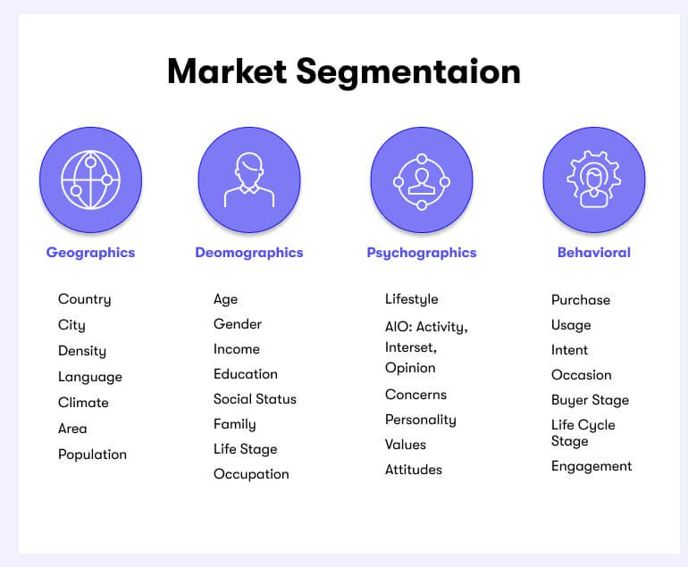

The market segmentation done in my project is based on geographic market segmentation where we have segmented the EV dataset of different region in India on the basis of probability of the usage of EV in each state

The process of market segmentation involves several steps:

* **Identifying Segmentation Variables:**

This involves determining the criteria or variables by which the market will be segmented. These variables could include demographics (age, gender, income, occupation), psychographics (lifestyle, values, attitudes), geographic location, behavior (usage patterns, brand loyalty), or other factors relevant to the specific industry or product.

* **Segmenting the Market:**

Once the segmentation variables are identified, the market is divided into distinct segments based on these variables. Each segment should be homogeneous within itself (i.e., similar characteristics) and heterogeneous between segments (i.e., different from other segments).

* **Targeting Segments:**

After segmentation, the next step is to evaluate and select which segments to target. This involves assessing the attractiveness of each segment based on factors such as size, growth potential, profitability, and compatibility with the company's resources and objectives.

* **Positioning:**

Once target segments are identified, companies must develop a unique positioning strategy for each segment. Positioning involves creating a distinct perception of the company's products or brand in the minds of consumers within each segment, highlighting the specific benefits or value propositions that are most relevant to them.

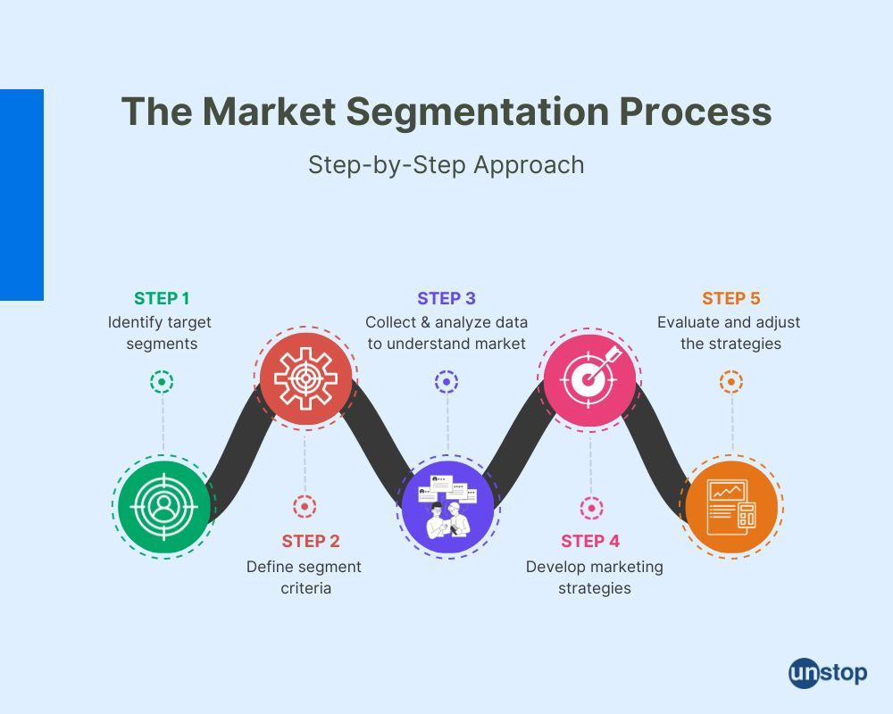

Dataset Overview:

The dataset contains detailed attributes of electric vehicle models, including brand, model name, acceleration time, top speed, driving range, energy efficiency, charging capabilities, powertrain type, plug type, body style, segment classification, seating capacity, and price in Euros.

Methodology:

Step1: Load data

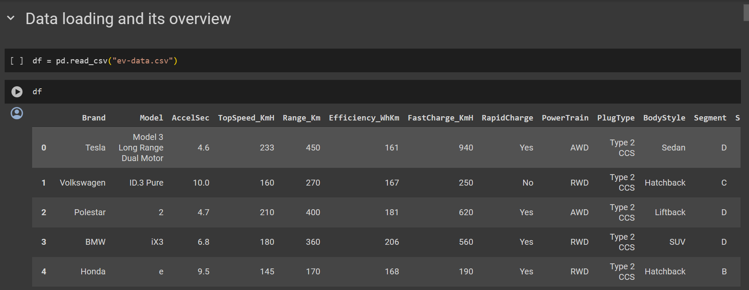

Step2: EDA

Price VS Brand

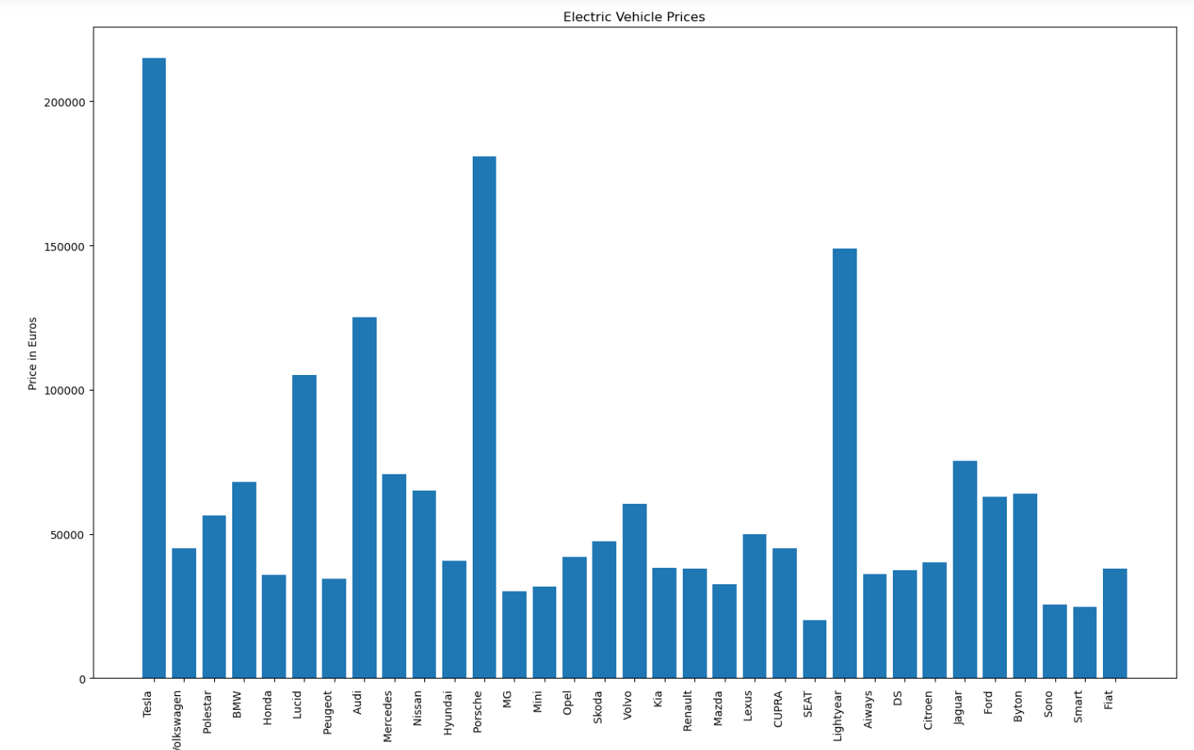

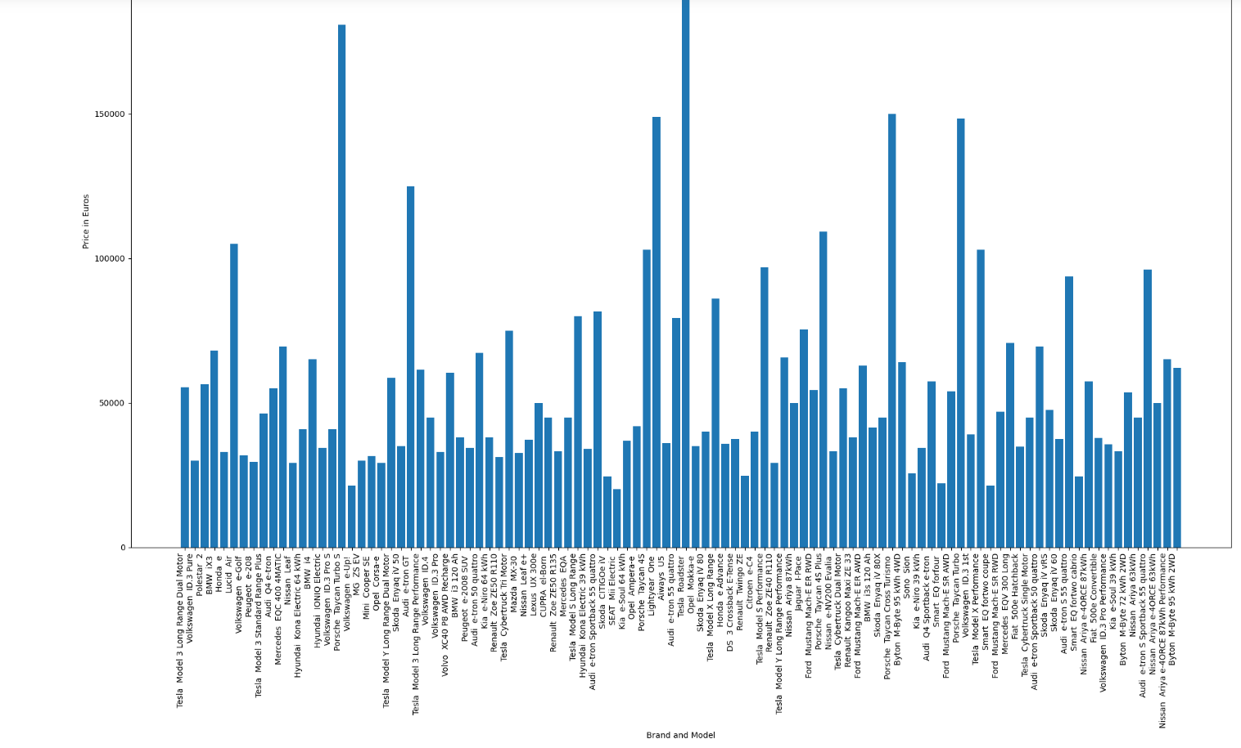

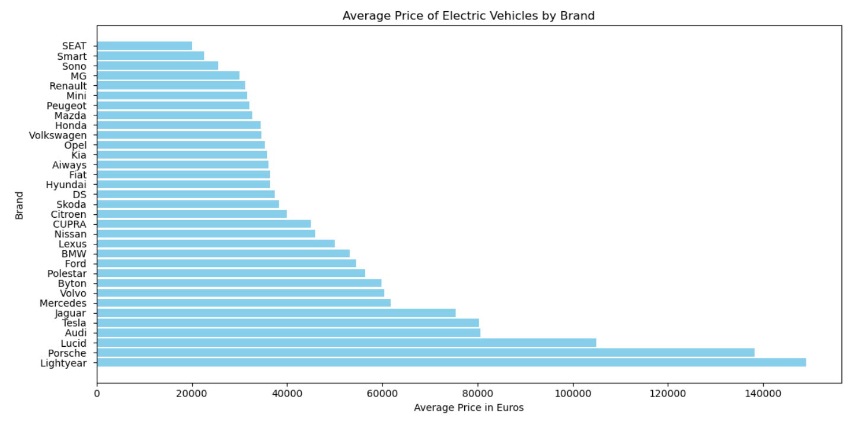

Energy efficiency vs EV Models

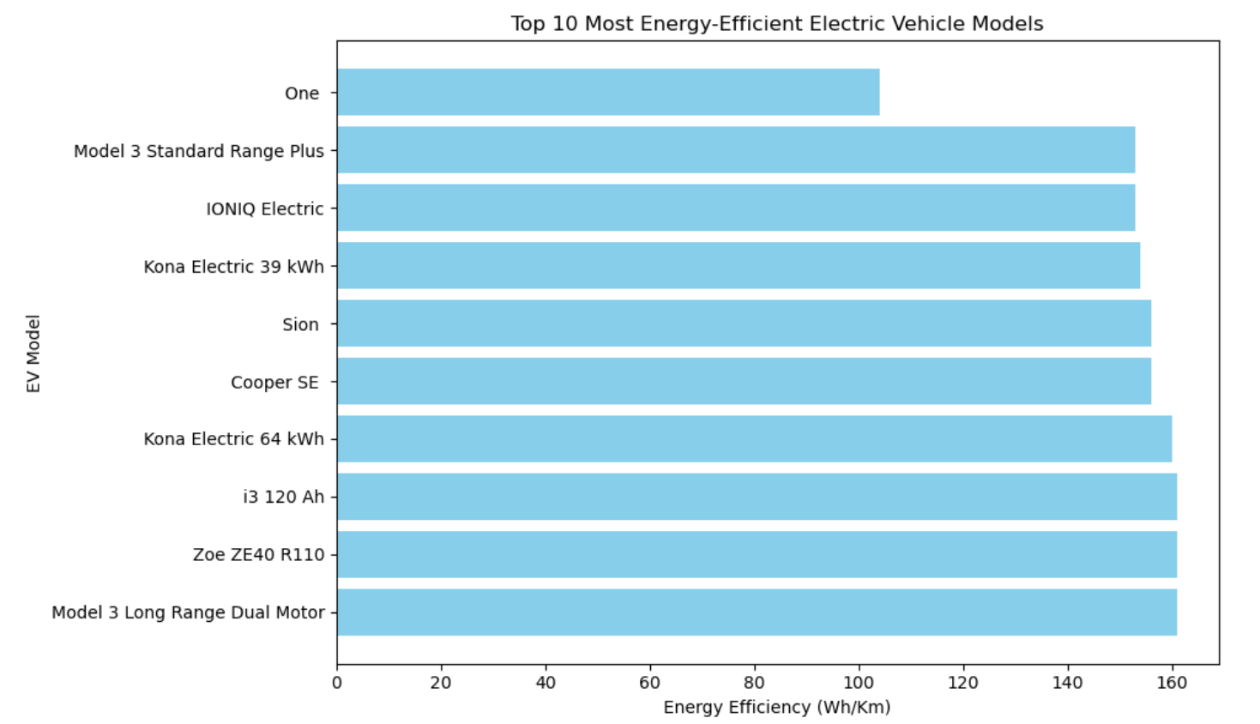

STEP 3: Data segmentation based on Price, Range, Models, Powertrain Type & Plug Type

Segmentation on the basis of Range

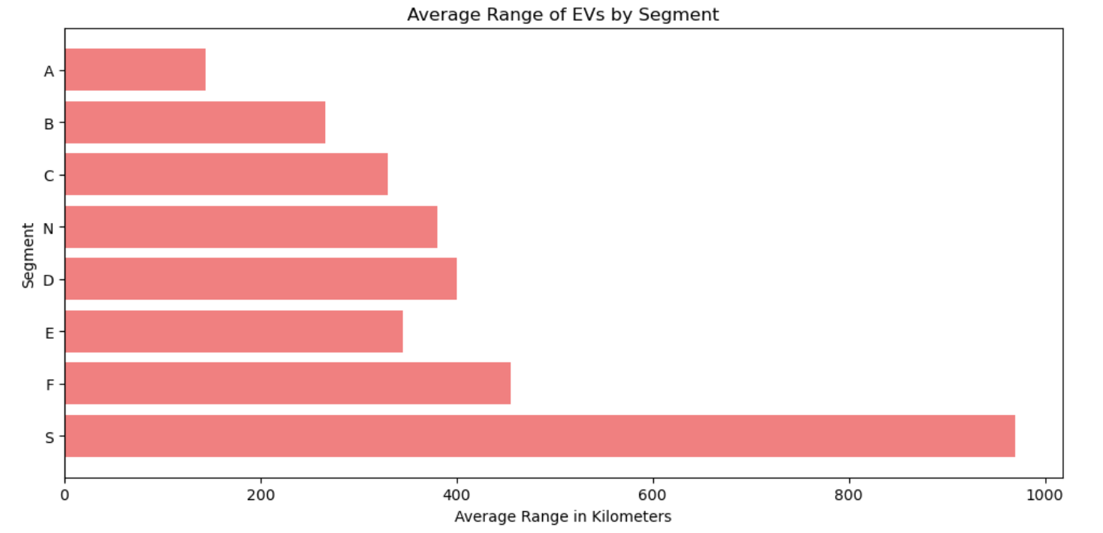

Segmentation on the basis of models:

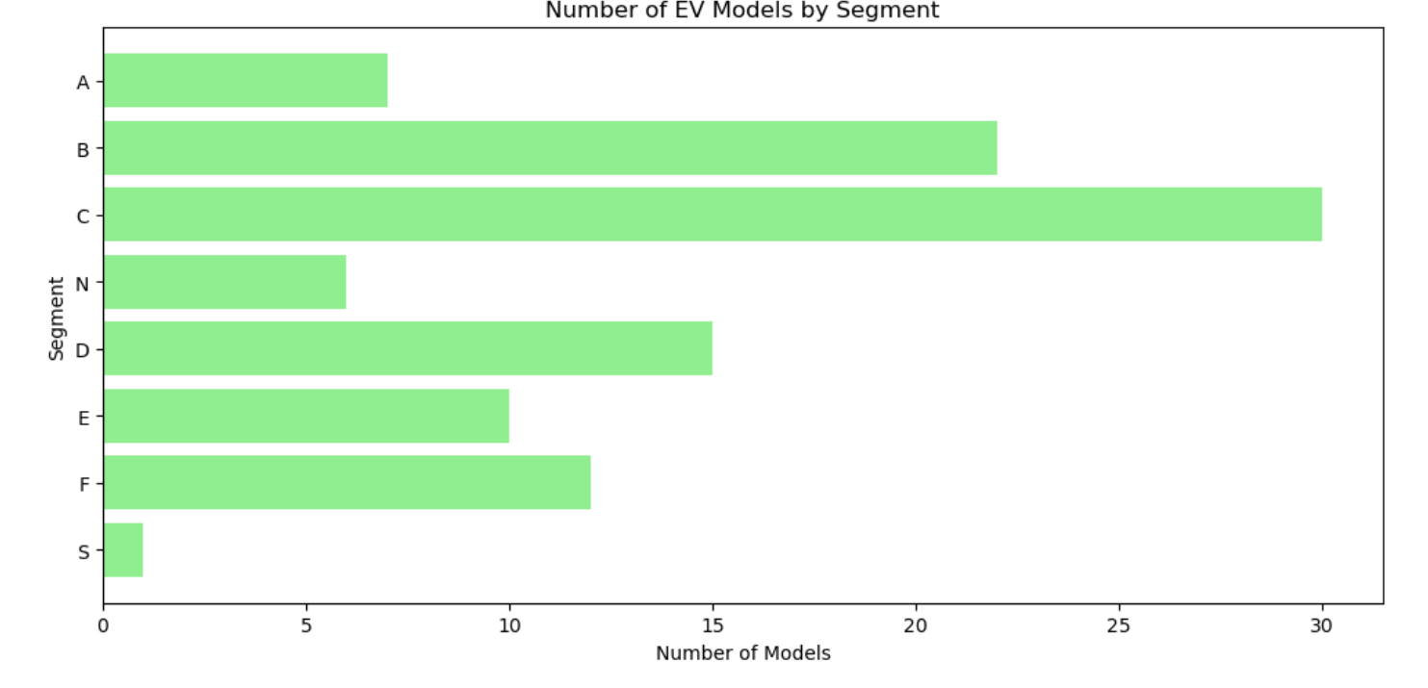

Segmentation on the basis of Price:

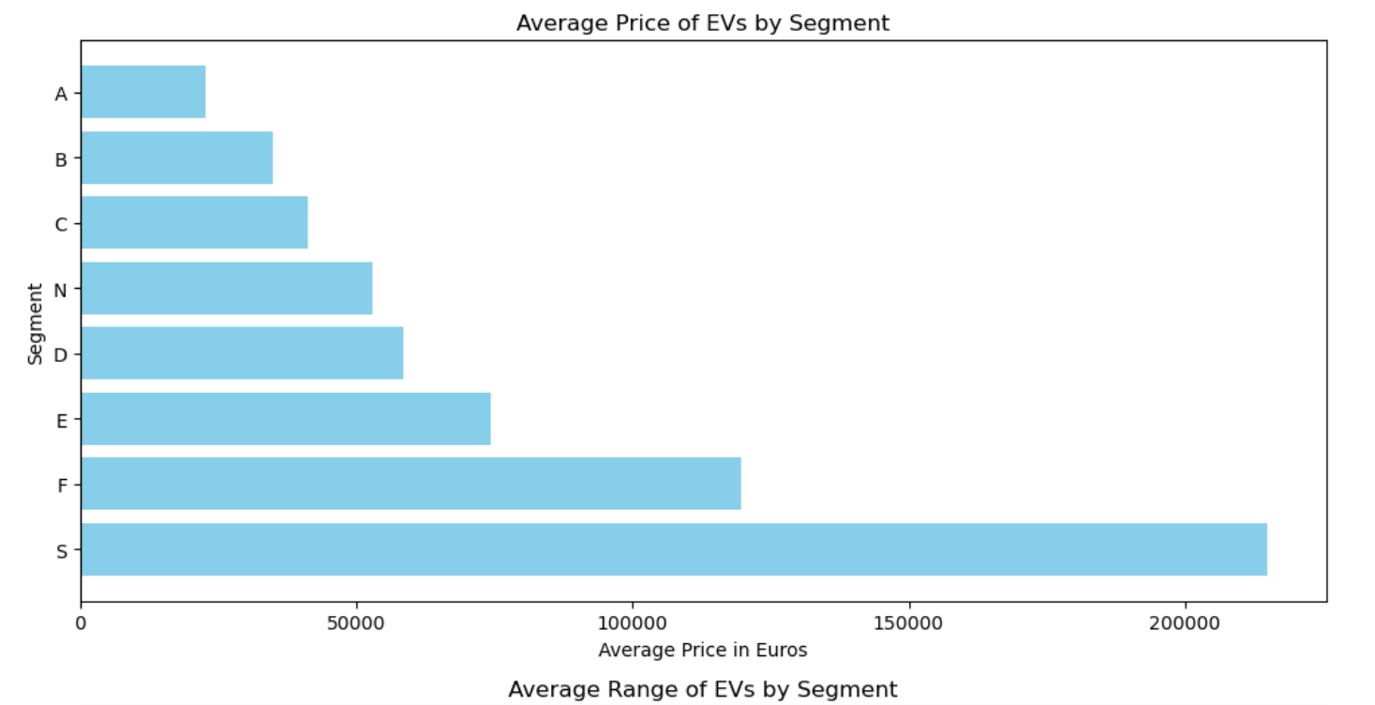

Distribution on the basis of power train type and plug type:

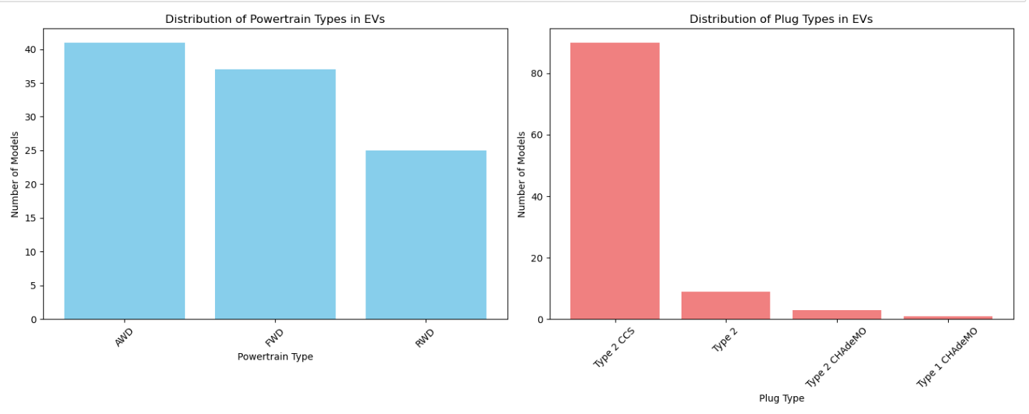STEP 4: K- Mean modeling:

Generation of the value of K from Elbow method:

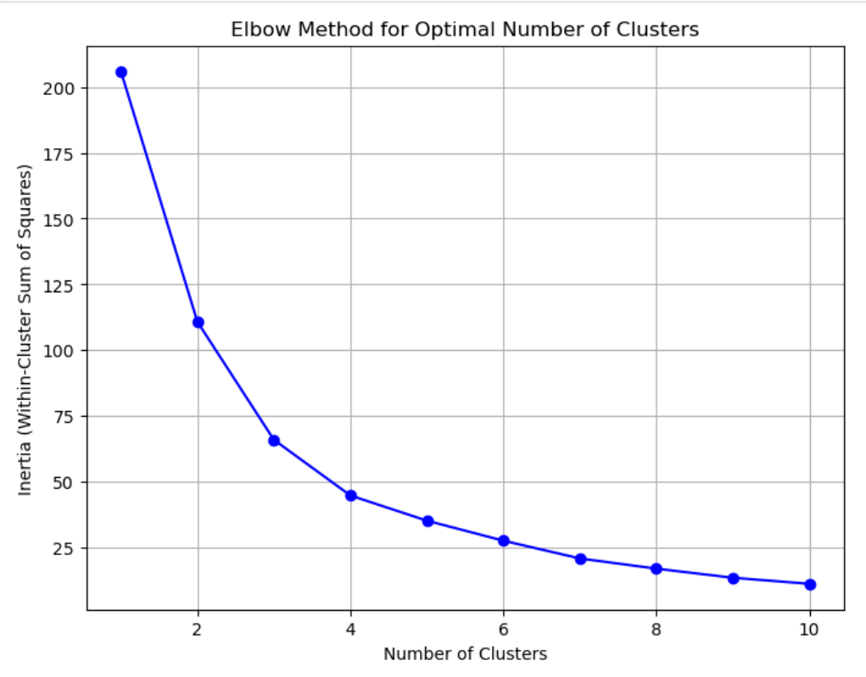

From the above graph we can say that the value of k can be 3 or 4. For the model generated in this project the value of k is taken to be as 3.

Plot after doing k mean clustering:

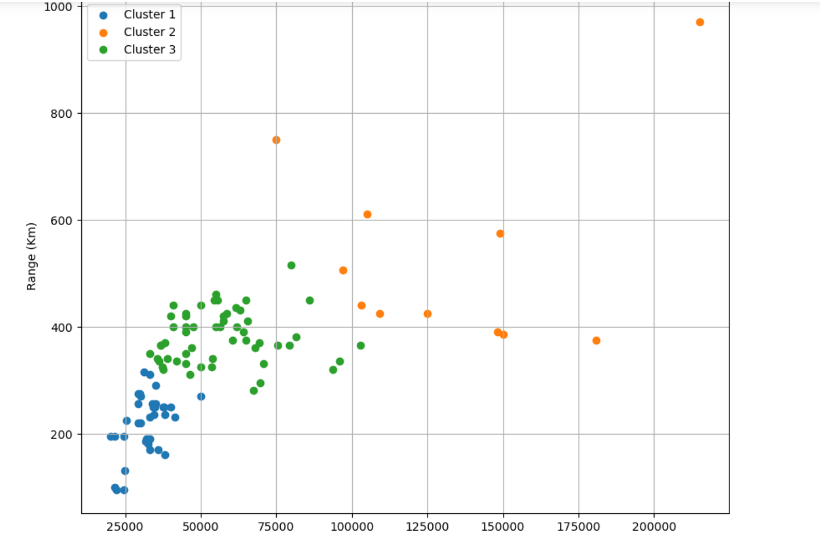

STEP 5: Final Plot for Market share of segmented data:

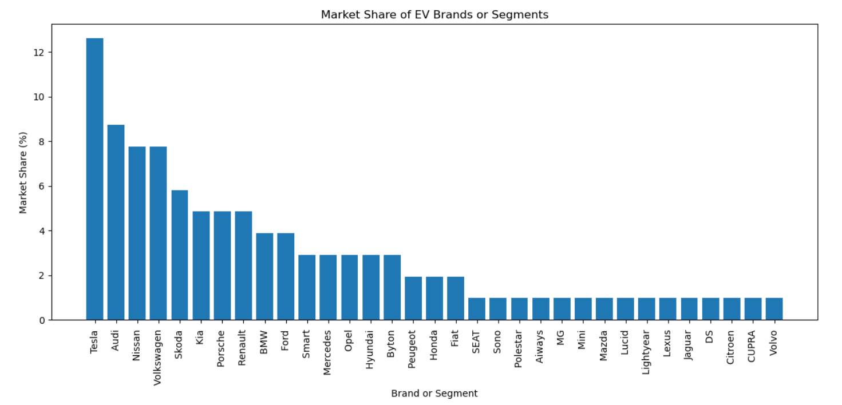

Potential Analyses and Insights:

1. **Price Comparison:**
   1. Analysis: Average prices of EVs across different brands were compared.
   2. Insight: Identified brands offering more affordable or premium models, aiding consumers in making informed purchasing decisions and manufacturers in understanding competitive pricing strategies.
2. **Efficiency Analysis:**
   1. Analysis: Evaluated the energy efficiency (Efficiency_WhKm) of EVs.
   2. Insight: Identified the most efficient models in terms of energy consumption, guiding consumers towards environmentally friendly options and manufacturers in improving energy efficiency.
3. **Range vs. Price:**
   1. Analysis: Explored the relationship between driving range (Range_Km) and price.
   2. Insight: Examined whether higher-priced models generally offer longer ranges, enabling consumers to assess the value proposition of EVs based on range and price considerations.
4. **Charging Capabilities:**
   1. Analysis: Examined the availability of fast charging and rapid charging options.
   2. Insight: Identified the convenience and accessibility of charging infrastructure, informing consumers about charging options and guiding manufacturers in prioritizing charging infrastructure development.
5. **Segment Analysis:**
   1. Analysis: Grouped EVs by market segment (Segment) and analyzed differences in prices, ranges, and features.
   2. Insight: Provided insights into consumer preferences within different market segments (e.g., SUVs vs. Sedans), guiding manufacturers in aligning product offerings with market demand.
6. **Powertrain and Plug Type:**
   1. Analysis: Investigated the popularity of different powertrain types and plug types among EVs.
   2. Insight: Informed manufacturers about technological preferences and infrastructure compatibility, guiding product development and charging infrastructure investments.
7. **Market Share Analysis:**
   1. Analysis: Examined the market share of different brands or segments within the EV market over time.
   2. Insight: Identified market leaders and trends, enabling stakeholders to understand competitive dynamics and anticipate future developments.

Conclusion:

The market segmentation analysis of electric vehicles provides valuable insights into consumer preferences, market trends, and competitive dynamics. These insights empower consumers to make informed choices, guide manufacturers in refining their offerings, and assist policymakers in supporting sustainable transportation initiatives. By leveraging the findings of market segmentation, stakeholders can contribute to the growth and advancement of the electric vehicle industry while addressing environmental concerns and promoting sustainable mobility solutions.