EV Segmentation

Mehul Pandey

Market Segmentation:

The transition to electric vehicles (EVs) is a pivotal step towards sustainable transportation in India, driven by environmental concerns and government incentives. Understanding the market segmentation of EV vehicles can provide crucial insights into regional adoption patterns and inform strategic decisions for stakeholders. This report delves into the segmentation analysis of the Indian EV market, examining state-wise data to discern usage patterns and identify opportunities for further penetration.

Market segmentation are usually of 4 types:

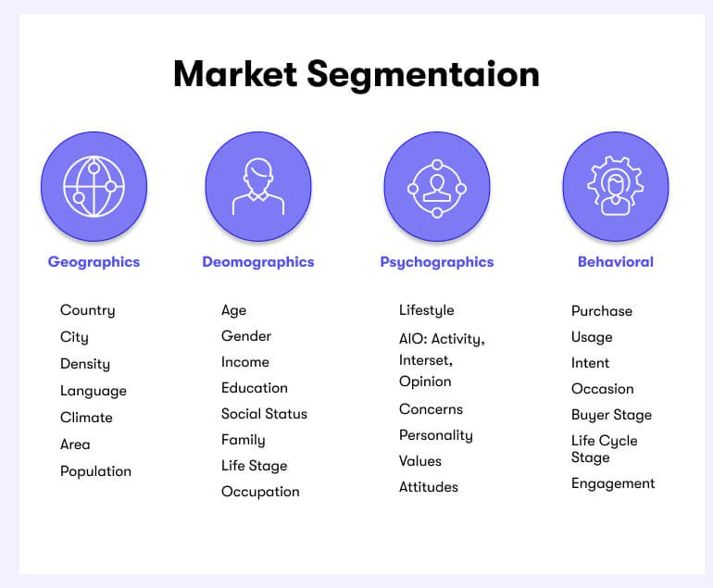

The market segmentation done in my project is based on geographic market segmentation where we have segmented the EV dataset of different region in India on the basis of probability of the usage of EV in each state

The process of market segmentation involves several steps:

* **Identifying Segmentation Variables:**

This involves determining the criteria or variables by which the market will be segmented. These variables could include demographics (age, gender, income, occupation), psychographics (lifestyle, values, attitudes), geographic location, behavior (usage patterns, brand loyalty), or other factors relevant to the specific industry or product.

* **Segmenting the Market:**

Once the segmentation variables are identified, the market is divided into distinct segments based on these variables. Each segment should be homogeneous within itself (i.e., similar characteristics) and heterogeneous between segments (i.e., different from other segments).

* **Targeting Segments:**

After segmentation, the next step is to evaluate and select which segments to target. This involves assessing the attractiveness of each segment based on factors such as size, growth potential, profitability, and compatibility with the company's resources and objectives.

* **Positioning:**

Once target segments are identified, companies must develop a unique positioning strategy for each segment. Positioning involves creating a distinct perception of the company's products or brand in the minds of consumers within each segment, highlighting the specific benefits or value propositions that are most relevant to them.

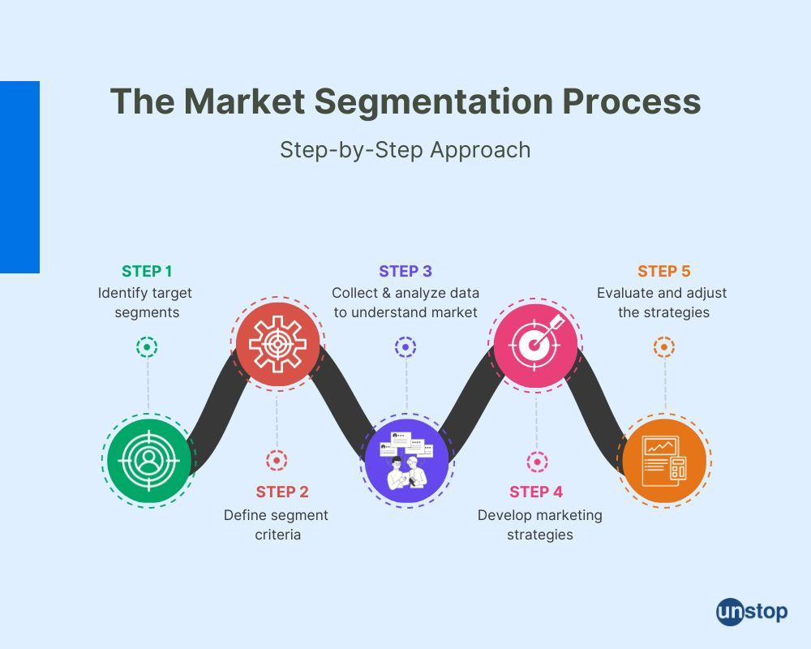

Methodology:

The segmentation analysis involved categorizing states based on the number of electric vehicles, using a threshold percentage of 0.03% to delineate between regions with varying degrees of EV adoption. Additionally, the presence of non-electric vehicles was considered to provide a comprehensive perspective on market dynamics and preferences.

Step1: Data importing

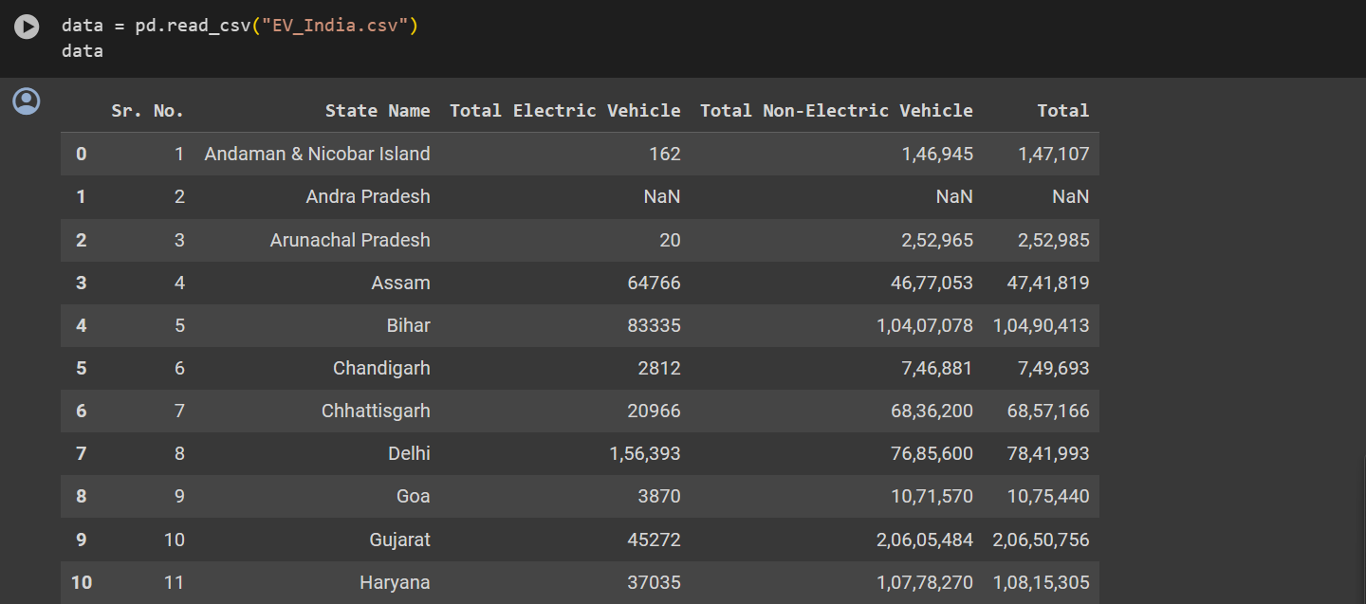

Step 2: Handling missing values



Step 3: Generating percentage of EV in every state

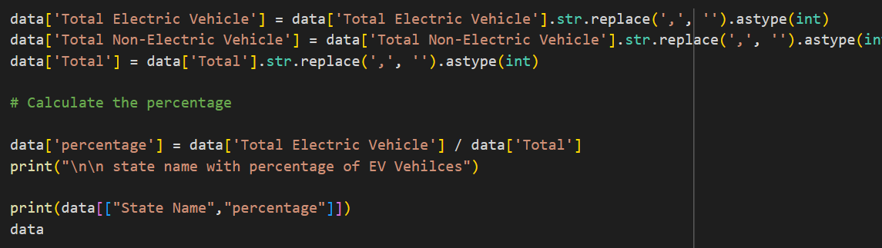

Step 4: Fixing a threshold value for segmenting states on the basis of percentage of EVs

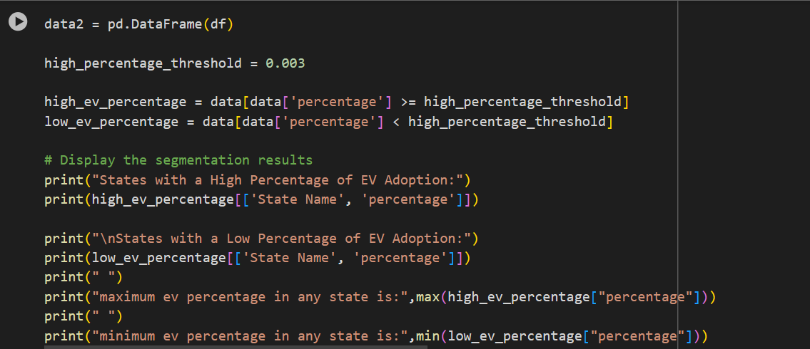

Step 5: Plotting graphs on the basis of segmentation done

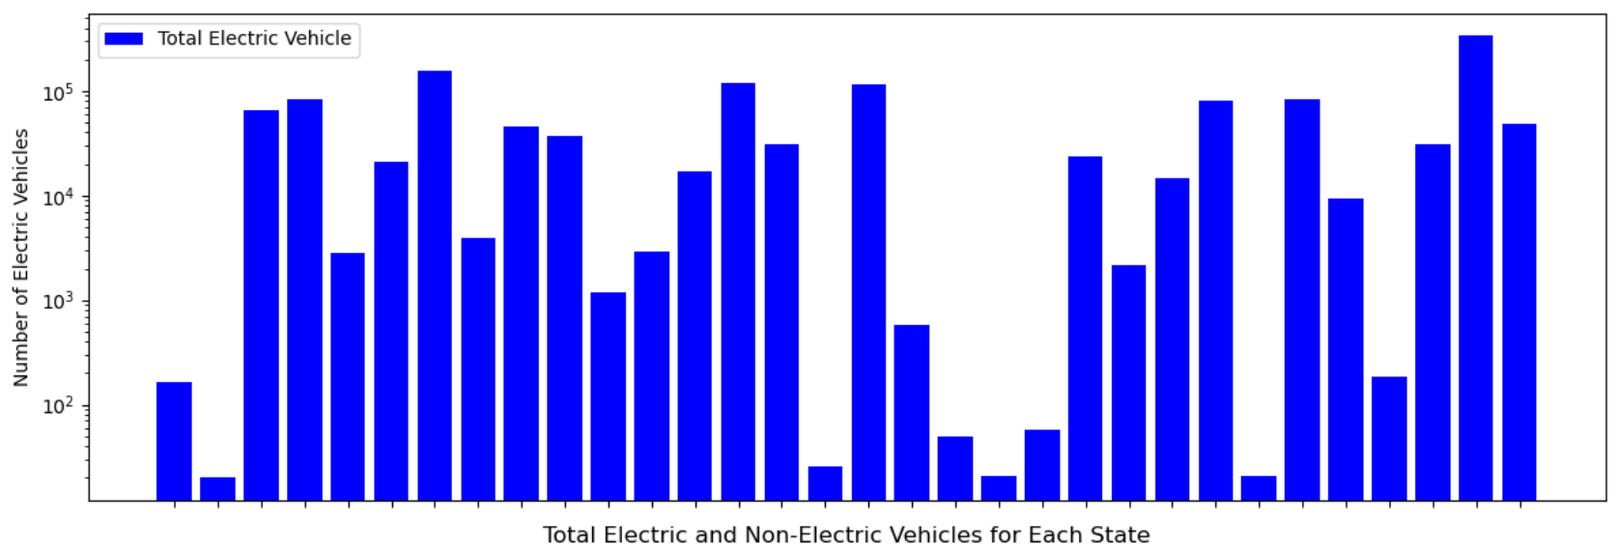

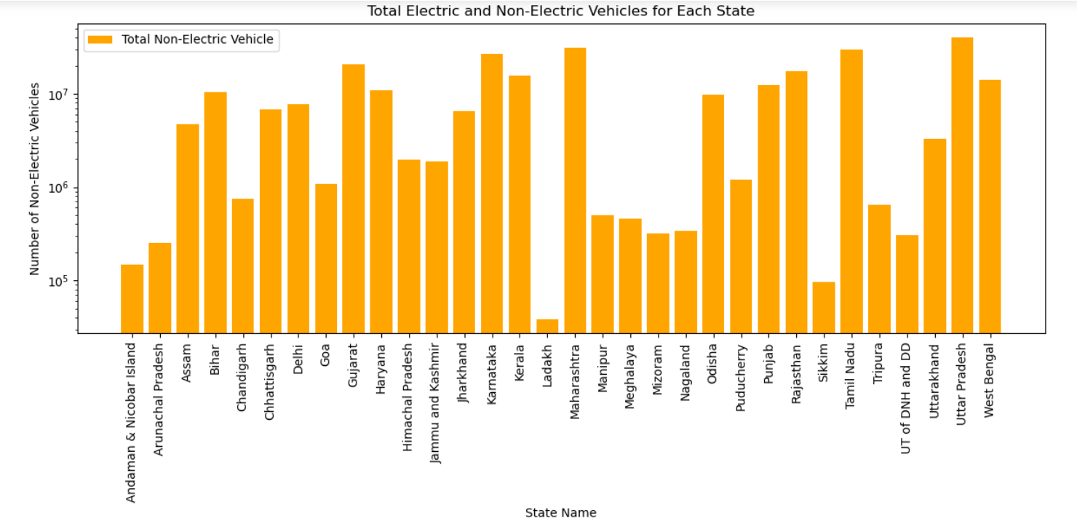

Findings:

**States with Higher EV Usage**:

Uttar Pradesh emerges as the leader in EV adoption, boasting the highest number of electric vehicles (3,37,180). It is followed closely by Delhi (1,56,393), Karnataka (1,20,532), Maharashtra (1,16,646), and Bihar (83,335). These states exhibit robust EV usage, indicating favorable conditions for electric mobility initiatives and suggesting a growing acceptance of EVs among consumers.

**States with Lower EV Usage:**

On the opposite end of the spectrum, states like Arunachal Pradesh, Sikkim, and Mizoram register the lowest number of electric vehicles, with Ladakh and Meghalaya trailing behind. These regions display comparatively lower rates of EV adoption, highlighting potential areas for targeted interventions such as infrastructure development and awareness campaigns to spur electric mobility.

**States with Lower EV Usage but Higher Non-EV Usage:**

Mizoram, Arunachal Pradesh, and Meghalaya exhibit a disparity between EV and non-EV usage, indicating a prevalent reliance on conventional vehicles despite lower EV adoption rates. This presents an opportunity for implementing policies and incentives to incentivize the transition towards electric vehicles and mitigate environmental impacts associated with traditional automobiles.

**States with Higher EV Usage and Lower Non-EV Usage:**

Notably, Delhi showcases higher EV usage coupled with lower non-EV usage, signaling a strong preference for sustainable transportation solutions in the region. Similarly, Tripura, Uttar Pradesh, and Karnataka also demonstrate a shift towards EV adoption, indicating a gradual transition away from fossil fuel-dependent vehicles.

**States with Balanced EV and Non-EV Usage:**

States like Assam, Gujarat, Haryana, Kerala, Odisha, Punjab, and West Bengal exhibit a balanced distribution of electric and non-electric vehicles. These regions present opportunities for promoting a diverse mix of transportation options, catering to varying consumer preferences while promoting sustainable mobility practices.

**States with Missing Data:**

Some states, including Andhra Pradesh, Lakshadweep, Madhya Pradesh, and Telangana, have incomplete data on both electric and non-electric vehicles. Addressing this data gap is crucial for accurately assessing market segmentation and formulating targeted strategies for EV adoption in these regions.

Conclusion:

The segmentation analysis sheds light on the heterogeneous nature of the Indian EV market, with distinct usage patterns observed across different states. By leveraging these insights, stakeholders can devise tailored strategies to accelerate EV adoption, address regional disparities, and foster a transition towards sustainable transportation systems nationwide. Effective policy measures, coupled with infrastructure development and awareness campaigns, are essential for driving widespread adoption of electric vehicles and realizing India's vision for a greener, cleaner future.