What is software?

Software is a set of instructions, data or programs used to operate computers and execute specific tasks. It is the opposite of hardware, which describes the physical aspects of a computer

What is software engineering?

Software engineering is the process of developing, testing and deploying computer applications to solve real-world problems by adhering to a set of engineering principles and best practices.

What are the types of software explain?

> Application software. The most common type of software, application software is a computer software package that performs a specific function for a user, or in some cases, for another > > > > > application. ...

> System software. ...

> Driver software. ...

> Middleware. ...

> Programming software

What is SDLC ? Explain each phases of SDLC?

An SDLC (software development life cycle) is a big-picture breakdown of all the steps involved in software creation (planning, coding, testing, deploying, etc.). Companies define custom SDLCs to create a predictable, iterative framework that guides the team through all major stages of development.

The 7 Phases of the Software Development Life Cycle

1 Planning & Analysis. The first phase of the SDLC is the project planning stage where you are gathering business requirements from your client or stakeholders. ...

2 Define Requirements. ...

3 Design. ...

4. Development. ...

5 Testing. ...

6 Deployment. ...

7 Maintenance

What is DFD ? Create a DFD diagram on flipkart .

A data flow diagram (DFD) is a graphical or visual representation using a standardized set of symbols and notations to describe a business's operations through data movement.

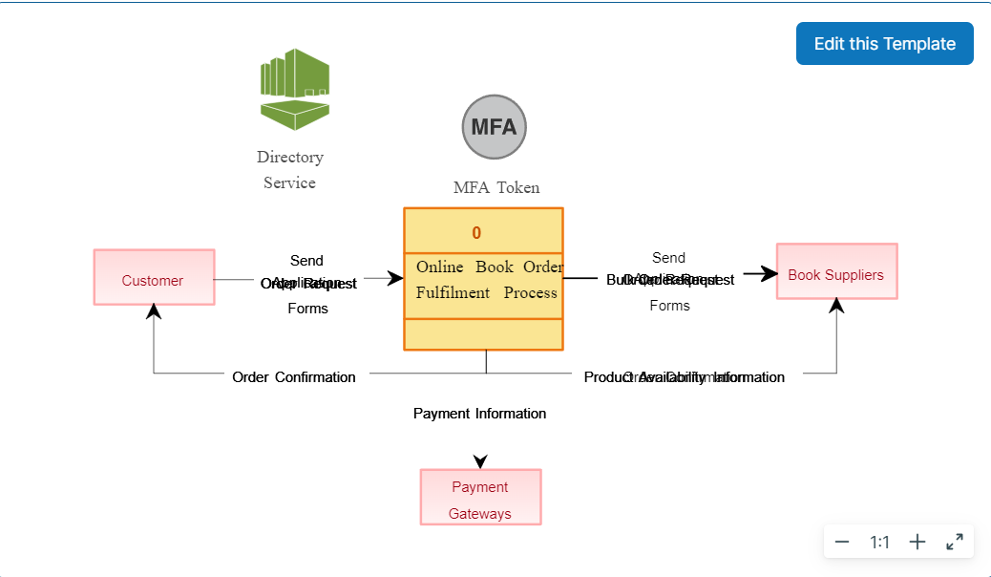

< What is Flow chart? Create a flowchart to make addition of two numbers.

A flowchart is a diagram that shows an overview of a program . Flowcharts normally use standard symbols to represent the different types of instructions . These symbols are used to construct the flowchart and show the step-by-step solution to the problem.

Algorithm:

Step 1: Start

Step 2: Declare variables num1, num2 and sum.

Step 3: Read values for num1, num2.

Step 4: Add num1 and num2 and assign the result to a variable sum.

Step 5: Display sum

Step 6: Stop

FLOWCHART :>

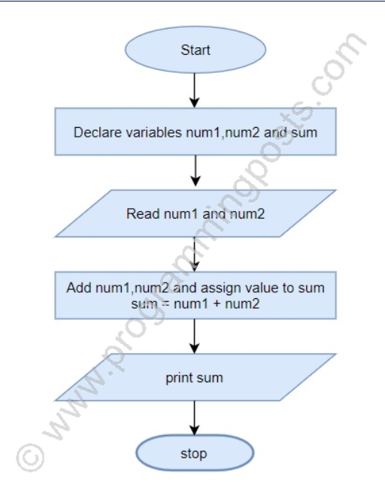

• What is Use case Diagram? Create a use-case on bill payment on paytm.

Identify the Actors (role of users) of the system.

For each category of users, identify all roles played by the users relevant to the system.

Identify what are the users required the system to be performed to achieve these goals.

Create use cases for every goal.

Structure the use cases.

