Primitive Types
These are immutable and not objects
Type | Example | typeof result | Notes
string | "Mehul" | "string" | Immutable
number | 42, 3.14 | "number" | NaN is also "number"
bigint | 123n | "bigint" | For very large integers
boolean | true, false | "boolean" | —
undefined | undefined | "undefined" | Default value of uninitialized variables
symbol | Symbol("id") | "symbol" | Unique identifier
null | null | "object" | Tricky! typeof null → "object" (historical bug)

Non-Primitive Types (Objects)
All other things are objects:
Type | Example | typeof result | Notes
Object | {a:1} | "object" | Plain object
Array | [1,2,3] | "object" | Use Array.isArray(arr) → true to distinguish
Function | function f(){} | "function" | Callable object, has properties
Date | new Date() | "object" | Use instanceof Date to check
RegExp | /abc/ | "object" | Use instanceof RegExp
Map/Set | new Map(), new Set() | "object" | Collection objects
Error | new Error("msg") | "object" | —

2. Tricky Points About JS Types
- null is "object"
typeof null; // "object" Historical bug, just remember null is a primitive but typeof reports "object".
- Arrays are objects
typeof []; // "object"
Array.isArray([]); // true
Arrays are a special kind of object, not a separate type in typeof.
- Functions are objects
typeof function(){}; // "function" Functions are callable objects, so they can have properties.
- NaN is a number
typeof NaN; // "number" Not a bug; JS defines NaN as a numeric type.
- Primitive wrapper objects
let str = "hello";
console.log(str.length); // 5
JS temporarily wraps primitives (string, number, boolean) as objects when you access properties.
- typeof vs instanceof
console.log([] instanceof Array); // true
console.log([] instanceof Object); // true
typeof only gives "object" or "function" for non-primitives.
instanceof checks the prototype chain, more precise.
QUESTION
1> let a;
console.log(typeof a);
console.log(typeof b);
Answer:
- typeof a → "undefined"
- typeof b → "undefined"
Why tricky: typeof does not throw an error for undeclared variables, unlike normal access.
2> let str1 = "hello";
let str2 = new String("hello");
console.log(typeof str1);
console.log(typeof str2);
console.log(str1 === str2);
Answer:
- typeof str1 → "string"
- typeof str2 → "object"
- str1 === str2 → false
Why tricky: new String() creates an object wrapper, not a primitive.
3> console.log(typeof 0); // "number"
console.log(typeof false); // "boolean"
console.log(typeof ""); // "string"
They are primitive types but falsy values.
4> let sym = Symbol("id");
console.log(typeof sym);
Answer: "symbol"
Why tricky: Symbols are new in ES6 and are a primitive, not an object.
5> console.log(Object.prototype.toString.call([]));
console.log(Object.prototype.toString.call({}));
console.log(Object.prototype.toString.call(null));
Answer:
- [] → "[object Array]"
- {} → "[object Object]"
- null → "[object Null]"
Why tricky: Object.prototype.toString gives a more precise type than typeof.
6> console.log(typeof function(){} === "object");
Answer: false
Why tricky: typeof returns "function" for functions, even though functions are technically objects.
Hoisting
Key points:
- Only declarations are hoisted, not initializations.
- Works for variables (var) and functions.
- let and const are hoisted but are in a temporal dead zone (TDZ).
-> var Hoisting
console.log(a); // undefined
var a = 5;
console.log(a); // 5
var a; is hoisted to the top → undefined
- Initialization = 5 stays in place.
Tricky point: Accessing a var before declaration does not throw error, just gives undefined.
-> let and const Hoisting
console.log(b); // ReferenceError
let b = 10;
console.log(c); // ReferenceError
const c = 20;

Declarations are hoisted, but variables are in temporal dead zone until initialized.
Accessing them before declaration throws ReferenceError.

-> Function Declaration Hoisting
sayHello(); // "Hello!"
function sayHello() {
console.log("Hello!");
}
Function declarations are fully hoisted (both name and body).
Can be called before declaration.

-> Function Expression Hoisting

sayHi(); // TypeError: sayHi is not a function
var sayHi = function() {
console.log("Hi!");
}
var sayHi; is hoisted → undefined
Initialization is not hoisted, so calling it throws TypeError.

-> Arrow Function Hoisting
hello(); // ReferenceError
let hello = () => console.log("Hi");
Like let/const, arrow functions are not hoisted.

-> Hoisting in Blocks
{
console.log(x); // ReferenceError
let x = 10;
}
let/const are block-scoped → TDZ applies inside the block.
var ignores block scope:
{
console.log(y); // undefined
var y = 20;
}
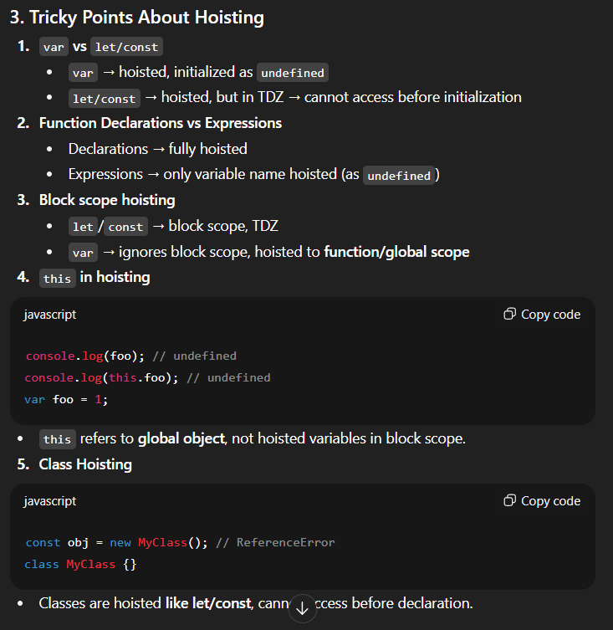
console.log(y); // 20

Declaration Type | Hoisted? | Initialization? | Can Access Before? | Scope
var | Yes | No (undefined) | Yes (undefined) | Function/global
let | Yes | No | No (TDZ) | Block
const | Yes | No | No (TDZ) | Block
Function decl. | Yes | Yes | Yes | Function/global
Function expr. | Yes (var) | No | No | Function/global or block if let/const
Class | Yes | No | No | Block

