**Problem Statement -Online learning continues to grow and in some countries it is growing faster than others. Where might online learning continue to grow in the upcoming years ?**

**Hypothesis**

* Countries/Regions having higher mobile subcription to internet usage ratio will be having higher demand for online learning courses.
* Countries having growing Annual GDP will see an upward trend for online learning courses.
* Countries having higher population are more likely to have higher online learning courses demand.

**Data Exploration**

There is a positive correlaration between internet usage ratio & mobile phone subscription

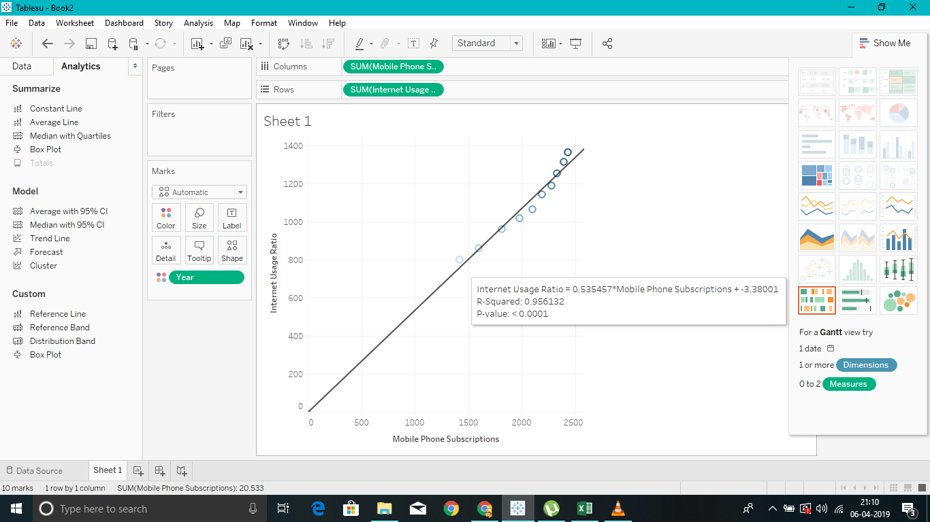

Positive correlation between internet usage ratio & Annual GDP. Therefore, as the GDP is increasing internet usage is also increasing.

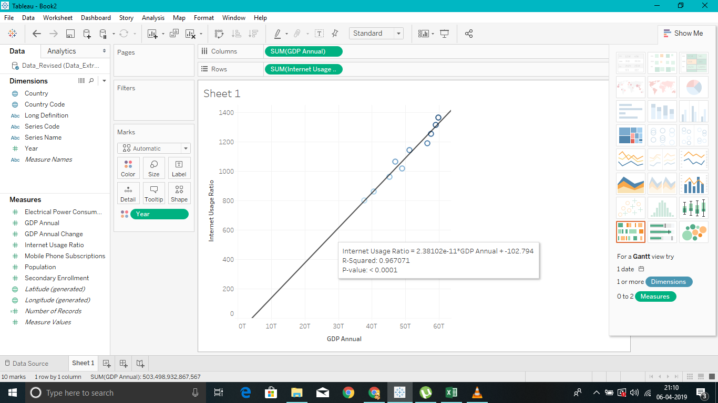

**Data Visualization**

Bar graph showing internet usage per 100 people vs countries

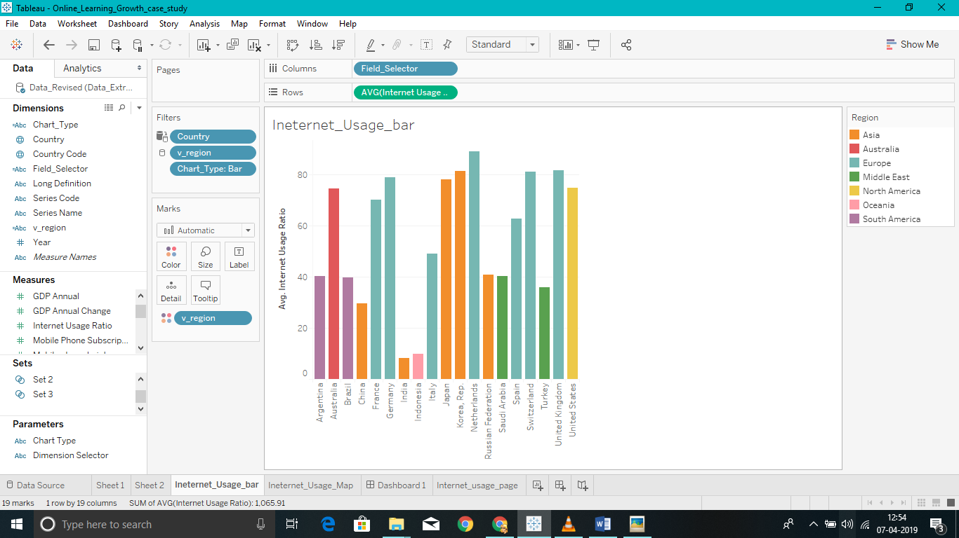

Map showing countries & their respective internet usage ratio

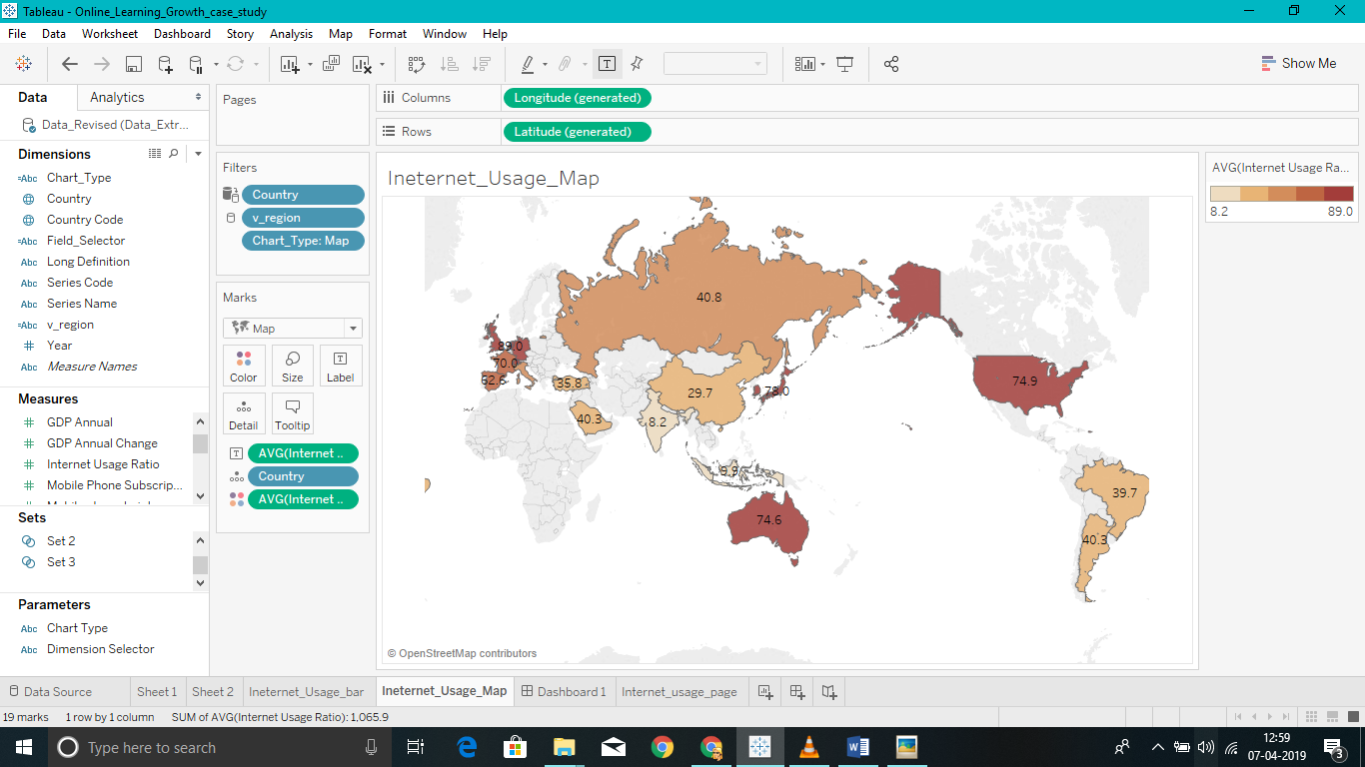

Graph showing internet usage trend over years for different countries – regions below average reference line are the target regions where the internet usage is still low

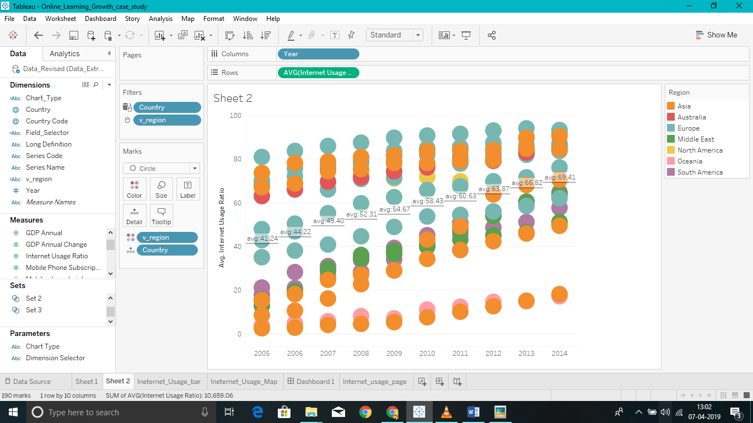

Countries having higher mobile subscription to internet usage ratio and in descending order of population- So these are the target countries where mobile subscription is high internet usage is still low and since their population is high these regions will see boom in online learning

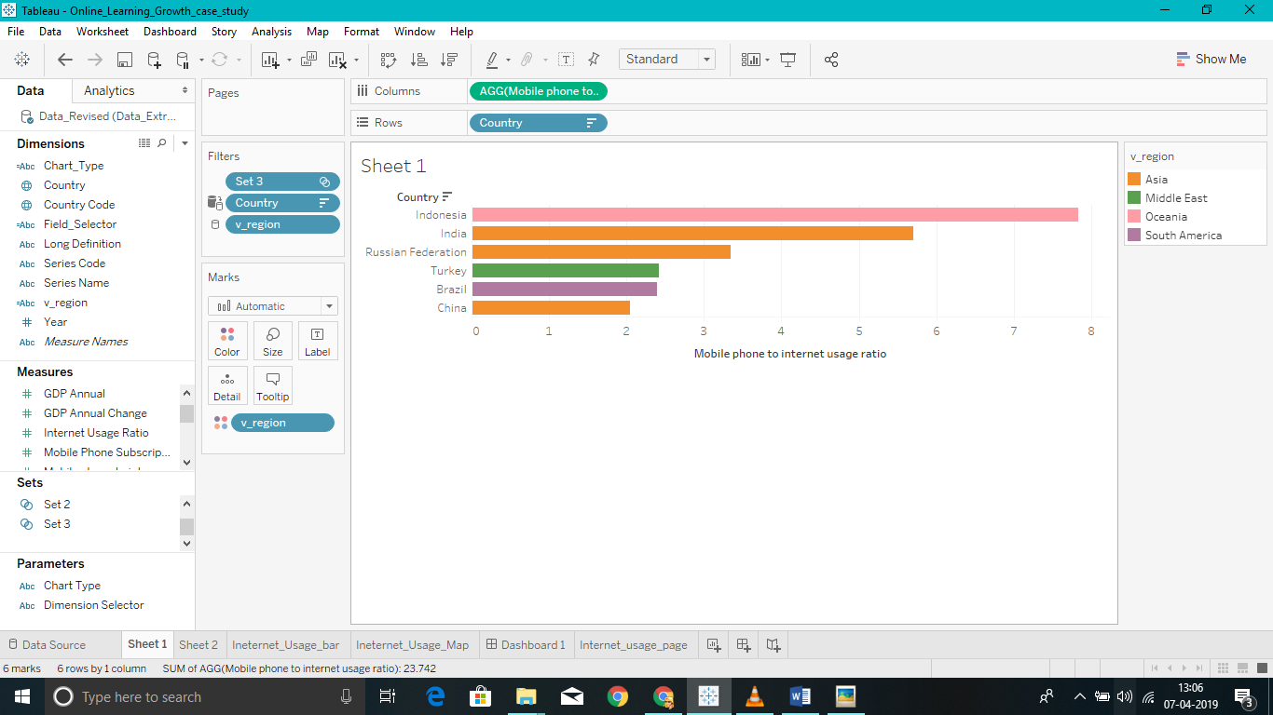

Countries in white region are target countries with changing years

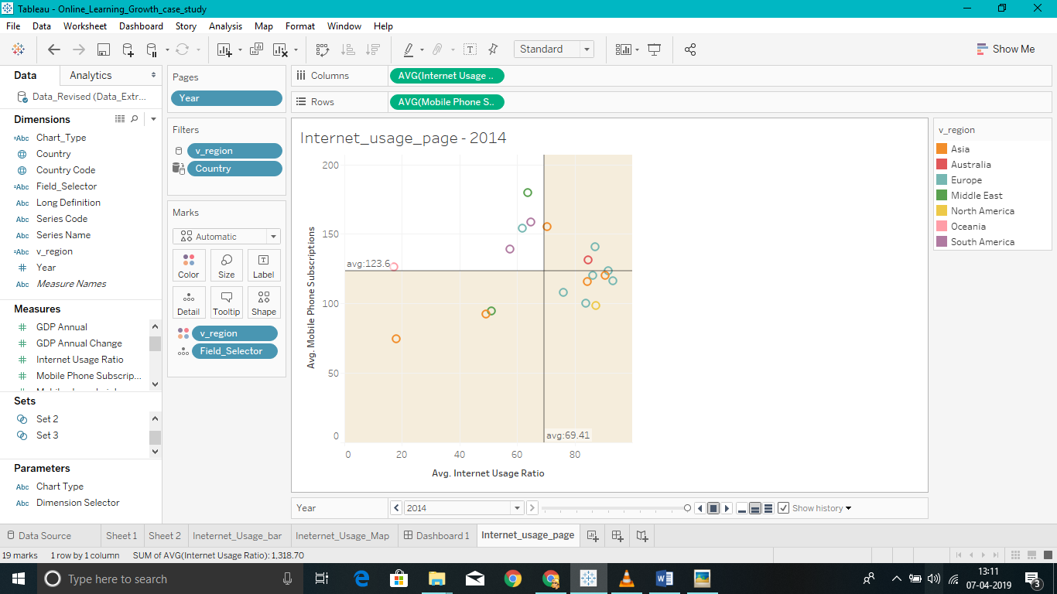

**Dashboard Screenshots**

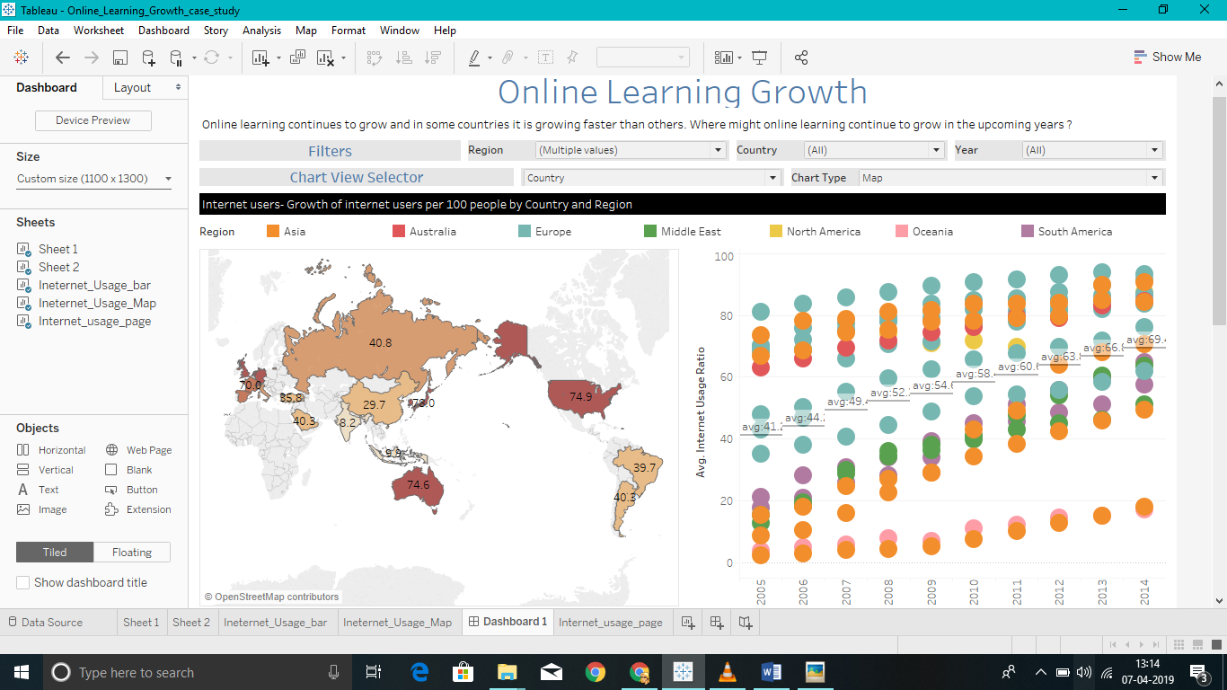

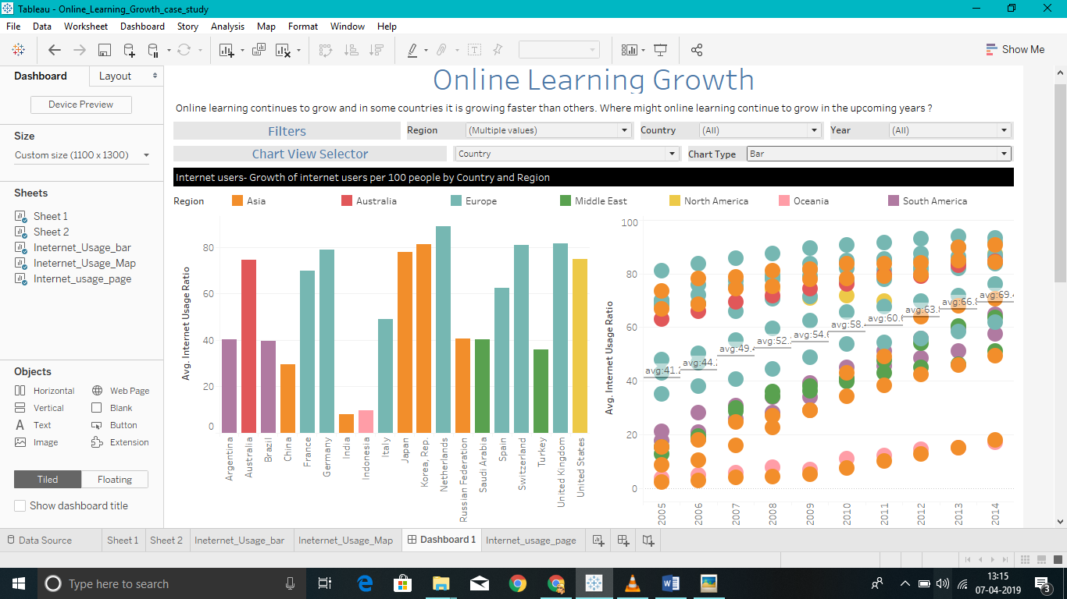

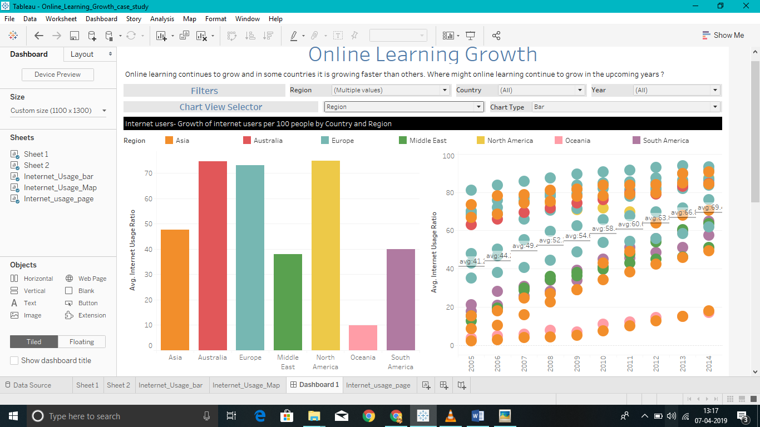

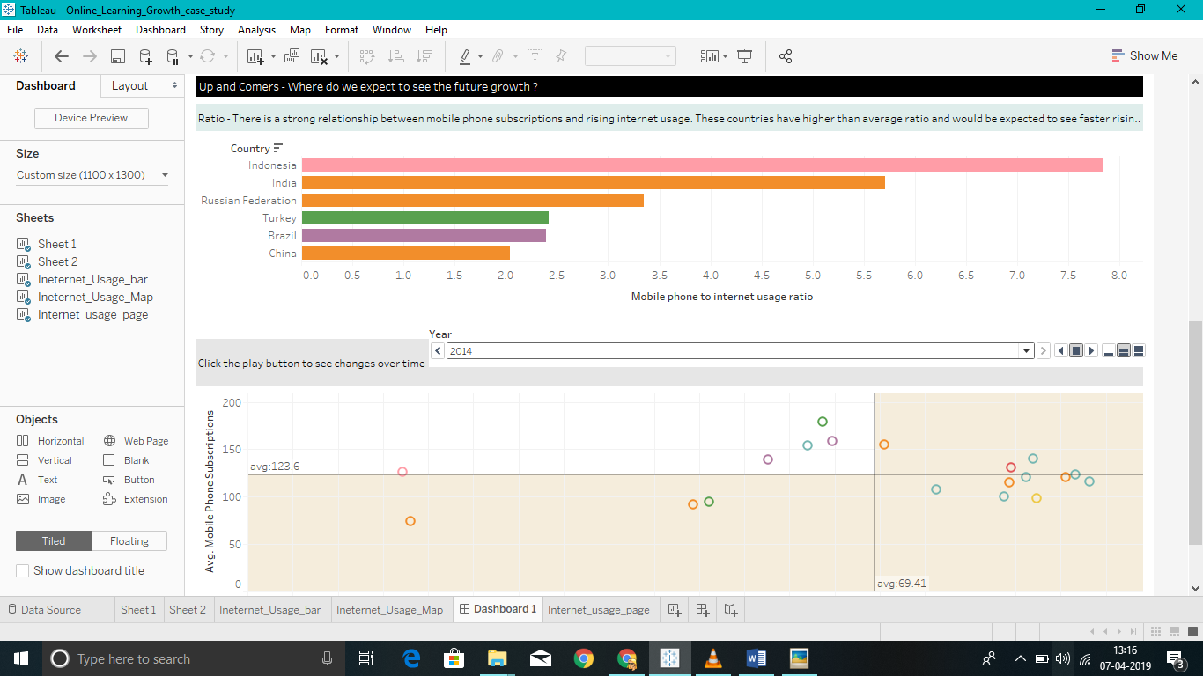

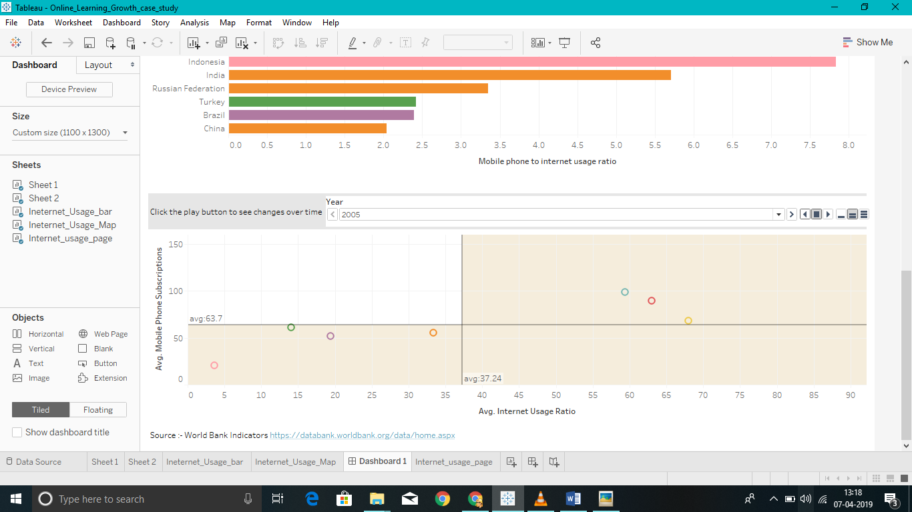

History over years of mobile subscription vs internet usage for South America

