**Cancer Checker**

Breast cancer is the most common types of cancer in women and the correct diagnosis can help treatment immensely. The goal of this application is to find out weather or not the tumor is benign or malignant based on previous data obtained from

We do this by comparing some metrics such as

* radius (mean of distances from center to points on the perimeter)
* texture (standard deviation of gray-scale values)
* perimeter
* area
* smoothness (local variation in radius lengths)
* compactness (perimeter^2 / area - 1.0)
* concavity (severity of concave portions of the contour)
* concave points (number of concave portions of the contour)
* symmetry
* fractal dimension (“coastline approximation” - 1)

first we imported the csv file containing past patient information

Then we got the averages of each of the mean measurements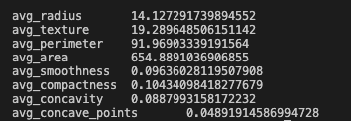

Using this we can get a upper bound and lower bound for values of known malignant cancer cells.

As shown above if a patient’s tumor details fall within the most common ranges the probability of the tumor being dangerous increases.

As a final answer we do some calculations and display how sure we are that this tumor is malignant as a percentage.