

\*MEHWISH NADEEM

\*(455426)

\*FOP assignment # 01.

TASKS#

1. Write a C++ program to display factors of a number using for loops.

Code;

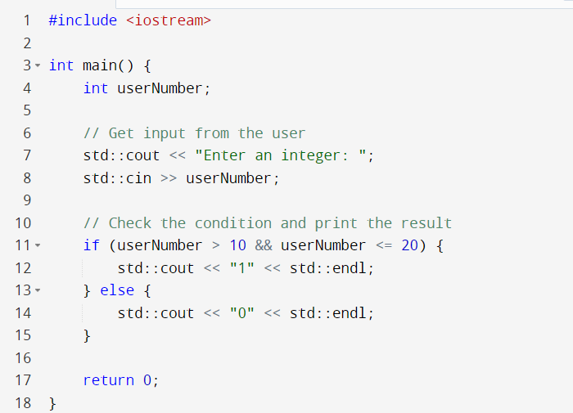

Output;

1. Write output to the following code.

#include

int main() {

int x = 5;

int y = 10;

if (x == 5)

if (y == 10)

std::cout << "x is 5 and y is 10" << std::endl;

else

std::cout << "x is not 5" << std::endl;

return 0;

}

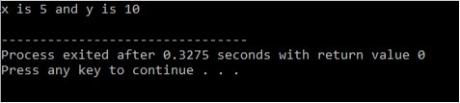

1. Write a C++ program, take an integer value from user and check if it’s greater than 10 and less thanequal to 20. Print 1 if yes and print 0 if no. Use appropriate datatype for output.

Code;

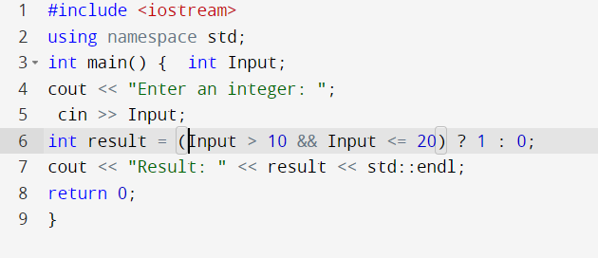

Output;

1. Write a C++ program that uses a while loop to find the largest prime number less than a given positive integer N. Your program should take the value of N as input from the user and then find the largest prime number less than or equal to N. You are not allowed to use any library or pre-existing functions to check for prime numbers.

Code;

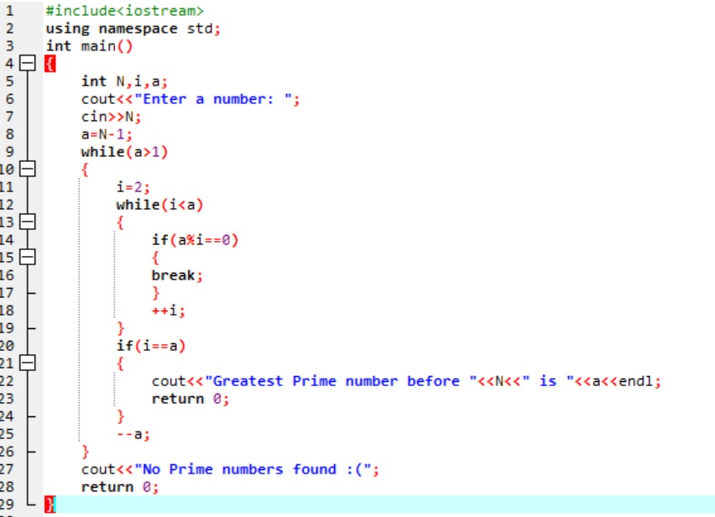

Output;

1. Write a C++ program, take two string as input from user and check if both strings are equal or not. If they are equal make them unequal by rotating string. e.g., Hello is turned into olleH etc.

Code;

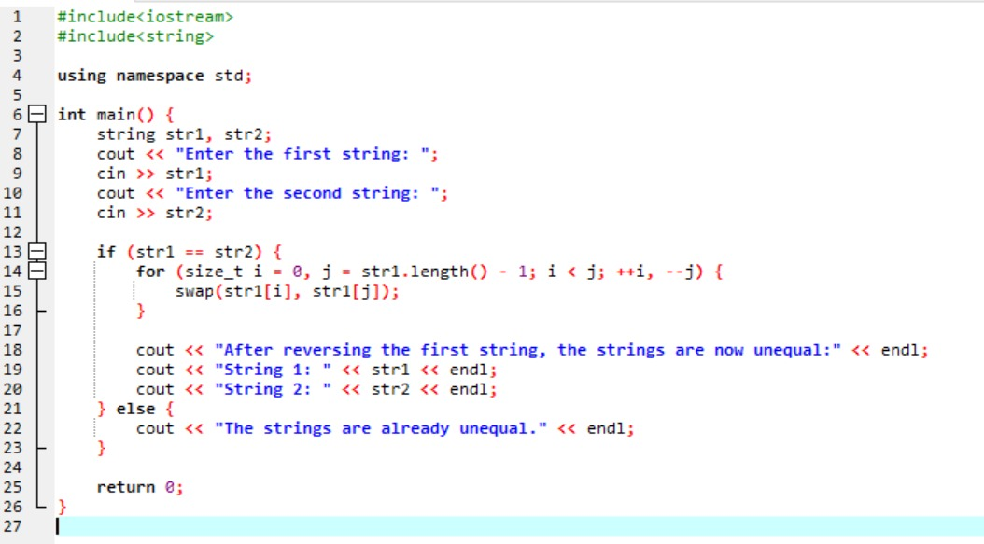

Output;

1. Perform division in C++ without / using for loops. You can use / only to display the final results. Your dividend must be greater than divisor.

Code;

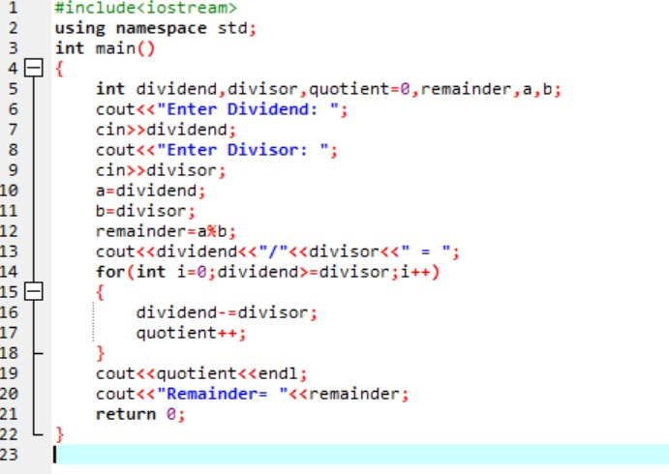

Output;

1. Write a C++program for a string which may contain lowercase and uppercase characters. The task is to remove all duplicate characters from the string and find the resultant string.

Code;

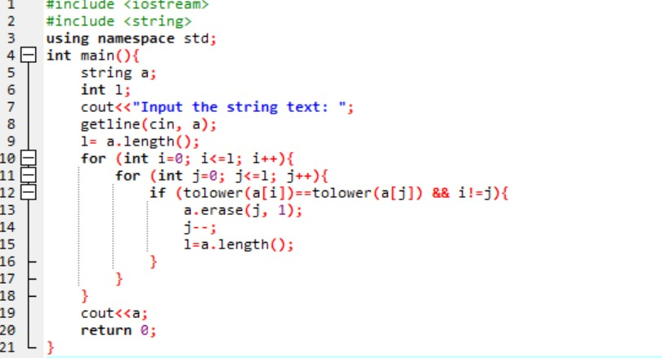

Output;

1. Suppose an integer array a[5] = {1,2,3,4,5}. Add more elements to it and display them in C++.

Code;

Output;

1. Given an integer array and an integer X. Find if there’s a triplet in the array which sums up to the given integer X.

Code;

Output;

1. Implement Bubble Sort on an array of 6 integers.

Code;

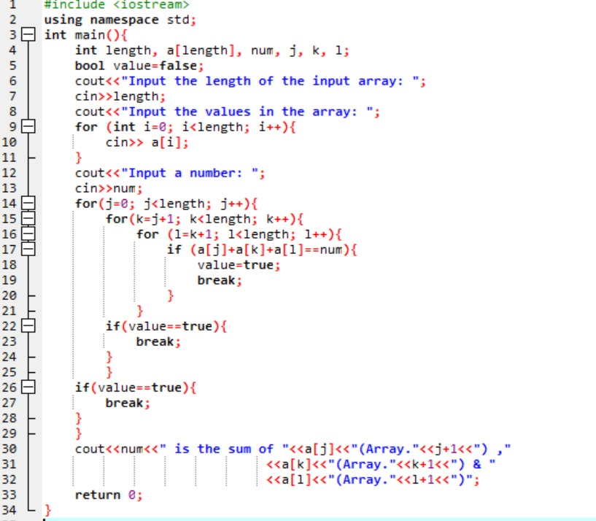

Output;

(the end)