**NATIONAL UNIVERSITY OF SCIENCES AND TECHNOLOGY**



**FUNDAMENTALS OF PROGRAMMING**

**Lab Instructor:** Muhammad Affan

**ASSIGNMENT #2**

**Student Name:** Mehwish Nadeem

**CMS ID:** 455426

**DATE:**

**11-10-2023**

**TASK 1**

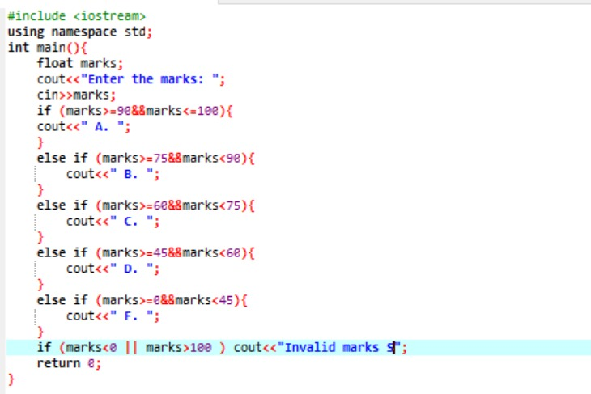

**TASK 2**

**TASK 3**

**TASK 4**

**TASK 5**

