**NATIONAL UNIVERSITY OF SCIENCES AND TECHNOLOGY**

**Fundamentals of Programming**

**Course Instructor:** Dr Khawaja Fahad Iqbal

**Lab Instructor:** Muhammad Affan

**Student Name:** Mehwish Nadeem

**CMS ID:** 455426

**DATE:**

**23-11-2023**

**TASK 1**

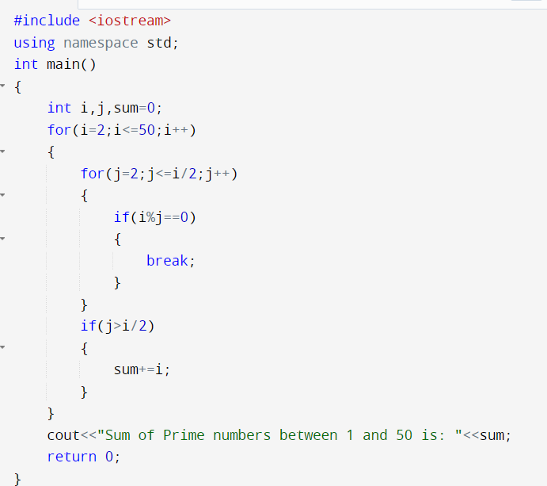

**TASK 2**

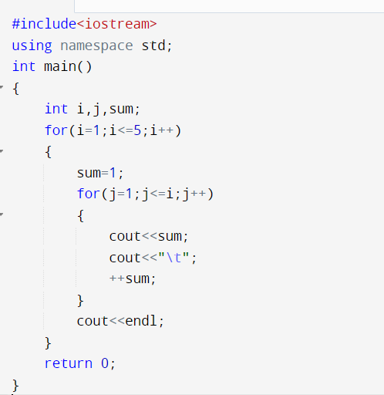

**TASK 3**

