

`MEHWISH NADEEM (455426).

`LAB TASK#07.

`SMME, NUST Islamabad.

\*LAB TASKS#

1) Take 10 integer inputs from users and store them in an array and print them on screen.

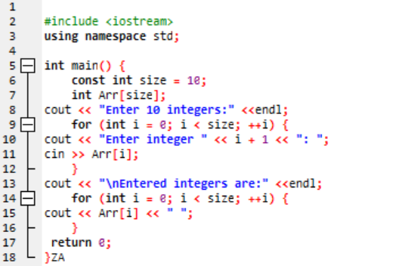

2)Write a program to find the sum and product of all elements of an array with 5 integer elements.

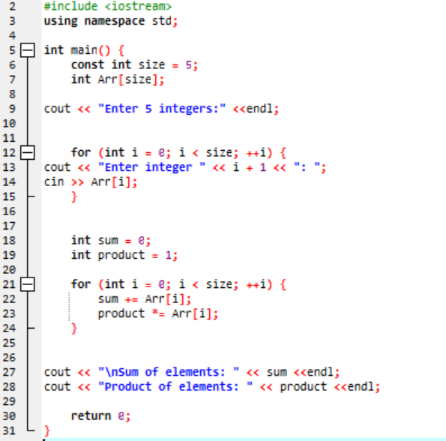

3)Print diamond pattern using a single array.

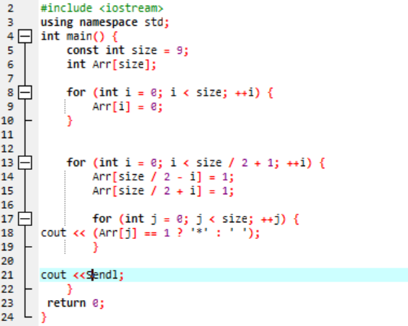

(The End )