**NATIONAL UNIVERSITY OF SCIENCES AND TECHNOLOGY**

**Home TASK (MANUAL 8)**

**Lab Instructor:** Muhammad Affan

**Student Name:** Mehwish Nadeem

**CMS ID:** 455426

**DATE:**

**05-12-2023**

**Task 1**

**Task 3**

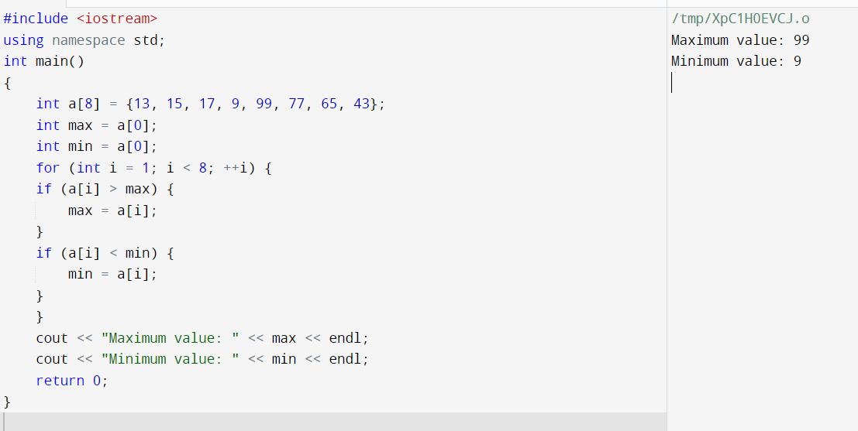

**Task 3**

