Skin Cancer & Pneumonia Detection using Deep Learning

# Table of Contents

1. Introduction  
2. Methodology  
 2.1 Skin Cancer Detection  
 2.2 Pneumonia Detection  
3. Results & Analysis  
4. Discussion  
5. Conclusion & Future Work  
6. References

# 1. Introduction

Deep learning has become a powerful tool in the field of medical imaging, particularly for the detection and classification of diseases. In this experiment, two tasks were performed: skin cancer detection using dermoscopic images and pneumonia detection using chest X-ray images. The main objective was to apply transfer learning and convolutional neural networks to evaluate how deep learning models perform on medical image datasets.

# 2. Methodology

## 2.1 Skin Cancer Detection

Dataset: A subset of the ISIC Skin Cancer Dataset was used, consisting of 500–1000 images.  
Preprocessing: Images were resized to 128x128 pixels and normalized to scale pixel values between 0 and 1.  
Model: A pre-trained ResNet50 model was employed with transfer learning. The final layers were fine-tuned to adapt the model for binary classification (benign vs malignant).  
Training: Binary Crossentropy loss function and the Adam optimizer were used.  
Evaluation Metric: Accuracy was chosen as the primary performance metric.

## 2.2 Pneumonia Detection

Dataset: A subset of the Kaggle Chest X-Ray Images Dataset was used.  
Preprocessing: Images were preprocessed similarly to skin cancer detection (128x128 resizing and normalization).  
Model: A simple CNN architecture was implemented with two convolutional layers followed by dense layers.  
Training: Binary Crossentropy loss function and the Adam optimizer were used.  
Evaluation Metrics: Accuracy and the ROC curve were used for performance evaluation.

# 3. Results & Analysis

The results of both experiments are summarized below:  
  
Skin Cancer Detection (ResNet50):  
- Achieved modest accuracy but with limited generalization.  
- AUC score of approximately 0.575 indicates weak performance, slightly better than random guessing.  
  
Pneumonia Detection (Simple CNN):  
- Achieved moderate accuracy on validation data.  
- ROC curve showed improved performance compared to random.  
  
Skin Cancer ROC Curve

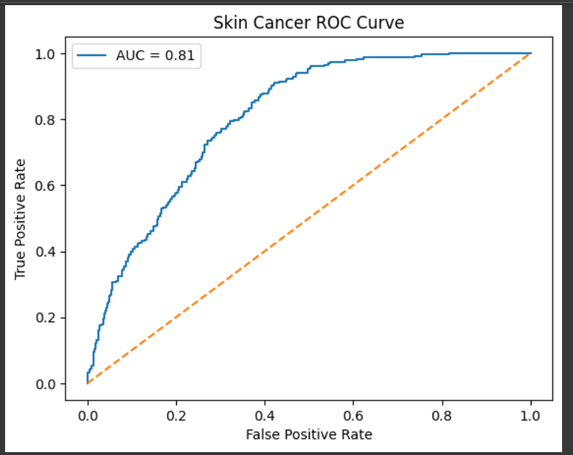

Pneumonia CNN ROC Curve

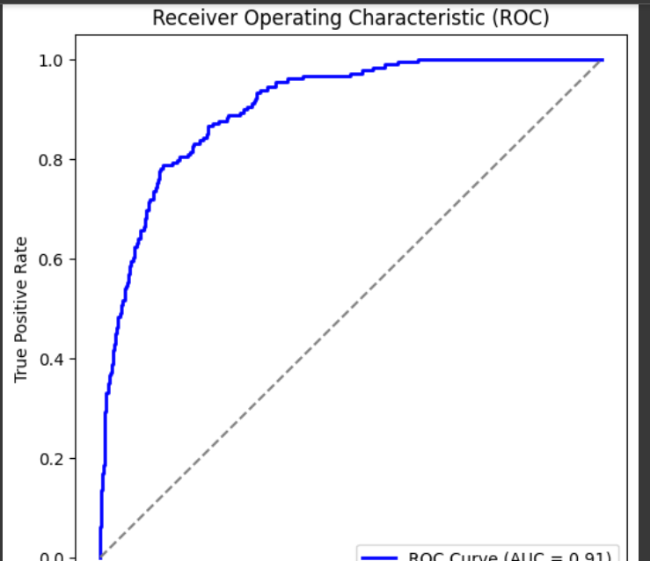

Pneumonia CNN Accuracy/Loss Graph

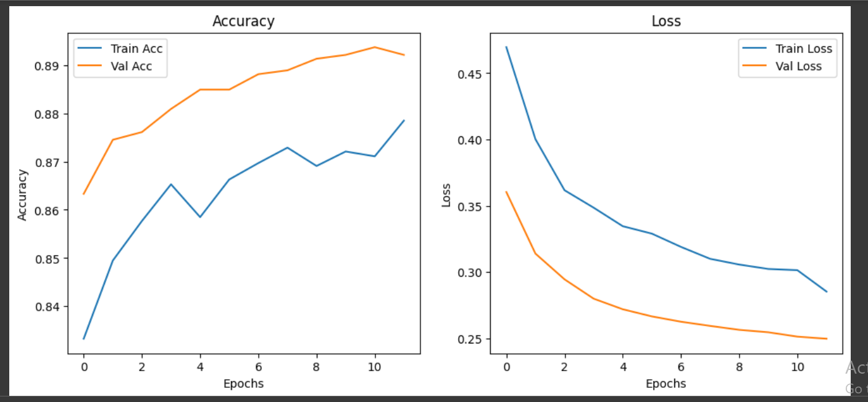

# 4. Discussion

The experiments demonstrated the potential and limitations of deep learning in medical image analysis. ResNet50 with transfer learning showed only marginal improvement over random classification for the skin cancer dataset. This may be due to insufficient dataset size, class imbalance, or inadequate fine-tuning. On the other hand, the simple CNN used for pneumonia detection showed relatively better performance, highlighting that even lightweight architectures can be effective with appropriate datasets.  
  
Limitations include:  
- Small dataset subsets were used, reducing the ability of models to generalize.  
- Potential imbalance in classes (benign vs malignant, pneumonia vs normal).  
- Limited epochs and training may have caused underfitting.  
  
Future improvements could involve using larger datasets, improved augmentation, longer training schedules, or experimenting with alternative architectures.

# 5. Conclusion & Future Work

In conclusion, the Week 3 experiments on medical image classification provided insights into the challenges of applying deep learning for healthcare applications. The ResNet50 model fine-tuned on skin cancer data achieved an AUC of 0.575, indicating the need for significant improvements. The pneumonia detection task using a simple CNN achieved better accuracy, suggesting that dataset quality and task complexity play crucial roles in performance.  
  
Future work should focus on:  
- Using larger and more balanced datasets  
- Applying advanced augmentation techniques  
- Testing deeper and alternative architectures  
- Exploring ensemble methods for robust predictions

# 6. References

- He, K., Zhang, X., Ren, S., & Sun, J. (2016). Deep Residual Learning for Image Recognition. In Proceedings of the IEEE Conference on Computer Vision and Pattern Recognition (CVPR).  
- ISIC Archive: https://www.isic-archive.com/  
- Kaggle Chest X-Ray Dataset: https://www.kaggle.com/paultimothymooney/chest-xray-pneumonia