四 川 轻 化 工 大 学 实 验 报 告
学院：自动化与信息工程学院 课程名称：PYTHON 日期：2021年10月*日
姓名 | 梅刚 | 组号 |  | 学号 | 20331050213 | 实验室 | A8-221
专业 | 智能科学与技术 | 组号 |  | 班级 | 2020级2班 | 实验老师 | 赵俊  刘永
实验  名称 | 实验二：Python基础语法实验2 |  |  |  |  | 成绩评定
所用  仪器  设备 | - 计算机  - PYTHON(3.9 64-bit)  - 编译器（pycharm）
实  验  目  的  和  要  求 | - 根据自己的学号，设A等于学号除以13取余数，B等于学号除以3的余数，C等于学号除以5的余数，D为学号除以7的余数，E为学号除以50的余数，编写一个脚本，以自己的学号为输入，输出A,B,C,D,E的值  2、With a given integral number n, write a program to generate a dictionary that contains (i, i x i) such that is an integral number between 1 and n (both included). and then the program should print the dictionary.Suppose the following input is supplied to the program: 8 Then, the output should be:{1: 1, 2: 4, 3: 9, 4: 16, 5: 25, 6: 36, 7: 49, 8: 64}  3、Write a program that accepts a comma separated sequence of words as input and prints the words in a comma-separated sequence after sorting them alphabetically.  Suppose the following input is supplied to the program:  without,hello,bag,world  Then, the output should be:  bag,hello,without,world  4、Write a program that computes the value of a+aa+aaa+aaaa with a given digit as the value of a.  Suppose the following input is supplied to the program:  9  Then, the output should be:  11106  5、Write a program to compute the frequency of the words from the input. The output should output after sorting the key alphanumerically.  Suppose the following input is supplied to the program:  New to Python or choosing between Python 2 and Python 3? Read Python 2 or Python 3.  Then, the output should be:  2:2  3.:1  3?:1  New:1  Python:5  Read:1  and:1  between:1  choosing:1  or:2  to:1  6、Write a program to compute the frequency of the words from the input. The output should output after sorting the key alphanumerically.  Suppose the following input is supplied to the program:  New to Python or choosing between Python 2 and Python 3? Read Python 2 or Python 3.  Then, the output should be:  2:2  3.:1  3?:1  New:1  Python:5  Read:1  and:1  between:1  choosing:1  or:2  to:1  7、Define a function which can generate a dictionary where the keys are numbers between 1 and 20 (both included) and the values are square of keys. The function should just print the keys only.  8、Write a program which can map() and filter() to make a list whose elements are square of even number in [1,2,3,4,5,6,7,8,9,10].
实  验  原  理 | - 题目1流程图；  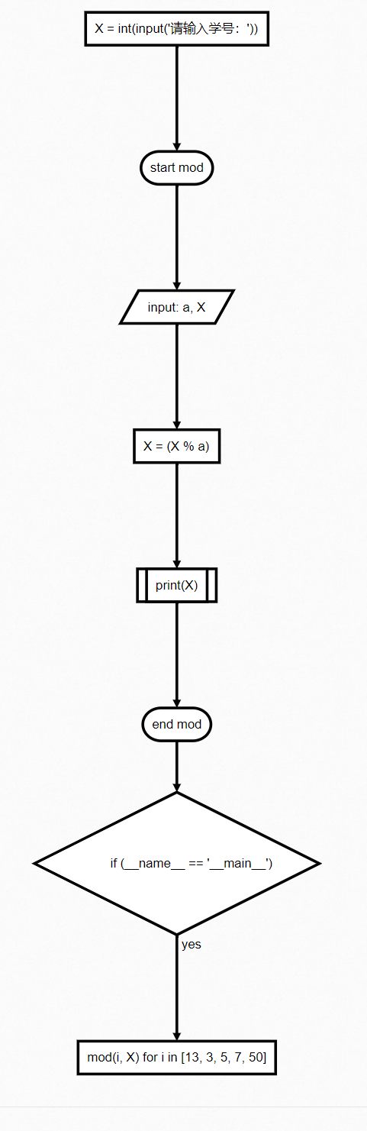  - 题目2流程图；  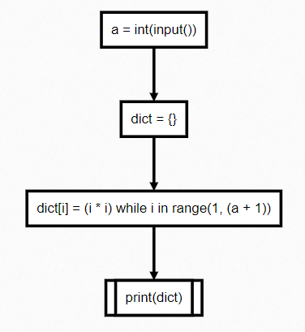  - 题目3流程图；  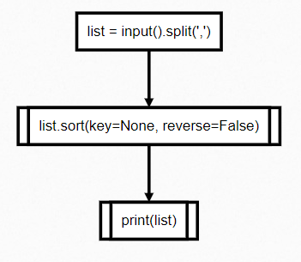  - 题目4流程图；  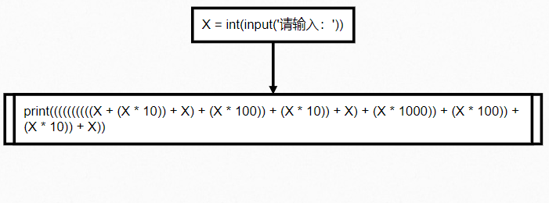  - 题目5流程图；  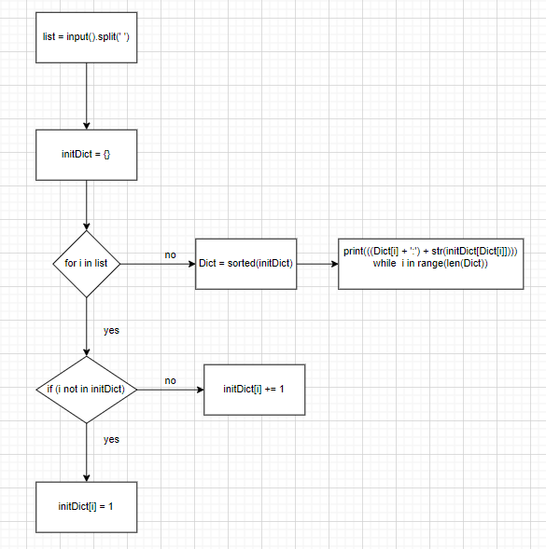  - 题目6流程图；  - 题目7流程图；  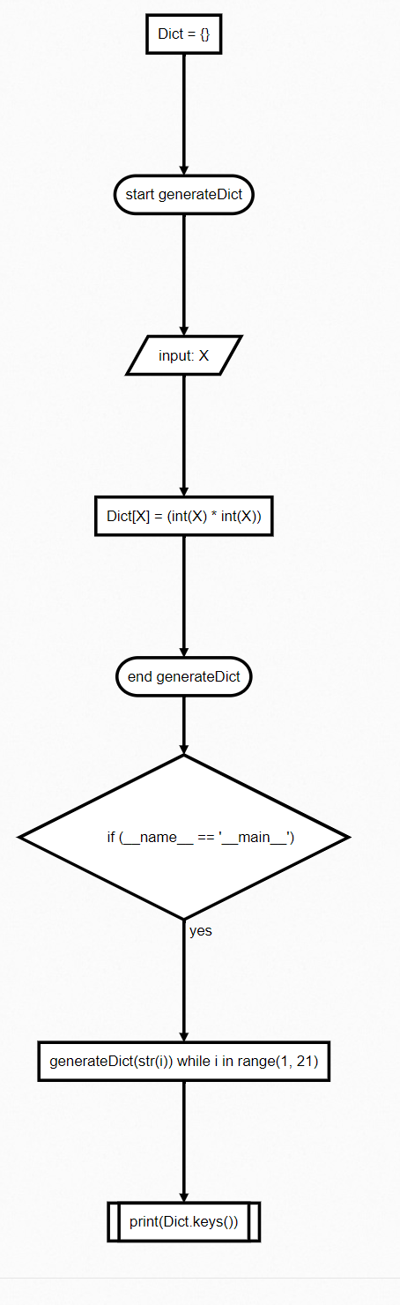  - 题目8流程图；  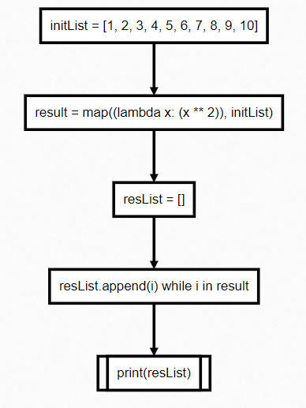
实  验  过  程  或  内  容  、  结  果  、  分  析  、  讨  论  、  结  论 | - 题目1程序源码  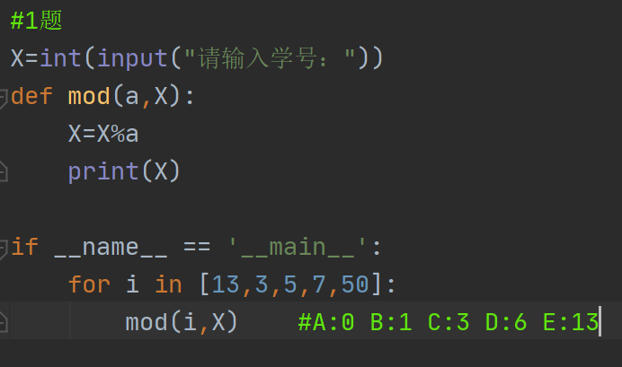  运行后的结果切图  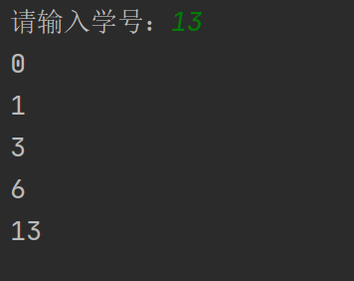  - 题目2程序源码  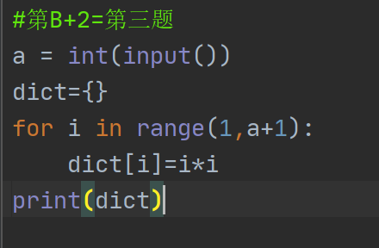  运行后的结果切图  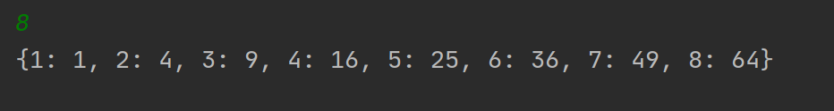  - 题目3程序源码  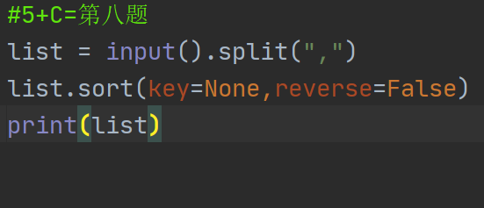  运行后的结果切图  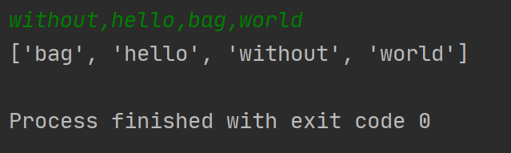  - 题目4程序源码  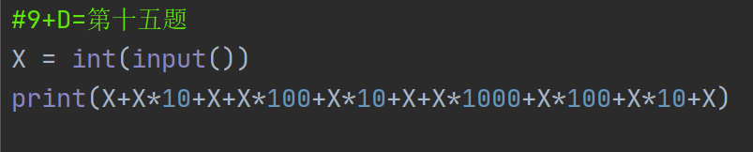  运行后的结果切图  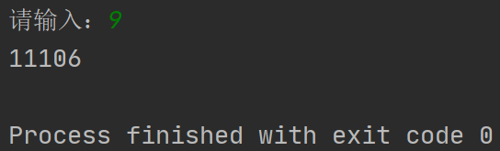  - 题目5程序源码  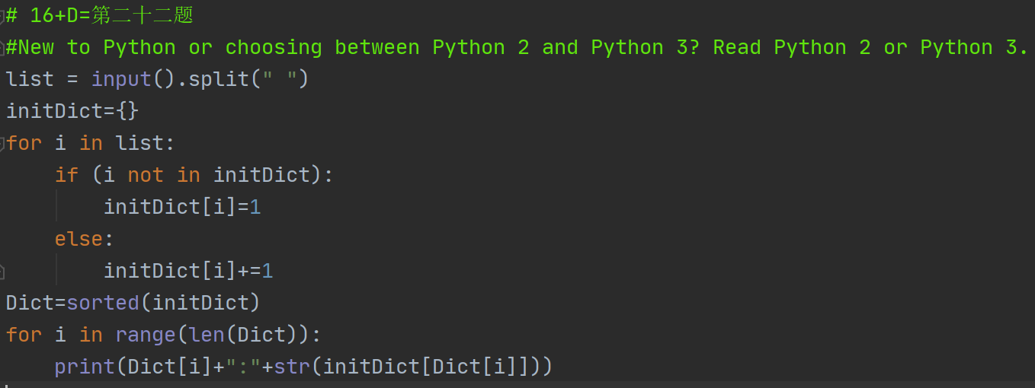  运行后的结果切图  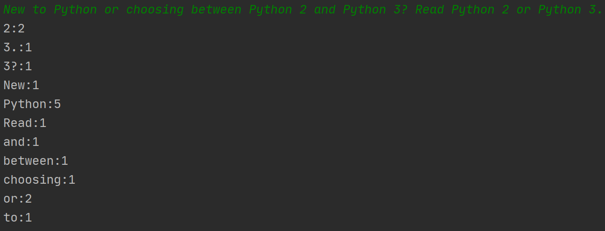  - 题目6程序源码  运行后的结果切图  - 题目7程序源码  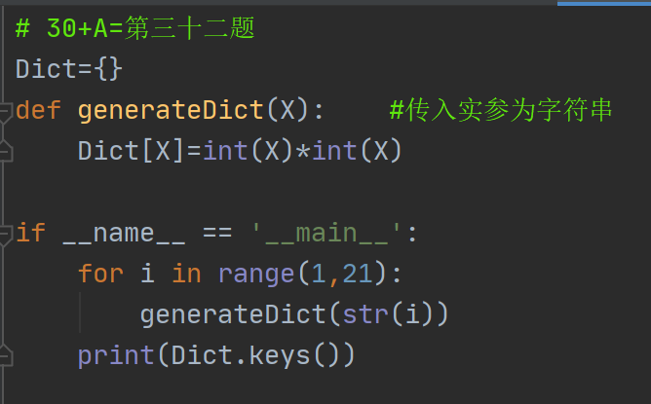  运行后的结果切图  - 题目8程序源码  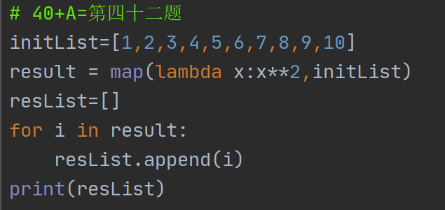  运行后的结果切图  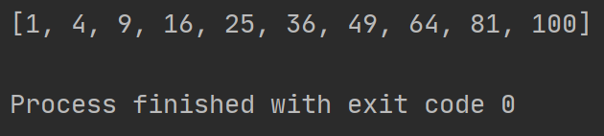
实  验  原  始  记  录 | 学习到了Python的一些基础语法，字典，列表的使用。

