Sales Analysis and Revenue Prediction for Electronic Retail Companies
Mai Pham,
Data Science student,
University of Auckland,
Auckland, New Zealand

Introduction
Electronic retail, also known as e-retailing, is the process of selling goods and services to consumers and businesses via online platforms [1]. Unlike traditional physical retail, e-retailing allows customers to order and pay for products or services without having to come to physical stores to purchase items. Therefore, electronic retail companies cannot rely completely on customers’ behaviour in stores. Instead, transaction data, which is recorded for each order and sold item, provides an important source of information about customers’ purchasing behaviour. Each transaction is recorded by different categories, which can reveal monthly revenue, total sales of each city, best-selling products, peak and slow hours, comparisons between high- and low-price-level product sales, and products frequently purchased together. Analysing the transaction data helps businesses identify purchasing and revenue patterns, allowing them to make informed and strategic decisions to improve sales in the future. Without using transaction data analysis, companies may heavily rely on customers’ behaviour observations at physical stores and assumptions about online customers, which potentially lead to biased decisions towards customers coming to physical stores.
Sales analysis matters because it helps companies make informed decisions and avoid costly mistakes. It enables businesses to identify revenue patterns and the busiest and slowest months, which allows them to plan staffing, inventory, and cash flow more effectively. Analysing order times can also help the marketing team to know when targeted customers are most likely to make purchases, allowing them to have a realistic schedule for the marketing campaigns and target the right clients. Additionally, it identifies clearly products frequently purchased together and forecasts revenue in the future, helping the electronic retail companies understand more about potential product bundles and anticipate future revenue to make better decisions about planning, inventory, supply orders, and budgets for future sales. Without this information, the companies may be understaffed in peak seasons or overstocked and overspend on advertising budgets at times when customer acquisition and sales are declining. This will lead to unnecessary expenses that affect businesses’ profit significantly.
This project aims to apply a complete data science workflow to discover sales patterns and build predictive models for order-level sales revenue of the electronic companies from the data collected by each transaction. The analysis project has two main parts:
- “Explore Dataset”: The dataset was explored by checking its structure, data types, row duplicates, numeric and categorical variables, missing values, correlations among variables, and statistical measures of numeric variables.
- “Research Questions”: The analysis investigates the insights of the given data comprehensively and develops models to forecast sales of the electronic retail companies. There are eight research questions:
- Which month generates the highest revenue?
- Which city contributes the most sales?
- Which products have the highest quantity sold and revenue contribution?
- What time of day has the highest order activity?
- Are expensive products sold less frequently?
- Which products are frequently purchased together?
- Can machine learning models predict sales revenue accurately?
- Which features are most important in predicting sales?
These 8 questions provide insights into monthly revenue, total sales of each city, best-selling products, peak hours, comparison between high- and low-price-level product sales, products frequently purchased together, and sales revenue predicted by using machine learning. These findings support the business decisions to increase revenue, improve product sales, and avoid costly mistakes in the future.

Dataset Understanding and Preprocessing

Dataset Overview
The data were recorded transactions for items sold by electronic retail companies from 1st January 2019 to 1st January 2020. Each row represented one product within an order, so there were multiple rows representing an order having more than one product. There were 185,950 rows and 11 columns corresponding to different variables, such as Unnamed: 0, Order ID, Product, Quantity Ordered, Price Each, Order Date, Purchase Address, Month, Sales, City, and Hour. These variables provided insights into customers’ purchasing behaviour and the interactions between them and predicted future revenue, allowing businesses to understand more about sales patterns over a year and make informed decisions based on predictive sales models.

Key Variables
There were eleven given variables in the dataset. Firstly, the “Order ID” variable was a unique ID for each order placed on a product. Since there were multiple rows representing products within an order, the variable was a key to link items together. In total, the dataset contained 178,437 unique orders. This variable helped the retail companies detect which products were frequently purchased together, as mentioned in question 6 of the Research Questions section. Secondly, the data in the “Product” column were items that were purchased, and there were 19 unique products sold in total. By using the variable, the businesses could identify sales per product easily and determine which items were best-sellers and peak seasons of each item, thereby creating a proper inventory plan for each product. Thirdly, the “Quantity Ordered” variable described how many of those products were ordered. The data for the variable were mostly one because customers tended to buy one per item in an order, especially for expensive products. However, there were 17,398 items purchased in quantities greater than one per order. It helped businesses have insights into the number of products that were sold and prepare product supplies and inventory for future sales effectively and avoid overstocking. Fourthly, the “Price Each” variable provides information about the price of one unit of that product. The data in this variable not only helped calculate total sales but also helped categorise products into different tiers. Fifthly, the “Order Date” variable represented the order date, helping to track the order time and define the data collection date range. Next, the “Purchase Address” variable showed the address to which the order was shipped. Lastly, the "Month" and “Hour”, “Sales”, and “City” variables were extra attributes formed from “Order Date”, “Price Each” and “Quantity Order”, and “Purchase Address” respectively. These variables provided more detailed information based on the given variables and helped identify the sales revenue by hours per day and cities, and predict future revenue, as mentioned in question 7 of the Research Questions section, supporting the electronic retail companies to make informed decisions to improve revenue in the future.

Data Cleaning
There were no missing values across all columns, suggesting that the data were recorded strictly or already cleaned before being provided. The “Unnamed: 0”, which indicated the row order in the dataset, made each row unique, as the orders of all rows were different. Dropping this column helped to detect duplicate rows, which were 264 rows. It left 185,686 unique rows after removing the duplicates. These 246 rows could lead to inaccurate sales analysis in the Research Questions section because they caused the total sales by months, cities, and products to be counted more than once, which means the total sales were inflated more than they actually were. Among variables, the variable Order Date was not in the correct data type, which was string, and was converted to datetime64[us]. This is important because it would help the machine understand and treat the data in the Order Date column as datetime instead of normal strings. It was also helpful to extract them to a new variable, Date.

Features engineering
There were two new features, which were Date and Price Tier, extracted from variables Order Date and Price Each, respectively. Firstly, the data in the Order Date column contained both date and time, and the transactions were not ordered by date. As a result, it was impossible to find the date range of the collected data. Adding a new variable, Date, to the dataset helped find the date range easily and check the purchasing date of each item. Regarding the Price Tier feature, it contains different levels of item price. There were 4 price tiers, such as Low (<$20), Medium ($20-100), High ($100-500), and Premium (>$500). The price tiers helped the companies assess the price segment of each product and determine whether products in the higher price segment were sold more frequently than products in the lower price segment, as mentioned in question 5 of the Research Questions section. Without having this variable, it would be difficult to identify which products were considered expensive items, as their prices varied.

Exploratory Data Analysis
With the dataset cleaned and sufficient variables included, the exploratory data analysis was conducted to answer the first five research questions.

Revenue by Month
Overall, there was an upward trend of total sales over the months. December had the highest total sales, which was $4,613,443.34, while the month with the least sales was January with $1,822,256.73. It suggested that the increase in electronics sales was linked to the Christmas holiday season in December, when customers tended to buy these products as gifts for family. Due to the holiday season and customers taking advantage of various promotions during peak season, the number of customers purchasing electronic products in January next year will be lower, leading to a significant decrease in overall revenue for that month. Additionally, sales started to grow after January, when the spring semester in the US began. This meant more customers needed to purchase new electronic products for their studies. This trend continued until April and began to decline in May as the semester ended. Sales then surged sharply in October when students might need to purchase electronic products for the fall semester.
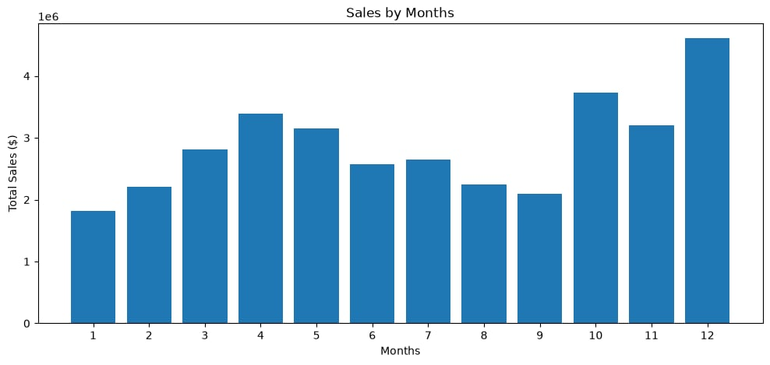
Fig. 1 Monthly sales

Revenue by city
Overall, San Francisco had the highest total revenue at $8.26 million in a year, while the city with the lowest revenue was Austin at $1.82 million. This shows a significant difference in sales performance between cities. Besides San Francisco, Los Angeles, New York City, and Boston also contributed to the companies' total revenue with figures of nearly $6 million, $5 million, and $4 million, respectively. This suggests that the companies should consider allocating more inventory and marketing resources to these cities. Furthermore, the businesses could consider potential promotional campaigns for low-revenue cities, such as Atlanta, Dallas, Seattle, Portland, and Austin, to attract more customers purchasing electronic products and improve their revenue contributions in the future.
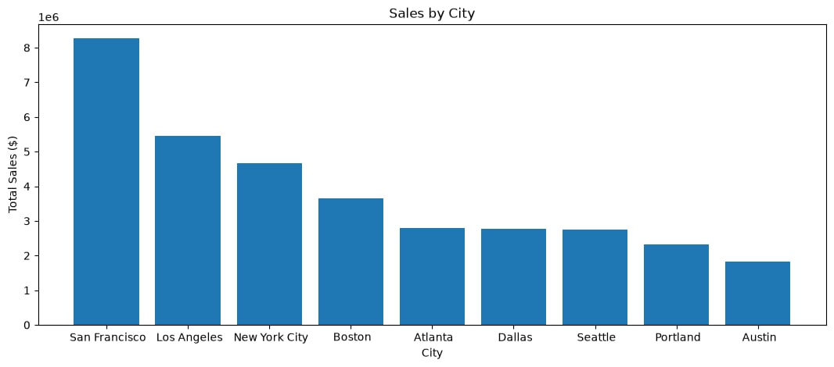
Fig. 2 Cities’ sales contributions

Top products by quantity vs. revenue contribution
Overall, AAA batteries (4-pack) were the highest-selling product with 30,986 units, accounting for 14.8% of total orders for the year. Conversely, the lowest-selling product was the LG hair dryer, with 646 units sold, representing 0.31% of total orders. Regarding the highest revenue contributor, the MacBook Pro laptop generated the most revenue at $8,032,500, accounting for 23.31% of total revenue. 4,725 MacBook Pro laptops were sold, representing 2.26% of total orders. Despite being the highest-selling product, AAA batteries (4-pack) contributed the least to total revenue, at $92,648.14, or 0.27%. This showed that a high sales volume did not mean high total revenue. Customers tended to purchase many inexpensive items with short lifespans, such as AAA batteries (4-pack), which led to a significantly large number of electronic items sold. However, for more expensive products with longer lifespans, such as MacBook Pro laptops and LG hair dryers, sales volume might not be as high as AAA batteries (4-pack), but they contributed significantly to total revenue. This suggested that businesses should carefully consider both the quantity of products ordered and their contribution to revenue when evaluating sales performance in order to make informed decisions about inventory and product supply.
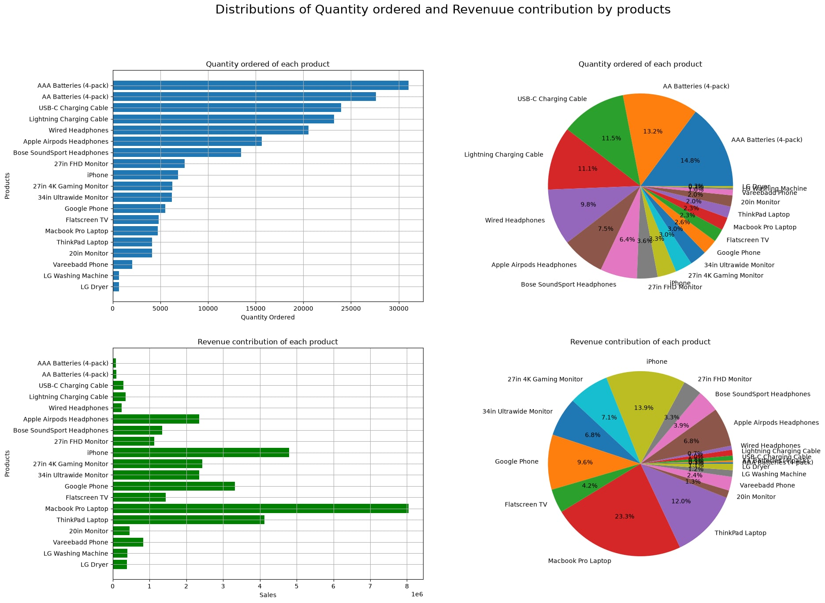
Fig. 3 Quantity Order and Revenue Distribution by Product

Quantity Orders by Hour
Overall, the quantity of orders showed an upward trend over the 24 hours of the day. During the daytime, more products were purchased compared to nighttime. The time of day with the highest order activity was 7 pm (7:00 PM), with 14,451 orders, while the time of day with the lowest order activity was 3 am, with 927 orders. Besides, the periods from 11 am to 1 pm and 6 pm to 8 pm also contributed significantly to the total quantity of products purchased (14,000 products sold per hour). This might be because most customers had their lunch break around 11 am to 1 pm and finished school or work around 5 pm. As a result, these times were ideal for them to relax and shop, leading to an increase in orders during those hours. On the other hand, most customers tended to sleep between 9 pm and 7 am, which meant the number of orders decreased significantly during that time. Therefore, electronic retail companies should consider customers' schedules and prepare inventory and promotions, especially around 11 am - 1 pm and 6 - 8 pm, to encourage customers to purchase electronic products in order to increase business revenue.
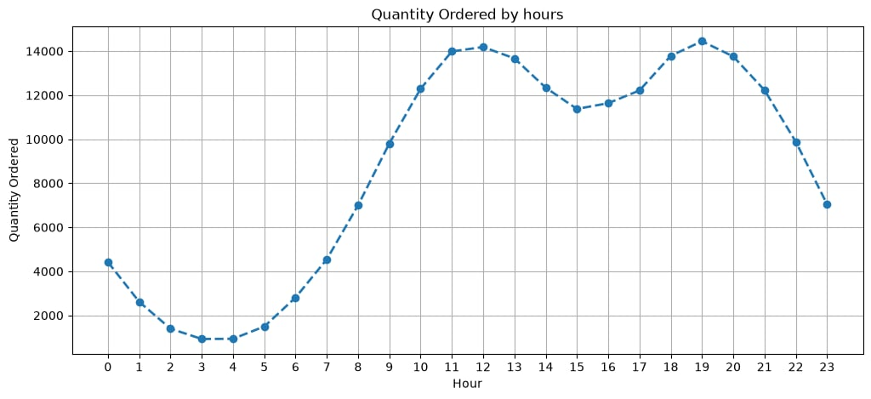
Fig. 4 Quantity Orders by Hour

Quantity Orders by Unit Price
The graphic distribution showed that expensive products sold less frequently. Low-price-level products, such as AAA batteries (4-pack), AA batteries (4-pack), and USB-C charging cables, had extremely high sales volumes, exceeding 20,000 units. Conversely, higher-priced products like iPhones, ThinkPad laptops, and MacBook Pro laptops had significantly lower sales. This was similar to the Top Products by Quantity vs. Revenue Contribution chart, which showed that customers tended to purchase many inexpensive items with short lifespans, such as AAA batteries (4-pack), leading to a significantly large number of electronic items sold. For more expensive products with longer lifespans, they purchased them less frequently, resulting in much lower sales. This also suggested businesses should carefully consider both the quantity of products ordered and their contribution to revenue when evaluating sales performance in order to make informed decisions about inventory and product supply.
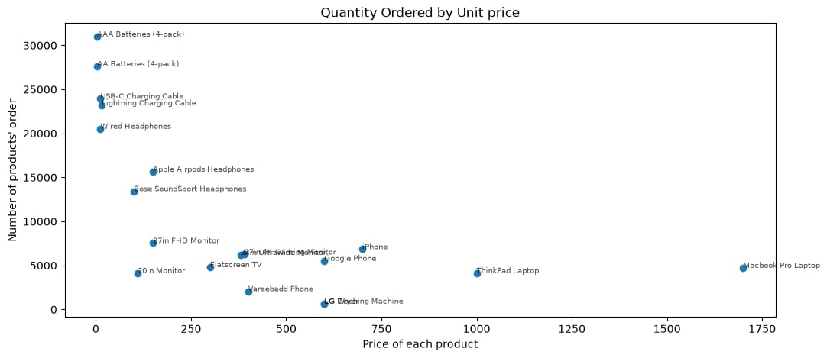
Fig. 5 Quantity Orders by Unit Price

Association Rule / Market Basket Analysis
Since there were multiple rows representing products within an order, grouping rows by Order ID helped get the full list of products purchased together in one order. There were 178,437 unique orders, with 6,879 orders containing more than one product. This meant that most orders only contained a single product.
"Antecedents" and "Consequents" indicated products purchased together in an order. "Support" indicated how often products in the antecedents and consequents columns appear together across all orders. “Confidence” showed the conditional probabilities between a group of products of how likely customers who purchased products in "Antecedents" column also bought items in "Consequents". “Lift” was a measure showing how likely products in "Antecedents" and "Consequents" columns were purchased together if they were independent.
Overall, Lightning charging cables and iPhones appeared together most frequently in all transactions, at a rate of 14.17%. 57.02% of customers who purchased Lightning charging cables also purchased iPhones. If customers buy an iPhone, they are 2.18 times more likely to buy a Lightning charging cable in the same order on average. Conversely, 54.21% of customers who bought an iPhone also purchased a Lightning charging cable. This meant that 3% of new iPhone buyers did not order a Lightning charging cable because they might already have a different cable with their old iPhone. Additionally, there were product groups that were frequently purchased together in an order, such as Vareebadd phones and USB-C charging cables, USB-C charging cables and Google phones, and 27-inch 4K gaming monitors and MacBook Pro laptops. This might be because they were usually used together. For example, a customer might need a Lightning charging cable to easily charge their iPhone. Or, a 27-inch 4K gaming monitor and a MacBook Pro laptop were purchased together because they might connect the MacBook Pro laptop's screen to the 4K gaming monitor. This suggested that the companies should consider items that were frequently used together and customer product usage trends to predict which products customers will purchase in a single order. This allowed the company to prepare product supplies and manage inventory effectively.
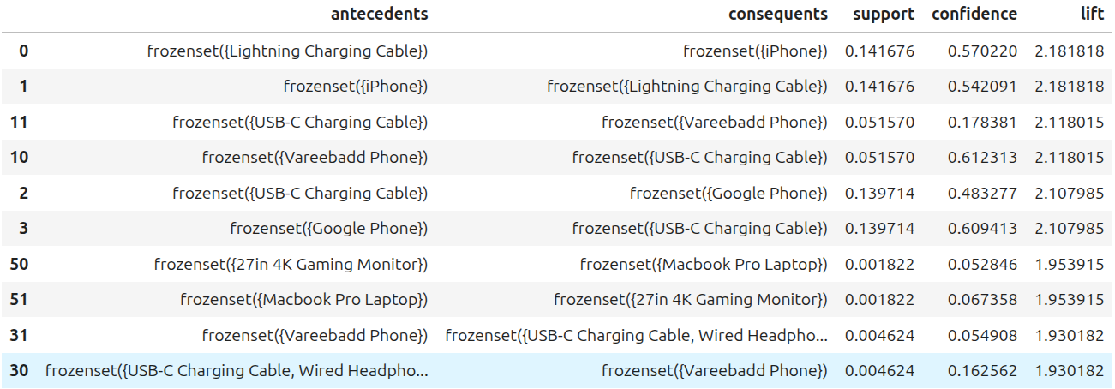
Fig. 6 Products groups

Machine Learning Modelling
The project aims to build predictive models for order-level sales revenue, so the response variable of the modeling is the "Sales" variable used for training and validating models. Since there were multiple rows recording items' transactions within an order, grouping them into a list by their Order ID helped develop trusted models. This was a regression problem where the "Sales" variable was a continuous target, so using metrics such as Mean Squared Error (MSE), Root Mean Squared Error (RMSE), and coefficient of determination (R²), were appropriate.

Feature Selection
The selected variables are "Month", "Hour", "City", "Num_Items", and "product_columns." The "Hour" variable was important, as it helped the models to learn the hour patterns to identify when sales were highest and lowest. The "Month" variable was also important, as it helped the models to learn about monthly sales patterns to predict sales in different months. The "City" variable was helpful for predictive models, as the models could learn the revenue patterns of each city. The "Num_Items" variable was helpful for the models, as it counted how many product lines the order had, and the models could learn the number of items per order pattern to predict the sales. The "product_columns" variable is a list of all products sold by orders, which was useful for the models to learn about product patterns to predict the sales revenue, as the prices of products varied.
The variables, which were not selected, were "Price Each", "Quantity Order", "Unnamed: 0" and "Order ID". The "Price Each" and "Quantity Order variables already provided the price of each product and the number of items per order. The "Sales" variable was calculated based on these two variables, which meant using them could lead to data leakage. The "Unnamed: 0" variable was the order of each transaction in the data set, which was not informative for training models. The "Order ID" variable was the identifier of each order, which meant it also was not informative to forecast the sales of the electronic retail companies.

Data Preparation
Firstly, group the data by its Order ID since there were multiple rows in the given dataset having the same Order ID. Secondly, create a list collecting all product names per order, then use TransactionEncoder to convert each order's product list into a row of boolean matrix (True/False). After that, the revenue and the product-flags table were merged on Order ID.
The "Month", "Hour", "City", "Num_Items", "product_columns" and "Sales" variables were split into a 70/30 ratio where 70% of the data was used for training models and 30% was used for validation. Since the data of "Month", "Hour" and "Num_Items" variables were on different scales, they were converted to the same scale by using StandardScaler. The "City" variable was converted from a categorical variable to 0 and 1 by using OneHotEncoder.
After preparing the data, they were used to train the Linear Regression, Lasso, Decision Tree, Random Forest Regressor, and Gradient Boosting Regressor models.

Evaluation
Overall, all models performed well in learning the data and predicting sales revenue quite accurately. The R² values ​​of Linear Regression, Random Forest, Decision Tree, Random Forest Regressor and Lasso were 0.998408, 0.997723, 0.997377, 0.994327, and 0.989749, which indicate the models explained 99.84%, 99.77%, 99.74%, 99.43%, and 98.97% of the variation in sales in the data set, respectively. Besides, the RMSE values ​​of Linear Regression, Random Forest, Decision Tree, Random Forest Regressor, and Lasso were 13.576405, 16.236270, 17.424988, 25.627068, and 34.448606, whose incorrect predictions were wrong by around $13,576, $16,236, $17,425, $25,627, and $34,449, respectively. Therefore, the best-performing model was Linear Regression, which explains the data the most and had the fewest incorrect predictions.
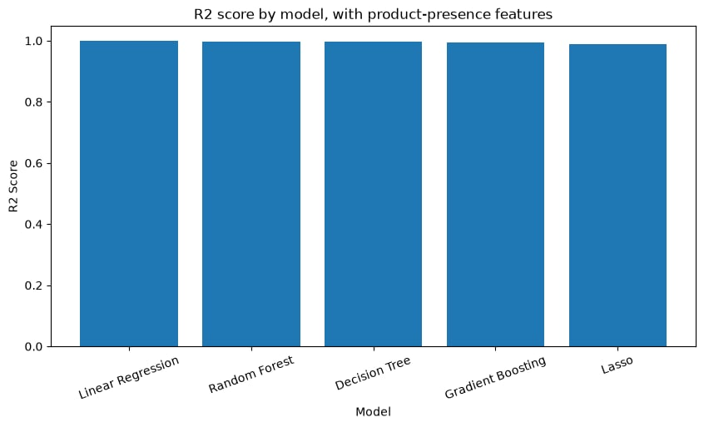
Fig. 7 R² Values by Models
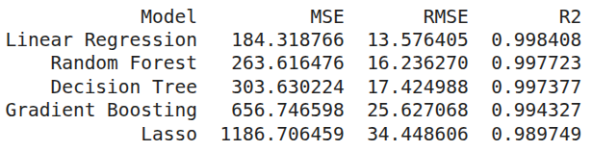
Fig. 8 MSE, RMSE, and R² by Models

Conclusion
Overall, high sales are concentrated in specific hours, months, cities, and products, which meant customer behavior was fairly consistent. This made predicting order-level sales relatively easy. Research questions 1 and 4 revealed clear sales patterns with a strong increase in transactions in December, and between 11 am - 1 pm and 6 pm-8 pm. Additionally, questions 2, 3, and 5 showed that San Francisco had the highest sales contribution among the nine cities, AAA batteries (4-pack) were the best-selling product, and MacBook Pro laptops contributed the most to the company's total revenue. Question 6 indicated which products were frequently purchased together, with Lightning Charging Cables and iPhones being the most common. This suggests that electronics companies need to consider customers' spending behaviors and preferences to make informed decisions about products, product supply, and inventory effectively.
There were some limitations in the project. Firstly, there was no information on customer and customer-level identifiers. It is difficult to distinguish whether the given transactions belong to the same person or multiple different people. If too much data is recorded from a single customer, the sales analysis and predictive models would be biased and cannot be generalized to the majority of customers. This meant companies could not use them. A second limitation is that the given data was for a single year. This means it only represents the pattern of 2019 and does not mean that other years will have similar sales patterns. This leads to the models being trained not being predictive and informative enough for companies to use in making decisions.

References

- [1] M. Hargrave, "Electronic Retailing (E-tailing): Definition, Types, Examples," Investopedia. [Online]. Available: https://www.investopedia.com/terms/e/electronic-retailing-e-tailing.asp. [Accessed: Aug. 9, 2026].

