1-1-1)

a)



b)



1_1_2)

$$f_{0}=2.1 GHz→λ_{0}=\frac{v_{p}}{f_{0}}, v_{p}=c/\sqrt{ϵ_{e} }$$

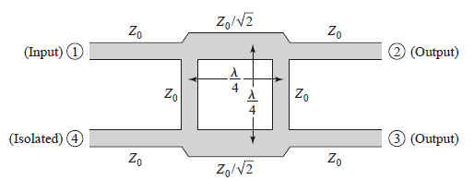

$$assuming Z_{0}=50 Ω$$

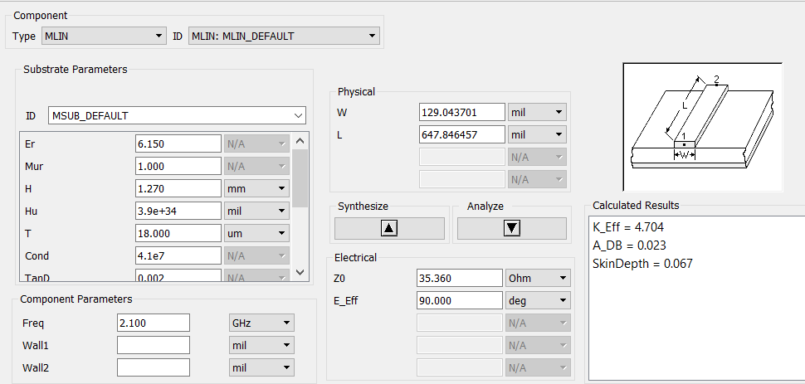

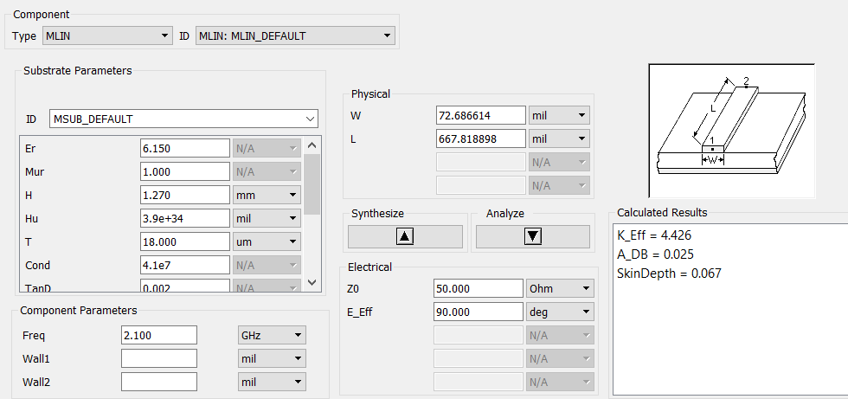

C)

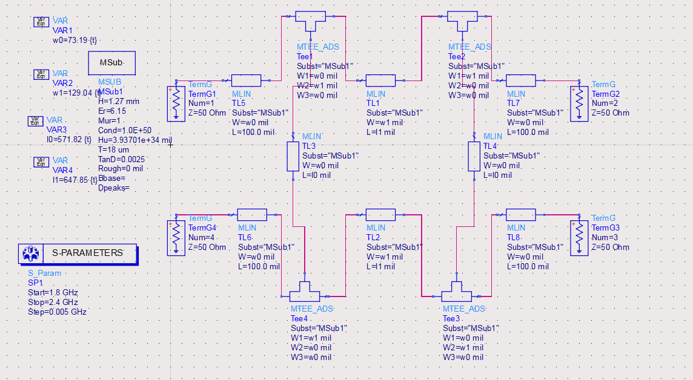

d)



e)



f)





1-1-3)

g)



h)



We have designed an amplifier that is matched at both ports and at the same time has the amplification similarity to the original PMA_5451.

1-1-4)

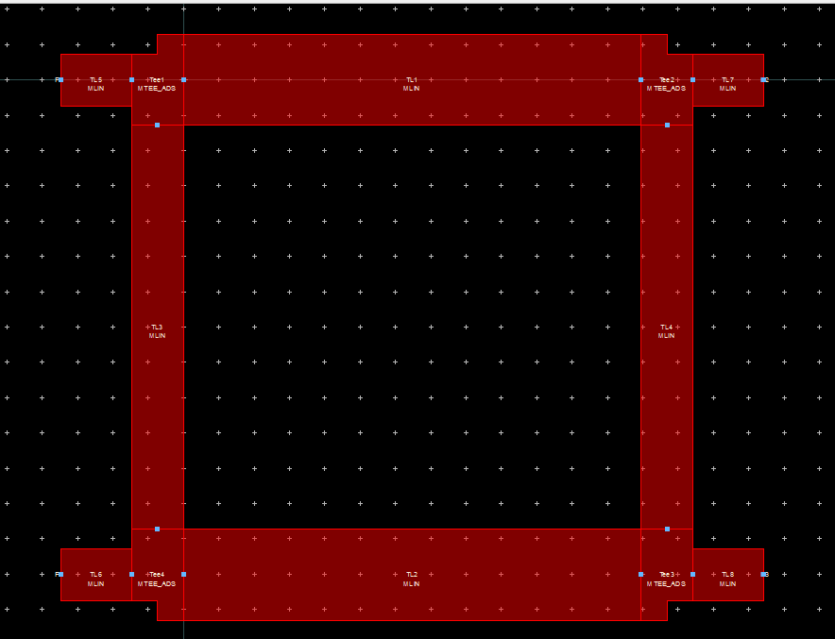





Matching circuit: a binomial three-section transformer.

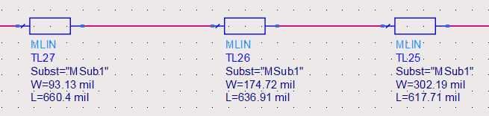

S11:









1-2-1)

a)

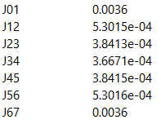

b,c)

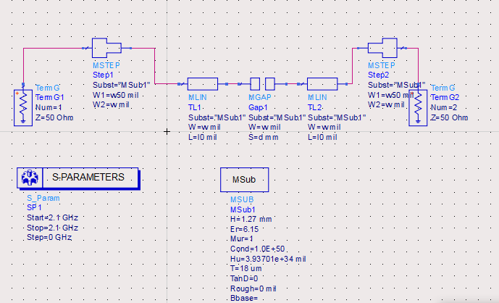

for J01: d=0.01mm , w=363.45mil , phi=-1.5708

for J12: d=1.4mm , w=389.45mil , phi=-1.5708

for J23: d=1.63mm , w=391.45mil. phi=-1.5708

for J34: d=1.66mm , w=391.45mil. phi=-1.5708

for J45: d=1.63mm , w=391.45mil. phi=-1.5708

for J56: d=1.4mm , w=391.45mil. phi=-1.5708

for J67: d=0.01mm , w=363.45mil. phi=-1.5708

$$λg=68mm→l_{j}=\frac{λ_{g}}{2π}\left(π+ϕ\right)=16.96mm$$

d,e)

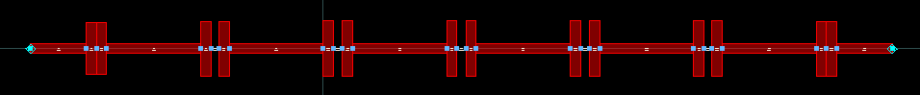





f)

for J01: d=0.027mm , w=363.45mil , phi=-1.5708

for J12: d=1.41mm , w=393.45mil , phi=-1.5708

for J23: d=1.63mm , w=393.45mil. phi=-1.5708

for J34: d=1.67mm , w=393.45mil. phi=-1.5708

for J45: d=1.63mm , w=393.45mil. phi=-1.5708

for J56: d=1.41mm , w=393.45mil. phi=-1.5708

for J67: d=0.027mm , w=363.45mil. phi=-1.5708





g)





Part3

1. Design parameters and antenna schematic:

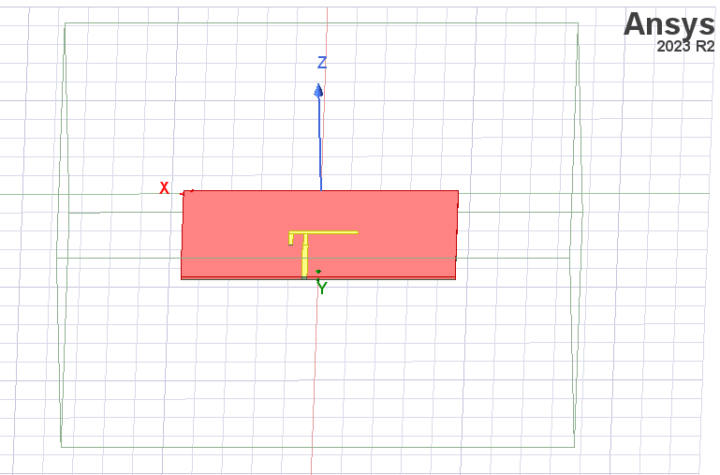

Figure Overview

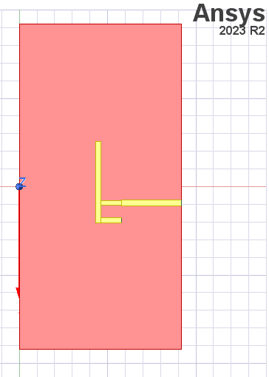

Figure Antenna Schematic

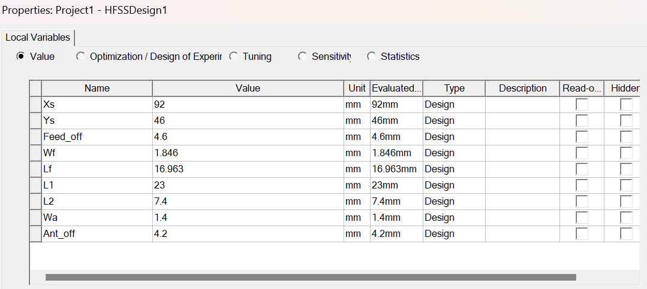

Figure Design Parameters

1. The resonance frequency is 2.0086 GHz

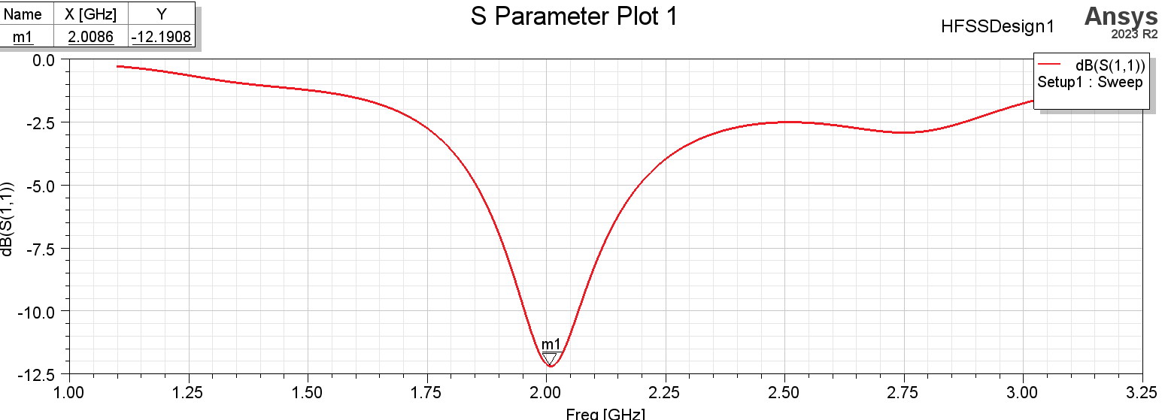

Figure S11

Wf and L1 after tuning for 3% bandwidth:

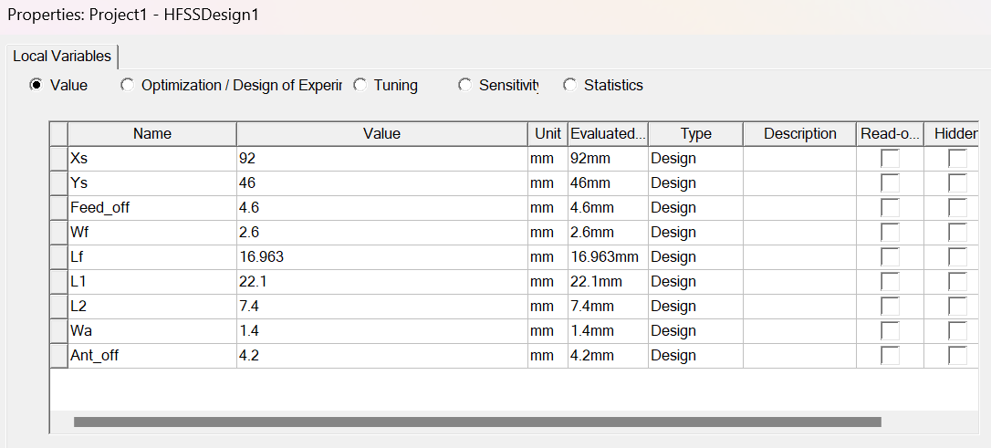

Figure Final parameters

1. 3% bandwidth means 64 MHz range around 2100 MHz, so S11 must be under -20dB from 2068 MHz to 2132 MHz.

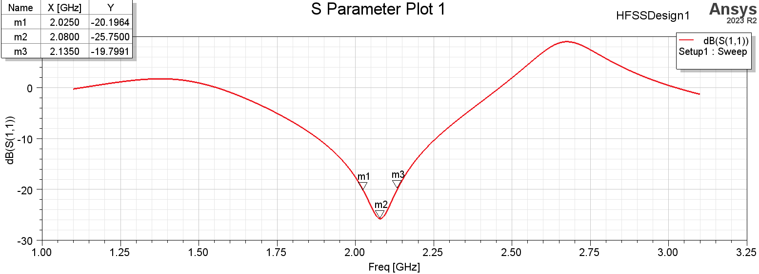

Figure S11 after tuning

1. Realized gain radiation pattern

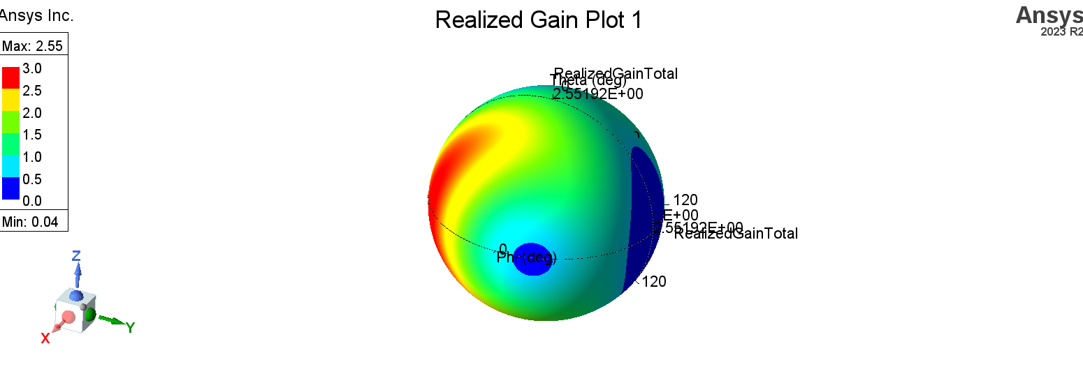

Figure Realized gain

1. Realized gain pattern

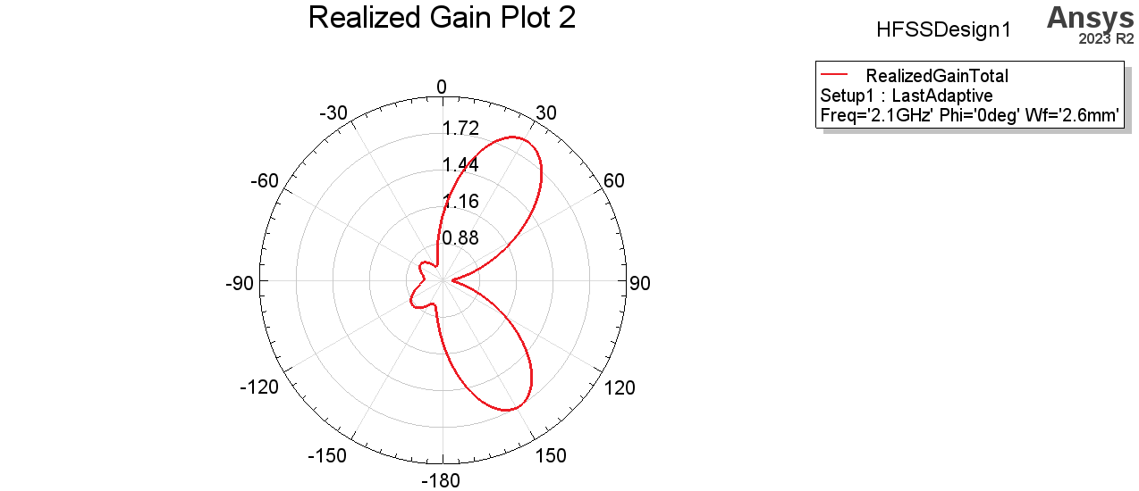

Figure Phi = 0

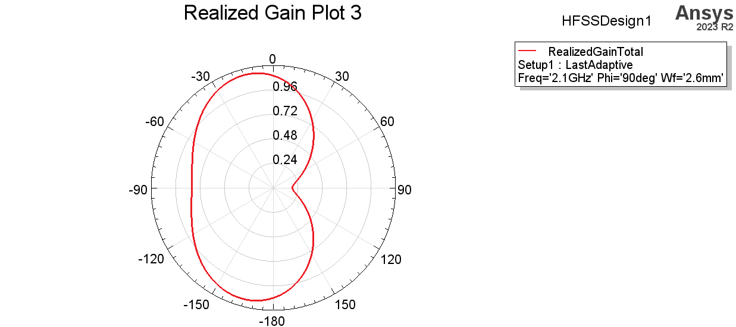

Figure Phi = 90

4)

