# A description of the problem and a discussion of the background. (Introduction where you discuss the business problem and who would be interested in this project.)

As a Chinese student living in Paris, I like to eat Chinese food and drink Bubble Tea (just like most Chinese students). But not every Chinese restaurant has a tea shop nearby. Sometimes it takes more than 30 minutes to reach the tea shop after the meal. With the increasing number of Chinese students studying in Paris, the number of tea shops will increase. In this project, I combined the information of the existing Chinese restaurants and tea shops in Paris, and recommended the address for opening the new bubble tea shop for investment merchants. Investors in the restaurant industry in Paris will be very emotional about this report.

# A description of the data and how it will be used to solve the problem (Data where you describe the data that will be used to solve the problem and the source of the data.)

Data information used: The location of the existing Chinese restaurant in Paris.（From foursquare） The location of the existing tea shop in Paris.（From foursquare）

Since the habit of most Chinese students is to buy a cup of milk tea after eating, the location of the new tea shop should be chosen near the existing Chinese restaurant and away from the existing tea shop to avoid excessive competition.

I will synthesize information about existing Chinese restaurants and tea shops, and then use machine learning methods (mainly k-means) to recommend the address of the new tea shop

# Results section where you discuss the results.

# The existing Chinese food stores have all been classified.

# 

Category 0 means that it is not recommended to open a tea shop here. Other categories represent different degrees of recommendation for opening a tea shop

# Discussion section where you discuss any observations you noted and any recommendations you can make based on the results.

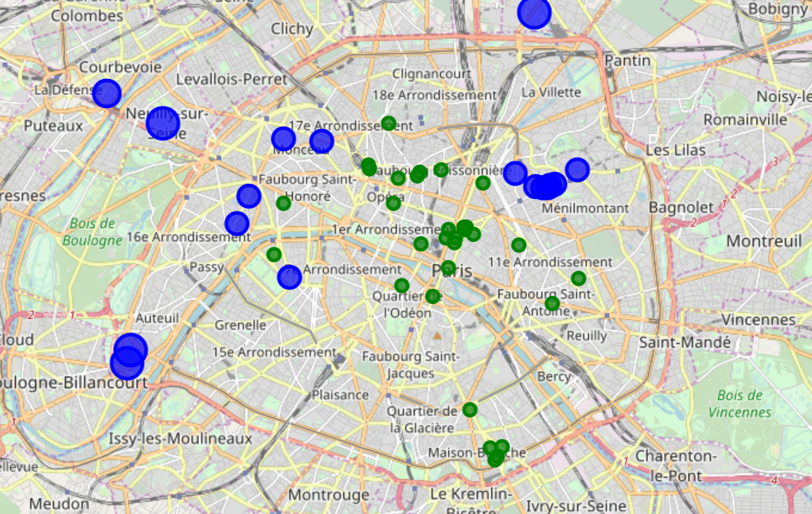

Blue dots are the recommended places to open a new tea shop. Opening a new tea shop in these places will not only ensure the number of customers (the customers who go to the Chinese restaurant are our potential customers), but also avoid the competition of existing tea shops.

**Conclusion section where you conclude the report.**

In this project, I used machine learning algorithms to provide merchants in the restaurant industry with the opening address of the new tea shop, and this conclusion can be reasonably explained. In this project, I successfully applied what I learned in this course. . . Data processing, machine learning, classification prediction, etc. I am very happy to complete this series of courses because I am very interested in data science, and I also believe that data science will be more developed in all walks of life. I also wish you all a happy learning!