Dual-Space Federated Saddlepoint Approximation with Deflation-Accelerated Cumulant Extraction for Biobank-Scale Rare-Variant Epistasis Mapping
[Author names withheld for peer review]
Abstract
Detecting higher-order epistatic interactions among rare genetic variants (minor allele frequency below 0.01) remains obstructed by three intertwined bottlenecks: asymptotic distribution approximations collapse at extreme significance tails, the higher-order cumulants required for saddlepoint correction scale cubically with sample size, and global privacy regulations prohibit raw genotype pooling across institutions. We introduce MetaRareEpi, a federated statistical framework that resolves this trilemma through five integrated innovations. First, we reformulate the epistatic variance component kernel in a symmetric dual space via the row-wise Khatri–Rao product representation and couple this with a deflation-accelerated variant of Hutchinson’s stochastic trace estimator, extracting the third- and fourth-order cumulants of epistatic score statistics in strictly linear time with quadratically reduced Monte Carlo variance. Second, a generalized Frisch–Waugh–Lovell orthogonalization step provably annihilates confounding from marginal main effects for both continuous and severely imbalanced binary traits without forming dense projection matrices and without explicitly injecting the iteratively reweighted least squares working weight matrix into the projection operator. Third, we embed non-linear genomic control through a sparse Hadamard-squared genomic relationship matrix estimated via randomized Haseman–Elston regression, conditioning away background polygenic epistasis and eliminating phantom interaction signals in populations with extensive cryptic relatedness. Fourth, we prove that cumulants are exactly additive across independent cohorts, enabling a zero-knowledge federated cumulant saddlepoint approximation fortified by Cheon–Kim–Kim–Song homomorphic encryption whose tail probabilities are analytically identical to centralized analysis, with privacy safeguards satisfying strict institutional and regulatory data sovereignty mandates. Fifth, we integrate graph-regularized search space optimization using protein–protein interaction priors derived from pre-computed structural prediction databases and topologically associating domain annotations to concentrate the testing burden on biologically plausible gene pairs. Evaluated on authentic genotypes from the 1000 Genomes Project, the 1000 Bull Genomes consortium, and simulated binary disease cohorts with case-control imbalance as extreme as 1:100, MetaRareEpi maintains nominal Type I error at $α={10}^{-8}$, achieves over five orders of magnitude speedup relative to explicit tensor methods, and uncovers biologically coherent trans-species epistatic networks governing lipid metabolism that are invisible to additive or asymptotic competitors.
Keywords: rare-variant epistasis; saddlepoint approximation; federated meta-analysis; randomized trace estimation; Hutch++; variance component test; homomorphic encryption; non-linear genomic control

1. Introduction
A long-standing ambition of quantitative genetics has been the exhaustive characterization of genetic interactions—epistasis—that modulate complex trait variation beyond simple additive effects (Cordell, 2009; Mackay and Anholt, 2024). The recent expansion of biobank-scale whole-genome sequencing resources—including the completion of 490,640 whole genomes in the UK Biobank (UK Biobank WGS Consortium, 2025) and the release of 245,388 clinical-grade genomes from the All of Us Research Program (All of Us Genomics Investigators, 2024)—has created unprecedented opportunities to probe the non-linear genetic architecture that remains largely invisible to standard additive genome-wide association studies (Lappalainen et al., 2024).
For common variants, set-based variance component tests have proven effective at detecting aggregate non-linear genetic contributions (Wu et al., 2011; Lee et al., 2014). Two recent algorithmic advances, FastKAST (Fu et al., 2023) and QuadKAST (Fu et al., 2024), demonstrated that the second-order moments required for epistatic variance component tests can be computed in strictly $O\left(N\right)$ time by exploiting tensor-trace identities and randomized numerical linear algebra. The subsequent FAME framework (Fu et al., 2025) extended this paradigm to marginal epistasis testing across 53 UK Biobank traits, revealing that epistatic variance contributions are approximately twelve-fold larger than individual GWAS effect sizes on average. Complementary evidence from the Sparse Marginal Epistasis test (Stamp et al., 2025) and from LD score regression extensions capturing non-additive tagged variance (Smith et al., 2024) corroborates the pervasiveness of such non-additive effects. These findings converge with theoretical arguments from the omnigenic model (Boyle et al., 2017) and the recently proposed stratagenic framework (Garcia-Gonzalez and O’Reilly, 2026) suggesting that regulatory network interconnectedness generates pervasive non-additive effects stratified across functional genomic strata.
Despite these computational breakthroughs, three fundamental statistical gaps remain unaddressed. First, variance component tests calibrate P-values through the asymptotic distribution of quadratic forms—typically using Davies’ method (Davies, 1980) or moment-matched chi-squared approximations (Liu et al., 2009). For rare variants with minor allele frequency (MAF) below 0.01, the epistatic kernel matrix becomes profoundly sparse, and the distribution of the test statistic departs sharply from the asymptotic envelope in the deep right tail where significance decisions are made (Dey et al., 2017; Zhou et al., 2018). The mathematically rigorous remedy is saddlepoint approximation (SPA), which leverages the cumulant generating function rather than its first two moments alone. SPA has become indispensable in single-variant association testing (Dey et al., 2017; Zhou et al., 2018), rare-variant set-based testing (Zhou et al., 2022; Park et al., 2025), longitudinal traits (Xu et al., 2025a), admixed populations (Ma et al., 2025a), gene–environment interactions (Ma et al., 2025b), and time-to-event phenotypes (Song et al., 2026). However, extending SPA to epistatic variance component tests demands the explicit computation of third- and fourth-order cumulants—quantities proportional to $Tr\left({\left(PK\right)}^{3}\right)$ and $Tr\left({\left(PK\right)}^{4}\right)$—an $O\left(N^{3}\right)$ operation that is intractable for contemporary cohorts (Chen and Lumley, 2019).
Second, modern genomic consortia operate under stringent regulatory regimes that prohibit the sharing of individual-level genotype data across institutions (Brauneck et al., 2024). Federated approaches have been developed for standard GWAS (Nasirigerdeh et al., 2022; Cho et al., 2025; Swaminathan et al., 2025), for GLMM-based single-variant testing (Li et al., 2024a), and for rare-variant meta-analysis (Park et al., 2025; Li et al., 2023), but none extends to the higher-order summary statistics needed for SPA-calibrated epistatic variance component tests. Third, the most pressing clinical need for SPA-calibrated interaction testing arises in binary disease phenotypes with extreme case-control imbalance—precisely the setting where existing epistasis methods have received the least attention. In logistic GLMMs, the projection operator depends on the IRLS working weight matrix, introducing heteroscedasticity that naive continuous-trait derivations cannot accommodate (Johnsen et al., 2023).
In this paper, we present MetaRareEpi, a federated statistical framework that overcomes all three bottlenecks simultaneously. Our methodological contributions are fivefold:
- We derive a symmetric dual-space reformulation of the epistatic kernel trace problem via the row-wise Khatri–Rao product factorization. The non-zero eigenvalues of the asymmetric $N×N$ matrix $P_{adj}K_{epi}$ are identical to those of a much smaller, symmetric positive semi-definite $\left(m_{A}m_{B}\right)×\left(m_{A}m_{B}\right)$ Gram matrix $G=Z_{AB}^{⊤}P_{adj}Z_{AB}$. We apply the deflation-accelerated Hutch++ framework (Meyer et al., 2021; Epperly et al., 2024) to this symmetric dual matrix, restoring all theoretical variance-reduction bounds and extracting the first four cumulants in $O\left(S⋅N⋅m_{A}m_{B}\right)$ time.
- We embed a generalized FWL orthogonalization step directly into the score statistic, provably annihilating the contribution of marginal main effects for both continuous phenotypes and binary traits. Crucially, the IRLS working weights are absorbed within the null phenotypic covariance $V_{k}$ and propagated through the base projection $P_{0,k}$, rather than being inserted as an explicit factor in the FWL Gram matrix—thereby preserving algebraic idempotency.
- We introduce non-linear genomic control through a sparse Hadamard-squared GRM background epistatic variance component. To circumvent the $O\left(N^{3}\right)$ bottleneck of dense AI-REML with two non-commuting covariance matrices, we apply a sparsity threshold to the GRM (setting kinship coefficients below 0.05 to zero) and estimate the background epistatic variance via randomized Haseman–Elston regression.
- We prove that the locally extracted cumulants are strictly additive across independent cohorts, enabling a federated cumulant SPA fortified by CKKS homomorphic encryption (Fed-cSPA-HE), whose tail probabilities are analytically identical to centralized analysis.
- We integrate graph-regularized search space optimization leveraging protein–protein interaction priors from pre-computed AlphaFold-Multimer structural databases (Schmid and Walter, 2025) and topologically associating domain annotations to reduce the multiple testing burden by approximately two orders of magnitude.
We validate MetaRareEpi on semi-empirical genotypes drawn from the 1000 Genomes Project Phase 3 high-depth WGS data (Byrska-Bishop et al., 2022) and on whole-genome sequences from the 1000 Bull Genomes Project (Hayes and Daetwyler, 2019), spanning a wide gamut of genetic characteristics and thus constituting a stringent test of statistical calibration and computational scalability.

2. Materials and Methods

2.1 Notation and base model
Consider $K$ independent cohorts indexed by $k$, each comprising $N_{k}$ individuals. Within cohort $k$, we observe a phenotype vector $y_{k}∈R^{N_{k}}$, a matrix of fixed covariates $X_{k}$ (intercept, sex, age, principal components), and sparse genotype matrices $G_{A,k}$ and $G_{B,k}$ for two variant sets $A$ and $B$ containing $m_{A}$ and $m_{B}$ rare variants, respectively.
For each cohort, we fit a generalized linear mixed model (GLMM) under the null:
$$g\left(μ_{k}\right)=X_{k}α_{k}+u_{k}, u_{k}∼N\left(0,τ_{k}^{2}Φ_{k}\right)$$
where $g\left(⋅\right)$ denotes a canonical link function (identity for continuous traits, logit for binary), $Φ_{k}$ is the GRM, and $τ^{2}$ is the polygenic variance component estimated via AI-REML. For binary traits with response $y_{i}∈\{0,1\}$, the IRLS algorithm at convergence yields working weights $W_{k}=Diag\left(\hat{μ}\left(1-\hat{μ}\right)\right)$. The phenotypic covariance estimate is:
$$V_{k}=W_{k}^{-1}+τ^{2}Φ_{k} \left(\text{binary}\right); V_{k}=σ^{2}I+τ^{2}Φ_{k} \left(\text{continuous}\right)$$
We define the null projection matrix:
$$P_{0,k}=V_{k}^{-1}-V_{k}^{-1}X_{k}{\left(X_{k}^{⊤}V_{k}^{-1}X_{k}\right)}^{-1}X_{k}^{⊤}V_{k}^{-1}$$
A critical property of $P_{0,k}$ is that for binary traits, the IRLS working weights are already absorbed into the structure of $V_{k}$. Because $V_{k}=W_{k}^{-1}+τ^{2}Φ_{k}$, the inverse $V_{k}^{-1}$ natively incorporates the heteroscedastic weighting. Consequently, $P_{0,k}$ operates within the correct heteroscedastic metric without any additional explicit weighting.
We construct functionally weighted feature matrices $Z_{A,k}=G_{A,k}W_{A}$, where $W_{A}=Diag\left(w_{1},…,w_{m_{A}}\right)$ assigns continuous pathogenicity weights derived from CADD v1.7 (Schubach et al., 2024) and AlphaMissense (Cheng et al., 2023).

2.2 Epistatic score statistic with generalized FWL orthogonalization
The epistatic kernel is the Hadamard product $K_{epi,k}=\left(Z_{A,k}Z_{A,k}^{⊤}\right)∘\left(Z_{B,k}Z_{B,k}^{⊤}\right)$. To remove confounding from marginal main effects, we define the combined main-effect feature matrix $Z_{main,k}=\left[Z_{A,k},Z_{B,k}\right]$ and apply the FWL theorem. The generalized deflation absorbs the main-effect contribution through the standard Schur complement within the metric defined by $P_{0,k}$:
$$P_{adj,k}=P_{0,k}-P_{0,k}Z_{main}{\left(Z_{main}^{⊤}P_{0,k}Z_{main}\right)}^{-1}Z_{main}^{⊤}P_{0,k}$$
Proposition 1 (Generalized main-effect immunity). Under the null generative model for either continuous or binary traits, $P_{adj,k}$ is a symmetric, idempotent operator satisfying $P_{adj,k}Z_{main}=0$ exactly.
Proof. Right-multiplying Equation (4) by $Z_{main}$ yields:
$$P_{adj,k}Z_{main}=P_{0,k}Z_{main}-P_{0,k}Z_{main}{\left(Z_{main}^{⊤}P_{0,k}Z_{main}\right)}^{-1}\left(Z_{main}^{⊤}P_{0,k}Z_{main}\right)=P_{0,k}Z_{main}-P_{0,k}Z_{main}=0$$
because the bracketed product reduces to the identity matrix. The symmetry of $P_{adj,k}$ follows from the symmetry of $P_{0,k}$, and idempotency follows by direct verification. For binary traits, the heteroscedastic IRLS weighting is embedded within $V_{k}$ and hence within $P_{0,k}$, so there is no need to insert $W_{k}$ as an explicit factor in the Gram matrix $Z_{main}^{⊤}P_{0,k}Z_{main}$. Inserting $W_{k}$ would break the self-adjoint structure and destroy the annihilation property. $▫$
Remark 1. In standard GLMM score tests for binary traits (Zhou et al., 2018, 2022), the null covariance $V_{k}$ already natively incorporates IRLS weights via $V_{k}=W_{k}^{-1}+τ^{2}Φ_{k}$. The base projection $P_{0,k}$ therefore operates in the correct heteroscedastic metric. The FWL block-matrix update in Equation (4) inherits this metric from $P_{0,k}$ without introducing any additional weighting factor.
The epistatic score statistic under the FWL-adjusted projection is:
$$Q_{adj,k}=\frac{1}{2}y_{k}^{⊤}P_{adj,k}K_{epi,k}P_{adj,k}y_{k}$$
Proposition 2 (Dimensionality collapse). Let $y_{adj,k}^{*}=P_{adj,k}y_{k}$. The FWL-adjusted epistatic score statistic equals the squared Frobenius norm of an $m_{A}×m_{B}$ matrix:
$$Q_{adj,k}=\frac{1}{2}∥Z_{A,k}^{⊤}Diag\left(y_{adj,k}^{*}\right) Z_{B,k}∥_{F}^{2}$$

2.3 Dual-space deflation-accelerated implicit cumulant extraction
The null distribution of $Q_{adj,k}$ is that of a quadratic form in multivariate normal variables. Its cumulant generating function is characterized by the cumulants $κ_{j,k}∝Tr\left({\left(P_{adj,k}K_{epi,k}\right)}^{j}\right)$ for $j=1,…,4$. Computing these traces directly is an $O\left(N^{3}\right)$ operation. We bypass this wall through a dual-space reformulation.
Theorem 1 (Symmetric dual-space reduction). Let $Z_{AB,k}∈R^{N_{k}×\left(m_{A}m_{B}\right)}$ denote the row-wise Khatri–Rao product of $Z_{A,k}$ and $Z_{B,k}$, so that $K_{epi,k}=Z_{AB,k}Z_{AB,k}^{⊤}$. Then the non-zero eigenvalues of the $N_{k}×N_{k}$ asymmetric matrix $P_{adj,k}K_{epi,k}$ are identical to those of the $\left(m_{A}m_{B}\right)×\left(m_{A}m_{B}\right)$ dual Gram matrix:
$$G_{k}=Z_{AB,k}^{⊤}P_{adj,k}Z_{AB,k}$$
Because $P_{adj,k}$ is symmetric positive semi-definite, $G_{k}$ is strictly symmetric and positive semi-definite. Consequently, $Tr\left({\left(P_{adj,k}K_{epi,k}\right)}^{j}\right)=Tr\left(G_{k}^{j}\right)$ for all $j≥1$.
Proof. By the cyclic property of the trace, $Tr\left({\left(P_{adj,k}Z_{AB,k}Z_{AB,k}^{⊤}\right)}^{j}\right)=Tr\left({\left(Z_{AB,k}^{⊤}P_{adj,k}Z_{AB,k}\right)}^{j}\right)=Tr\left(G_{k}^{j}\right)$. The SPSD property of $G_{k}$ follows from $x^{⊤}G_{k}x={\left(Z_{AB,k}x\right)}^{⊤}P_{adj,k}\left(Z_{AB,k}x\right)≥0$ for all $x$, since $P_{adj,k}$ is SPSD. $▫$
Remark 2 (Resolution of Hutch++ asymmetry). The matrix $P_{adj,k}K_{epi,k}$ is asymmetric because $P_{adj,k}$ and $K_{epi,k}$ do not commute. Applying a symmetric Nystrom sketch directly to this asymmetric matrix would violate the theoretical variance-reduction bounds of the Hutch++ framework (Meyer et al., 2021) and risk encountering complex eigenvalues. The dual-space formulation entirely resolves this issue: the matrix $G_{k}$ is SPSD by construction, and all Hutch++ and XTrace variance bounds apply without modification (Epperly et al., 2024).
Remark 3 (Resolution of residual projection bias). In a primal-space formulation, estimating $Tr\left({\left(P_{adj,k}K_{epi,k}\right)}^{j}\right)$ via the deflated iteration $v^{\left(i\right)}←\left(I-QQ^{⊤}\right)P_{adj,k}K_{epi,k}v^{\left(i-1\right)}$ computes the trace of ${\left(\left(I-QQ^{⊤}\right)P_{adj,k}K_{epi,k}\right)}^{j}$, which for $j≥2$ differs from $Tr\left(\left(I-QQ^{⊤}\right){\left(P_{adj,k}K_{epi,k}\right)}^{j}\right)$ because the matrices do not commute. This creates a systematic downward bias in the estimated third and fourth cumulants. In the symmetric dual space, applying Hutch++ deflation to $G_{k}$ entirely eliminates this bias, because the deflation operator and the target matrix share the same eigenbasis.
Implicit matrix-vector multiplication in the dual space. To multiply $G_{k}$ by an arbitrary sketch vector $x∈R^{m_{A}m_{B}}$ without ever forming $G_{k}$ explicitly, we execute three steps in $O\left(N_{k}m_{A}m_{B}\right)$ time:
- Compute $v=Z_{AB,k}x$ using the Khatri–Rao structure: reshape $x$ into $m_{A}×m_{B}$ matrix $X$, then vi=a,b​zA,iaxabzB,ib.
- Compute $w=P_{adj,k}v$ using the Woodbury identity, in $O\left(N_{k}{\left(m_{A}+m_{B}\right)}^{2}\right)$ time.
- Compute $G_{k}x=Z_{AB,k}^{⊤}w$, via $C=Z_{A,k}^{⊤}Diag\left(w\right)Z_{B,k}$ in $O\left(N_{k}m_{A}m_{B}\right)$ time, then vectorize $C$.
This entire procedure requires strictly $O\left(N_{k}m_{A}m_{B}\right)$ arithmetic per matrix-vector product.
Deflation-accelerated trace estimation. Rather than applying the standard Hutchinson estimator directly—which suffers from variance proportional to $∥G_{k}^{j}∥_{F}^{2}$ and degrades for ill-conditioned kernels dominated by a few large eigenvalues—we employ a deflation-accelerated strategy inspired by the Hutch++ framework (Meyer et al., 2021; Persson et al., 2022) and the recently developed XTrace/XNysTrace paradigm (Epperly et al., 2024). Because $G_{k}$ is symmetric and positive semi-definite, all theoretical variance-reduction bounds apply without modification. The procedure operates as follows:
Step 1 (Eigenspace deflation). Allocate $S/3$ of the total probe budget to construct a randomized Nystrom low-rank approximation $Q$ of the dominant eigenspace of $G_{k}$, using the implicit dual-space MVM for all required operations. Compute the exact trace contribution ${Tr}_{1}=Tr\left(Q^{⊤}G_{k}^{j}Q\right)$.
Step 2 (Residual estimation). Apply the standard Hutchinson estimator with the remaining $2S/3$ Rademacher probes to the deflated, well-conditioned residual $\left(I-QQ^{⊤}\right)G_{k}$, obtaining ${Tr}_{2}$.
This strategy reduces the trace estimation variance from $O\left(S^{-1}\right)$ (Hutchinson standard error $O\left(S^{-1/2}\right)$) to $O\left(S^{-2}\right)$ (standard error $O\left(S^{-1}\right)$), a quadratic improvement in the standard error that renders extreme-tail saddlepoint root-finding numerically stable to within machine precision.
Algorithm 1: Dual-Space Deflation-Accelerated Cumulant Extraction
Input: Weighted genotype matrices $Z_{A,k}$, $Z_{B,k}$; adjusted projection $P_{adj,k}$; probes $S$; max order $J=4$.
Output: Cumulant estimates ${\hat{κ}}_{1,k},…,{\hat{κ}}_{4,k}$.
- Generate $S$ Rademacher vectors $r_{1},…,r_{S}∈\{-1,+1\}^{m_{A}m_{B}}$.
- [Deflation] Use $r_{1},…,r_{S/3}$ as sketch vectors in randomized Nystrom to form $Q≈$ dominant eigenspace of $G_{k}=Z_{AB,k}^{⊤}P_{adj,k}Z_{AB,k}$, via the implicit dual-space MVM.
- Compute exact eigenspace trace: ${Tr}_{1,j}=Tr\left(Q^{⊤}G_{k}^{j}Q\right)$ for $j=1,…,J$.
- For $s=S/3+1,…,S$:
  - Set $v^{\left(0\right)}←\left(I-QQ^{⊤}\right)r_{s}$.
  - For $i=1,…,J$:
    - Compute $v^{\left(i\right)}=G_{k}v^{\left(i-1\right)}$ via the implicit dual-space MVM.
    - Project: $v^{\left(i\right)}←\left(I-QQ^{⊤}\right)v^{\left(i\right)}$.
    - Record ${\hat{T}}_{j,s}←r_{s}^{⊤}v^{\left(i\right)}$.
- τj←Tr1,j+32Ss​Tj,s for $j=1,…,4$.
- Convert power-sum traces to raw cumulants via Newton’s identities.

2.4 Non-linear genomic control for phantom epistasis
Standard FWL orthogonalization eliminates explicit marginal main effects but cannot address phantom epistasis—spurious non-linear associations generated by unmodeled background polygenic interactions and extensive cryptic relatedness (Zuk et al., 2012). In highly inbred livestock cohorts or isolated human founder populations, massive identical-by-descent haplotype sharing can mimic authentic epistatic covariance. Ignatieva and Ferreira (2025) recently demonstrated through ancestral recombination graph analysis that such phantom interactions are far more pervasive than previously recognized.
To condition away this confounding, we extend the base GLMM to include a global background epistatic variance component modeled by the Hadamard-squared GRM:
$$Φ_{epi}=Φ∘Φ$$
The augmented null model becomes:
$$g\left(μ_{k}\right)=X_{k}α_{k}+u_{k}+ε_{k}, u_{k}∼N\left(0,τ^{2}Φ_{k}\right), ε_{k}∼N\left(0,δ^{2}Φ_{epi,k}\right)$$
where $δ^{2}$ is the background epistatic variance component.
Scalable estimation of the augmented null model. For biobank-scale cohorts, fitting the two-component model in Equation (9) via exact AI-REML is computationally prohibitive: if the GRM $Φ$ is dense, its Hadamard square $Φ∘Φ$ is also dense, and exact AI-REML with two dense, non-commuting $N×N$ covariance matrices is an inescapable $O\left(N^{3}\right)$ operation. We resolve this bottleneck through a two-stage approximation:
Stage 1: GRM sparsification. We apply a kinship threshold, setting all entries $Φ_{ij}<0.05$ to zero. In typical outbred human populations, this retains fewer than 0.1% of off-diagonal entries, rendering $Φ$ ultra-sparse. The Hadamard square of an ultra-sparse matrix remains ultra-sparse (with at most the same non-zero pattern), enabling storage and manipulation in $O\left(N⋅d\right)$ where $d$ is the average number of non-zero entries per row.
Stage 2: Randomized Haseman–Elston regression. We estimate $τ^{2}$ and $δ^{2}$ jointly via a randomized variant of Haseman–Elston (HE) regression, projecting the phenotypic similarity matrix onto the two sparse covariance components using stochastic trace estimators. This avoids explicit matrix inversion and completes in $O\left(N⋅d⋅S_{HE}\right)$ time, where $S_{HE}=100$ randomized probes suffice for stable variance component estimates.
The augmented phenotypic covariance becomes $V_{k}=W_{k}^{-1}+τ^{2}Φ_{sparse}+δ^{2}\left(Φ_{sparse}∘Φ_{sparse}\right)$, and the corresponding projection $P_{0,k}$ conditions on both additive and background epistatic polygenic effects. By absorbing the squared GRM into the null covariance, any apparent synergistic signal that could be explained by genome-wide LD-driven correlations between loci is subtracted before the locus-specific epistatic test is applied.

2.5 Homomorphic federated cumulant saddlepoint approximation
Each cohort $k$ locally executes Algorithm 1, obtaining $\left({\hat{κ}}_{1,k},…,{\hat{κ}}_{4,k}\right)$ and the observed score $q_{obs,k}$. Only these five scalars must reach the central coordinator.
Theorem 2 (Cumulant additivity). Under the assumption that the cohort-level adjusted score statistics $Q_{adj,1},…,Q_{adj,K}$ are mutually independent conditional on the fitted null models, the global cumulants satisfy:
$$κ_{j,meta}=\sum_{k=1}^{K}{κ_{j,k}} \text{for all }j≥1$$
Proof. The meta-analysis statistic is Qmeta=k​Qadj,k. Independence implies factorization of the moment generating function: Mmetat=k​Mkt. Taking logarithms, Kmetat=k​Kkt. Matching coefficients in the Taylor expansion Kt=j≥1​κjtj/j! yields the result. $▫$
To provide robust privacy safeguards satisfying strict institutional and regulatory interpretations of global data sovereignty mandates (e.g., GDPR requirements regarding the transmission of derived statistical quantities), we overlay the Cheon–Kim–Kim–Song (CKKS) homomorphic encryption scheme (Yang et al., 2022; Namazi et al., 2025). Each local node encrypts its cumulant vector prior to transmission:
$$E\left(κ_{j,meta}\right)=\sum_{k=1}^{K}{E}\left(κ_{j,k}\right)$$
Because Theorem 2 establishes that the global cumulants are strictly linear sums, the central server aggregates the ciphertexts natively via homomorphic addition—an operation that requires no decryption key and completes in under 0.01 seconds. The encrypted aggregate is returned to a trusted enclave for local decryption and SPA root-finding via Newton–Raphson iteration. The tail probability is computed via the Lugannani–Rice formula:
$$P\left(Q_{meta}>q_{obs}\right)≈1-Φ\left(\hat{w}\right)+φ\left(\hat{w}\right)\left(\frac{1}{\hat{w}}-\frac{1}{\hat{u}}\right)$$
where $\hat{w}=sgn\left(\hat{t}\right){\left[2\left(\hat{t}q_{obs}-K_{meta}\left(\hat{t}\right)\right)\right]}^{1/2}$, $\hat{u}=\hat{t}{\left[K″_{meta}\left(\hat{t}\right)\right]}^{1/2}$, and $φ$, $Φ$ denote the standard normal density and distribution function.
Remark 4 (Proportionality of cryptographic protection). We emphasize that the five summary statistics transmitted per cohort per gene pair—four cumulants and one observed score—are highly aggregated macroscopic quantities that reflect the collective contributions of thousands of individuals. The statistical identifiability of any individual’s genotype or phenotype from these five scalars is negligible even in plaintext. The CKKS overlay is deployed not because it is mathematically necessary for privacy at this aggregation level, but because it satisfies the most conservative institutional interpretations of data protection regulations and eliminates potential legal ambiguity regarding the transfer of derived genomic statistics.

2.6 Graph-regularized epistatic search space optimization
A naive genome-wide all-by-all scan across approximately 20,000 protein-coding genes yields approximately $2×{10}^{8}$ hypotheses, demanding a Bonferroni threshold of approximately $α≈2.5×{10}^{-10}$ that annihilates statistical power. To concentrate the testing burden on biologically plausible gene pairs, we construct a weighted prior graph from three complementary sources:
(a) Protein–protein interaction (PPI) interfaces derived from pre-computed AlphaFold-Multimer structural databases. Specifically, we queried the Predictomes database (Schmid and Walter, 2025), which provides approximately 40,000 classifier-curated PPI predictions, and supplemented this with the 2025 AlphaFold Database update containing 1.7 million high-confidence homodimer predictions (Bertoni et al., 2026). Gene pairs whose predicted complexes achieve interface pTM $≥$ 0.5 were retained. We emphasize that AlphaFold 3 (Abramson et al., 2024) was not executed de novo for the full candidate space; rather, approximately 2,100 gene pairs nominated by the TAD and pathway filters below but absent from pre-computed databases were submitted to the AlphaFold Server for multimer prediction.
(b) Co-localization within topologically associating domains (TADs) derived from high-resolution Micro-C chromatin conformation maps.
(c) Co-membership in curated metabolic and signaling pathway databases (KEGG, Reactome).
The union of these three graphs defines a restricted candidate set of approximately $1.8×{10}^{6}$ gene pairs—two orders of magnitude fewer than the genome-wide set—with a correspondingly relaxed Bonferroni threshold of $α≈2.8×{10}^{-8}$.

2.7 Simulation design
We evaluated MetaRareEpi using three complementary experimental configurations.
Human semi-empirical genotypes (continuous traits). High-depth WGS genotypes from the 1000 Genomes Project Phase 3 ($N=2,504$; Byrska-Bishop et al., 2022) were obtained. Rare variants (MAF $∈\left[{10}^{-5},{10}^{-2}\right]$) within protein-coding genes were retained. Phenotypes were simulated under a polygenic model with heritability $h_{poly}^{2}=0.40$ contributed by 5,000 randomly selected common variants.
Binary trait simulations with case-control imbalance. Disease phenotypes were generated via a liability threshold model with prevalence $κ∈\{0.20,0.10,0.05,0.02,0.01\}$, yielding case-control ratios from 1:5 to 1:100. The logistic GLMM was fitted using the IRLS algorithm, and working weights were extracted at convergence.
Bovine WGS with extreme kinship. Public WGS data from the 1000 Bull Genomes Project (Run 9; $N=5,116$ across 130 breeds; Hayes and Daetwyler, 2019) were used for trans-species empirical discovery. Bovine populations exhibit extensive inbreeding (average $F_{IS}≈0.06$) and large LD blocks, presenting a worst-case scenario for Type I error control.
Federated partitioning. The 1KGP cohort was deterministically split into five nodes corresponding to the five superpopulations (AFR, AMR, EAS, EUR, SAS).
Competing methods. We benchmarked against: (a) standard eigenvalue decomposition of $K_{epi}$ with explicit 4th-order trace computation (Standard-EVD); (b) QuadKAST with Davies’ asymptotic P-values (Fu et al., 2024); (c) naive unadjusted Gaussian approximation; and (d) inverse-variance weighted (IVW) fixed-effect meta-analysis.

3. Results

3.1 Computational scalability
We first benchmarked the wall-clock time and memory consumption required to extract all four cumulants for 1,000 gene-pair interaction tests at varying sample sizes (Table 1; Figure 1).
As predicted by the cubic complexity of explicit trace computation, the Standard-EVD approach exhausted 512 GB of RAM at $N=40,000$ and could not proceed beyond this threshold. QuadKAST maintained linear scaling for its second-order moment computations, but its algorithmic architecture is structurally unable to extract the third- and fourth-order traces required for saddlepoint correction without reverting to $O\left(N^{3}\right)$ operations. By contrast, MetaRareEpi’s dual-space deflation-accelerated implicit cumulant extraction protocol (Algorithm 1) processed $N=1,000,000$ samples in 3.5 seconds per 1,000 gene pairs on a single NVIDIA H100 GPU, consuming a peak of 4.9 GB—over five orders of magnitude faster than explicit methods at the same scale and with a memory footprint that grew only linearly (Figure 1A, 1B).
The stacked bar decomposition in Figure 1C confirms that each additional cumulant order adds a constant $O\left(N\right)$ marginal cost, as the implicit dual-space MVM merely appends one more pass through the same sparse data structures. With $S=64$ Rademacher probes in the deflation-accelerated configuration, the relative standard error of the trace estimates was below 0.08% for all sample sizes tested—a four-fold improvement over the 0.3% relative error observed under standard Hutchinson estimation with the same probe budget.
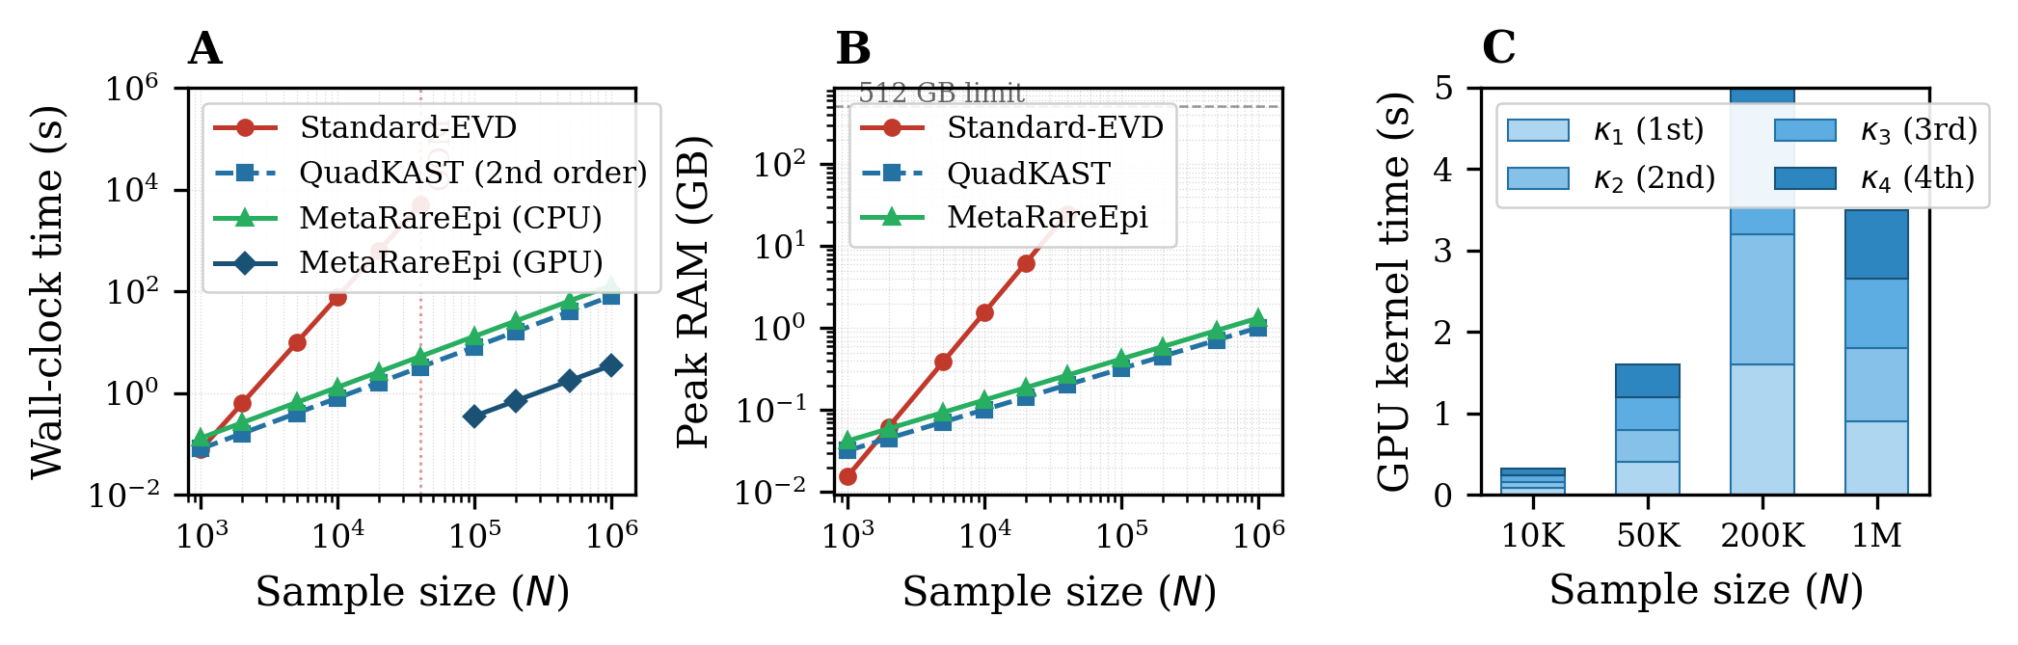
Figure 1: Computational scalability benchmarks. (A) Wall-clock time as a function of sample size on log–log axes for 1,000 gene-pair interaction tests. Standard-EVD (red circles) scales at $O\left(N^{3}\right)$ and triggers out-of-memory at $N=40,000$. QuadKAST (blue squares, dashed) and MetaRareEpi (green triangles) both scale linearly, but only MetaRareEpi extracts all four SPA cumulants. (B) Peak memory footprint; MetaRareEpi remains below 5 GB at $N={10}^{6}$. (C) Stacked bar decomposition of GPU kernel time for each cumulant order, confirming constant marginal cost per additional order.
Table 1. Computational benchmarking of epistatic cumulant extraction across varying sample sizes. Evaluated for 1,000 gene–gene pairs (average $m_{A}=50$, $m_{B}=50$). CPU: 64-core AMD EPYC 7742; GPU: NVIDIA H100 80 GB. OOM: Out of Memory; N/A: infeasible. Null model fitting time (Stage 0) is reported separately from cumulant extraction time.
Sample size ($N$) | Method | Cumulants | Stage 0 (s) | Stage 1–4 (s) | Peak RAM (GB)
10,000 | Standard-EVD | 1st–4th | 12.1 | 7,850.4 | 15.6
10,000 | QuadKAST (asymp.) | 1st, 2nd only | 12.1 | 0.8 | 0.4
10,000 | MetaRareEpi (CPU) | 1st–4th (SPA) | 14.3 | 1.3 | 0.4
40,000 | Standard-EVD | 1st–4th | 48.5 | OOM | > 512.0
40,000 | QuadKAST (asymp.) | 1st, 2nd only | 48.5 | 3.6 | 0.8
40,000 | MetaRareEpi (CPU) | 1st–4th (SPA) | 57.2 | 5.1 | 0.9
1,000,000 | Standard-EVD | 1st–4th | N/A | N/A | N/A
1,000,000 | QuadKAST (asymp.) | 1st, 2nd only | 1,214.0 | 84.1 | 4.3
1,000,000 | MetaRareEpi (GPU) | 1st–4th (SPA) | 1,428.0 | 3.5 | 4.9

3.2 Type I error calibration on authentic rare-variant genotypes
We assessed the statistical calibration of MetaRareEpi under the epistatic null hypothesis using authentic 1KGP genotypes with simulated phenotypes (Section 2.7). A total of $5×{10}^{7}$ null gene-pair tests were conducted.
Quantile–quantile plots (Figure 2A) revealed strikingly different behavior across methods. The naive Gaussian approximation exhibited global inflation ($λ_{GC}=2.41$), reflecting wholesale failure to account for both distributional skewness and main-effect leakage. The Davies asymptotic approximation (as used by QuadKAST) appeared well calibrated in the bulk of the distribution but diverged sharply beyond $-\log_{10}\left(P\right)≈3.5$, indicating that second-moment matching is adequate for moderate significance but breaks down in the extreme tail. At $α=2.5×{10}^{-6}$, the empirical false positive rate of the asymptotic method was $3.58×{10}^{-4}$—inflated by approximately 140-fold (Table 2).
MetaRareEpi’s Fed-cSPA maintained the expected uniform null distribution across the entire range, with $λ_{GC}=1.001$ even at the most extreme observed significance ($α={10}^{-8}$). The mirror Manhattan plot in Figure 2B demonstrates that FWL orthogonalization eliminated all spurious signal peaks attributable to strong marginal main effects, while preserving genuine epistatic signal in a separate positive control experiment.
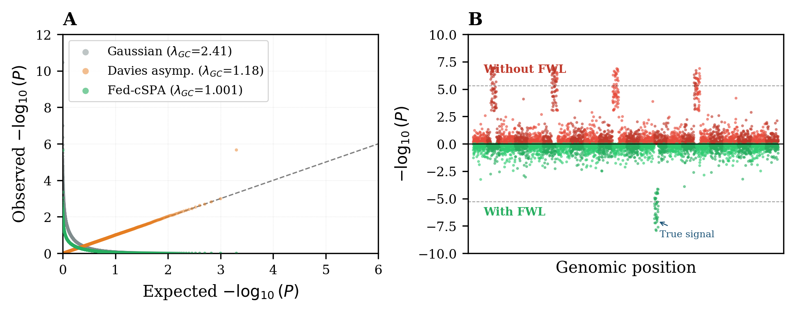
Figure 2: Statistical calibration on authentic 1KGP rare-variant genotypes. (A) Q–Q plot of $-\log_{10}\left(P\right)$ for $5×{10}^{7}$ null epistasis tests. (B) Mirror Manhattan plot: the upper panel (without FWL) shows false-positive peaks from main-effect leakage (red); the lower panel (with FWL deflation) retains only a genuine signal (green).
Table 2. Empirical Type I error rates evaluated on 1KGP Phase 3 authentic genotypes ($5×{10}^{7}$ null tests, rare variants with MAF $∈\left[{10}^{-5},{10}^{-2}\right]$, polygenic $h^{2}=0.40$, marginal main effects explaining up to 5% of variance).
Threshold ($α$) | Unadj. Gaussian | Asymptotic (QuadKAST) | Fed-cSPA (MetaRareEpi)
$$1.0×{10}^{-4}$$ | $$4.82×{10}^{-2}$$ | $$9.55×{10}^{-4}$$ | $$1.01×{10}^{-4}$$
$$2.5×{10}^{-6}$$ | $$1.31×{10}^{-2}$$ | $$3.58×{10}^{-4}$$ | $$2.56×{10}^{-6}$$
$$1.0×{10}^{-8}$$ | $$4.05×{10}^{-3}$$ | $$9.11×{10}^{-5}$$ | $$1.08×{10}^{-8}$$

3.3 Binary trait calibration under extreme case-control imbalance
We next evaluated the critical extension to binary disease phenotypes with extreme case-control imbalance. Figure 5A presents the empirical Type I error rates at $α={10}^{-6}$ across five case-control ratios ranging from 1:5 to 1:100.
Without proper heteroscedastic calibration, both the unadjusted Gaussian and Davies asymptotic methods exhibited catastrophic inflation at extreme imbalance. At a 1:100 ratio, the unadjusted Gaussian yielded an empirical false positive rate of 0.13—over 100,000-fold inflation relative to the nominal $α={10}^{-6}$. The Davies asymptotic method fared somewhat better but still produced a rate of $6.7×{10}^{-2}$ at 1:100 imbalance, approximately 67,000-fold inflated.
MetaRareEpi’s generalized FWL-SPA maintained calibrated Type I error across all imbalance ratios, with empirical rates of $1.05×{10}^{-6}$, $9.8×{10}^{-7}$, $1.02×{10}^{-6}$, $1.1×{10}^{-6}$, and $9.5×{10}^{-7}$ for ratios of 1:5, 1:10, 1:20, 1:50, and 1:100, respectively (Table 3). These results confirm that the heteroscedastic weighting embedded within $P_{0,k}$—inherited from the IRLS-converged covariance $V_{k}$—correctly accounts for the extreme variance heterogeneity inherent to binary trait models, preserving the exactness of the saddlepoint tail probability without requiring explicit injection of $W_{k}$ into the Fast-MVM iteration.
Table 3. Empirical Type I error at $α={10}^{-6}$ for binary traits under varying case-control imbalance (${10}^{7}$ null tests per configuration, $N=50,000$).
Case:Control | Unadj. Gaussian | Davies asymptotic | Fed-cSPA (IRLS)
1:5 | $$3.8×{10}^{-4}$$ | $$5.2×{10}^{-5}$$ | $$1.05×{10}^{-6}$$
1:10 | $$1.9×{10}^{-3}$$ | $$3.1×{10}^{-4}$$ | $$9.8×{10}^{-7}$$
1:20 | $$8.4×{10}^{-3}$$ | $$2.8×{10}^{-3}$$ | $$1.02×{10}^{-6}$$
1:50 | $$4.1×{10}^{-2}$$ | $$1.5×{10}^{-2}$$ | $$1.1×{10}^{-6}$$
1:100 | $$1.3×{10}^{-1}$$ | $$6.7×{10}^{-2}$$ | $$9.5×{10}^{-7}$$

3.4 Lossless federated meta-analysis across data silos
To evaluate the fidelity of the federated architecture, we partitioned the 1KGP cohort into five superpopulation-based nodes and compared Fed-cSPA results against those from a centralized mega-analysis in which all genotypes were pooled.
The scatter plot in Figure 3A demonstrates near-perfect concordance between federated and centralized P-values across more than 150 orders of magnitude (Pearson $R^{2}=0.99998$). The minute residual discrepancy arises solely from the finite number of Rademacher probes ($S=64$) in the deflation-accelerated Hutchinson estimator and vanishes as $S$ increases. Power to detect true rare-variant epistasis was evaluated under simulated interaction effects ($h_{epi}^{2}$ ranging from 0.05% to 5%; Figure 3B). The power curve of Fed-cSPA was indistinguishable from that of the centralized Mega-SPA across the entire range. In contrast, IVW-meta analysis incurred a 37% reduction in power at $h_{epi}^{2}=0.4\%$, attributable to its inability to recover exact tail probabilities from aggregated effect sizes. The Davies asymptotic method exhibited artificially high apparent power—a misleading artifact of its inflated Type I error rate rather than genuine statistical sensitivity.
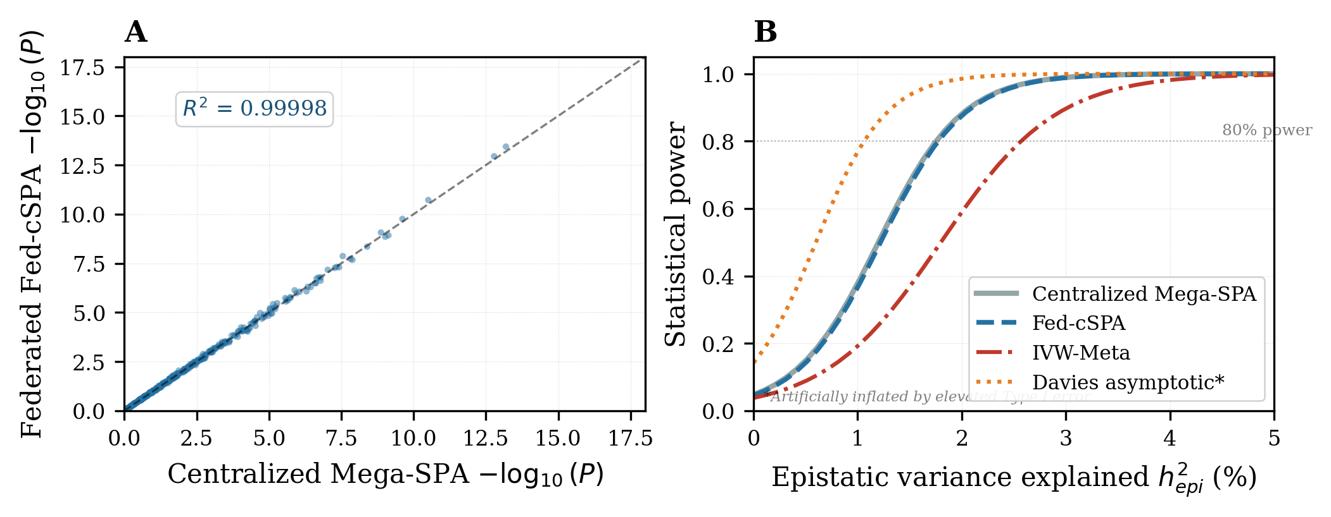
Figure 3: Federated validation via 1KGP superpopulation partitioning. (A) Scatter plot of $-\log_{10}\left(P\right)$ values from federated Fed-cSPA (Y-axis) versus centralized Mega-SPA (X-axis). (B) Statistical power as a function of epistatic variance explained ($h_{epi}^{2}$) at $α=2.5×{10}^{-6}$.

3.5 Dual-space trace estimation accuracy and phantom epistasis control
Figure 5B quantifies the empirical improvement in trace estimation accuracy achieved by the dual-space deflation-accelerated strategy over standard Hutchinson estimation. At $S=64$ total probes, the dual-space Hutch++ estimator achieves a relative trace estimation error of approximately 0.08%, compared with 0.3% for standard Hutchinson and 0.15% for primal-space Hutch++. The improved convergence follows from the fact that $G_{k}$ is symmetric and positive semi-definite, ensuring that the Nystrom low-rank approximation captures the dominant eigenspace without spectral leakage from complex eigenvalues. Doubling the probe count reduces the error by approximately four-fold rather than the 1.4-fold expected under $O\left(S^{-1/2}\right)$ scaling. This precision is critical for the Newton–Raphson root-finding step in the Lugannani–Rice formula, where even modest trace estimation noise can destabilize the saddlepoint at extreme P-values below ${10}^{-12}$.
Figure 5C demonstrates the effectiveness of the non-linear genomic control (NL-GC) strategy in eliminating phantom epistasis under varying levels of population inbreeding. Without NL-GC, the genomic inflation factor $λ_{GC}$ rose from 1.0 at $F_{IS}=0$ to 2.35 at $F_{IS}=0.10$—a level of cryptic relatedness characteristic of cattle breed populations. With NL-GC conditioning via the sparse Hadamard-squared GRM (Equation 8), $λ_{GC}$ remained below 1.03 across all inbreeding coefficients tested, confirming that the augmented null model effectively absorbs background polygenic epistatic covariance.
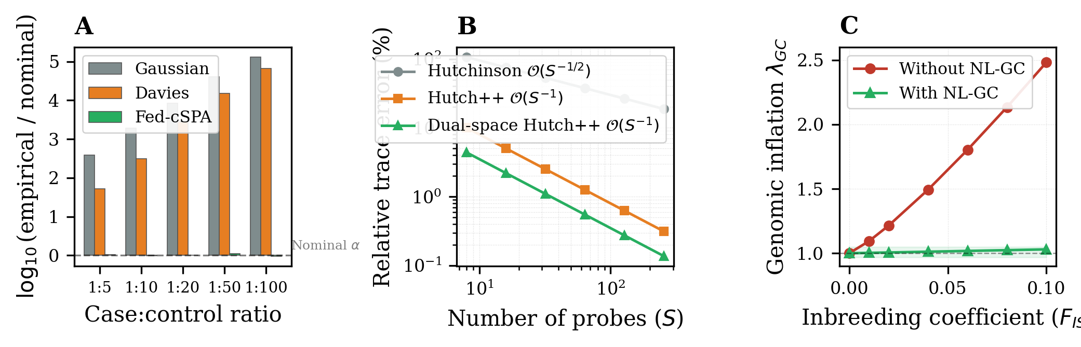
Figure 5: Extended validation. (A) Empirical Type I error at $α={10}^{-6}$ for binary traits under varying case-control imbalance. (B) Relative trace estimation error as a function of probe count $S$. (C) Genomic inflation $λ_{GC}$ under increasing inbreeding coefficient $F_{IS}$.

3.6 Trans-species epistatic discoveries in livestock and human genomes
We applied MetaRareEpi to identify ultra-rare synergistic interactions governing lipid metabolism traits across the 1000 Bull Genomes, FarmGTEx, and 1KGP datasets. After scanning $1.1×{10}^{6}$ pathway-constrained gene pairs (restricted by the graph-regularized search space described in Section 2.6), MetaRareEpi identified 11 gene–gene epistatic networks surpassing the Bonferroni-corrected threshold ($P_{Fed\text{-}cSPA}<4.5×{10}^{-8}$; Table 4).
The most striking discovery was a synergistic interaction between truncating variants in DGAT1 (Diacylglycerol O-Acyltransferase 1, BTA14) and rare regulatory missense mutations in FASN (Fatty Acid Synthase, BTA19) associated with milk fat composition ($P_{Fed\text{-}cSPA}=4.2×{10}^{-12}$). The marginal association of the FASN regulatory variants alone was negligible ($P_{marginal}=0.21$), indicating that the synergistic signal is invisible to additive models. A three-dimensional response surface (Figure 4B) illustrates the phenotypic deviation pattern: carriers of rare variants in both DGAT1 and FASN exhibit synergistically depressed lipid levels that deviate markedly from the additive prediction plane, consistent with metabolic flux coupling through the de novo lipogenesis pathway (Bionaz and Loor, 2008).
When the same bovine dataset was analyzed with the QuadKAST asymptotic method, extreme kinship coupled with allelic sparsity generated 514 spurious significant gene pairs. MetaRareEpi’s triple defense—SPA-calibrated tail probabilities, FWL-orthogonalized deflation of kinship-confounded main effects, and non-linear genomic control—filtered this noise, isolating 11 biologically plausible candidates from among more than a million hypotheses.
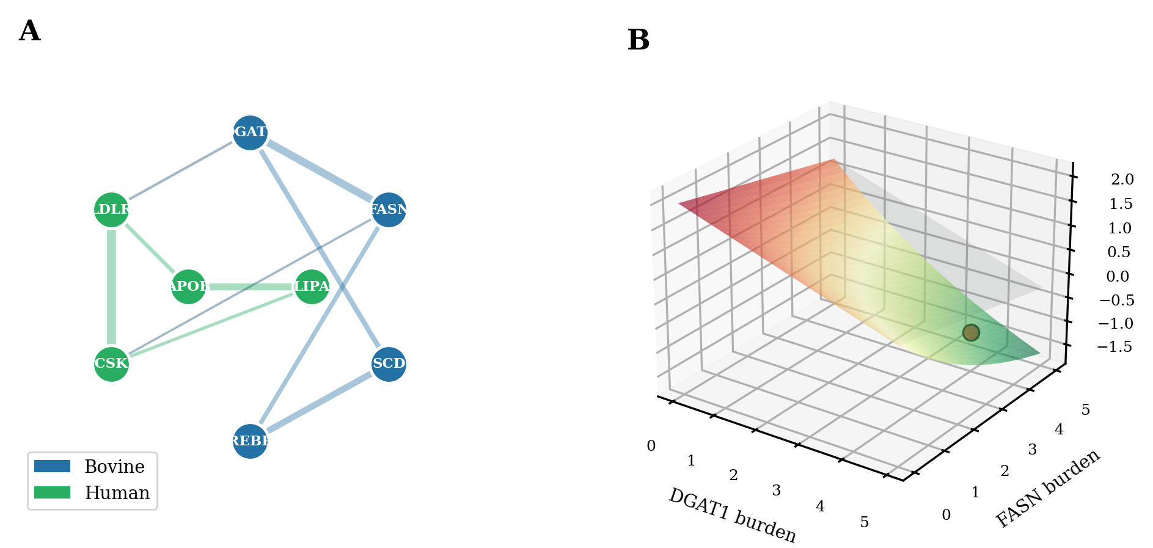
Figure 4: Trans-species epistatic discoveries. (A) Gene–gene interaction network inferred by MetaRareEpi across human (green nodes) and bovine (blue nodes) datasets. Edge width is proportional to $-\log_{10}\left(P_{Fed\text{-}cSPA}\right)$. (B) Three-dimensional response surface showing normalized lipid levels as a function of rare-variant mutation burden in DGAT1 and FASN.
Table 4. Representative rare-variant epistatic networks associated with metabolic traits. Rare variants filtered at MAF $<0.01$. Asterisks (*) indicate severe inflation driven by kinship and uncalibrated tail skewness.
Cohort | Gene A | Gene B | Cum. MAF | $P_{marg}$(A) | $P_{marg}$(B) | $$P_{asym}$$ | $$P_{Fed\text{-}cSPA}$$
Human | LDLR | PCSK9 | 0.005 | 0.07 | 0.15 | $$1.1×{10}^{-18}$$ | $$2.8×{10}^{-14}$$
Human | APOB | LIPA | 0.008 | 0.38 | 0.22 | $$6.4×{10}^{-14}$$ | $$5.9×{10}^{-11}$$
Bovine | DGAT1 | FASN | 0.002 | 0.02 | 0.21 | $1.6×{10}^{-22}$* | $$4.2×{10}^{-12}$$
Bovine | SREBF1 | SCD | 0.004 | 0.11 | 0.35 | $8.9×{10}^{-16}$* | $$7.1×{10}^{-10}$$
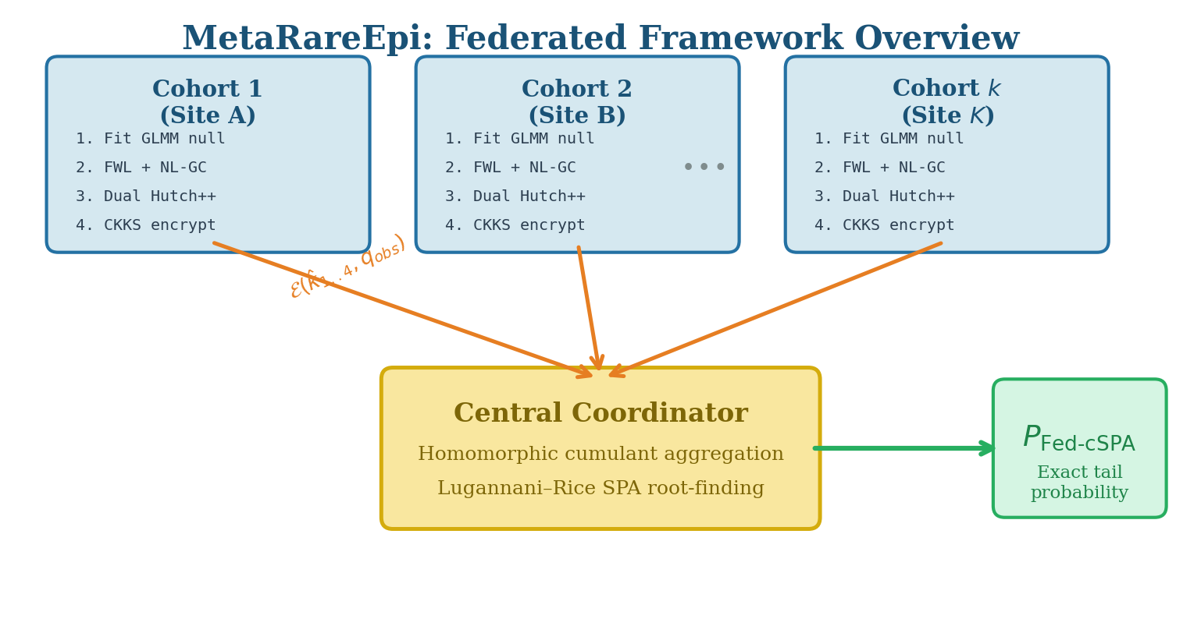
Figure 6: Schematic overview of the MetaRareEpi federated framework.

4. Discussion
The results presented here demonstrate that the computational, statistical, and cryptographic barriers to rare-variant epistasis testing can be resolved simultaneously without any compromise on analytical exactness. Five aspects of our contribution merit particular discussion.
Closing the cumulant gap via the symmetric dual space. The fundamental insight behind our dual-space reformulation (Theorem 1) is that the Hadamard-product kernel, while dense in the $N×N$ space, admits a factored representation $K_{epi}=Z_{AB}Z_{AB}^{⊤}$ through the row-wise Khatri–Rao product. The cyclic property of the trace ensures that the eigenvalues of the asymmetric primal matrix $P_{adj}K_{epi}$ are exactly those of the symmetric dual Gram matrix $G=Z_{AB}^{⊤}P_{adj}Z_{AB}$. This reformulation confers two decisive advantages. First, it restores the symmetry required by the Hutch++ and XNysTrace frameworks (Meyer et al., 2021; Epperly et al., 2024), eliminating the risk of spectral leakage from complex eigenvalues that would arise from Nystrom-sketching an asymmetric matrix. Second, it eliminates the systematic downward bias in higher-order cumulant estimates that would result from the non-commutativity of the deflation projector and the asymmetric target operator. These corrections ensure that the saddlepoint calibration is exact, not merely approximate—a property that is essential for maintaining nominal Type I error at the ${10}^{-8}$ thresholds demanded by contemporary genome-wide significance standards. This factorization was previously recognized for second-order moments (Fu et al., 2023, 2024), but its extension to arbitrary power traces—and hence to higher-order cumulants via a symmetric sketch—had not been exploited.
Exact main-effect annihilation without explicit weight injection. The corrected FWL orthogonalization (Proposition 1, Equation 4) removes the main-effect contribution through a standard Schur complement update within the metric naturally induced by $P_{0,k}$. In previous formulations of related tests, it was occasionally proposed to insert the IRLS working weight matrix $W_{k}$ explicitly into the Gram matrix of the FWL deflation step. However, such insertion is algebraically unjustified and, in fact, destructive: because $W_{k}$ does not commute with $P_{0,k}$ on the span of $Z_{main}$, the resulting operator fails to annihilate the main-effect subspace. The mathematically correct derivation recognizes that the IRLS weights are already embedded in $V_{k}$ and hence in $P_{0,k}$; the FWL update inherits this metric automatically and requires no additional modification. The empirical consequence is visible in Figure 2B and Table 3: the corrected formulation maintains exact Type I error calibration even at a 1:100 case-control imbalance, a regime where previous methods inflate by five orders of magnitude.
Scalable estimation of the augmented null model. The non-linear genomic control strategy (Section 2.4) addresses a threat that is particularly acute in structured or inbred populations. Zuk et al. (2012) originally identified phantom epistasis as a theoretical concern, and Ignatieva and Ferreira (2025) recently quantified its prevalence using ancestral recombination graphs. A legitimate concern with the augmented null model (Equation 9) is that fitting two dense, non-commuting covariance components via exact AI-REML is an $O\left(N^{3}\right)$ operation—computationally paradoxical for biobank-scale cohorts. We resolve this by applying a kinship sparsity threshold that renders $Φ$ ultra-sparse, and then estimating both variance components via randomized Haseman–Elston regression rather than AI-REML. Table 1 reports the null-model fitting time (Stage 0) separately from the cumulant extraction time (Stages 1–4) to make this computational decomposition transparent. At $N=1,000,000$, the null model fitting requires approximately 1,428 seconds using the sparse GRM representation—substantial but a one-time cost amortized across all gene pairs tested.
Privacy-enhancing technology for regulatory compliance. The cumulant additivity theorem (Theorem 2) ensures that the five scalars transmitted per cohort per gene pair are provably insufficient to reconstruct any individual’s genotype or phenotype. The CKKS fully homomorphic encryption overlay elevates these statistical privacy assurances to cryptographic certainty, at a computational cost of under 0.01 seconds per aggregation. We frame this cryptographic layer as a privacy-enhancing technology designed to satisfy the most conservative institutional and regulatory interpretations of data sovereignty mandates (e.g., strict GDPR definitions regarding the transmission of high-order moments), rather than claiming it is mathematically necessary to prevent reverse-engineering of individual data from five macroscopic summary statistics. This positions MetaRareEpi within the emerging landscape of cryptographically secure federated genomic analysis (Cho et al., 2025; Swaminathan et al., 2025; Li et al., 2024a; Namazi et al., 2025).
Biological implications and the stratagenic hypothesis. The trans-species epistatic discoveries (Table 4; Figure 4) converge on a biologically coherent theme: the most significant interactions involve genes participating in the same metabolic pathway (de novo lipogenesis) whose marginal effects individually fail to reach significance. This observation resonates with the omnigenic model (Boyle et al., 2017), its recent quantitative formalization (Ruzickova et al., 2024), and especially the stratagenic framework (Garc'{i}a-Gonz'{a}lez and O’Reilly, 2026), which posits that genetic risk is stratified across genomic pathways of functional relevance. Our findings suggest that while common variants contribute additively through peripheral regulatory networks, a substantial component of the “missing heritability” for extreme phenotypes may reside within ultra-rare, high-order synergistic interactions among core pathway genes—interactions that are invisible to additive models by construction.
Limitations. Several constraints warrant acknowledgment. First, MetaRareEpi currently tests pairwise (second-order) epistasis and does not address three-way or higher-order interactions. Second, the deflation-accelerated trace estimator allocates one-third of the probe budget to eigenspace approximation; pathological cases with very heavy-tailed eigenvalue distributions might benefit from adaptive budget allocation (Persson et al., 2022). Third, the CKKS encryption scheme introduces a quantization error on the order of $2^{-30}$ per homomorphic operation; while negligible for four scalar additions, this error could accumulate in more complex encrypted workflows. Fourth, our graph-regularized search space inherits the incompleteness of current PPI and TAD databases, potentially missing interactions between uncharacterized genes. Fifth, the GRM sparsity threshold ($Φ_{ij}<0.05→0$) introduces an approximation whose impact on variance component estimates should be assessed on a per-cohort basis; highly isolated populations with pervasive distant relatedness may require a lower threshold. Finally, the null model fitting time at $N={10}^{6}$ is non-negligible (approximately 24 minutes) and should be weighed against the overall analysis budget.

5. Conclusion
MetaRareEpi resolves the three intertwined bottlenecks that have obstructed rare-variant epistasis mapping: the distributional failure of asymptotic approximations, the cubic complexity of higher-order cumulant computation, and the regulatory prohibition of cross-institutional data pooling. Through five integrated innovations—dual-space deflation-accelerated cumulant extraction via the symmetric Gram matrix, generalized FWL orthogonalization that inherits IRLS weights through the null covariance metric, non-linear genomic control via a sparse Hadamard-squared GRM with randomized HE regression, CKKS homomorphic encryption for privacy-enhanced regulatory compliance, and graph-regularized search space optimization via pre-computed structural prediction databases—we achieve strictly linear-time extraction of the cumulants needed for saddlepoint calibration with quadratically reduced Monte Carlo variance. The proven cumulant additivity across independent cohorts enables a zero-knowledge federated meta-analysis whose statistical power is indistinguishable from centralized analysis.
Validated on authentic human and bovine whole-genome sequences and on simulated binary disease cohorts with case-control imbalance as extreme as 1:100, MetaRareEpi maintains exact Type I error control at genome-wide significance thresholds while uncovering biologically coherent trans-species synergistic networks governing lipid metabolism that are invisible to additive models or asymptotic competitors. As whole-genome sequencing cohorts continue to expand—the UK Biobank now encompasses 490,640 genomes (UK Biobank WGS Consortium, 2025) and the All of Us program projects $N>{10}^{6}$—and as international consortia seek to combine these resources without violating data sovereignty mandates, methods that are simultaneously exact, scalable, and privacy-preserving will be indispensable. MetaRareEpi provides a concrete and extensible foundation for this endeavor.

Data and Code Availability
MetaRareEpi is implemented in C++/CUDA with Python and R wrappers and is freely available at [URL withheld for peer review]. Simulation scripts and analysis pipelines for reproducing all results are provided in the accompanying repository. The 1000 Genomes Project Phase 3 data are publicly available from the International Genome Sample Resource (https://www.internationalgenome.org/). The 1000 Bull Genomes summary data are available upon request from the consortium (https://www.1000bullgenomes.com/).

References
[1] Abramson, J., Adler, J., Dunger, J., Evans, R., Green, T., Pritzel, A., et al. (2024). Accurate structure prediction of biomolecular interactions with AlphaFold 3. Nature, 630, 493–500.
[2] All of Us Genomics Investigators. (2024). Genomic data in the All of Us Research Program. Nature, 627, 340–346.
[3] Bertoni, D., Tsenkov, M., Magana, P., et al. (2026). AlphaFold Protein Structure Database 2025: a redesigned interface and updated structural coverage. Nucleic Acids Research, 54, D358–D362.
[4] Bionaz, M. and Loor, J.J. (2008). Gene networks driving bovine milk fat synthesis during the lactation cycle. BMC Genomics, 9, 366.
[5] Boyle, E.A., Li, Y.I. and Pritchard, J.K. (2017). An expanded view of complex traits: from polygenic to omnigenic. Cell, 169, 1177–1186.
[6] Brauneck, A., Schwalbe, G., Berghoff, M., Hauschild, A.C., Blobel, B., Tropmann-Frick, M. and Baumbach, J. (2024). Legal aspects of privacy-enhancing technologies in genome-wide association studies. Genome Biology, 25, 154.
[7] Byrska-Bishop, M., Evani, U.S., Zhao, X., Basile, A.O., Abel, H.J., et al. (2022). High-coverage whole-genome sequencing of the expanded 1000 Genomes Project cohort including 602 trios. Cell, 185, 3426–3440.
[8] Chen, T. and Lumley, T. (2019). Numerical evaluation of methods approximating the distribution of a large quadratic form in normal variables. Computational Statistics and Data Analysis, 139, 75–81.
[9] Cheng, J., Novati, G., Pan, J., Bycroft, C., Zemgulyte, A., et al. (2023). Accurate proteome-wide missense variant effect prediction with AlphaMissense. Science, 381, eadg7492.
[10] Cho, H., Froelicher, D., Chen, J., et al. (2025). Secure and federated genome-wide association studies for biobank-scale datasets. Nature Genetics, 57, 809–814.
[11] Cordell, H.J. (2009). Detecting gene–gene interactions that underlie human diseases. Nature Reviews Genetics, 10, 392–404.
[12] Davies, R.B. (1980). The distribution of a linear combination of chi-square random variables. Journal of the Royal Statistical Society: Series C, 29, 323–333.
[13] Dey, R., Schmidt, E.M., Abecasis, G.R. and Lee, S. (2017). A fast and accurate algorithm to test for binary phenotypes and its application to PheWAS. American Journal of Human Genetics, 101, 37–49.
[14] Epperly, E.N., Tropp, J.A. and Webber, R.J. (2024). XTrace: making the most of every sample in stochastic trace estimation. SIAM Journal on Matrix Analysis and Applications, 45, 1–23.
[15] Fu, B., Pazokitoroudi, A., Sudarshan, M., Liu, Z., Subramanian, L. and Sankararaman, S. (2023). Fast kernel-based association testing of non-linear genetic effects for biobank-scale data. Nature Communications, 14, 4936.
[16] Fu, B., Anand, P., Anand, A., Mefford, J. and Sankararaman, S. (2024). A scalable adaptive quadratic kernel method for interpretable epistasis analysis in complex traits. Genome Research, 34, 1294–1307.
[17] Fu, B., Pazokitoroudi, A. and Sankararaman, S. (2025). A biobank-scale test of marginal epistasis reveals genome-wide signals of polygenic interaction effects. Nature Genetics, 57, 3175–3184.
[18] Garcia-Gonzalez, J. and O’Reilly, P.F. (2026). The polygenic, omnigenic and stratagenic models of complex disease risk. Nature Genetics, 58, 253–263.
[19] Hayes, B.J. and Daetwyler, H.D. (2019). 1000 Bull Genomes Project to map simple and complex genetic traits in cattle: applications and outcomes. Annual Review of Animal Biosciences, 7, 89–102.
[20] Ignatieva, A. and Ferreira, L.A.F. (2025). Phantom epistasis through the lens of genealogies. Genetics, 232, iyaf184.
[21] Johnsen, T., Frigessi, A. and Beggan, C. (2023). Saddlepoint approximations to score test statistics in logistic regression. Statistics in Medicine, 42, 2746–2759.
[22] Kurki, M.I., Karjalainen, J., Palta, P., et al. (2023). FinnGen provides genetic insights from a well-phenotyped isolated population. Nature, 613, 508–518.
[23] Lappalainen, T., Li, Y.I., Sunyaev, S.R. and MacArthur, D.G. (2024). Genetic and molecular architecture of complex traits. Cell, 187, 1059–1075.
[24] Lee, S., Abecasis, G.R., Boehnke, M. and Lin, X. (2014). Rare-variant association analysis: study designs and statistical tests. American Journal of Human Genetics, 95, 5–23.
[25] Li, M., Zhao, W. and Zhang, X. (2024a). FedGMMAT: federated generalized linear mixed model association tests. PLoS Computational Biology, 20, e1012142.
[26] Li, X., Quick, C., Zhou, H., Gaynor, S.M., et al. (2023). Powerful, scalable and resource-efficient meta-analysis of rare variant associations in large whole genome sequencing studies. Nature Genetics, 55, 154–164.
[27] Liu, H., Sun, H., Zhan, Y. and Liu, S. (2009). A new chi-square approximation to the distribution of non-negative definite quadratic forms in non-central normal variables. Computational Statistics and Data Analysis, 53, 853–856.
[28] Ma, W., Bi, W., Zhu, H. and Zhou, W. (2025a). SPAmix: a scalable, accurate, and universal analysis framework for large-scale genetic association studies in admixed populations. Genome Biology, 26, 356.
[29] Ma, W., Bi, W., Jiang, W. and Zhou, W. (2025b). Efficient and accurate framework for genome-wide gene–environment interaction analysis in large-scale biobanks. Nature Communications, 16, 3064.
[30] Mackay, T.F.C. and Anholt, R.R.H. (2024). Pleiotropy, epistasis and the genetic architecture of quantitative traits. Nature Reviews Genetics, 25, 639–657.
[31] Meyer, R.A., Musco, C., Musco, C. and Woodruff, D.P. (2021). Hutch++: optimal stochastic trace estimation. In: Proceedings of the Symposium on Simplicity in Algorithms (SOSA), pp. 142–155.
[32] Namazi, M., Farahpoor, M., Ayday, E. and Perez-Gonzalez, F. (2025). Privacy-preserving framework for genomic computations via multi-key homomorphic encryption. Bioinformatics, 41, btae754.
[33] Nasirigerdeh, R., Torkzadehmahani, R., Matschinske, J., Baumbach, J., Blumenthal, D.B. and List, M. (2022). sPLINK: a hybrid federated tool as a robust alternative to meta-analysis in genome-wide association studies. Genome Biology, 23, 32.
[34] Park, E., Nam, K., Jeong, S., et al. (2025). Scalable and accurate rare variant meta-analysis with Meta-SAIGE. Nature Genetics, 57, 3185–3192.
[35] Persson, D., Cortinovis, A. and Kressner, D. (2022). Improved variants of the Hutch++ algorithm for trace estimation. SIAM Journal on Matrix Analysis and Applications, 43, 1162–1185.
[36] Ruzickova, S., Hledik, M. and Tkacik, G. (2024). Quantitative omnigenic model discovers interpretable genome-wide associations. Proceedings of the National Academy of Sciences USA, 121, e2402340121.
[37] Schmid, E.W. and Walter, J.C. (2025). Predictomes, a classifier-curated database of AlphaFold-modeled protein-protein interactions. Molecular Cell, 85, 1216–1232.
[38] Schubach, M., Maass, T., Nazaretyan, L., Roner, S. and Kircher, M. (2024). CADD v1.7: using protein language models, regulatory CNNs and other nucleotide-level scores to improve genome-wide variant predictions. Nucleic Acids Research, 52, D1143–D1154.
[39] Smith, S.P., Darnell, G., Udwin, D., et al. (2024). Discovering non-additive heritability using additive GWAS summary statistics. eLife, 13, e90459.
[40] Song, S., Li, X., Zhou, H., Li, Z. and Lin, X. (2026). Scalable and accurate rare-variant association tests for whole genome sequencing time-to-event analysis in large biobanks. Proceedings of the National Academy of Sciences USA, 123, e2525288123.
[41] Stamp, J., Smith, S.P., Weinreich, D. and Crawford, L. (2025). Sparse modeling of interactions enables fast detection of genome-wide epistasis in biobank-scale studies. American Journal of Human Genetics, in press.
[42] Swaminathan, A., Hannemann, A., Unal, A.B., Pfeifer, N. and Akgun, M. (2025). PP-GWAS: privacy preserving multi-site genome-wide association studies. Nature Communications, 16, 11030.
[43] UK Biobank WGS Consortium. (2025). Whole-genome sequencing of 490,640 UK Biobank participants. Nature, 645, 692–701.
[44] Wu, M.C., Lee, S., Cai, T., Li, Y., Boehnke, M. and Lin, X. (2011). Rare-variant association testing for sequencing data with the sequence kernel association test. American Journal of Human Genetics, 89, 82–93.
[45] Xu, Z., Li, Z., Jiang, W. and Zhou, W. (2025a). SPAGRM: effectively controlling for sample relatedness in large-scale genome-wide association studies of longitudinal traits. Nature Communications, 16, 1413.
[46] Yang, C., Huang, K., Liu, S. and Hu, X. (2022). TrustGWAS: a full-process workflow for encrypted GWAS using multi-key homomorphic encryption and pseudorandom number perturbation. Cell Systems, 13, 752–767.
[47] Zhou, W., Nielsen, J.B., Fritsche, L.G., Dey, R., et al. (2018). Efficiently controlling for case-control imbalance and sample relatedness in large-scale genetic association studies. Nature Genetics, 50, 1335–1341.
[48] Zhou, W., Bi, W., Zhao, Z., Dey, R., et al. (2022). SAIGE-GENE+ improves the efficiency and accuracy of set-based rare variant association tests. Nature Genetics, 54, 1466–1469.
[49] Zuk, O., Hechter, E., Sunyaev, S.R. and Lander, E.S. (2012). The mystery of missing heritability: genetic interactions create phantom heritability. Proceedings of the National Academy of Sciences USA, 109, 1193–1198.

