Measurement protocol

Physical Setup:
Creation of Lowpass Filter using Coil and Resistor with 1000Ohm. These are the items closest to the values found in the simulation. An analogue filter is implemented using a capacitor and a resistor of 100Ohm.
The measurement is connected to the ground (black cable), the voltage source (brown cable) and inbetween the coil and the resistor (green cable). The measurement between the voltage source and the ground is the input signal. The measurement between the green cable and the ground is the filtered signal.
Optionally the capacitor-resistor filter can be measured using the yellow cable.
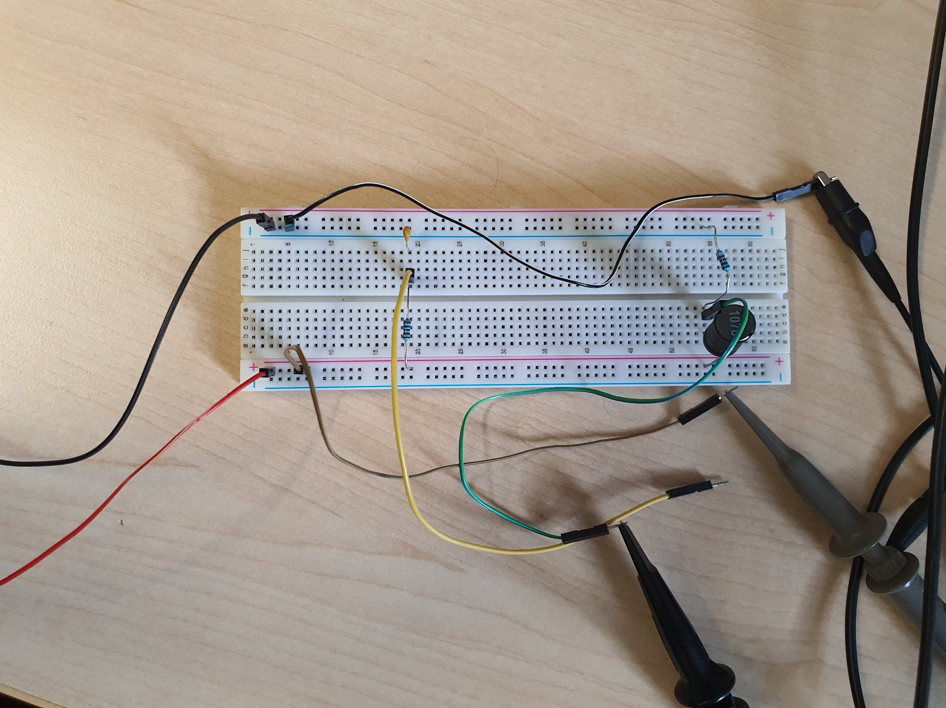

The measurement probes are connected to the oscilloscope using two channels.
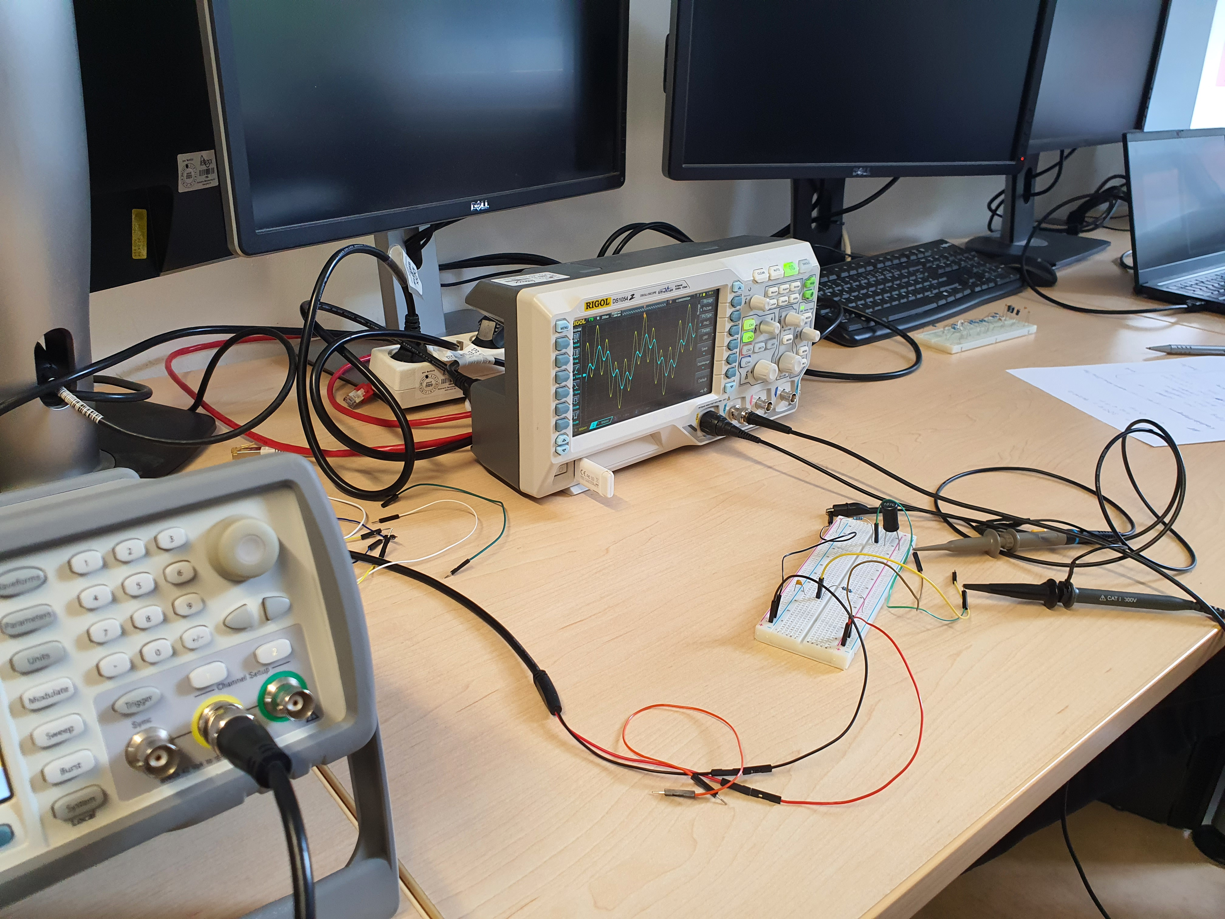

The waveform generator is connected to the voltage and the ground cables on the breadboard.
This completes the physical setup.
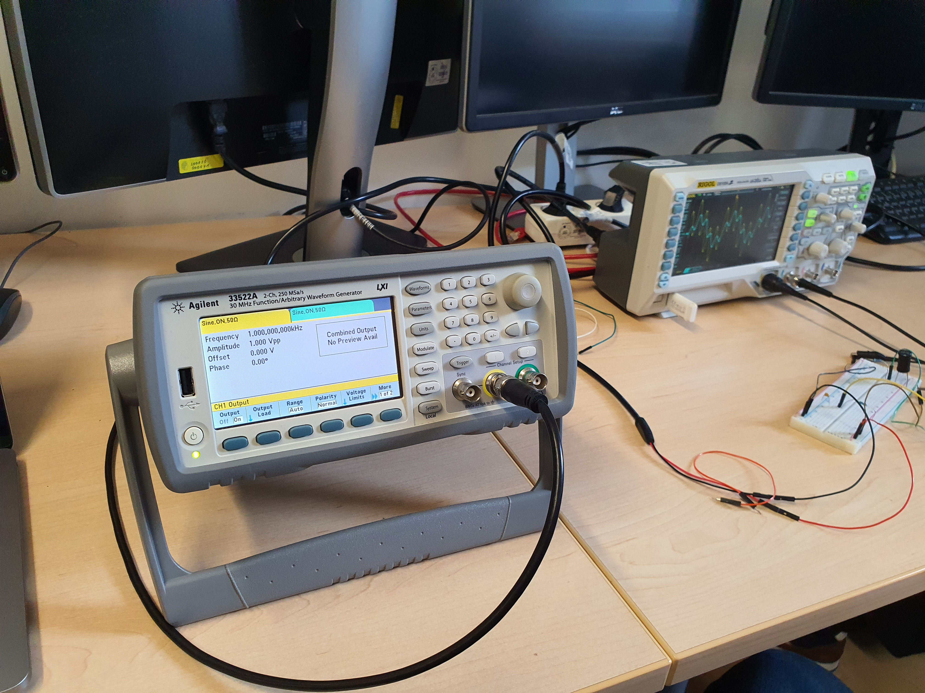

Measurement:
In the first step a sinus signal is used as input. The signal and the filtered signal is then plotted in the oscilloscope and can be seen in „Sinus_LowPassCap.png“ and „Sinus_LowPassCoil.png“. The effect of the filter is clearly visible.
Sinus_LowPassCap.png

Sinus_LowPassCoil.png
Next a noise waveform is generated as a signal and the resulting filtered signal is measured. This can be seen in „Waveform_*msSpan_LowPass*.png“. The signals was measured both for a 1ms span and a 2ms span. Also here the effect of the filter is visible. Data datatracks are stored as a .csv file for later analysis. This is done with a 600K datadepth. A single datatrack is recorded with a 6M depth taking more than 10 minutes.
Waveform_1msSpan_LowPassCap.png
Waveform_1msSpan_LowPassCoil.png
Waveform_2msSpan_LowPassCap.png

Waveform_2msSpan_LowPassCoil.png

The same noise signal is then used to generate an FFT in the oscilloscope. The resulting plot can be seen in „FFT_Unfiltered_LowPass*.png“. The effect of the filter is not clearly visible. It is worked out in the data analysis visible in „FFT_LowPass*_**.png“ using the previously stored
FFT_Unfiltered_LowPassCap.png
FFT_Unfiltered_LowPassCoil.png

