

Variational Neural Cellular
Automate
Dieter Meier Helge, Zhiqian Yu, Xiaoyan Xue, Yubao Ma

Zhiqian Yu - Coding & Tranining, Dieter Meier Helge - Coding & Training,  Xiaoyan Xue - Coding & Inference & Report, Yubao Ma – Report, All Member - Poster
  VNCA Model Structure
  Variational autoencoder with classical encoder and neural cellular automata decoder
  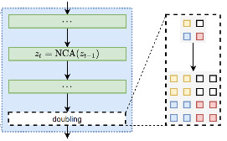
  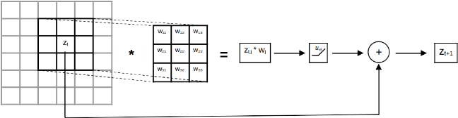
  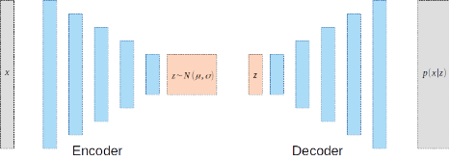
  Fig 1. NCA Single Layer Fig 2. Doubling NCA Fig 3. Variational NCA
  - VNCA cmobines NCA and (Variational Autoencoders)VAE. It processes states layer by using local update rules, evolving the initial state to a high-resulotion state. (Fig 2)
  - The model updates each cell’s state through conv operations and a learnable non-linear function. (Fig 1)
  - It encodes the input into latent variable via variational inference and reconstructs through a decoder. (Fig 3)
  - VNCA maximizes the Evidence Lower Bound (ELBO), optimizing both the KL divergence and reconstruction error.
  MedMNIST - Dataset
  We use colored (RGB) 2D dataset from MedMNIST for our traning of models. Used datasets are: Path, Derma, Retina, Blood and Breast.
  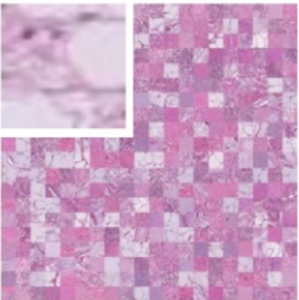  Path | 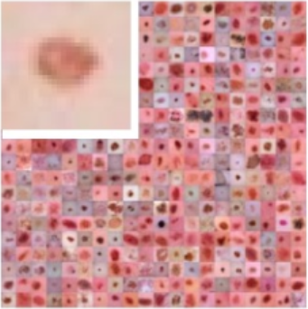  Derma | 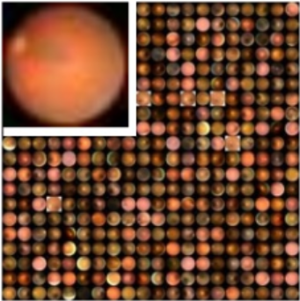  Retina | 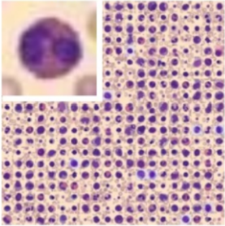  Blood
  Model & Hyperparameter Losses
  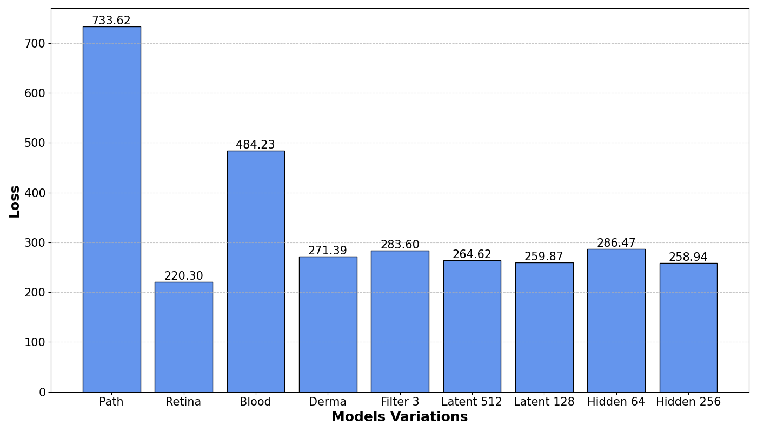
  4 models trained with defaults setting. 5 models trained for Hyperparameter tune.
  The default parameters are Filter Size = 5, Latent Space = 256, Hidden State = 128, Epochs = 50K
  Loss Type: Evidence Lower Bound, consisting of a reconstruction error and a KL divergence term.
  Losses Explaination: The extrem high Path and Blood losses may due to instability during training caused by gradient vanish. They ended unexpected during training and then resumed from last saved epoch.
  Conways Game of Life
  Survival, death and birth of cell depending on neighbours
  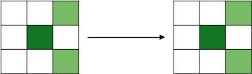
  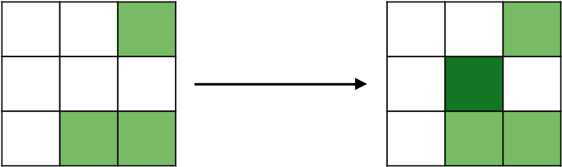
  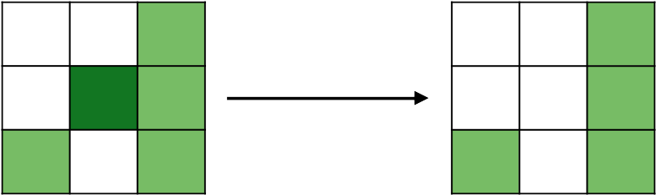
  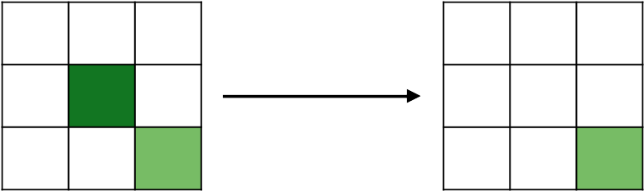
  MedMNIST Training Results
  With all the datasets we use, we train them with 50K epoch. Results are the 30 Steps evolution process.
  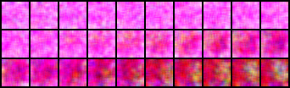 | Path
  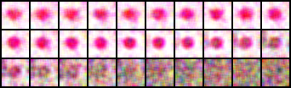 | Derma
  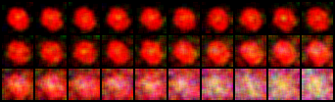 | Retina
  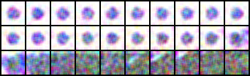 | Blood
  Hyperparameter Tune
  We choose Derma dataset for Hyperparameter tests, with 50K epochs and 1 variable changed each time. Results are the 30 Steps evolution process.
  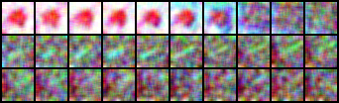 | Filter Size  Test=3  Default=5
  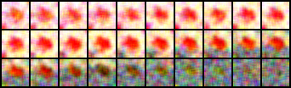 | Hide State  Test=64  Default=128
  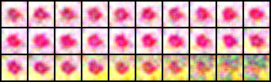 | Hide State  Test=256  Default=128
  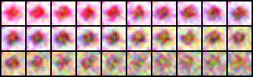 | Latent Space  Test=128  Default=256
  Latent Space
  Test=512
  Default=256

