

Variational Neural Cellular
Automate
Zhiqian Yu – Coding & Model Tranining, Dieter Meier Helge – Coding & Model Training
Xiaoyan Xue – Coding & Inference & Report, Yubao Ma - Report

  VNCA Model Structure
  Variational autoencoder with classical encoder and neural cellular automata decoder
  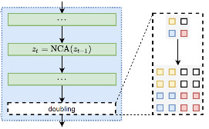
  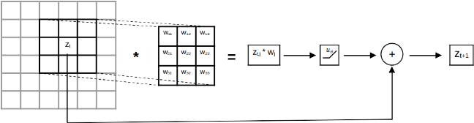
  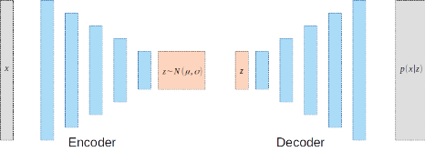
  NCA Single Layer Doubling NCA Variational NCA
  MedMNIST - Dataset
  We use colored (RGB) 2D dataset from MedMNIST for our traning of models. Used datasets are: Path, Derma, Retina, Blood and Breast.
  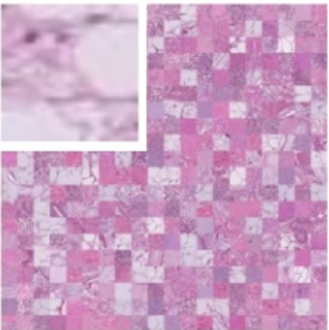  Path | 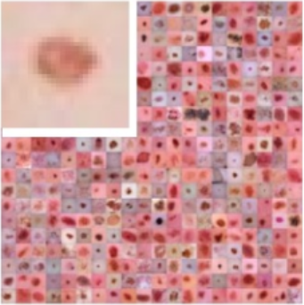  Derma | 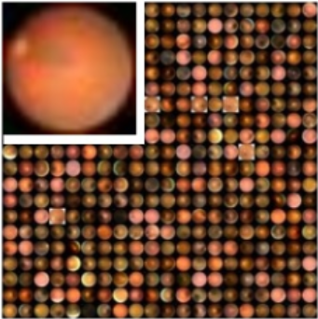  Retina | 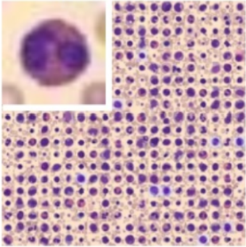  Blood
  Conways Game of Life
  Survival, death and birth of cell depending on neighbours
  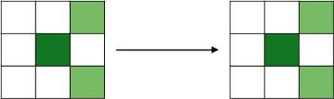
  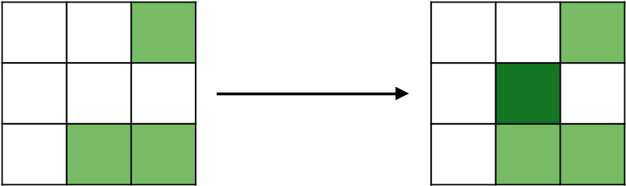
  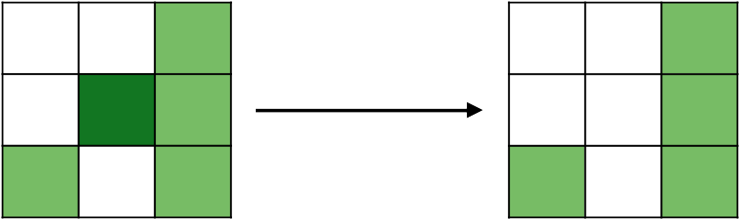
  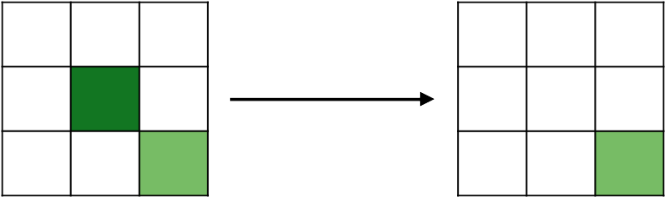
  MedMNIST Training Results
  With all the datasets we use, we train them with 50K epoch. Results are the 30 Steps evolution process.
  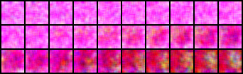 | Path
  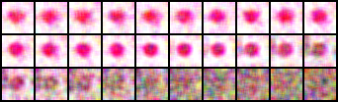 | Derma
  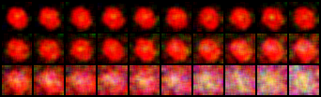 | Retina
  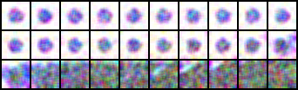 | Blood
  Hyperparameter Tune
  We choose Derma dataset for Hyperparameter tests, with 50K epochs and 1 variable changed each time. Results are the 30 Steps evolution process.
  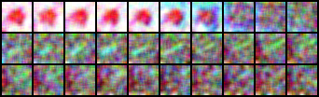 | Filter=3
  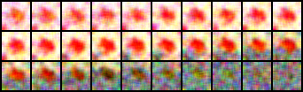 | Hide=64
  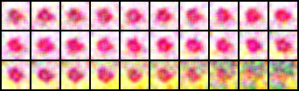 | Hide=256
  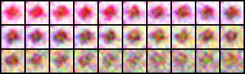 | Z=128
   | Z=512

