

Variational Neural Cellular
Automate
Zhiqian Yu – Coding & Model Tranining, Dieter Meier Helge – Coding & Model Training
Xiaoyan Xue – Coding & Inference & Report, Yubao Ma - Report

Model architecture |  | Conways Game of Life
Variational autoencoder with classical encoder and neural cellular automata decoder  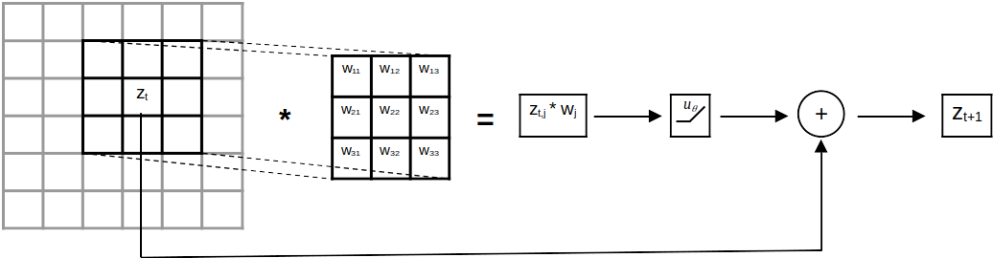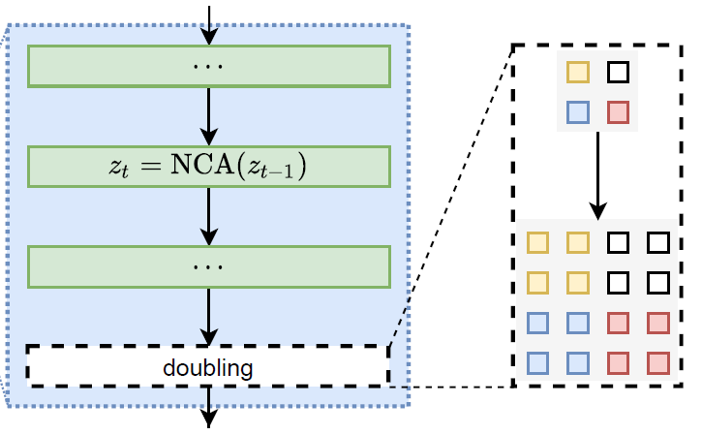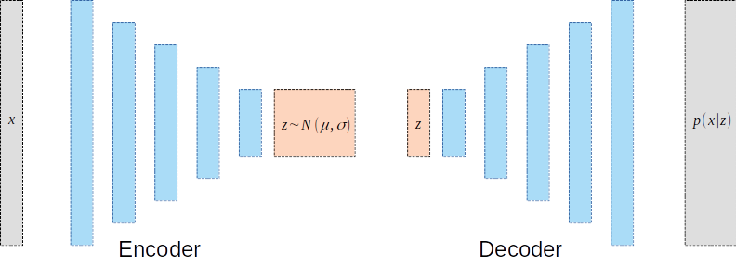  NCA Single Layer Doubling NCA Variational NCA | |  | Survival, death and birth of cell depending on neighbours  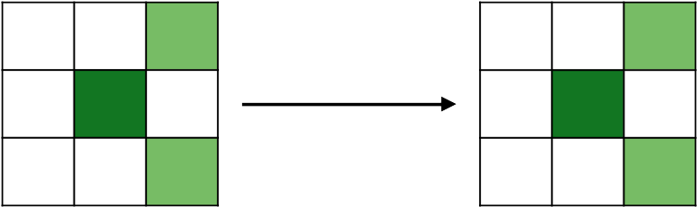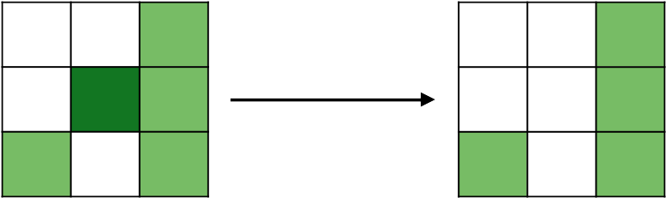  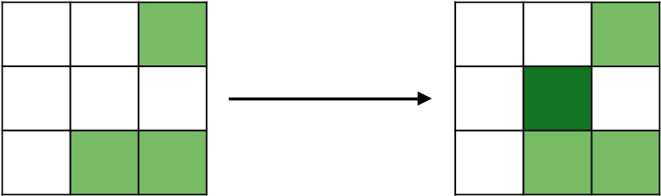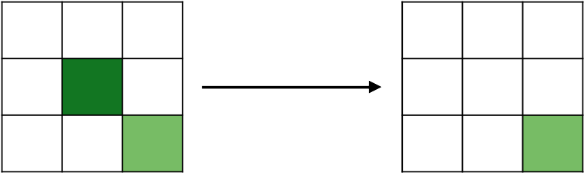

MedMNIST - Dataset |  |  |  |  | MedMNIST Training Results
We use colored (RGB) 2D dataset from MedMNIST for our traning of models. Used datasets are: Path, Derma, Retina, Blood and Breast. |  |  |  |  | With all the datasets we use, we train them with 50K epoch. Results are the 30 Steps evolution process.
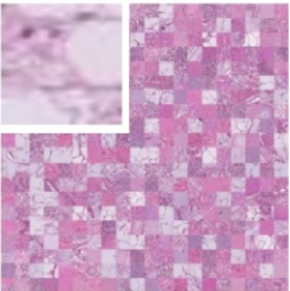  Path | 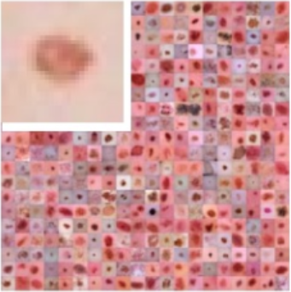  Derma | 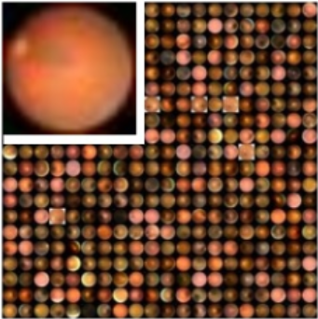  Retina | 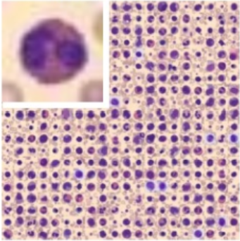  Blood |  | 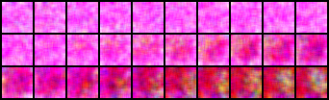 | Path
 |  |  |  |  | 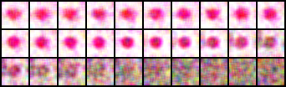 | Derma
 |  |  |  |  | 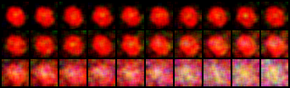 | Retina
 |  |  |  |  | 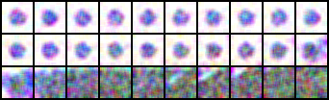 | Blood
VNCA Model Structure |  |  |  |  | Hyperparameter Tune
Encoder – Decoder structure combined with |  |  |  |  | We choose Derma dataset for Hyperparameter tests, with 50K epochs and 1 variable changed each time. Results are the 30 Steps evolution process.
 |  |  |  |  | 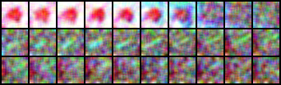 | Filter=3
 |  |  |  |  | 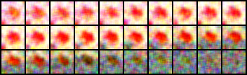 | Hide=64
 |  |  |  |  | 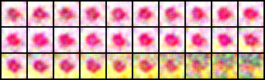 | Hide=256
 |  |  |  |  | 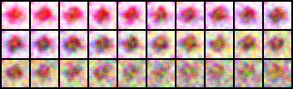 | Z=128
 |  |  |  |  |  | Z=512
 |  |  |  |  | Training Environment
Nvidia RTX 4090 @ 400Watt
~ 2 batches(32 width)/second
50.000 / 100.000 epochs - 7h / 14h

Special Model Layer

