Joshua Meier

Abstract

How did the footprint and biocapacity develop over the last 50 years?  
How different is the situation in different countries and are there repeating patterns?

Development of Biocapacity  
AND Footprint worldwide

Visualisation of Footprint/Biocapacity and Population Growth

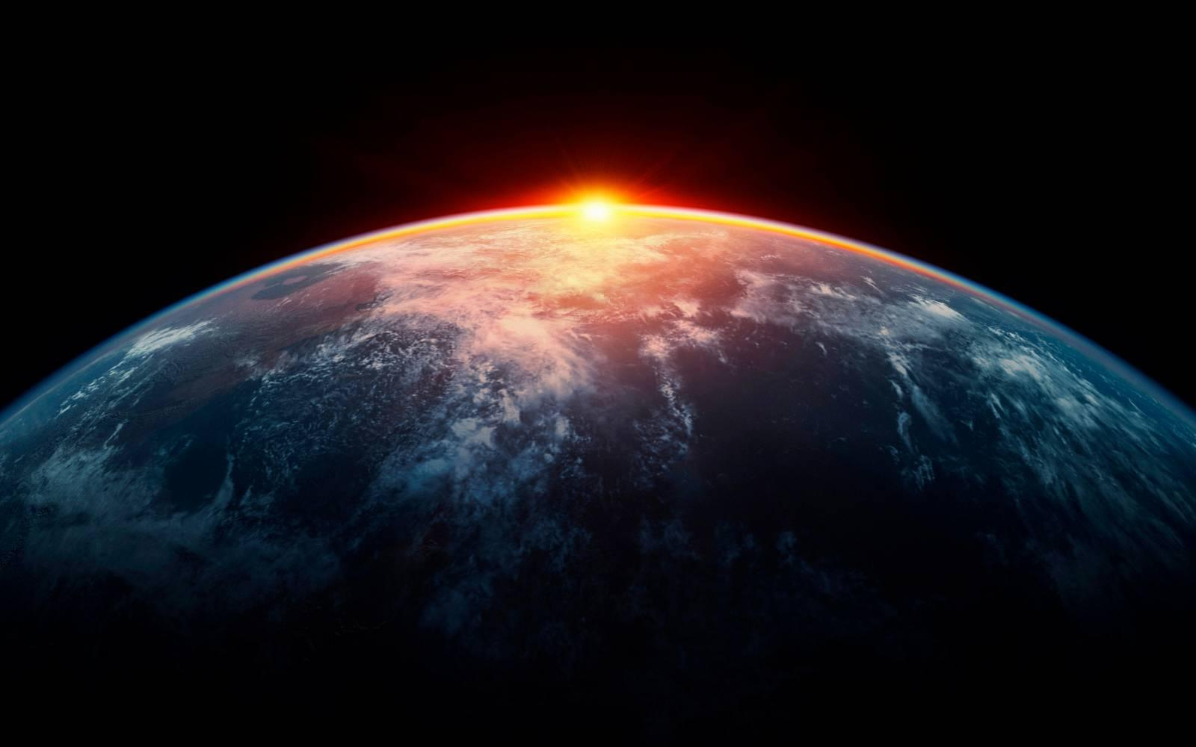

Table of Contents

Introduction 2

Visualization Methods 2

Map 2

Line diagrams 2

Stacking images 3

Colour Scheme 3

Interactions 3

Different colours of world 3

Zoom and Pan 3

Change year of map 4

Detail on demand 4

Stories 4

Population growth is problematic 4

First world countries used to many resources for a long time 4

Current measures are not enough 4

Relevance of indicators 4

Summary 5

Table of Pictures 5

# Introduction

Goal of this ivisPro Application is to show how the footprint and biocapacity have developed over the last years. And should give the user the possibility to compare countries and see how the development of a specific country processed. It should provide enough information to allow a good evaluation of the ecological situation so that people can form their opinion by diving into the data.

# Visualization Methods

## Map

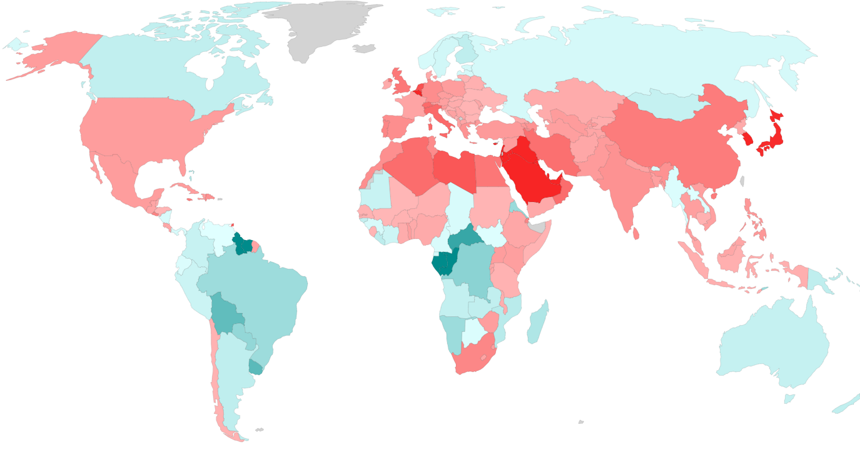

Picture : World Map

To compare countries with each other, a map is used. This give the user a great overview over the whole planet. It’s possible to see the difference between footprint and biocapacity (image 1), the footprint per person or the biocapacity per person.

## Line diagrams

Picture : Development of Population

Picture 3: Line Graph: Development of Footprint and Biocapacity

To visualize the development over a time of a specific country, a line diagram was used. It is easy to see trends over time.

## Stacking images

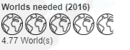

Picture 4: Number of Worlds needed

To show how many worlds would be needed if the footprint of the whole world is equal to the footprint of an average person in a specific country, images are stock over each other. This should highlight this information and is more eye catching than just a number.

Picture 5: Colour Scheme for colour blind people

## Colour Scheme



Picture : Colour Scheme

For the whole application, two colours are used. The blue colour indicates biocapacity and the red colour footprint. Red is used because it is a danger colours and blue are a natural colour with a good contrast to the red colour even for colour-blind users.

## Interactions

### Different colours of world



Picture 7: Button: Change display modes of the world

With the three buttons above it’s possible to show the balance between footprint and biocapacity, only the footprint per person or only the biocapacity per person.

### Zoom and Pan

Picture : Zoom Button

It’s possible to zoom in and out in the map. It’s also possible to pan in order to navigate to a specific country

### Change year of map

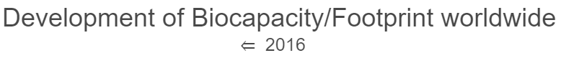

Picture 9: Arrow Button to Change Year

With the arrow button it is possible to change the year of the data which is user to colours the world.

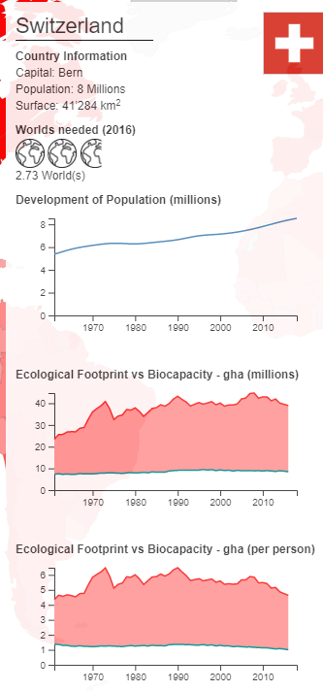

### Detail on demand

On hover it is possible to access additional data over a specific country which gives a great overview over the country and it is possible how the country developed over time.

Picture 10: Detail Dialog with Additional Information

# Stories

## Population growth is problematic

In many countries, especially third world countries, it is possible to see a strict correlation between population growth and development of the footprint in the whole countries. Furthermore, it is possible to see the biocapacity per person decreases in the same pace as the population growths.

## First world countries used to many resources for a long time

In first world countries (i.e. Switzerland, Germany or the USA), the application shows that an ecological deficit exits for a long time. It is constant but it is not improving.

## Current measures are not enough

Even though people are talking about climate change and that it is inevitable to act, the worldwide situation is getting worse. It indicates that current measures and innovation are not good enough and that more effort is required and almost every country has room for improvement.

## Relevance of indicators

There are a few countries where the visualized information is contradictory. Because it is possible visualize the balance between biocapacity or only the footprint, a country can look as good example in one way and as a sinner in another. Reason for these observations are that if a country has many forests or low population density, more biocapacity is provide per person which allows them to have a high footprint. It’s a hard question to answer if they have the right to consume more.

# Summary

The whole application gives a good overview of the development of footprint and biocapacity, but it does not show which events lead to certain changes. It may be quite interesting to add additional datasets which allows more accurate and detailed interpretation, and which helps to understand which measures make sense for which country.

# Table of Pictures

Picture 1: World Map 2

Picture 2: Development of Population 2

Picture 3: Line Graph: Development of Footprint and Biocapacity 2

Picture 4: Number of Worlds needed 3

Picture 5: Colour Scheme for colour blind people 3

Picture 6: Colour Scheme 3

Picture 7: Button: Change display modes of the world 3

Picture 8: Zoom Button 3

Picture 9: Arrow Button to Change Year 4

Picture 10: Detail Dialog with Additional Information 4