Vector tile space (in the Houdini viewport)

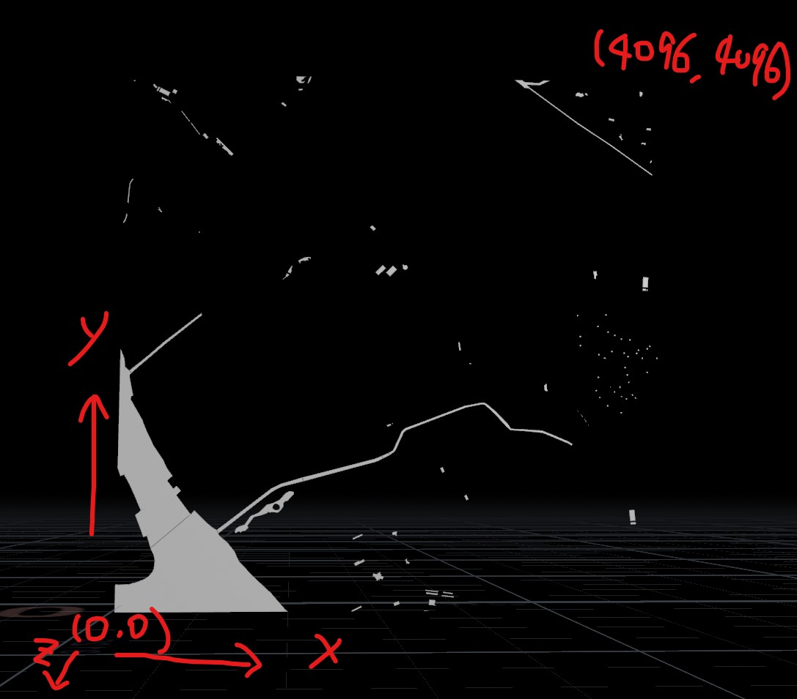

Vector tile space is 2D and only has x and y coordinates

When importing vector tile data directly into Houdini or three.js, if you just match x and y axis directly in the 3D space, the above image shows what you will see. All 2D shapes will appear to stand up, as y is the up vector both in Houdini and three.js.

In Houdini, the z axis is positive running away from the viewport camera (viewport default camera direction). Z axis is negative running

Houdini custom vector tile space:

This space will be used for all instance geometry points (trees, batched models)

This space is expected to work directly in three.js without the need to do scaling or rotation, because the units are in meters, which is consistent with the map 3D space unit. The orientation is also the same, as both using y as the up vector.

All we need to do after loading the batched models and add some offsets

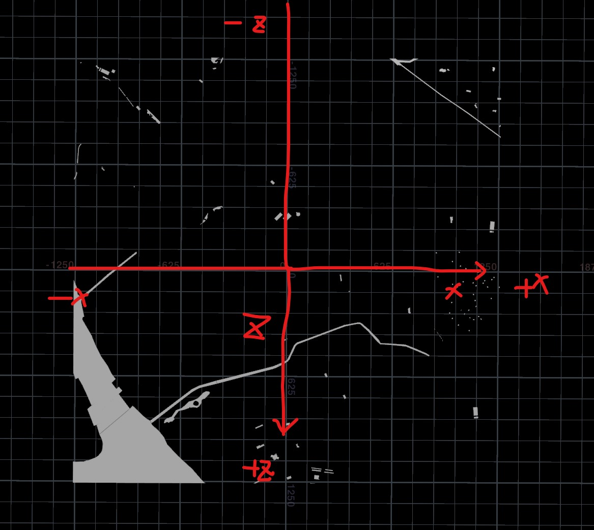

Formulas to transform between vector tile space and my custom Houdini space:

In the above image, the center is always the origin (0,0,0) where both x=0, z=0

Let x1, y1 be the original vector space coordindates

Let x2, z2 be my custom Houdini space

x2 = x1 \* scale - offset

z2 = - y1 \* scale + offset

zoom = 14

earthRadius = 6371008.8

earthCircumfrence = 2 \* math.pi \* earthRadius

extent = 4096

scale = earthCircumfrence / (extent \* 2 \*\* zoom)

offset = extent \* scale / 2