Master Pemotong Pajak

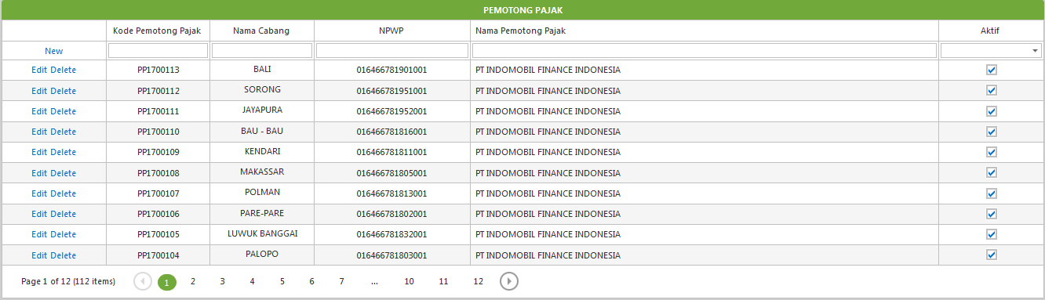

Master Wajib Pajak

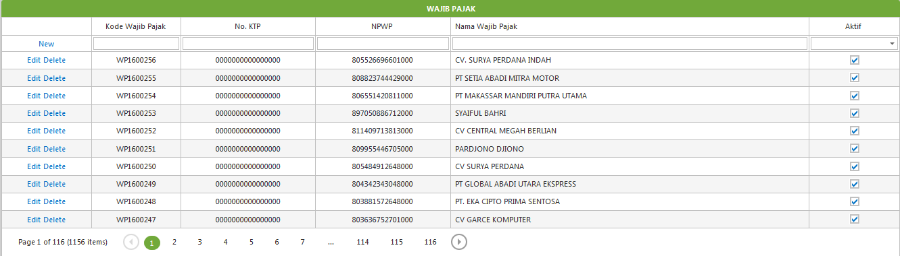

Master Inisial Cabang

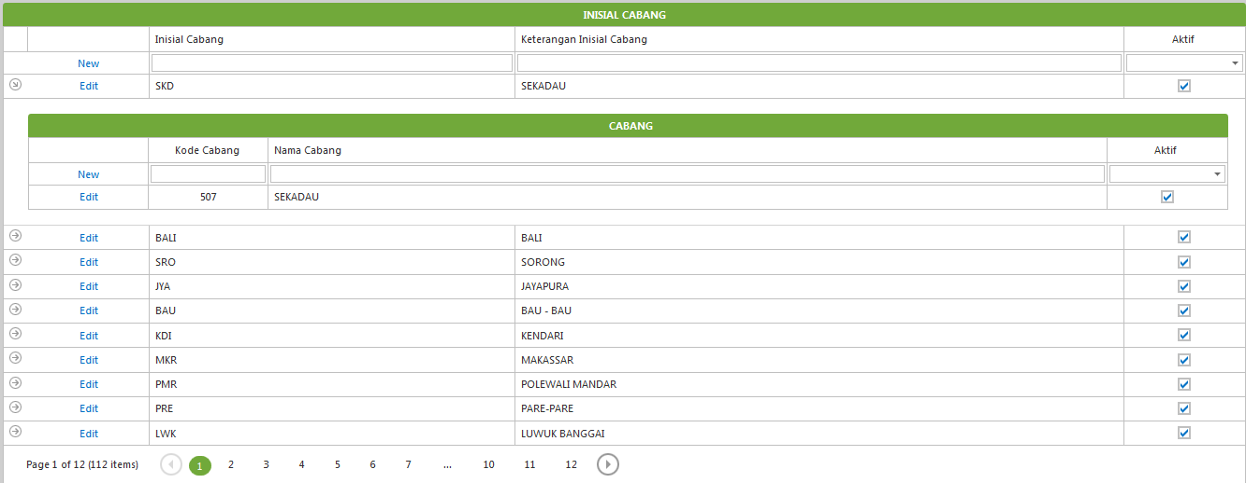

Master Jenis Penghasilan

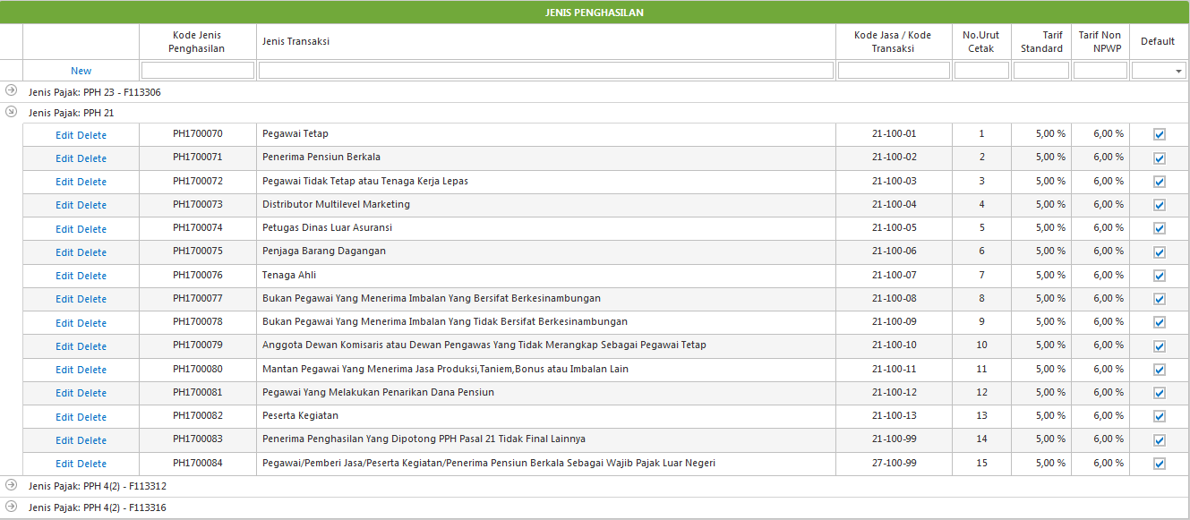

Transaction Bukti Potong Browse

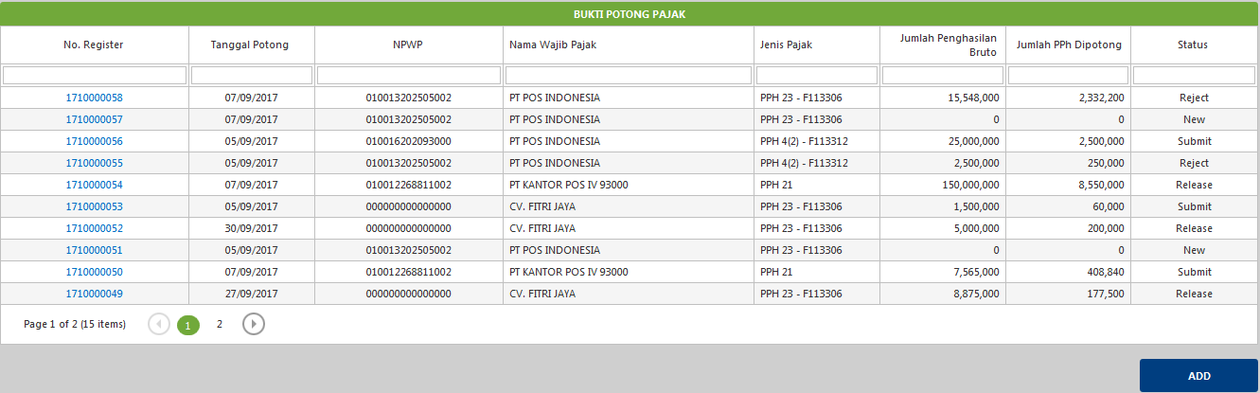

Transaction Bukti Potong Input

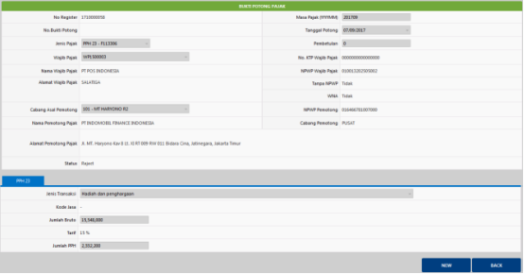

Transaction Persetujuan

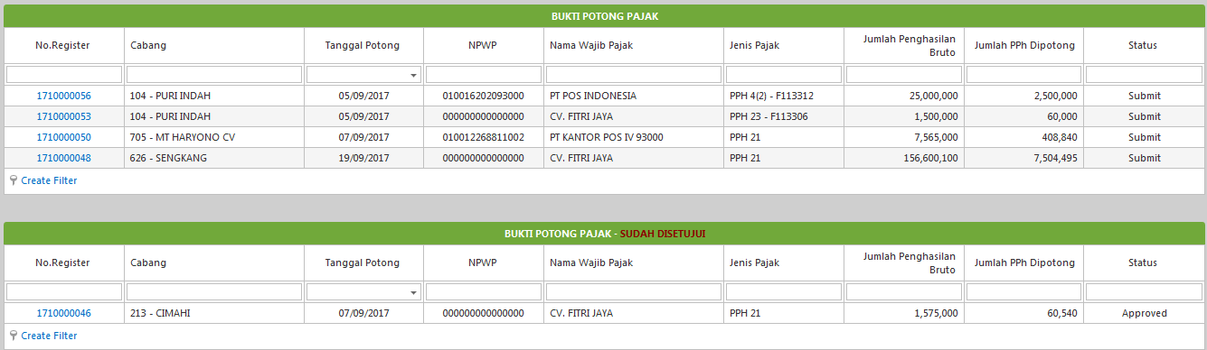

Transaction Release

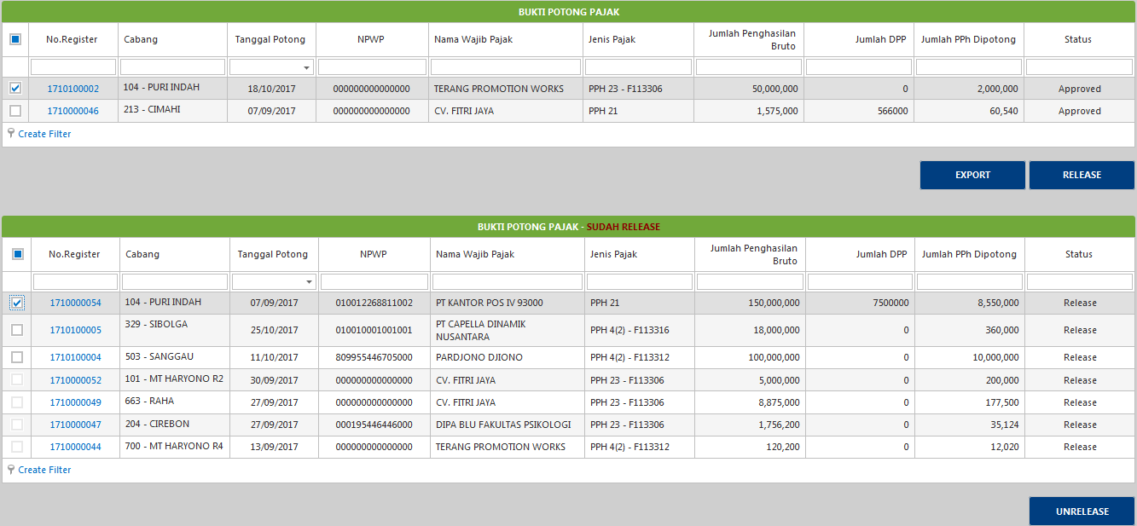

Transaction Hasil DS

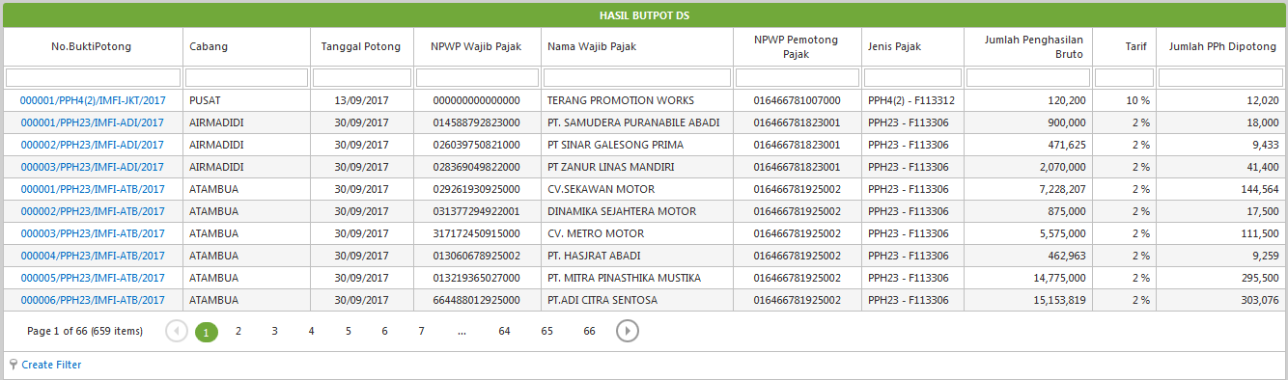

Proses Masa Pajak



Proses Butpot



Proses Butpot Data Gagal

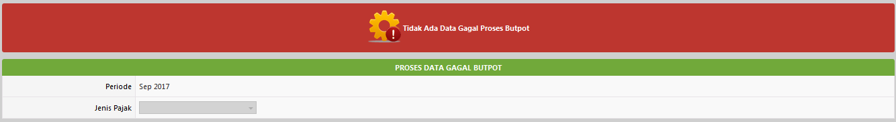

Proses Convert To CSV

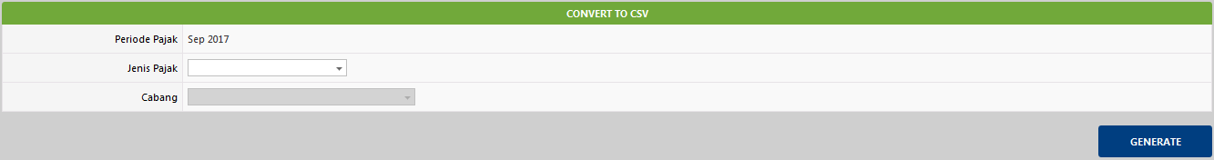

Report Bukti Potong Pajak

