電通二甲微處理器實驗 實驗結報

實驗名稱 | 四合一七段顯示器
組別 |  | 組員 | 梅凌寒06052411

- 實驗目的
了解七段顯示器之顯示原理:
1.共陰極與共陽極七段顯示器之不同?
2.如何讓七段顯示器顯示0-F?
3.如何控制四合一七段顯示器?
4. 如何讓四合一七段顯示器顯示四位數字?
- 實驗步驟1
Arduino接好四合一七段顯示器之電路
四合一七段顯示器每隔0.3秒鐘會跳一個數字,從
0000->0059->0100->跳至2359後歸零
實驗結果及分析
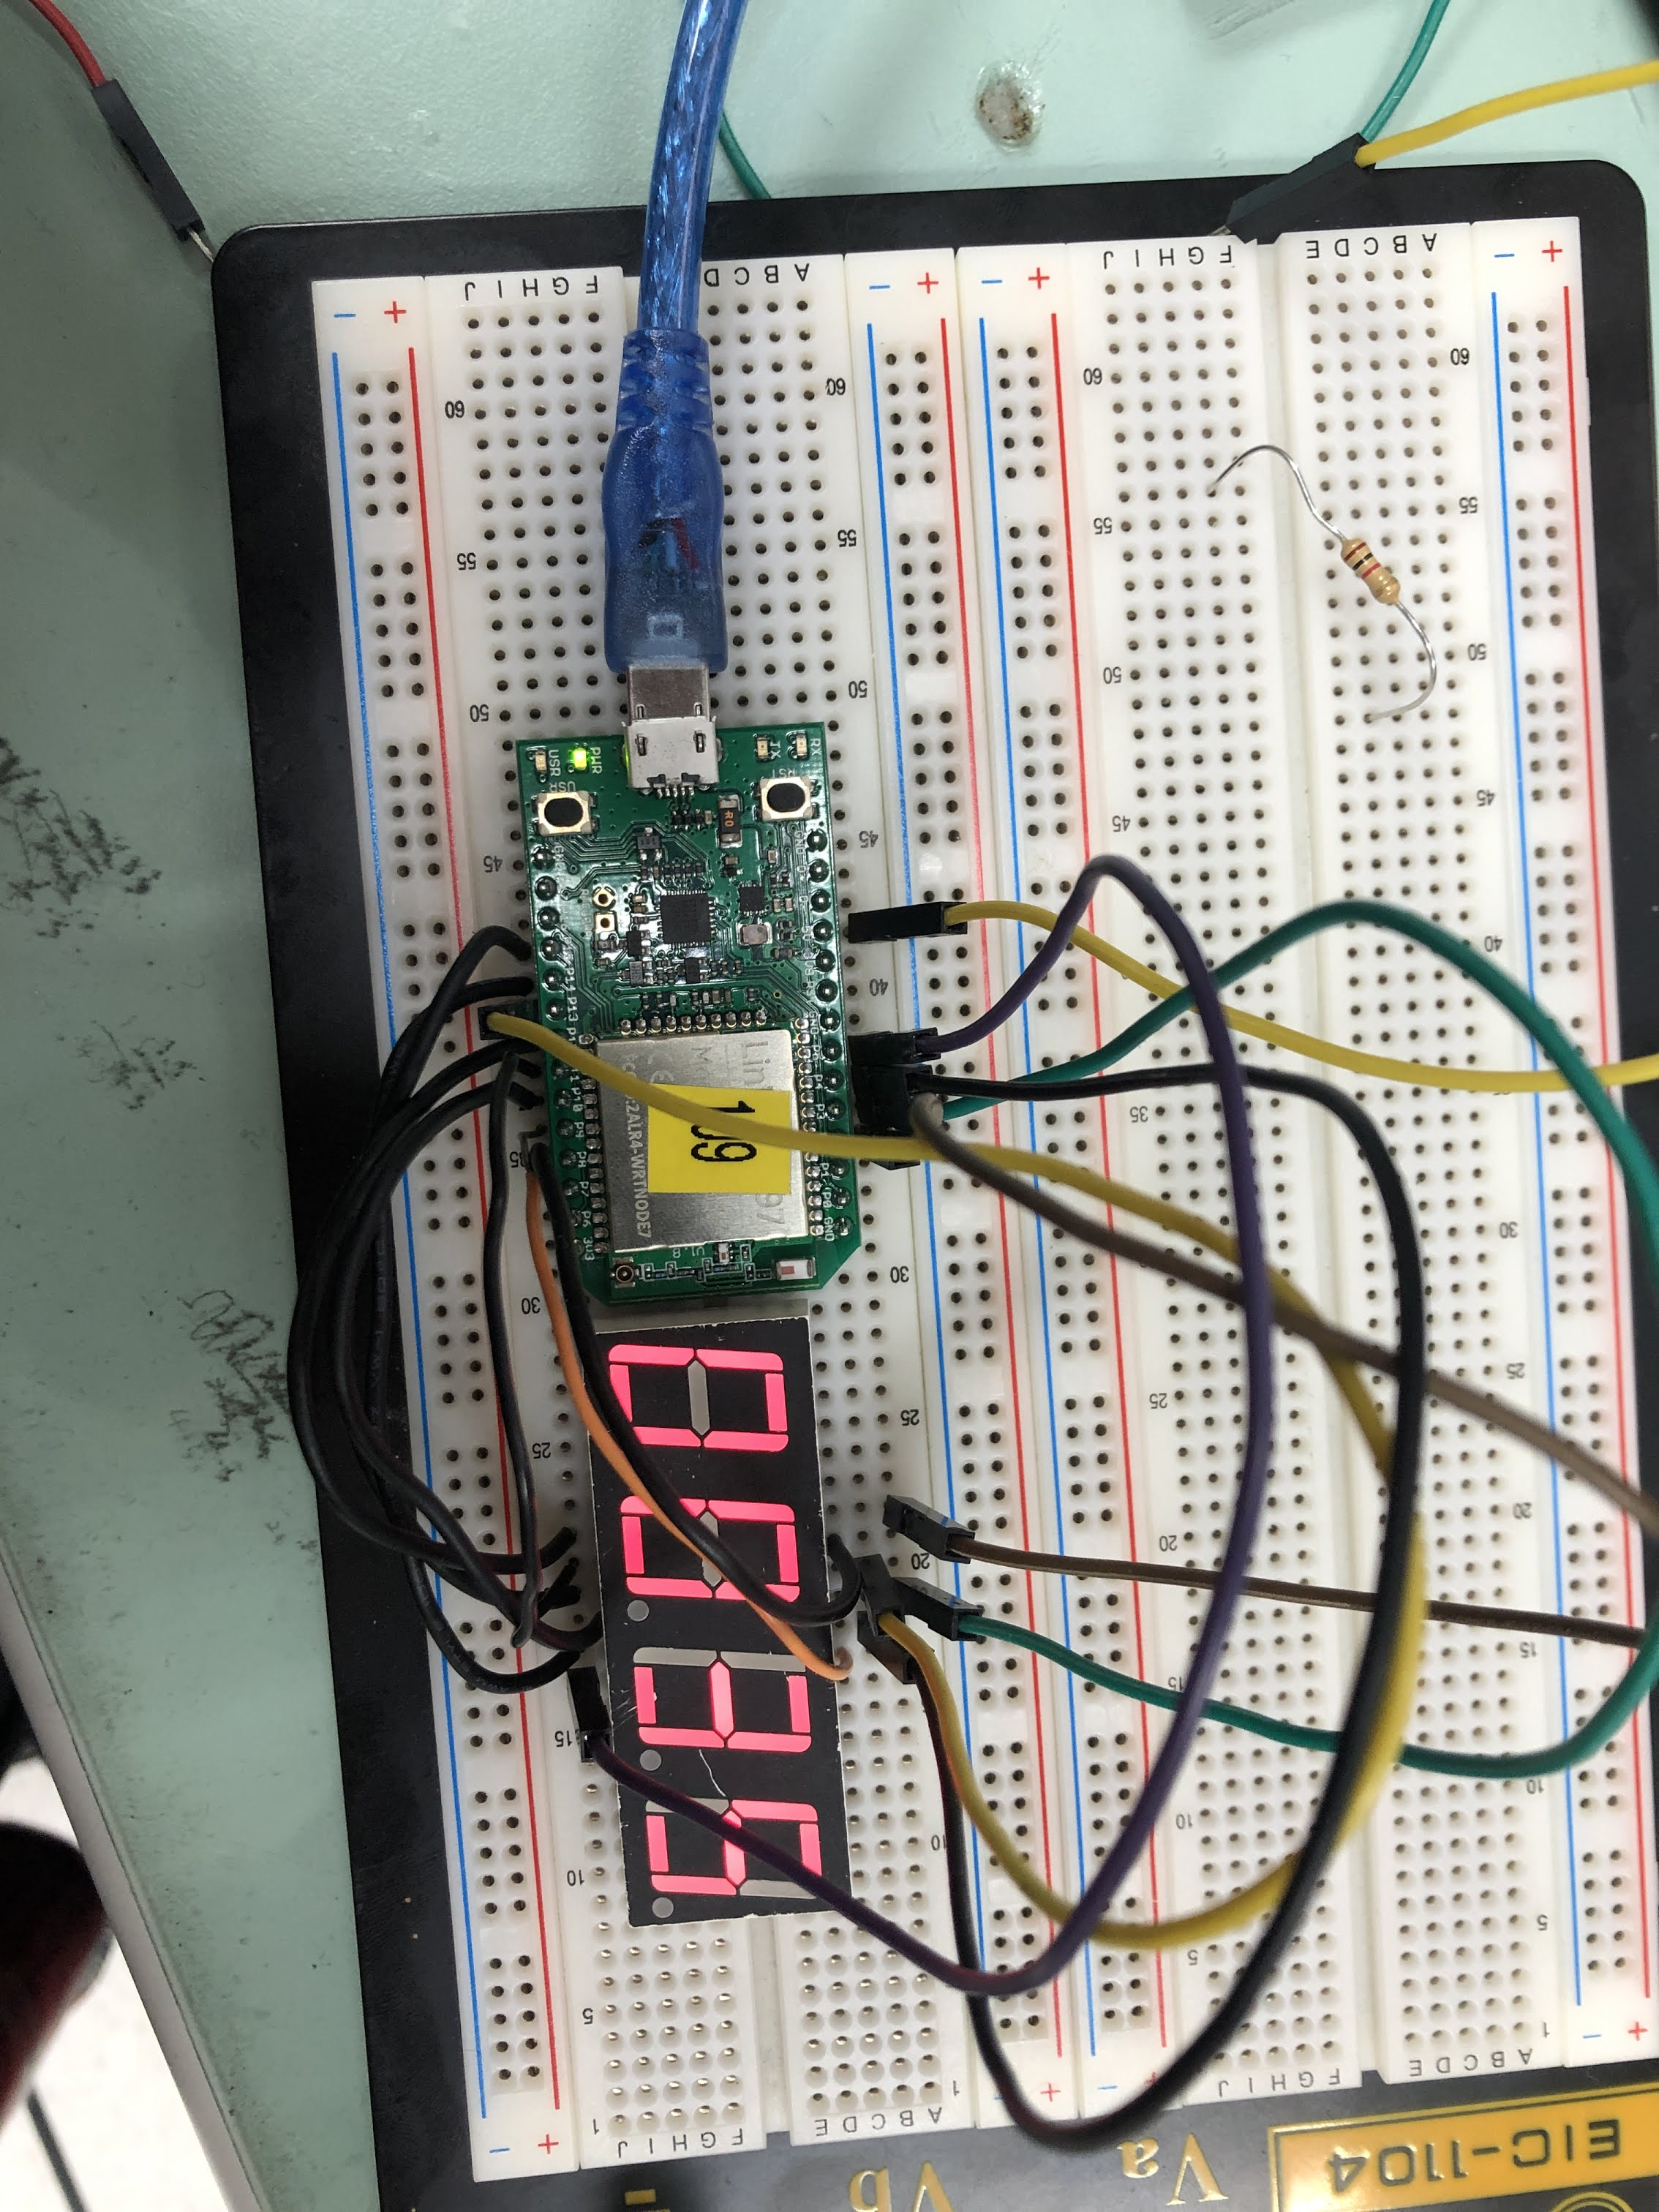

電路圖:
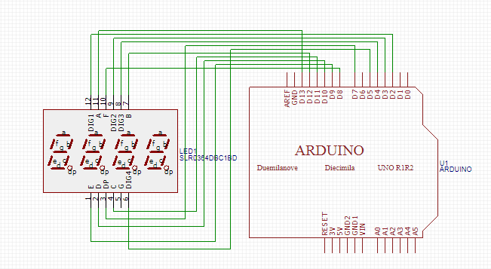
程式碼1
#include "SevSeg.h"
SevSeg sevseg; //Instantiate a seven segment controller object

void setup() {
byte numDigits = 4;
byte digitPins[] = {2, 3, 4, 5};
byte segmentPins[] = {8,9,10,11,12,13,14,15};
byte hardwareConfig = COMMON_CATHODE;
sevseg.begin(hardwareConfig, numDigits, digitPins, segmentPins);
sevseg.setBrightness(90);

}

void loop() {
static unsigned long timer = millis();
static int a=0,b=0;
if(millis()-timer>=300)
{
timer+=300;
a++;
if(a==60)
{
a=0;
b++;
}
if(b=24)
{
b=0;
}
sevseg.setNumber(a+b*100);
}
sevseg.refreshDisplay();
}

程式碼2
#include "SevSeg.h"
SevSeg sevseg; //Instantiate a seven segment controller object

void setup() {
pinMode(6,INPUT);
byte numDigits = 4;
byte digitPins[] = {2, 3, 4, 5};
byte segmentPins[] = {8,9,10,11,12,13,14,15};
byte hardwareConfig = COMMON_CATHODE;
sevseg.begin(hardwareConfig, numDigits, digitPins, segmentPins);
sevseg.setBrightness(90);

}

void loop() {
static unsigned long timer = millis();
static int a=0,b=0;
if(millis()-timer>=300)
{
timer+=300;
a++;
if(a==60)
{
a=0;
b++;
}
if(b=24)
{
b=0;
}
sevseg.setNumber(a+b*100);
}
if(digitalRead(6))
{
a=b=0;
}
sevseg.refreshDisplay();
}

程式碼3
#include "SevSeg.h"
SevSeg sevseg; //Instantiate a seven segment controller object

void setup() {
byte numDigits = 4;
byte digitPins[] = {2, 3, 4, 5};
byte segmentPins[] = {8,9,10,11,12,13,14,15};
bool resistorsOnSegments = false; // 'false' means resistors are on digit pins
byte hardwareConfig = COMMON_CATHODE; // See README.md for options
sevseg.begin(hardwareConfig, numDigits, digitPins, segmentPins, resistorsOnSegments);
sevseg.setBrightness(90);
pinMode(6,INPUT);
pinMode(17,INPUT);
}

void loop()
{

static unsigned long timer = millis();
static int deciSeconds = 0;
boolean val=digitalRead(6);
boolean Pin17=digitalRead(17);
if(val)
{
sevseg.setNumber(0000, 3);
sevseg.refreshDisplay();
if(Pin17==HIGH)
deciSeconds=2400;
else
deciSeconds=0;

}
else if(Pin17==HIGH)
{
sevseg.setNumber(deciSeconds, 3);
if (millis() - timer >= 300)

{
timer += 300;
deciSeconds--;
if (deciSeconds%100 == 59)
{
deciSeconds=deciSeconds-59;
}
else
{
deciSeconds=deciSeconds-1;
}
}
if (deciSeconds == 0)
deciSeconds =2400 ;

sevseg.refreshDisplay(); // Must run repeatedly
}
else
{
sevseg.setNumber(deciSeconds, 3);
if (millis() - timer >= 300)
{
timer += 300;
deciSeconds++;
if (deciSeconds%100 == 59)
{
deciSeconds=deciSeconds+41;
}
else
{
deciSeconds=deciSeconds+1;
}
if (deciSeconds == 2400)
deciSeconds =0 ;
}

sevseg.refreshDisplay(); // Must run repeatedly
}
}

- 心得討論
這次實驗很好玩又有趣 但中間還是遇到很多麻煩 比如一開始數字顯示不出來但還好最後還是做完了

