電通二乙微處理器實驗 實驗結報

實驗名稱 | Lab08-中斷控制與超音波測距
組別 |  | 組員 | 梅凌寒06052411

- 實驗目的
Arduino於當按下Pin2外部中斷0時,讀入超音波測距之值顯示於PC上
- 如何讀取超音波測距之值
- 如何將超音波測距之值顯示於LCD上
- Arduino如何規劃外部中斷INTO
- 接一SW,當按下SW時暫停所有中斷,實驗結果又如何?

1.實驗步驟
接電路
電路圖
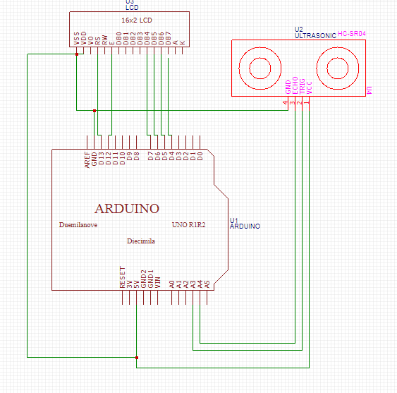
程式碼
#include <LiquidCrystal.h>
#include <Ultrasonic.h>
LiquidCrystal lcd(15, 14, 5, 4, 3, 2);
#define TRIGGER_PIN 12
#define ECHO_PIN 13
Ultrasonic ultrasonic(TRIGGER_PIN, ECHO_PIN);
void setup() {
lcd.begin(16, 2);
Serial.begin(9600);
}
void loop(){
float cmMsec, inMsec;
long microsec = ultrasonic.timing();
cmMsec = ultrasonic.convert(microsec, Ultrasonic::CM);
inMsec = ultrasonic.convert(microsec, Ultrasonic::IN);
lcd.setCursor (0,0);
lcd.print("MS: "); lcd.print(microsec);
lcd.setCursor(0, 1);
lcd.print(" CM: ");lcd.print(cmMsec);
lcd.print(",IN: "); lcd.print(inMsec);
delay(1000);
lcd.clear();
delay(100);

}
實驗結果及分析
讀取超音博測距值顯示在LCD上

2.

電路圖
程式碼
#include <LiquidCrystal.h>
#include <Ultrasonic.h>
LiquidCrystal lcd(8,9,11,12,13,14);
#define TRIGGER_PIN 4
#define ECHO_PIN 5
volatile boolean state=LOW;
Ultrasonic ultrasonic(TRIGGER_PIN, ECHO_PIN);
void setup() {
digitalWrite(6,INPUT);
Serial.begin(9600);
lcd.begin(16, 2);

attachInterrupt(2, int0, FALLING);
}
long microsec;
float cmMsec, inMsec;
void loop(){
if(digitalRead(6)==LOW)
{ noInterrupts();}
else
{ interrupts();}
lcd.print("MS: "); lcd.print(microsec);
lcd.setCursor(0, 1);
lcd.print("CM: ");lcd.print(cmMsec);
lcd.print(",IN: "); lcd.print(inMsec);
delay(1000);

}

void int0()
{

microsec = ultrasonic.timing();
cmMsec = ultrasonic.convert(microsec, Ultrasonic::CM);
inMsec = ultrasonic.convert(microsec, Ultrasonic::IN);
lcd.clear();

}
- 心得討論
這次實驗還挺好玩的,雖然一開始會手忙腳亂地,但還好最後有能做出來

