電通二乙微處理器實驗 實驗結報

實驗名稱 | Lab 12溫濕度感應器
組別 |  | 組員 | 梅凌寒06052411

- 實驗目的
讓DHT-11可以一直量測溫濕度
整合Timer與DHT-11量測溫濕度
- 實驗步驟
修改Timer1之_callback1，量測DHT-11之溫濕度
修改timer.start，使其1秒鐘量一次
- 程式碼
#include <LWiFi.h>
#include "MCS.h"
#include "DHT.h"

#define DHTPIN 2
#define DHTTYPE DHT11

DHT dht(DHTPIN, DHTTYPE);
char _lwifi_ssid[] = "mei-iPhone";
char _lwifi_pass[] = "wdsr1111";
MCSDevice mcs("DlFxlBdm", "zn9fLRqAYygJd7w0");

MCSDisplayFloat Temperature("temp");
MCSDisplayFloat Humidity("humi");
void setup()
{
dht.begin();
Serial.begin(9600);
Serial.println("Connect to Wifi");
while (WiFi.begin(_lwifi_ssid, _lwifi_pass) != WL_CONNECTED) {
Serial.println("Wifi Reconnecting..");
delay(1000);
}

Serial.println("Connect to MCS...");
while (!mcs.connected()) {
Serial.println("MCS Reconnecting..");
mcs.connect();
}
Serial.println("MCS Connected!");
Serial.println("Humidity and temperature\n\n");
mcs.addChannel(Temperature);
mcs.addChannel(Humidity);
}

void loop()
{
while (!mcs.connected()) {
mcs.connect();
if (mcs.connected()) {
Serial.println("MCS Reconnect");
}
}
mcs.process(1000);
float h = dht.readHumidity();
float t = dht.readTemperature();
if (isnan(h) || isnan(t)) {
Serial.println("Failed to read from DHT sensor!");
return;
}
Serial.print("Humidity: ");
Serial.print(h);
Serial.print(" %\t");
Serial.print("Temperature: ");
Serial.print(t);
Serial.print(" *C ");
Humidity.set(h);
Temperature.set(t);
Serial.println("Add sensor value.");
delay(200);
}
——————————————————————————————————
#include "DHT.h"

#define DHTPIN 2 // Digital pin connected to the DHT sensor

//#define DHTTYPE DHT11 // DHT 11
#define DHTTYPE DHT11 // DHT 22 (AM2302), AM2321
//#define DHTTYPE DHT21 // DHT 21 (AM2301)

#include "Arduino.h"
#include "LTimer.h"
DHT dht(DHTPIN, DHTTYPE);
LTimer timer0(LTIMER_0);
float h,t,f,hic,hif;
void _callback0(void *usr_data)
{ Serial.print(F("Humidity: "));
Serial.print(h);
Serial.print(F("% Temperature: "));
Serial.print(t);
Serial.print(F("'C "));
Serial.print(f);
Serial.print(F("'F Heat index: "));
Serial.print(hic);
Serial.print(F("'C "));
Serial.print(hif);
Serial.println(F("'F"));
}
void setup() {
Serial.begin(9600);
timer0.begin();
Serial.println(F("DHTxx test!"));

dht.begin();
timer0.start(1000, LTIMER_REPEAT_MODE, _callback0, NULL);
}

void loop() {

h = dht.readHumidity();
// Read temperature as Celsius (the default)
t = dht.readTemperature();
// Read temperature as Fahrenheit (isFahrenheit = true)
f = dht.readTemperature(true);

// Check if any reads failed and exit early (to try again).
if (isnan(h) || isnan(t) || isnan(f)) {
Serial.println(F("Failed to read from DHT sensor!"));
return;
}

// Compute heat index in Fahrenheit (the default)
hif = dht.computeHeatIndex(f, h);
// Compute heat index in Celsius (isFahreheit = false)
hic = dht.computeHeatIndex(t, h, false);

}
- 實驗結果及分析
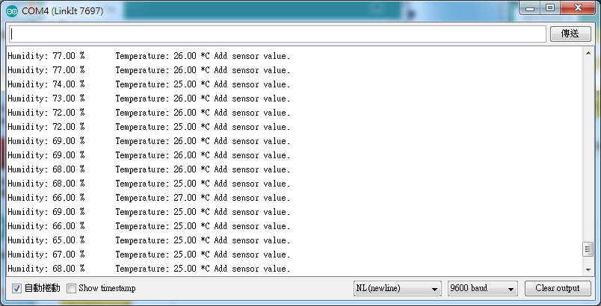
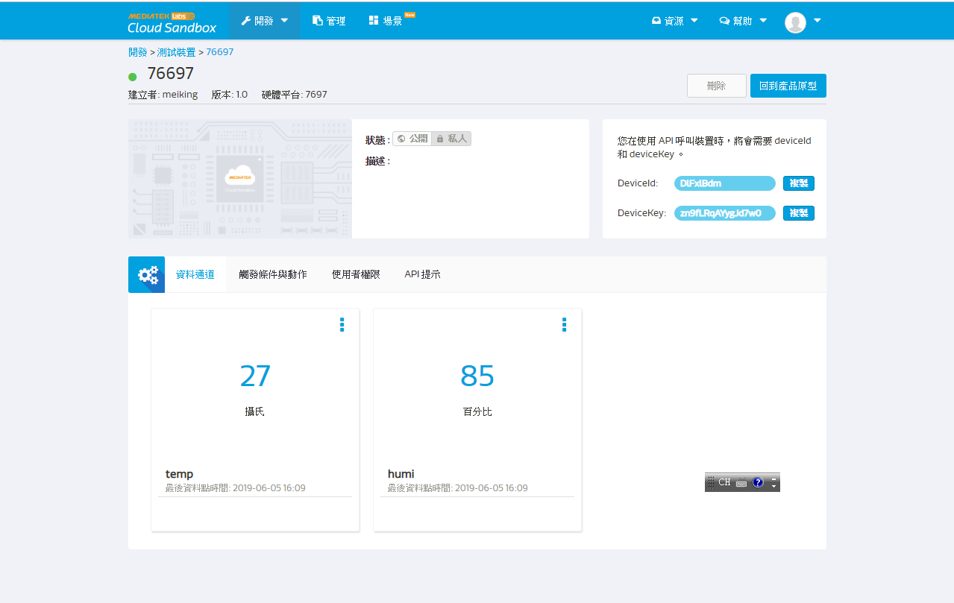
- 心得討論
這次實驗蠻有趣，可以測量生活中的數據，mcs cloud也十分強大
- 修正電路圖
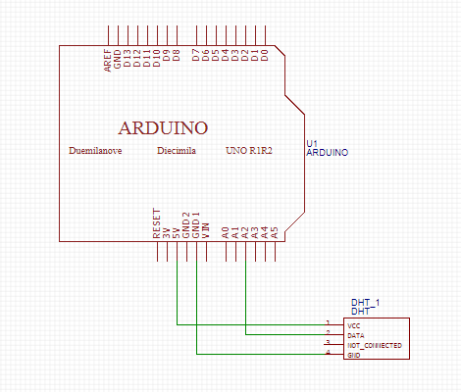
- 修正程式碼

