1. Enter the name of the project and its location.
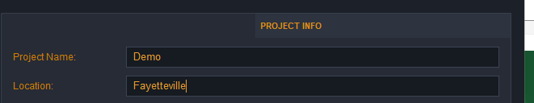

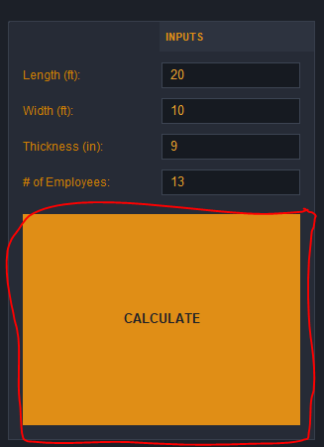

2. Enter the dimensions of the concrete pad you would like to build and the number of employees you will have working on the project.

3. Press the calculate button to see the cost to build the pad.

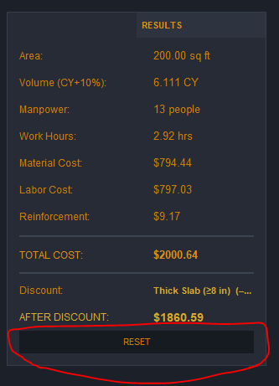

4. Here is where the program shows you the cost of the concrete pad. It also shows the values used to calculate the cost.

5. You can press the reset button to clear out all of the data you put into the program.
5. Here, you can save, load, and delete projects. There are several preset projects saved in the program.

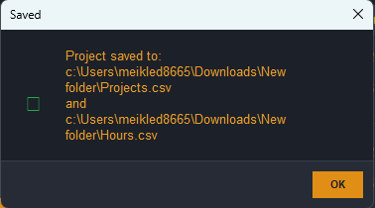
6. after saving the project, the program will give you a confirmation message and tell you what file the project was saved to.

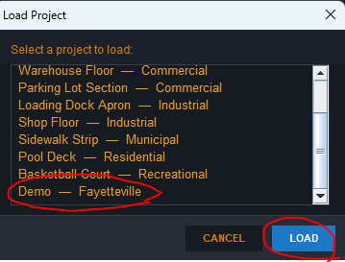
7. Clicking the load project button will bring up a menu where you can find every saved project. Click on the project you would like to see and click load.

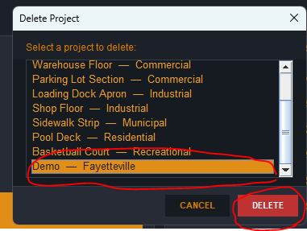
8. The delete button will bring up an almost identical menu that also functions almost the exact same way. Click on the project you would like to delete and click the delete button.

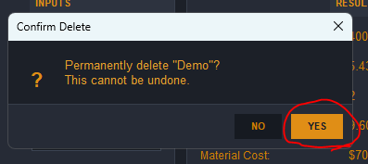
9. The program will bring up a confirmation message. Click yes and the project will be deleted from the program.

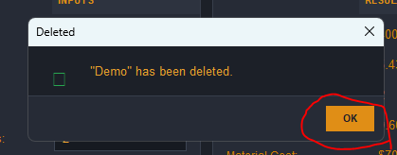
10. the program will bring up one last confirmation message, letting you know that the project has been deleted.

