目录
Identification 1
2019 1
2020 2
2021 2
2022 3
2023 4
2024 5
2025 6
Verification 7
数据集 9

https://github.com/ASU-APG/awesome_attribution_of_generative_models

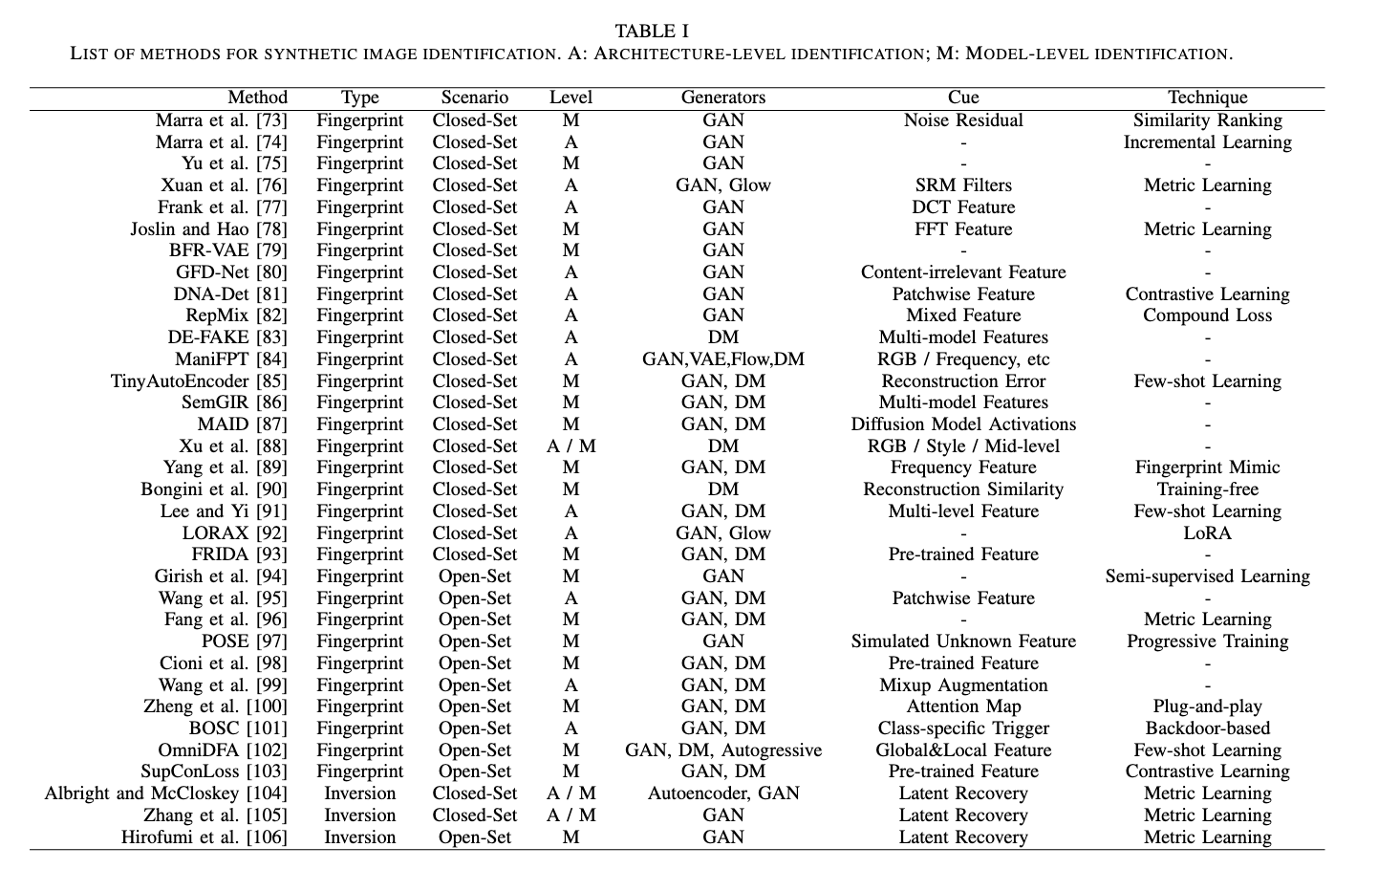

Identification

用于从N个候选模型中选择出正确的源模型，检测器在open-set场景中最好拥有拒识能力

2019

- Do GANs Leave Artificial Fingerprints? MIPR 2019.
Francesco Marra, Diego Gragnaniello, Luisa Verdoliva, Giovanni Poggi
核心思想：基于GAN噪声残差相似度的检测。受相机固有缺陷导致的光响应非均匀性（PRNU）启发，提取不同GAN生成图像中的指纹，将与测试图像的指纹距离最接近的指纹对应的GAN作为源模型。Model-level
数据集：真实图像来自RAISE共2k；生成图像来自CycleGAN/ProGAN/StarGAN（共18个版本），不同迁移域，共20种*1k张，https://www.grip.unina.it/download/DoGANs/
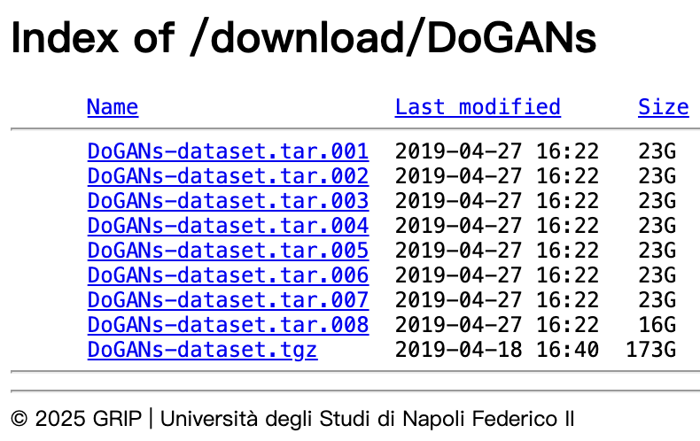
代码（未开源）：https://grip-unina.github.io/DoGANs/

- Attributing Fake Images to GANs: Learning and Analyzing GAN Fingerprints. ICCV 2019.
Ning Yu, Larry Davis, Mario Fritz. University of Maryland, USA
核心思想：设计一个分类网络，实现N+1溯源
数据集：真实图像来自CelebA和LSUN各20k；生成图像来自ProGAN, SNGAN, CramerGAN, and MMDGAN，各200k张（生成图像集未公开）。Model-level
代码（Tensorflow版本）：https://github.com/ningyu1991/GANFingerprints

- Incremental learning for the detection and classification of GAN-generated image. WIFS, 2019.
Francesco Marra; Cristiano Saltori; Giulia Boato; Luisa Verdoliva. University Federico II of Naples, Italy
核心思想：增量学习，缓解泛化性难题。Model-level
数据集：DoGANs，生成图像加了Glow
代码：未开源

- Source Generator Attribution via Inversion. CVPR Workshops 2019.
Michael Albright and Scott McCloskey. Honeywell ACST, USA
核心思想：给定一个probe image，和多个GANs，通过损失优化的方式，找到最佳结果对应的潜向量，选择重建效果最接近probe image的GAN。Model-level
数据集：MNIST（1k张 for AutoEncoder）; CelebA（100张 for ProGAN+SAGAN, respectively）
代码：未开源

- Scalable fine-grained generated image classification based on deep metric learning. arXiv, 2019.
Xuan, Xinsheng and Peng, Bo and Wang, Wei and Dong, Jing. Chinese Academy of Sciences, China
核心思想：基于度量学习，面向溯源泛化性问题的解决，分三阶段，训练阶段用交叉熵损失+center loss，fine-tune阶段用triplet loss，测试阶段构建模板库，通过计算测试图像与模版库特征向量的L2损失得到预测结果。实验分closed set 和 open set。Model-level
数据集：真实图像来自CelebA（10k训练+100测试）；生成图像来自7个模型（BEGAN, DCGAN, Glow, PGGAN, StyleGAN, IntroVAE and WGANGP）7*(10k训练集+100测试集)
代码：未开源

2020

- Leveraging Frequency Analysis for Deep Fake Image Recognition. ICML, 2020.
Joel Frank, Thorsten Eisenhofer, Lea Schönherr, Asja Fischer, Dorothea Kolossa, Thorsten Holz
核心思想：系统研究了GAN生成图像在频域中的固有缺陷，揭示了不同架构的GAN在频域中均存在明显的网格状伪影，并证明这些伪影源于生成器中的上采样操作。通过实验验证了频域指纹相较于图像域指纹的优越性。Model-level
代码：https://github.com/RUB-SysSec/GANDCTAnalysis
数据集：用的和Yu一样的数据集

2021
- Towards discovery and attribution of open-world gan generated images. ICCV 2021.
Sharath Girish, Saksham Suri, Saketh Rambhatla, Abhinav Shrivastava. University of Maryland, USA
核心思想：提出了一种迭代算法，通过结合网络训练、异常检测、聚类及精炼等步骤，有效发现先前未见过的GAN生成器。Model-level
数据集：真实图像来自CelebA, CelebA-HQ,ImageNet and LSUN,DTD, FashionGen, Night and Shoes；生成图像来自StarGAN, BEGAN, ProGAN, SNGAN, AttGAN, MMDGAN, CramerGAN, StyleGAN, BigGAN, S3GAN, 未公开
代码：https://github.com/Sharath-girish/openworld-gan

- Does a GAN leave distinct model-specific fingerprints?. BMVC 2021.
Yuzhen Ding, Nupur Thakur and baoxin Li. Arizona State University, USA
核心思想：方法名称BFR-VAE，提出基于Bayesian+VAE的GAN模型指纹提取方法，并通过JS散度和相关性系数等距离比较的方式验证了通过这种方法提取出的指纹的可靠性。Model-level
数据集：真实图像来自CelebA和LSUN，生成图像来自ProGAN，SNGAN，MMDGAN，CramerGAN，StyleGAN and StarGAN共6种
代码：未开源

- On attribution of deepfakes. arXiv 20210303.
Baiwu Zhang, Jin Peng Zhou, Ilia Shumailov, Nicolas Papernot. University of Toronto, Canada
核心思想：提出Strict Attribution 和 Relaxed attribution 场景，想法和Albright类似。Model-level
数据集：未公开，生成图像来自ProGAN、StyleGAN和StyleGAN2，各2k张人脸图像
代码：未开源

- Learning to disentangle gan fingerprint for fake image attribution. arXiv, 20210616.
Tianyun Yang, Juan Cao, Qiang Sheng, Lei Li, Jiaqi Ji, Xirong Li, Sheng Tang
核心思想：方法名称GFD-Net，显式将语义内容特征与模型特定的GAN指纹特征进行解耦，学习与图像内容无关、但与生成器高度相关的指纹表示。
数据集：全是GAN图像，未公开

2022

- Deepfake Network Architecture Attribution. AAAI 2022.
Tianyun Yang, Ziyao Huang, Juan Cao, Lei Li, Xirong Li. Chinese Academy of Sciences
核心思想：方法名称DNA-Det，实现模型架构溯源architecture attribution，一阶段使用自监督学习使模型学习用于分类的特征，二阶段实施GAN架构分类。两阶段均使用对比学习。
数据集：3种分辨率，10种GAN架构(ProGAN:4+StyleGAN:11+StyleGAN2:8+Others:19)，已公开(50G+)
StyleGAN2: 12,640+14,031+20,000+5,000 =51k
CramerGAN: 40,000=40k
CycleGAN: 1,321
InfoMaxGAN: 80,000=80k
MMDGAN: 80,000=80k
ProGAN: 20k+9k+280k+130k=439k
StyleGAN: 10.5k
SNGAN: 60k
SSGAN: 38,595
StackGAN2: 11,500
以上 ～812,587
Real: ~250k
代码：https://github.com/ICTMCG/DNA-Det

- RepMix: Representation Mixing for Robust Attribution of Synthesized Images. ECCV 2022.
Tu Bui, Ning Yu, and John Collomosse. University of Surrey, UK
核心思想：混合样本+新型软标签损失
数据集：名称Attribution88，真实图像来自CelebA和LSUN，12000x8x11=1056k张图像，7GANs (ProGAN, CramerGAN, MMDGAN, SNGAN, Stylegan, Stylegan2, Stylegan3) + 1real
代码：https://github.com/TuBui/image_attribution

- Did you use my GAN to generate fake? post-hoc attribution of GAN images via latent recovery. IJCNN 2022.
Syou Hirofumi; Kazuto Fukuchi; Yohei Akimoto; Jun Sakuma. Univresity of Tskuba, Japan
核心思想：梯度优化找到每个candidate generator的最优latent，比较相似度。Model-level
数据集：真实图像来自CelebA和LSUN，生成图像来自ProGAN和StyleGAN
代码：未开源

2023

- DE-FAKE- Detection and Attribution of Fake Images Generated by Text-to-Image Generation Models. CCS, 2023.
Zeyang Sha, Zheng Li, Ning Yu, Yang Zhang. CISPA, Gernamy
核心思想：real images +N kinds of fake images 一起，detection and attribution。CLIP提取文本特征和图像特征，concat送入MLP分类。有少部分关于unseen model判别的内容。Model-level
数据集：真实图像来自ImageNet；生成图像来自SD，Glide，LDM DALL·E未公开
代码：https://github.com/zeyangsha/De-Fake

- Progressive Open Space Expansion for Open-Set Model Attribution CVPR 2023.
Tianyun Yang, Danding Wang, Fan Tang, Xinying Zhao, Juan Cao, Sheng Tang. Chinese Academy of Sciences
核心思想：设计轻量级 Augmentation Models，模拟未知模型指纹，构造伪开放集样本；多个 augmentation 模型逐步引入（每轮新增一个）以模拟更多元的开放空间。Model-level
数据集：OSMA，真实图像来自CelebA/Face-HQ/ImageNet/Youtube/LSUN，生成图像来自BigGAN, ContraGAN, FaceShifter, FSGAN, FaceSwap, StarGAN, ProGAN, SAGAN, SNGAN, AttGAN, MMDGAN, InfoMaxGAN, StyleGAN, StyleGAN2, StyleGAN 3, S3GAN, Wav2Lip公开（50G+）
Real: 10414
（除了黄色的，其余生成图像总共210777）
Fake: AttGAN: 5301
BigGAN: 266（上传到服务器后自动统计,~= 43052）
ContraGAN: 431
FaceShifter: 220
FaceSwap: 70
FSGAN: 444
InfoMax-GAN: 5371+5376=10747
MMDGAN: 500+500+5500+5500+990+500*4+5365+500=20855
ProGAN: 500+500+5500+5500+5377+500*4+(5371+5380+5371+5259+5259+976)+500=47493
S3GAN: 5258
SAGAN: 265
SNGAN: 1000+1000+5500+9785+5387+1000+1000+1000+7472+1000+8799+1000=43943
starGAN: 5240
styleGAN: 1000+1000+9766+5500+8752+1000+1000+1000+1000+1000=31018
styleGAN2:1000+5500+982=7482
styleGAN3: 1000+1000+5500+5500+1000+1000+1000+1000+1000+5000+5000=28000+
wav2lip: 272*20=5440
代码：https://github.com/ICTMCG/POSE

- Open Set Classification of GAN-based Image Manipulations via a ViT-based Hybrid Architecture. CVPR Workshops 2023.
Jun Wang, Omran Alamayreh, Benedetta Tondi, Mauro Barni. University of Siena, Italy
核心思想：首先利用CNN提取特征图，再将特征图划分为patch并送入ViT，通过自注意力机制建模不同局部区域之间的相关性，从而捕获生成模型或操控方式引入的判别性伪迹。Model-level
数据集：StyleGAN2, StyleGAN3, Taming Transformer, Latent Diffusion and LSGM, 50k*5=250k，未公开
代码：https://github.com/wangjun9276/OpenGANForensics

- Open Set Synthetic Image Source Attribution BMVC 2023.
Shengbang Fang, Tai D. Nguyen, Matthew C. Stamm. Drexel University, USA
核心思想：使用度量学习，首先使用CNN提取特征，然后计算距离实现attribution或rejection。使用ProxyNCA++来训练得到较好的embedding提取网络。Model-level
数据集：真实图像来自CelebA/LSUN/FFHQ/ImageNet；生成图像来自ProGAN, Projected-GAN, StyleGAN, StyleGAN2, StyleGAN3, Taming Transformer, and Stable Diffusion。每个模型和数据组合生成10k张图像。8:1:1划分数据集，并划分unseen数据用于open-set测试。未公开
代码：未开源

2024

- ManiFPT: Defining and Analyzing Fingerprints of Generative Models. CVPR, 2024.
Hae Jin Song, Mahyar Khayatkhoei, Wael AbdAlmageed
核心思想：首先定义何为artifacts和fingerprints，然后使用图像的RGB, frequency, or ResNet-learned feature space特征用来完成溯源。Model-level，但也包括一些cross-dataset的实验
代码：https://github.com/cocoaaa/manifpt-homepage/
数据集：

- Tiny Autoencoders are Effective Few-Shot Generative Model Detectors. WIFS, 2024.
Luca Bindini, Giulia Bertazzini, Daniele Baracchi, Dasara Shullani, Paolo Frasconi, and Alessandro Piva. University of Florence, Italy
核心思想：少样本学习，使用自编码器对图像进行重建，利用重建特征训练一个SVM进行溯源，与DE-FAKE进行比较。Model-level
数据集：GenImage的子集（1k for each generator），真实图像来自ImageNet；生成图像来自ADM, GLIDE, Midjourney, Stable Diffusion V1.4, Stable Diffusion V1.5, VQDM, Wukong 和 BigGAN
代码：未开源

- Are CLIP features all you need for Universal Synthetic Image Origin Attribution? ECCV Workshop, 2024.
Dario Cioni, Christos Tzelepis, Lorenzo Seidenari, and Ioannis Patras. University of Florence
核心思想：将基于patch的ViT模块预训练模型特征（CLIP/DINOv2）与logistic regression或KNN结合。Model-level
代码：https://github.com/ciodar/UniversalAttribution
数据集：GenImage / OSMA

2025

- BOSC: A Backdoor-based Framework for Open Set Synthetic Image Attribution. TIFS, 2025.
Jun Wang, Benedetta Tondi, Mauro Barni. University of Siena, Italy
核心思想：方法名称BOSC，设计class-specific trigger，只有当trigger图像与指定类别的图像匹配时，输出backdoor类别（N+1）。如果是open-set图像，那么永远不会输出backdoor类别，以此完成拒识。Architecture-level
代码：未公开

- Model Synthesis for Zero-Shot Model Attribution. TMM, 2025.
Tianyun Yang, Juan Cao, Danding Wang, Chang Xu. 中科院
核心思想：
代码：https://github.com/TianyunYoung/Model-Fingerprint

- Detecting Origin Attribution for Text-to-Image Diffusion Models. WACV, 2025.
Katherine Xu, Lingzhi Zhang, Jianbo Shi. University of Pennsylvania, USA
核心思想：使用现成的backcone（EfficientFormer / CLIP / DINOv2），利用图像的RGB/Style/Mid-level特征训练分类器。也考虑了Cross-domain generalization场景。考虑了different model checkpoints (within the same architecture), diverse scheduling algorithms, varied initialization seeds, and a range of inference steps，因此是model-level
数据集：未公开
代码：未开源

- Few-Shot Class-Incremental Model Attribution Using Learnable Representation From CLIP-ViT Features. arXiv, 20250311
Hanbyul Lee, Juneho Yi. Sungkyunkwan University
核心思想：使用few shot class-incremental learning (FSCIL) mechanism，使用low-level和high-level的特征,CLIP-ViT作为backbone。Model-level
数据集：
代码：

- LoRAX: LoRA eXpandable Networks for Continual Synthetic Image Attribution. arXiv, 20250410
Danielle Sullivan-Pao, Nicole Tian, Pooya Khorrami. MIT Lincoln Laboratory & Yale University
核心思想：使用LoRA用于新类别出现的小样本学习场景，提高检测器的重训效率。Model-level
数据集：CDDB dataset
代码：https://github.com/mit-ll/lorax_cil

《待补充》
- Detection, Attribution and Localization of GAN Generated Images. arXiv 2021.
M Goebel，L Nataraj，T Nanjundaswamy，TM Mohammed，BS Manjunath
核心思想：将图像三通道共现矩阵输入XceptionNet变体

- FIDAVL: Fake Image Detection and Attribution using Vision-Language Model. ICPR, 2024.
Mamadou Keita, Wassim Hamidouche, Hessen Bougueffa Eutamene, Abdelmalik Taleb-Ahmed, Abdenour Hadid.
核心思想：基于BLIP2的Q-Former和Vicuna 7b

- Whodunit: Detection and Attribution of Synthetic Images by Leveraging Model-specific Fingerprints
Alexander Wißmann, Steffen Zeiler, Robert M. Nickel, Dorothea Kolossa. MAD Workshop, 2024.
核心思想：使用DCT、功率谱密度(Power Spectral Density, PSD)（频域）以及自相关系数（像素域）训练分类器。

- Forensic Self-Descriptions Are All You Need for Zero-Shot Detection, Open-Set Source Attribution, and Clustering of AI-generated Images CVPR,2025
Tai D. Nguyen, Aref Azizpour, Matthew C. Stamm
核心思想：自监督学习，基于真实图像构建图像的法证自描述

- ReTD: Reconstruction-Based Traceability Detection for Generated Images ICASSP, 2025.
Weizhuo Chen, Fangfang Yuan, Cong Cao, Kun Peng, Dakui Wang, Yanbing Liu. Chinese Academy of Sciences
核心思想：重建残差送入（CNN+Transformer+MLP）训练完成检测

- DeepGuard: Identification and Attribution of AI-Generated Synthetic Images Electronics, 2025.
Yasmine Namani, Ikram Reghioua, Gueltoum Bendiab, Mohamed Aymen Labiod, Stavros Shiaeles
核心思想：

- Autonomous and Self-Adapting System for Synthetic Media Detection and Attribution arXiv, 20250404
Aref Azizpour, Tai D. Nguyen, Matthew C. Stamm Drexel University
核心思想：

Verification

用于判断测试图像是否由特定源模型生成（二分类问题，是/否），检测器在open-set场景中最好拥有泛化能力

- Where Did I Come From? Origin Attribution of AI-Generated Images. NeurIPS, 2023.
Zhenting Wang, Chen Chen, Yi Zeng, Lingjuan Lyu, Shiqing Ma. Rutgers University, USA
核心思想：方法名称RONAN，单个模型的溯源。
数据集：真实图像来自CIFAR-10/ImageNet/CUB-200-2011；生成图像来自DCGAN，StyleGAN2- ADA，TransGAN，StyleGAN XL，Control-GAN，StackGAN-v2；DDIM，DDPM，Consistency Diffusion Model，Stable Diffusion v2；VAE，未公开
代码：https://github.com/ZhentingWang/RONAN

- Reverse engineering of generative models: Inferring model hyperparameters from generated images. IEEE TPAMI 2023.
Vishal Asnani, Xi Yin, Tal Hassner, Xiaoming Liu. Michigan State University, USA
核心思想：
数据集：构建116个模型*1k张图像用于模型释义；attribution数据集同Yu et al.
代码：https://github.com/vishal3477/Reverse_Engineering_GMs

- How to Trace Latent Generative Model Generated Images without Artificial Watermark? ICML, 2024
Zhenting Wang, Vikash Sehwag, Chen Chen, Lingjuan Lyu, Dimitris N. Metaxas, Shiqing Ma. Rutgers University, USA
核心思想：方法名称LatentTracer，使得重建误差最小的inverted latent，无需训练
数据集：生成图像来自sd v1.4, sd v1.5, sd v2-base, sd v2.1, sd xl, Kandinsky，需按代码生成
代码：https://github.com/ZhentingWang/LatentTracer

- Single-Model Attribution of Generative Models Through Final-Layer Inversion. ICML, 2024.
Mike Laszkiewicz, Jonas Ricker, Johannes Lederer, Asja Fischer. Ruhr University Bochum, Germany
核心思想：FLIPAD，final-layer inversion +
数据集：真实图像来自CelebA/LSUN；生成图像来自DCGAN, WGAN-GP, LSGAN, EBGAN
代码：https://github.com/MikeLasz/flipad

- Attributing and Detecting Fake Images Generated by Known GANs. SPW, 2020.
Matthew Joslin and Shuang Hao. University of Texas at Dallas, USA
核心思想：无需训练分类器，提取GAN图像FFT特征的平均作为fingerprint，然后和 test image FFT 计算相似度，根据相似度判断是否为源模型
数据集：公开；真实图像来自CelebA/FFHQ；生成图像来自ProGAN,StyleGAN和StarGAN（1024张计算指纹🫆+1k张用于测试）
代码：https://github.com/utd-simlab/gan-attribution

- Which Model Generated This Image? A Model-Agnostic Approach for Origin Attribution. ECCV, 2024.
Fengyuan Liu, Haochen Luo, Yiming Li, Philip Torr, and Jindong Gu. Oxford University
核心思想：方法名称OCC-CLIP，将溯源问题转化为一个单分类任务，用到了Prompt optimization
数据集：train_val_test.zip (301688张图像) https://drive.google.com/file/d/10uFtyVs7YewC-nqpHu9c57sqs4R_2Z20/view (真实图像来自COCO, ImageNet, Flickr, and CC12M,生成图像来自SD, VQ-D, LDM, Glide, GALIP, DALLE3 + GauGAN, ProGAN, and StyleGAN2)
代码：https://github.com/uwFengyuan/OCC-CLIP

- A siamese-based verification system for open-set architecture attribution of synthetic images. PRL, 2024.
Lydia Abady, Jun Wang, Benedetta Tondi, Mauro Barni. University of Siena, Italy
核心思想：先训练一个孪生网络作为特征提取器，然后接一个denselayer完成验证任务
数据集：真实图像来自CelebA/FFHQ；10种生成图像来自BigGAN, BEGAN, ProGAN, StyleGAN2, StyleGAN3, StarGANv2, DDPM, Latent Diffusion, LSGM and taming transformers；其中，closed-set包含5个模型（BigGAN, BEGAN, ProGAN, StyleGAN2, StyleGAN3），open-set包含其余5个模型
代码：https://github.com/lydialy8/openset_attribution_synthetic_images

- FreqCross: A Multi-Modal Frequency-Spatial Fusion Network for Robust Detection of Stable Diffusion 3.5 Generated Images. 20250708, arXiv.
Guang Yang. UC Berkley
核心思想：只检测SD3.5生成的图像
数据集：
代码：

数据集
- WILD: a new in-the-Wild Image Linkage Dataset for synthetic image attribution. IJCNN workshop, 2025.
Pietro Bongini, et al.
核心思想：
数据集：3个GANs；12个DMs；5个其他
Closed-set: Adobe Firefly (ADF), DALL·E 3 (DE3), FLUX.1 (FX1), FLUX 1.1 Pro (FXP), Freepik (FPK), Leonardo AI (LEO), Midjourney (MDJ), Stable Diffusion 3.5 Large (S35), Stable Diffusion XL Turbo (SXL), Starry AI (STR)
Open-set: DALL·E 1 (DE1) [21], Deep AI (DPA) [22], Hotpot AI (HPA) [23], NVIDIA Sana PAG (NVS) [24], Stable Cascade (SCD) [25], Stable Diffusion Attend&Excite (SAE) [26], StyleGAN (SG1) [27], StyleGAN2 (SG2) [28], StyleGAN3 (SG3) [29], Tencent Hunyuan (THY) [30]
代码：

文献汇总

- Attributing Fake Images to GANs: Learning and Analyzing GAN Fingerprints. ICCV 2019
- Do GANs Leave Artificial Fingerprints? MIPR，2019.
- Incremental learning for the detection and classification of GAN-generated image. WIFS, 2019
- Source Generator Attribution via Inversion. CVPR Workshops 2019
- Scalable fine-grained generated image classification based on deep metric learning. arXiv, 2019
- Attributing and Detecting Fake Images Generated by Known GANs. SPW, 2020
- Towards discovery and attribution of open-world gan generated images. ICCV 2021
- Does a GAN leave distinct model-specific fingerprints?. BMVC 2021
- Deepfake attribution: On the source identification of artificially generated images. Wires, 2021
- On attribution of deepfakes. arXiv 20210303
- RepMix: Representation Mixing for Robust Attribution of Synthesized Images. ECCV 2022
- Deepfake Network Architecture Attribution. AAAI 2022
- Did you use my GAN to generate fake? post-hoc attribution of GAN images via latent recovery. IJCNN 2022
- Where Did I Come From? Origin Attribution of AI-Generated Images. NeurIPS, 2023
- DE-FAKE- Detection and Attribution of Fake Images Generated by Text-to-Image Generation Models. CCS, 2023
- Reverse engineering of generative models: Inferring model hyperparameters from generated images.IEEE TPAMI 2023
- Open Set Synthetic Image Source Attribution. BMVC 2023
- Progressive Open Space Expansion for Open-Set Model Attribution. CVPR 2023
- Open Set Classification of GAN-based Image Manipulations via a ViT-based Hybrid Architecture. CVPR Workshops 2023
- Single-Model Attribution of Generative Models Through Final-Layer Inversion. ICML, 2024
- How to Trace Latent Generative Model Generated Images without Artificial Watermark? ICML, 2024
- Tiny Autoencoders are Effective Few-Shot Generative Model Detectors. WIFS, 2024
- Which Model Generated This Image? A Model-Agnostic Approach for Origin Attribution. ECCV, 2024.
- A siamese-based verification system for open-set architecture attribution of synthetic images. PRL, 2024
- Detecting Origin Attribution for Text-to-Image Diffusion Models. WACV, 2025
- ReTD: Reconstruction-Based Traceability Detection for Generated Images ICASSP, 2025
- Few-Shot Class-Incremental Model Attribution Using Learnable Representation From CLIP-ViT Features. arXiv, 2025
- LoRAX: LoRA eXpandable Networks for Continual Synthetic Image Attribution arXiv, 2025

