**Question 1**

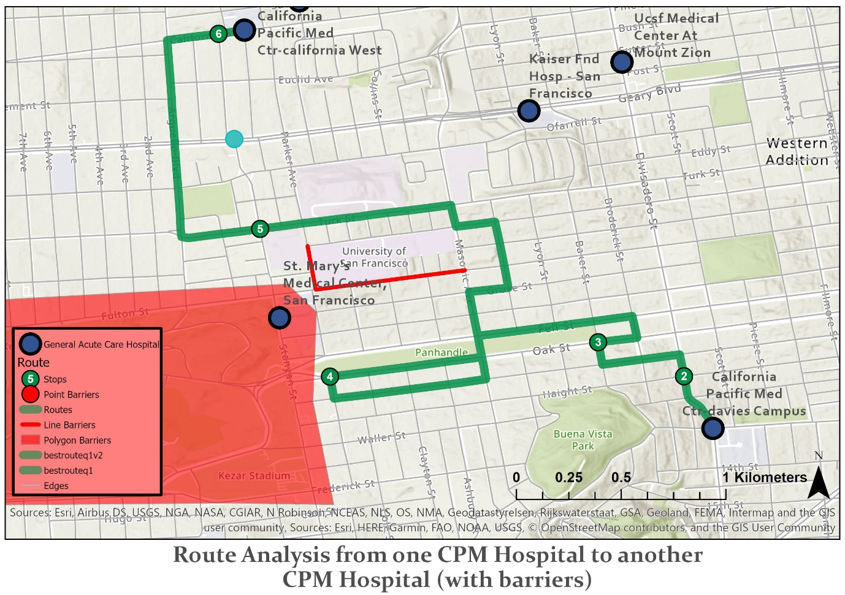

The ambulance is required to transport Patient Zero in California for COVID-19 from California Pacific Med (CPM) Ctr-davies Campus facility to another CPM Ctr-california West facility since it is presumed that the CPM Ctr-california West facility has better equipment and doctors to treat and research on Patient Zero. However, there is a large scale protest for Americans protesting against Trump’s inaction to deal with COVID-19 virus and it is held at a nearby park – Golden Gate Urban Park (Polygon Barriers) and the nearby University, University of San Francisco, has hired dozen of guards to cordon off the roads near the protest citing for students’ safety (Line Barriers). In addition, there is a heavy accident near the CPM Ctr-california West facility (Point Barriers).

The ambulance plans to travel the usual route from stop 4, enter to the express way near the park, and turn right to stop 5, but it only realise that they have made a grave mistake after passing by stop 4 and seeing the huge protest turnout, and they have no idea but to take a detour (route analysis decided that the optimal path is to U-turn and divert away from the park to head to stop 5, before going to the CPM Ctr-california West facility.

**Question 2a**

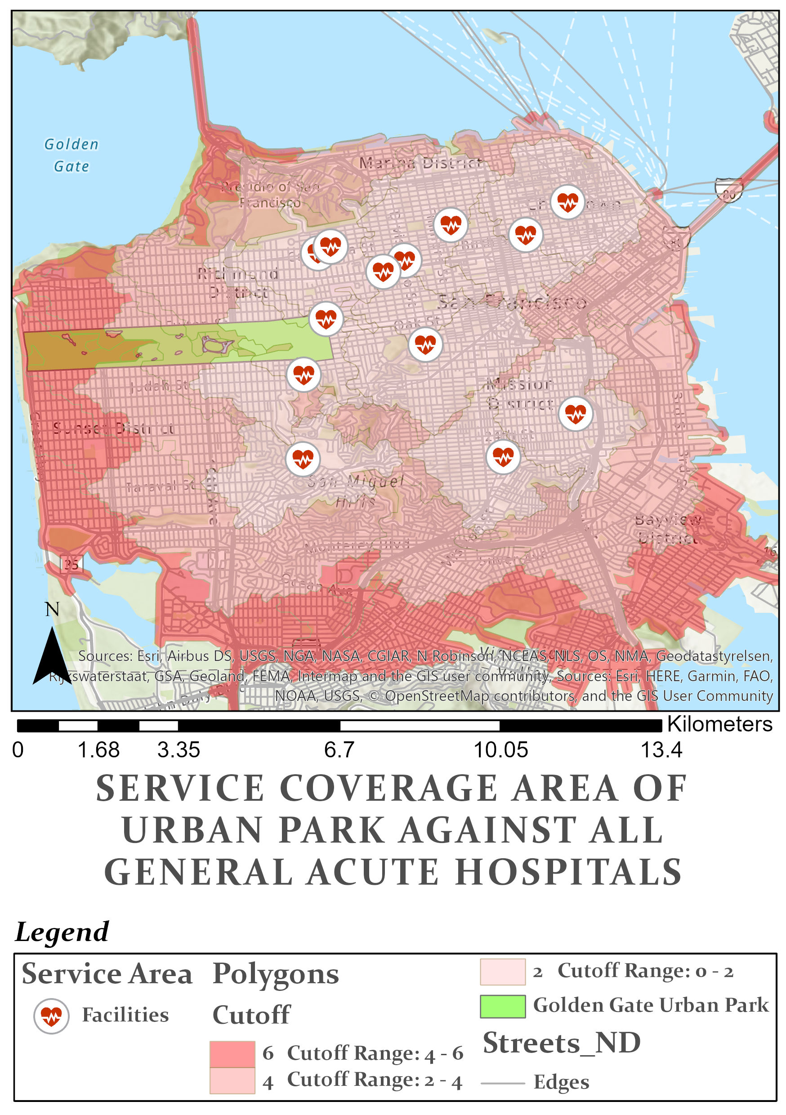

**Question 2b (Test)**

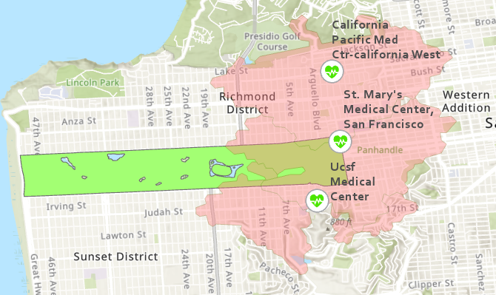

Three hospital facilities are within 2 minutes away from Golden Bridge Urban Park. These hospital facilities are California Pacific Med Ctr-california West, St. Mary’s Medical Center – San Francisco, and Ucsf Medical Center. The rest of the hospital facilities may be slightly more than 2 minutes, or way beyond 2 minutes.

**Question 3a**

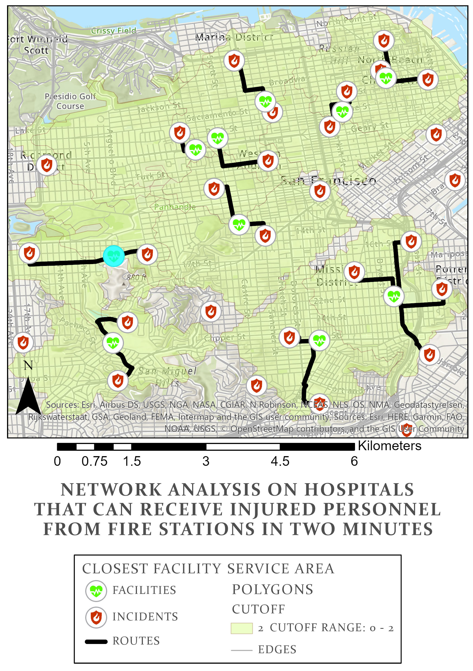

**Question 3b**

|  |  |
| --- | --- |
| **Hospitals** | **Fire Stations (within 2 mins of drive time to Hospital)** |
| California Pacific Medical Center - St. Luke's Campus | Station 32, Station 11 |
| San Francisco General Hospital | Station 9 (near-edge), Station 37, Station 29, Station 7 |
| Laguna Honda Hospital And Rehabilitation Center | Station 39, Station 20 |
| Ucsf Medical Center | Station 12, Station 22 |
| Kaiser Fnd Hosp - San Francisco | Station 10 |
| California Pacific Med Ctr-davies Campus | Station 21, Station 6 |
| California Pacific Med Ctr-pacific Campus | Station 16, Station 38 |
| St. Francis Memorial Hospital | Station 3, Station 41 |
| Chinese Hospital | Station 2, Station 28, Station 13 |
| Ucsf Medical Center At Mount Zion | Station 5 |