Urban Emergency Network: London Fire Response Visualization 20204

Background:
With fire incidents being a global threat to public safety, improving the efficiency of fire emergency response has become an important task to ensure the safety of the city.
To reduce losses caused by the fire, some countries such as US, have set a standard response time for fire trucks to fires: 360s. However, the average response time to primary fires in England was 9 minutes(Helene Clark, 2023).
In order to have a better understanding of fire safety in London, this visualization aims to present a brief overview of the fire incident response times in 2024.

Research
This project mainly focuses on the spatial and temporal distribution of London 2024 fire emergency response time and the impact of response efficiency of each fire station on their overall rescue performance, with the aim of identifying potential bottlenecks and room for improvement through data analysis and visualization.

Data:
Incident records provided by the London Fire Brigade include details such as date, time, location, type, property, and response time. This report focusing on the fire incidents happened in 2024, 16008 records were applied. London fire station data was extracted from OpenStreetMap. London borough spatial data was provided by London datastore.

Methods:
The core of the design revolves around an interactive Mapbox GL JS map, which serves as the primary spatial reference for the data. Overlaid on the map are multiple data layers including fire station locations and the corresponding incident events. The visualization incorporates a time slider that allows users to select a specific month. As users move the slider, the map dynamically updates to display the average response times for each borough as well as the connections between fire stations and incident locations. These connections are rendered as arcs using deck.gl’s ArcLayer, with the arc colors determined by the response time to visually represent the severity of the delay. Additionally, a line chart built with Chart.js is used to provide a detailed view of each station’s performance over the year.

Result：
https://meimao76.github.io/LFBtimemap/
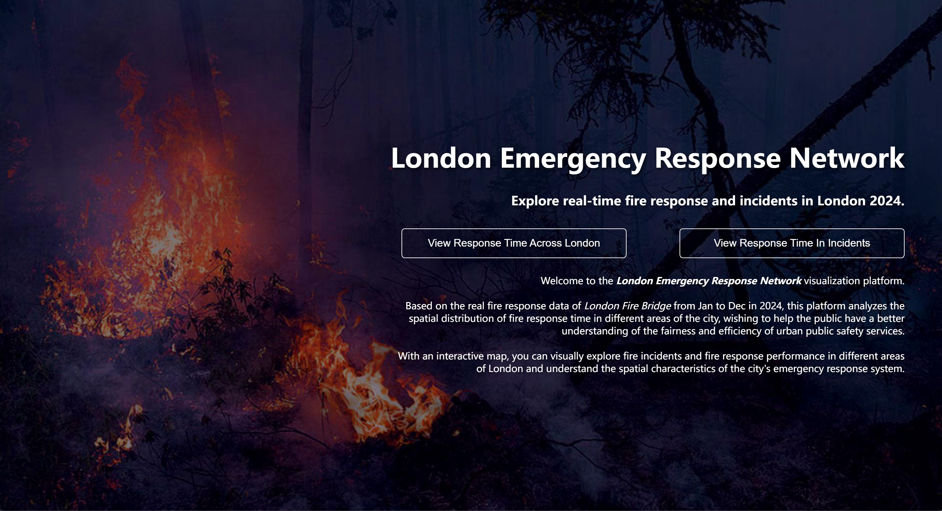
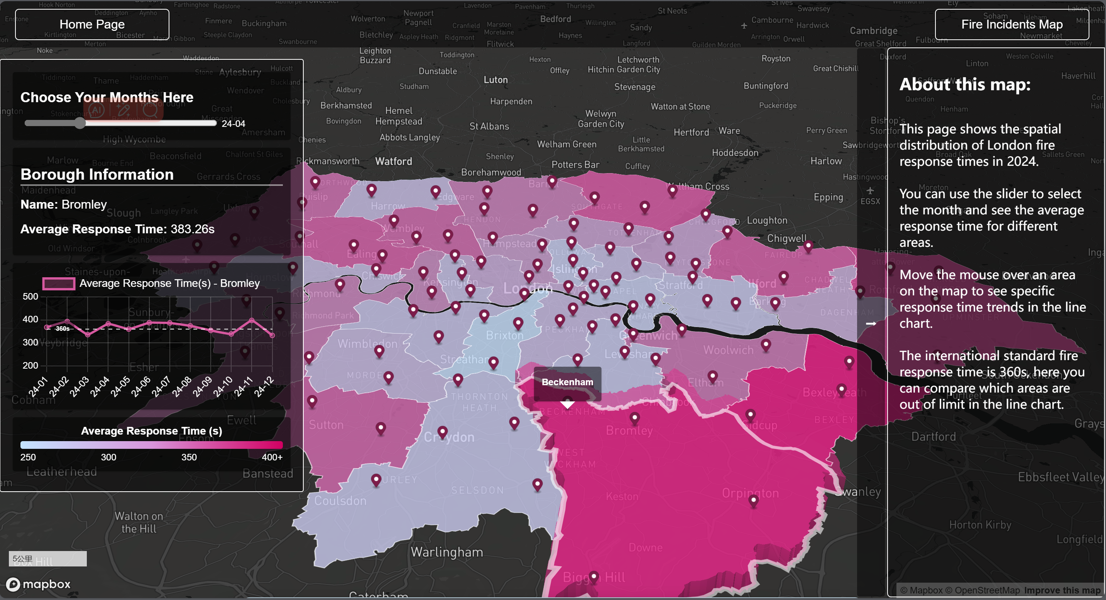
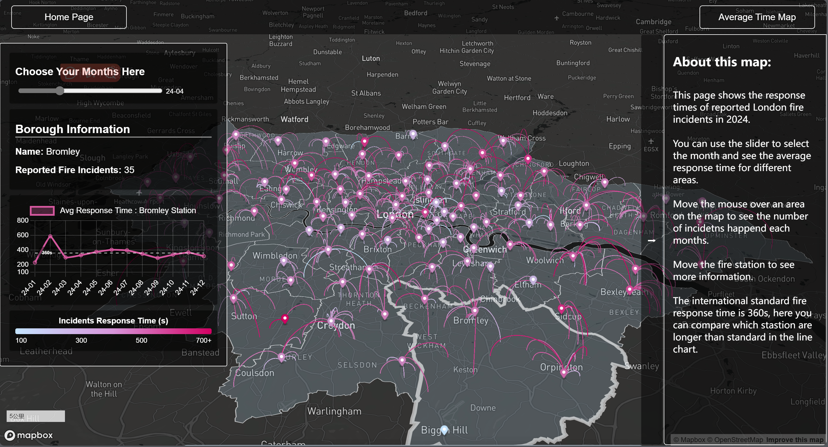
Data sources:
https://data.london.gov.uk/dataset/london-fire-brigade-incident-records
https://data.london.gov.uk/dataset/london-fire-brigade-mobilisation-records
https://data.london.gov.uk/
https://www.openstreetmap.org/
References:
Ambulance response times by totally communications (no date). Available at: http://www.ambulanceresponsetimes.co.uk/ (Accessed: 7 March 2025).
Helene Clark (2023) Detailed analysis of response times to fires attended by fire and rescue services: England, April 2022 to March 2023. GOV.UK. Available at: https://www.gov.uk/government/statistics/detailed-analysis-of-response-times-to-fires-year-to-march-2023/detailed-analysis-of-response-times-to-fires-attended-by-fire-and-rescue-services-england-april-2022-to-march-2023 (Accessed: 7 January 2025).
london fire stations | explore (2023). Available at: https://london-fire.labs.theodi.org/explore/ (Accessed: 7 March 2025).
LFB incident mapping (no date). Available at: https://lfbincidentmapping.london-fire.gov.uk/ (Accessed: 7 March 2025).

