Exploring Fire Response Times in London:

A Data-Driven Approach to Analysis and Modeling

Student Number: 24042785 Word Count: 1727

# Introduction

Fire incident is one of the most common threats to the public safety worldwide, causing a considerable cost of life and property in the society. In 2020, the estimated total economic and social cost of fire in England has reached £12.0 billion (Simon Palmer, 2023). The loss in these incidents increase with the time of emergency response. In the case of New Zealand, this figure reaches NZ$671 for each 10 seconds (Challands, 2010).

In order to reduce the losses caused by the fire incidents, some made the effort to set a standard response time. In America, NFPA sets up a standard of the fire truck arrival within 6 minutes. While in England, reports had showed that in 2023, the average of response time has reached to 9 minutes (Helene Clark, 2023).

Being a key factor in the loss of fire incidents, research on response time has mainly focused on four aspects, spatial analysis, socioeconomic factors, emergency service efficiency and seasonal impact, using spatial analysis, spatial survival analysis, multivariate and quantile regression.

Geographical conditions and transportation networks have a powerful impact on fire response times. Research in Sweden found that response times in remote areas are higher than in urban areas, while traffic congestion and complex road network in cities can also increase response times (Hassler, Andersson Granberg and Ceccato, 2024).

When it comes to social factors, research has showed that communities with lower socioeconomic status are more likely to be severely impacted by fires, including property loss and casualties (Kc and Corcoran, 2017). Some areas with a high proportion of the elderly, which meaning an increase need of faster response, tend to have lower services (Yu *et al.*, 2020).

Additional, fire response time is affected by both the time, the season (Kc and Corcoran, 2017), and the spatial distribution of the fire station (Taylor, 2017).

London's diverse social structures and resource allocation lead to outstanding variations in response times, shaped by economic, cultural, and societal factors. Aiming to provide a statistic basis for further optimizing the allocation of fire station and policy formulation, this study will mainly focus on London areas to explore:

1. Do fire response times differ across areas and do they exist certain patterns?
2. What could be the potential factors how they interact the differences?

# Data and Methods

## Data Description

Incident records provided by the London Fire Brigade include details such as date, time, location, type, property, and response time. Here we choose the more recent time (2018-2023) records in order to better align with contemporary policy and planning needs. The total number of the incidents attended by the LFB is 670993. To ensure more accurate model fitting, extreme event records with response times less than 30 seconds or longer than 900 seconds (Kc and Corcoran, 2017), left with 623345 incidents.

The histogram and KDE plot (**Fig 1**) show a right-skewed, unimodal distribution of fire response times, with most values between 200-400 seconds and a long tail indicating occasional extreme response times.

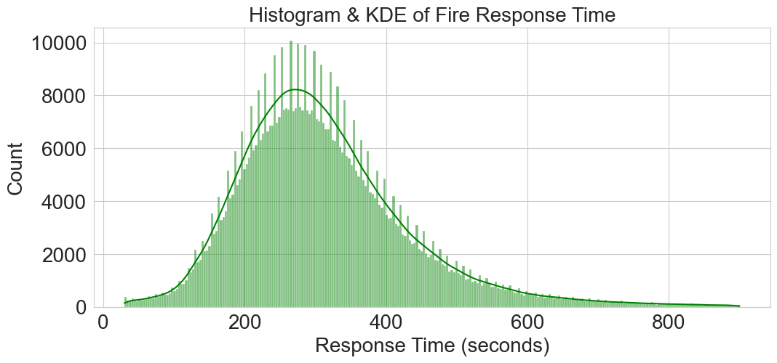

**Figure 1** Histogram and KDE of Fire Response Time

Following Kc and Corcoran’s research (2017), we selected 11 variables from four categories. Then a correlation analysis was conducted to avoid multicollinearity, ensuring model interpret ability. Variables with Pearson correlations above 0.8 were excluded. The final datasets are presented in **Table 1**, and the numeric data distributions are shown in **Fig 2**.

**Table 1** Selected Variables

|  |  |  |  |
| --- | --- | --- | --- |
| Variable | Group | Type | Description |
| Income deprivation | Socio-economic indicators | Numeric | London boroughs' median income deprivation ranking |
| Dwellings density | Numeric | The number of dwellings per square kilometers |
| Road density | Infrastructure indicators | Numeric | The length of total roads per square kilometers |
| Traffic flow | Numeric | Million vehicle kilometers travelled by all motor vehicles and all cars in London. |
| Fire stations | Numeric | The number of fire stations in London. |
| Peak-time | Time indicators | Categorical | Whether the incident happens in peak-time. |
| Season | Categorical | Whether the incident happens in winter. |
| False alarm | Incident types | Categorical | Whether the incident is false alarm or not |
| Dwelling | Categorical | Whether the incident happens in dwellings |

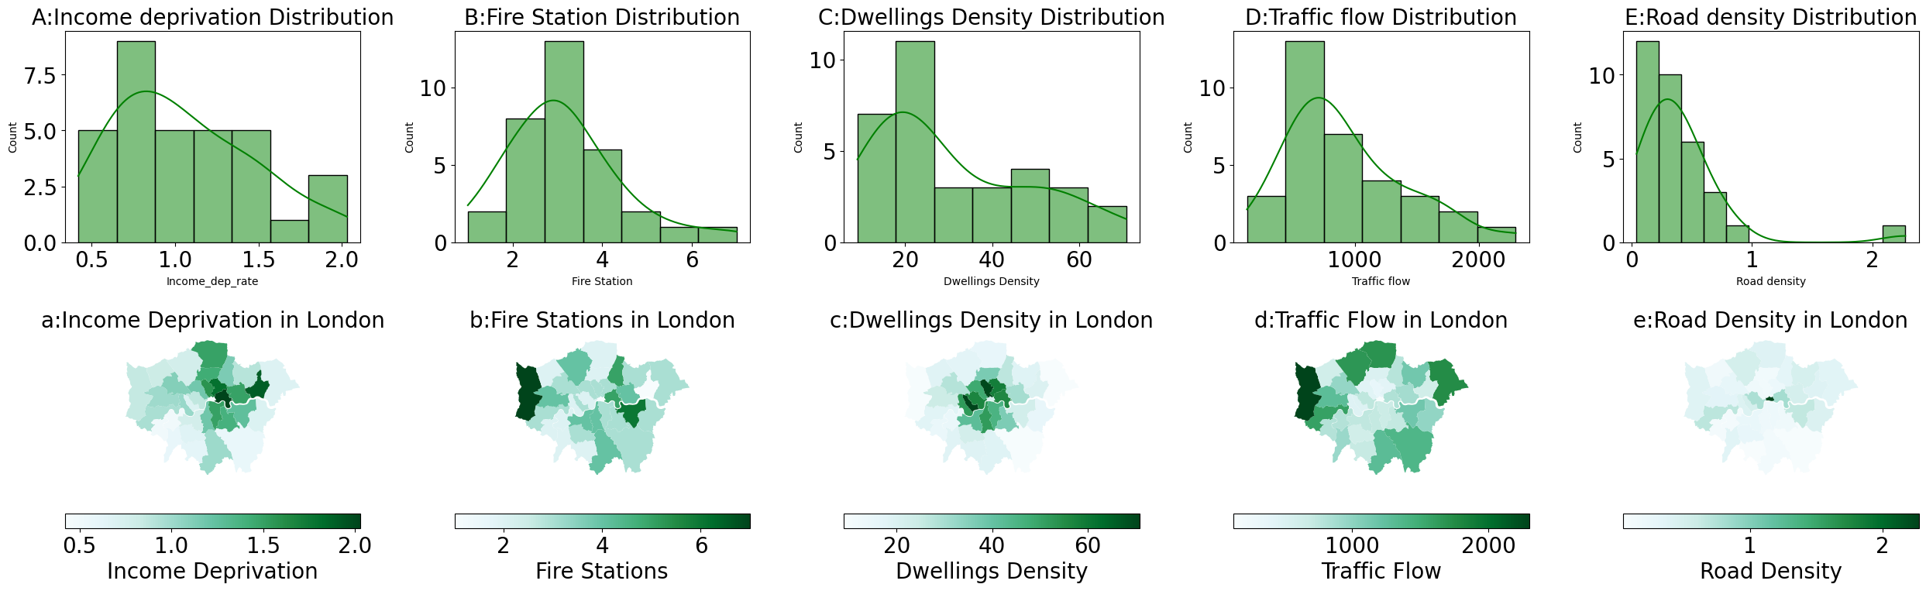

**Figure 2** Distribution of Variables

## Methods and Models

To analyze differences in fire response times across London boroughs, we choose ANOVA to test whether there is a significant difference in the mean response time. Followed by a Tukey HSD test and T-test, significant results (p < 0.05) can help to identify specific borough differences.

In order to have a deeper understanding of the factors, influence in different groups and how they differ from areas, this report tried *Linear* *Mixed-Effects Model* regression (LMM).

Mixed-Effects Model is a statistical method widely used in processing hierarchical data, which can estimate fixed effects and random effects at the same time. Fixed effects measure the global variables, while random effects capture variability between groups or individuals and help describe non-independence in the data (Gelman and Hill, 2006).

Thus, it allows for the estimation of both fixed effects such as income factors and random effects such as borough groups. By incorporating these random effects, the model captures spatial heterogeneity in response times across boroughs.

# Results

## Differences and Patterns between Boroughs

**Fig 3** presents the geographical distribution of average fire response times across London. The ANOVA test (F-statistic: 936.99, P-value: 0.0 < 0.05) rejects the null hypothesis, indicating significant differences in response times between boroughs. A Tukey HSD test (**Fig 4**) shows notable differences in response times for areas like the City of London, Kensington and Chelsea, and Tower Hamlets, while differences between boroughs like Barking and Dagenham and Barnet are minimal. Inner London demonstrates more efficient services, whereas fringe areas, such as Hillingdon, show higher response times.

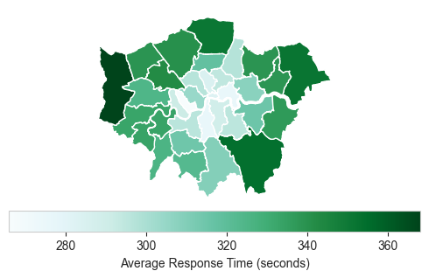

**Figure 3** Average Fire Response Time by Boroughs in London

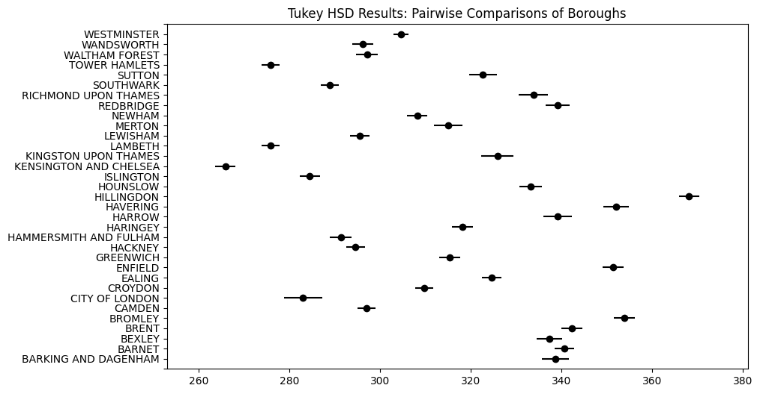

**Figure 4** Tukey HSD Result

According to the Office for National Statistics, boroughs are divided London into Inner London and Outer London. A T-test on the response times for all fire incidents recorded in both regions. The results show as in **Table 2,** the distribution of two different regions is showed in **Table 3** and **Fig 5**. Given the extremely small p-value, null hypothesis of no significant difference in response times between Inner and Outer London, thereby indicating a statistically significant difference in response times between the two regions, suggesting better transportation, resource allocation, and service density in inner London, while outer London face potential service imbalances.

However, the value of Cohen's d (d=−0.347) indicates a small to moderate practical significance. This suggests that while the difference is statistically detectable due to the large sample size, the practical impact may be limited. Thus, further investigation is needed.

**Table 2** T-Test Result

|  |  |  |  |  |
| --- | --- | --- | --- | --- |
| Inner London Sample Size | Inner London Sample Size | T-Statistic | P-Value | Cohen's d |
| 319,480 | 303,865 | −136.427 | 0.000 | -0.347 |

**Table 3** Statistics of Regions

|  |  |  |  |
| --- | --- | --- | --- |
| Region | Mean | Median | Std |
| Inner London | 292.265137 | 277 | 110.367055 |
| Outer London | 333.689030 | 317 | 128.174612 |

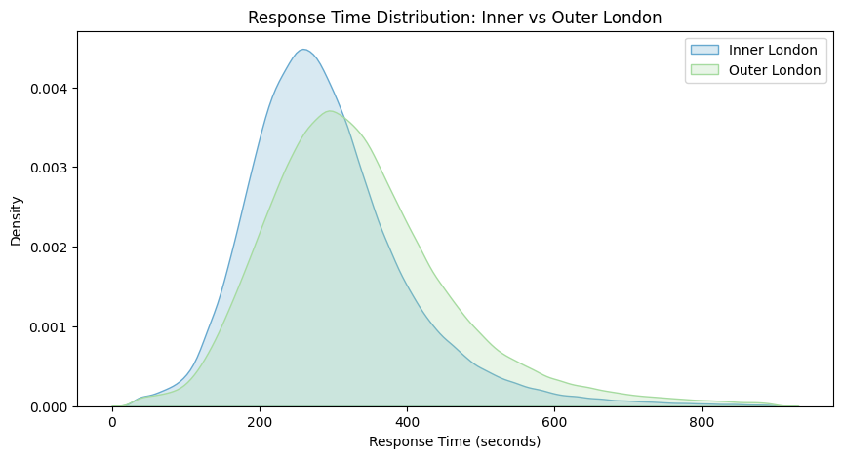

**Figure 5** Density of Inner and Outer London Response Time

## Regression and Correlations in Factors

Before formally conducted LMM, a null model with no fixed effects is needed, to evaluate the significance of the random effect. Results (**Table 4**) show successful convergence, with 50% of variance explained by group-level differences, indicating notable variation in response times between groups.

**Table 4** Null Model Result

|  |  |  |  |  |
| --- | --- | --- | --- | --- |
| Intercept | p-value (Intercept) | Group Var | Log-Likelihood | ICC |
| 314.799 | 0.000 | 14,185.597 | -3,864,078.66 | 0.5 |

The mixed-effects model used response time as the dependent variable with 9 fixed effects and Inner/Outer London as random effects. A significant group variance (Group Var = 13,993.304) was observed. This model better fit to the data than null model (log-likelihood = -3,859,831.64 vs. -3,864,078.66) and low marginal R² (0.024) indicate limited impact of independent variables, while regional differences (Conditional R² = 0.512) play a key role in response times.

The coefficients (**Fig 6**) show that non-false alarms increase response times; while dwelling incidents reduce them. More fire stations and higher road density could lower response times. Peak-time incidents slightly delay responses, while winter and traffic volume have minimal effects. Random effects (**Fig 7**) show the differences between the two groups, with Inner London reducing response times by 3.78 seconds compared to the average.

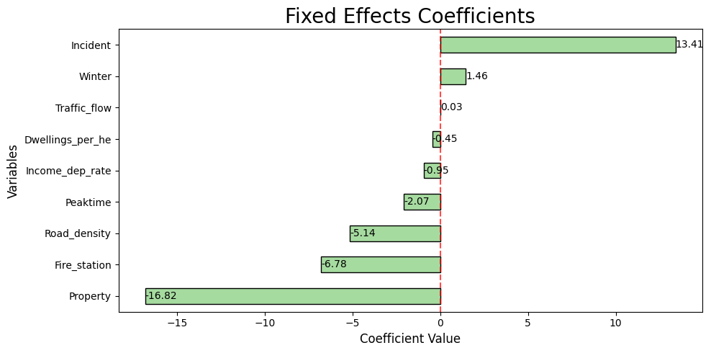

**Figure 6** The Coefficients of Fixed Effects

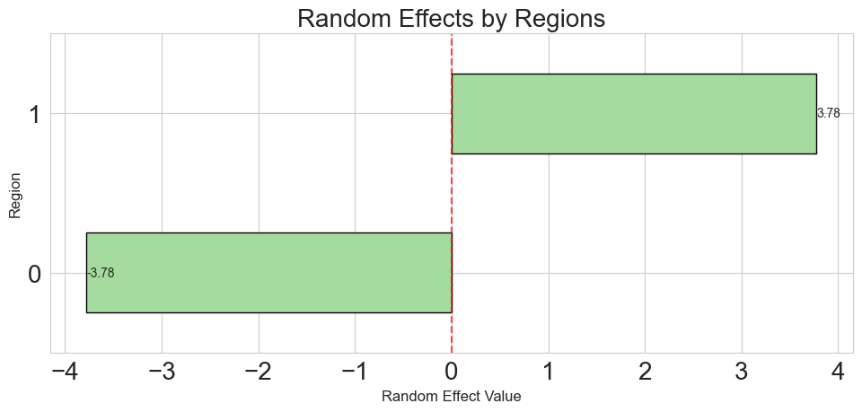

**Figure 7** The Value of Random Effects

Interaction terms (**Table 5**) revealed that time and seasonal factors showed no huge differences between Inner and Outer London in influencing response times. Income deprivation had a stronger impact on response times in Inner London, while dwelling density affected Outer London more considerably. Outer London experienced longer response times for incidents in dwellings but shorter times for non-false alarms.

**Table 5** Mixed Linear Model Regression Results

|  |  |  |  |  |  |  |
| --- | --- | --- | --- | --- | --- | --- |
| Variable | Coefficient | Std. Error | z-value | P>|z| | 95% CI Lower | 95% CI Upper |
| Intercept | 328.358 | 118.548 | 2.77 | 0.006 | 96.007 | 560.708 |
| Income_dep_rate | 6.65 | 0.64 | 10.395 | 0 | 5.396 | 7.903 |
| Region | 22.445 | 167.232 | 0.134 | 0.893 | -305.324 | 350.214 |
| Income_dep_rate: Region | -6.712 | 1.035 | -6.488 | 0 | -8.74 | -4.684 |
| Dwellings_per_km | -0.411 | 0.019 | -21.875 | 0 | -0.448 | -0.374 |
| Dwellings_per_km: Region | -0.657 | 0.067 | -9.805 | 0 | -0.789 | -0.526 |
| Fire_station | -12.738 | 0.316 | -40.251 | 0 | -13.358 | -12.118 |
| Fire_station: Region | 8.467 | 0.37 | 22.864 | 0 | 7.741 | 9.193 |
| Traffic_flow | 0.032 | 0.002 | 20.947 | 0 | 0.029 | 0.035 |
| Traffic_flow: Region | -0.01 | 0.002 | -5.757 | 0 | -0.014 | -0.007 |
| Road_density | -6.731 | 0.615 | -10.948 | 0 | -7.936 | -5.526 |
| Road_density: Region | 9.319 | 1.547 | 6.022 | 0 | 6.286 | 12.352 |
| Peaktime | -2.284 | 0.438 | -5.215 | 0 | -3.143 | -1.426 |
| Peaktime: Region | 0.313 | 0.625 | 0.501 | 0.617 | -0.912 | 1.538 |
| Winter | 1.572 | 0.482 | 3.262 | 0.001 | 0.628 | 2.517 |
| Winter: Region | -0.09 | 0.697 | -0.13 | 0.897 | -1.457 | 1.276 |
| Incident | 16.188 | 0.455 | 35.563 | 0 | 15.296 | 17.08 |
| Incident: Region | -5.199 | 0.652 | -7.968 | 0 | -6.477 | -3.92 |
| Property | -9.805 | 0.649 | -15.1 | 0 | -11.078 | -8.533 |
| Property: Region | -11.823 | 0.842 | -14.038 | 0 | -13.474 | -10.173 |

According to the result, response time in Inner London benefits from enhanced transplantation, additional infrastructure, and a higher density of fire stations. The impact of income deprivation and dwelling density on response times also differ across regions. In Outer London, higher dwelling density leads to longer response times more than Inner London did, suggesting that the road connections and accessibility might be lower in these areas.

Time factors like peak-time and seasons have very small effects. However, due to the limit study area, it is reasonable that the time trends in different regions were similar. A comparison analysis between different countries might be needed for further investigation. Despite this, other analysis including real-time traffic and environmental data are still useful to explore further results.

# Discussion and Conclusion

## Conclusion

This study used a Linear Mixed-Effects Model (LMM) to analyze factors influencing fire response times in London and revealed some spatial patterns. The results showed that due to better infrastructure and fire station density, response times in Inner London are shorter while Outer London faced longer delays. This result suggests some service imbalances and accessibility issues.

Results show that response times vary spatially, aligning with the findings reported in previous studies (Kc and Corcoran, 2017). The degree of variation is more dependent on the type of physical infrastructure and socio-economic indicators while less on temporal factors of an area. Regional variations had a more substantial impact on response times than other fixed factors. This emphasizes the need to account for spatial variation in emergency service planning.

To reduce time of emergency response time, roads densities and number of new fire stations could be expanded. On top of that, differentiated policies are required for Inner and Outer London aiding incident response times and equitable resource allocation. Invest in infrastructure in Outer London, and improve coverage of fire stations.

## Discussion and Limitations

The LMM successfully revealed the differences between spatial groups and the influences of other factors. However, its predictive power is limited due to the absence of critical spatial and environmental variables, also it fails to account for nonlinear relationships frequently observed in social science research. Advanced methods, such as machine learning or GIS-based geographical regression, could be conducted in future studies to address these issues and to enhance the model’s predictive performance.

Another major limitation lies in the exclusion of extreme events (e.g., incidents with response times exceeding 900 seconds), which may obscure important patterns under extreme conditions and limit the generalizability of the findings.

Key infrastructure-related variables, such as road network connectivity, intersection density, and traffic bottlenecks, were not incorporated into the model, despite their documented impact on emergency response efficiency.

To address these limitations, future research should incorporate detailed geospatial variables, including road network metrics, land use patterns, and real-time traffic data, to better capture spatial dependencies and environmental influences. These improvements would not only make the models more relevant and accurate but also provide valuable insights for urban planning and policy-making.

# References

Challands, N. (2010) ‘The Relationships Between Fire Service Response Time and Fire Outcomes’, *Fire Technology*, 46(3), pp. 665–676. doi: 10.1007/s10694-009-0111-y.

Gelman, A. and Hill, J. (2006) *Data Analysis Using Regression and Multilevel/Hierarchical Models*. Cambridge University Press. doi: 10.1017/CBO9780511790942.

Hassler, J., Andersson Granberg, T. and Ceccato, V. (2024) ‘Socio-spatial Inequities of Fire and Rescue Services in Sweden: An Analysis of Real and Estimated Response Times’, *Fire technology*, 60(1), pp. 193–212. doi: 10.1007/s10694-023-01496-3.

Helene Clark (2023) *Detailed analysis of response times to fires attended by fire and rescue services: England, April 2022 to March 2023*. GOV.UK. Available at: https://www.gov.uk/government/statistics/detailed-analysis-of-response-times-to-fires-year-to-march-2023/detailed-analysis-of-response-times-to-fires-attended-by-fire-and-rescue-services-england-april-2022-to-march-2023 (Accessed: 7 January 2025).

Kc, K. and Corcoran, J. (2017) ‘Modelling residential fire incident response times: A spatial analytic approach’, *Applied Geography*, 84, pp. 64–74. doi: 10.1016/j.apgeog.2017.03.004.

Simon Palmer (2023) *Economic and social cost of fire*. GOV.UK. Available at: https://www.gov.uk/government/publications/economic-and-social-cost-of-fire/economic-and-social-cost-of-fire (Accessed: 7 January 2025).

Taylor, B. M. (2017) ‘Spatial Modelling of Emergency Service Response Times’, *Journal of the Royal Statistical Society Series A: Statistics in Society*, 180(2), pp. 433–453. doi: 10.1111/rssa.12192.

Yu, D. *et al.* (2020) ‘Disruption of emergency response to vulnerable populations during floods’, *Nature Sustainability*, 3(9), pp. 728–736. doi: 10.1038/s41893-020-0516-7.