

  Name | : | AISYAH BINTI MOHD ABU BAKAR
  Age | : | 37 years old
  Talent ID | : | T23249
  Programme | : | ORAL HEALTH
  Designation | : | DENTAL OFFICER UG 52
  Workplace | : | PUSAT PERGIGIAN KANAK-KANAK & INSTITUT LATIHAN KEMENTERIAN KESIHATAN MALAYSIA (PERGIGIAN)
  CPD / NSR Points
  2019 - 0
  LNPT Points
  2021 - 93.17
  2020 - 92.97
  2019 - 93.42

PERSONALITY STATEMENT SUMMARY
I am thrilled to participate in this TGP programme because it enables me to obtain valuable skills such as inspiring and motivating others, enhancing communication skills, creating connections, problem-solving, decision-making, time management, and strategy.
I suppose TGP should choose me because, despite my limited of experience, I’ve tried my best to be a competent leader. I've been working with a lot of groups and units where most of the people were older and had more experience. I believe working in a group seems better than working alone. I always adhere to the TEAM philosophy (together everyone achieves more) when performing tasks. I always think ahead and come up with the best plan to make sure that goals are met.
I hope to gain a lot of knowledge from TGP, specifically on handling projects and tasks. Moreover, I wish to collaborate with other professionals from different agencies. Furthermore, I hope that TGP will discover my hidden potential and improve my confidence. I picture myself in five years as a more confident employee and a leader who could really supervise more effectively. In addition, I hope to be able to organise a project with a more scientific and community-oriented approach in order to increase community awareness, particularly about oral health.
PERSONALITY TEST SUMMARY
Cenderung berasa sangat bimbang terhadap perkara yang tidak penting dan tiada keyakinan dengan kebolehan diri, dan menilai sesuatu perkara atau situasi secara negatif. Seorang yang sangat pendiam, kurang berinteraksi secara sosial dan suka kepada kehidupan yang tenang. Sangat mudah bersimpati dan prihatin. Sangat cenderung mengambil tindakan atau keputusan berdasarkan kepada perasaan yang dialami dan tidak tegas. Tidak suka apabila orang lain mempersoalkan tindakan yang buat. Namun bersikap sangat fleksibel, spontan, terbuka dan suka kepada situasi kerja yang tidak mengongkong.
Kebolehpercayaan menjawab: Diterima (Tinggi).
TGP PROJECT – Area of interest
- ORAL HEALTH - Children Dental Anxiety In Relation To DentalCaries in Children Dental Centre & MOH Training Institute (Dental) Malaysia

TGP COMPETENCY ASSESSMENT
 | Self-Assessment |  | Referee Assessment
 | Score | Level | Average Score | Level
Leadership | 60.0 | 2 | 85.0 | 3
Interpersonal Relationships | 70.0 | 3 | 85.0 | 3
Organizational Governance | 66.7 | 2 | 86.7 | 3
Professional Values | 72.0 | 3 | 86.0 | 3
Personal Values | 60.0 | 2 | 90.0 | 4
Overall | 66.0 | 2 | 86.5 | 3
ASSESSMENT SUMMARY

 | LEADERSHIP  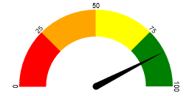  85.0% | AREA FOR IMPROVEMENT  (Based on referees’ assessment*)
  Change Leadership
  Team Leadership
  Conflict managament
 | INTERPERSONAL RELATIONSHIP  85.0% | AREA FOR IMPROVEMENT  (Based on referees’ assessment*)
  Communication Skill
  Teamwork & Collaboration
  Negotiation Skill
 | ORGANISATIONAL GOVERNANCE  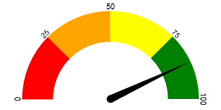  86.0% | AREA FOR IMPROVEMENT  (Based on referees’ assessment*)
  Financial Skills Process Management
  Human Resource Management
 | PROFESSIONAL VALUES  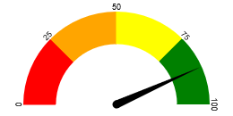  86.7% | AREA FOR IMPROVEMENT  (Based on referees’ assessment*)
  Continuous Quality Improvement
  Community Awareness & Strengthening
 | PERSONAL VALUES  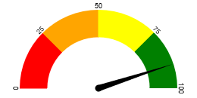  90.0% | AREA FOR IMPROVEMENT  (Based on referees’ assessment*)
  -
PANELS COMMENTS
Highly Potential & Candidate shall improve her leadership skills through this programme.

