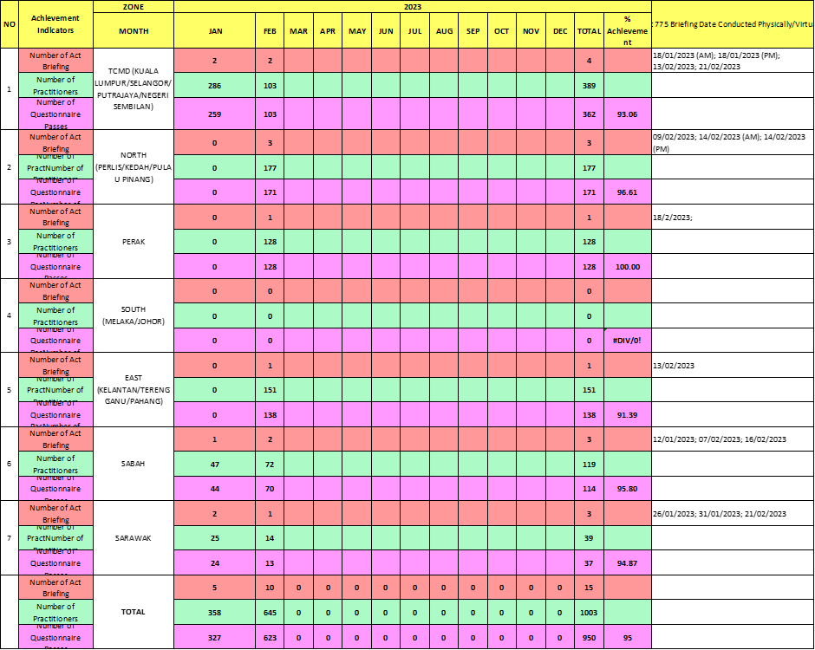

**TABLE 2: GANTT CHART SHOWS THE ACT 775 BRIEFING CONDUCTED BY TCMD AND TCMB FOR 2023**

In addition, more promotion and awareness campaign regarding registration of T&CM practitioner should be done by T&CM Council through proactive participation of the staff by opening registration booth nationwide to promote more T&CM practitioner to be registered on the spot. Other than that, the practitioner T&CM Council also can cooperate with T&CM practitioner association to promote the importance of being a registered T&CM practitioner. Apart from that, after February 2024, which we will be entering into phase 3 of enforcing the Act 775, this Act briefing session should be ended and to be replaced by questionnaire type examination. Practitioner have to answer the questionnaire after they have studied the Act 775 in details by themselves and the T&CM Council should take over this duty and proceed to register them thereafter.